|  |  |  |  |
| --- | --- | --- | --- |
|  | United Nations | ECE/TRANS/WP.15/AC.2/2018/39 | |
|  | **Economic and Social Council** | | Distr.: General  12 June 2018  Original: English |

**Economic Commission for Europe**

Inland Transport Committee

**Working Party on the Transport of Dangerous Goods**

**Joint Meeting of Experts on the Regulations annexed to the   
European Agreement concerning the International Carriage   
of Dangerous Goods by Inland Waterways (ADN)  
(ADN Safety Committee)**

**Thirty-third session**

Geneva, 27–31August 2018  
Item 5 of the provisional agenda

**Reports of informal working groups**

Executive summary of the result of the second meeting of the informal working group “loading on top in barges”

Transmitted by the Federation of European Tank Storage Associations (FETSA), the European Barge Union (EBU), the European Skippers Organisation (ESO), the European Bulk Oil Traders' Association (EBOTA) and Fuels Europe [1]*,[2]**

|  |  |
| --- | --- |
| *Summary* |  |
| **Executive summary:** | Executive summary of results of the first and second meetings of the informal working group on loading on top in barges; complete summary of information and answers to the questions raised and within the mandate given during the thirtieth, thirty-first and thirty-second sessions of the ADN Safety Committee.  During the second meeting that took place in The Hague, the Netherlands on the 24 April 2018 and that was organized by FETSA, representatives of the following organizations were present: Port of Rotterdam, Port of Amsterdam, Fuels Europe, EBU, ESO, EBOTA and FETSA. |
| **Action to be taken:** | The informal working group invites the Safety Committee to study the proposals as detailed in the introduction and annexes below, and to extend the informal working group’s mandate to further work on the proposals including but not limited to proposals for amendments to 1.2.1, 1.4, 2.1, 5.4, 7.2, 8.6.3 of ADN, and a proposal to incorporate the loading on top operation in 7.2.4.12 and 8.1.11 of ADN. |
| **Related documents:** | Informal document INF.15 of the thirtieth session  Informal document INF.6 of the thirty-first session as addendum to document ECE/TRANS/WP.15/AC.2/2017/44  Informal document INF.9 of the thirty-second session |

Introduction

1. Loading on top in inland waterway barges is a frequent and well-controlled operation performed mainly in the various (sea-) ports. It is carried out by industry professionals and follows high international industry standards with respect to health, safety and the environment, and, as a result, has been without accidents and incidents for many years.

2. The operation follows the need for optimization in an increasingly complex environment of local, national and international regulation and logistic constraint. Different products are manufactured at different locations all around the globe; various seaports in Europe in general, not limited to those in the Antwerp-Rotterdam-Amsterdam (ARA) range, welcome many sea-going tankers and facilitate various complex logistic operations between tankers, inland waterway tankers, and land-based installations such as oil-terminals and refineries. Such operations are not limited to loading on top of inland waterway barges. It’s not limited to the mentioned area either. As such, and in line with UNECEs view on inland water transport, a pan-European vision and solution is required.

3. (European) Ports are highly regulated by a variety of local, national and international laws. So are manufacturing sites, oil-terminals, and carriers. Laws and regulations follow and facilitate international trade. This is also true for ADN, ADR, RID, where the various UNECE bodies meet, discuss, decide and form working groups with non-governmental organizations to clarify interpretations, and adapt ADN, ADR, and RID to meet with current needs.

4. The UNECE Inland Transport Committee facilitates the international movements of persons and goods by inland transport modes, as reflected in the 2011 “[UNECE White paper on Efficient and Sustainable Inland Water Transport in Europe](http://www.unece.org/fileadmin/DAM/trans/main/sc3/publications/WhitePaper_Inland_Water_Transport_2011e.pdf)”[3] There is a recognition to adapt to a fast changing environment. The UNECE white paper recognizes that inland water transport represents a safe, reliable and environmentally friendly mode of transport, with the potential and the need to grow[4].

5. Although many barriers have been taken away, UNECE recognized the need to continue to eliminate administrative, technical and legal barriers for inland navigation [5].

6. The Pan-European vision for efficient and sustainable inland water transport also considers the use of river information service (RIS)[6]; it sees the challenges placed by market requirements, particularly in sea-ports [7].

7. Document [ECE/TRANS/SC.3/189](https://www.unece.org/fileadmin/DAM/trans/doc/2017/sc3wp3/ECE-TRANS-SC3-WP3-2017-inf_09e.pdf) “Fostering the role of Inland Water Transport in the World within the Framework of the Sustainable Development Agenda”[8] refers to the role of Inland Water Transport in the context of relevant sustainable development goals[9]. In other words, there is work being done in other UNECE bodies to grow the inland water transport industry in a sustainable way, whilst looking at the market requirements.

8. Our proposals link into some of the sustainable development goals as mentioned in this UNECE publication of the International Conference of Inland Water Transport in the world.

* Sustainable Development Goal 3 – Ensure healthy lives and promote well-being for all at all ages
* Sustainable Development Goal 7 – Ensure access to affordable, reliable, sustainable and modern energy for all
* Sustainable Development Goal 9 – Build resilient infrastructure, promote inclusive and sustainable industrialization and foster innovation
* Sustainable Development Goal 11 – Make cities and human settlements inclusive, safe, resilient and sustainable
* Sustainable Development Goal 13 – Take urgent action to combat climate change and its impacts

9. ADN is goal based regulation. Meaning that the participants under ADN must comply, but ADN will not describe how to do that. Our proposals will reflect that.

10. During an earlier meeting the Safety Committee recognized that this type of operation happens on various locations within the territory of the ADN. It was stated that “if this happens, we must have a closer look at it”.

11. Members of the informal working group including FuelsEurope, EBOTA, EBO/ESO and FETSA understand the concerns raised by some of the delegates in past meetings. It is recognized that there is a need to better describe the operation to bring transparency and controllability. We understand the sensitivity as history taught us all a few times about the illegal blending of waste streams observed in seagoing vessels. We have to take this seriously.

12. There should be no doubt that loading on top is not at all about allowing waste blending but on defining what can be allowed and under what controllable conditions. It is also not about limitless loading on top/commingling. We are proposing loading on top/commingling of bio-components into a very limited number of products for the transport sector in accordance with existing European legislation, such as the Renewable Energy Directive[10] and Fuels Quality Directive[11]. We are proposing a limited number of UN numbers to be loaded on top.

13. Clear and enforceable rules, setting clear responsibilities and accountabilities are needed, leading to less room for interpretation.

14. ADN does offer possibilities, as the process map of a typical loading on top/commingling operation shows. Clear responsibilities and accountabilities for a loading on top operation can be assigned to the various participants as we will show you.

15. FuelsEurope, EBOTA, FETSA, EBU/ESO, want to actively contribute to formulating in clear terms and in full transparency what types of loading on top can be allowed, with the support of the Dutch Seaport Association including Port of Amsterdam, Rotterdam and Flushing for an adaptation of ADN and with full focus on a safe operation. Therefore, we invite the ADN Safety Committee to study the proposals as detailed in the annexes to this document, and to extend the informal working group’s mandate to further work on the proposals, including proposals for amendments and insertions in ADN 1.2.1, 1.4, 2.1, 5.4, 7.2, 8.6.3, and a proposal to incorporate the loading on top operation in 7.2.4.12 and 8.1.11.

16. Our proposal is to allow a limited number of loading on top of operations, in particular:

(a) A loading on top of products with the same UN-number. Those products are given in table 1, 2 and 3 of Annex I;

(b) Loading on top on board for Gasoline (UN 1203), Gasoil (UN 1202) and heavy fuel oil (UN 3082) with a limited number of (bio-)components in their own group. The bio-components are listed in table 4 of Annex I. The loading on top/commingling proportions as well as the bio-components used, are to be executed in line with the fuel quality specifications in-place in order to still allow the products to be used as transport fuels.

Annex I

List of proposed substances

I. List of proposed substances

1. In response to questions around the first working document[12] and INF 9[13], the informal working group has developed a non-exhaustive example list of substances, grouped in 3 tables, by compatibility. Products mentioned in each group are normal components in the type of fuels (i.e. Ethanol UN 1170 is a common ‘ingredient’ of the mixture which we call “Gasoline” and is classified under UN 1203);

2. The Safety Committee is invited to consider the following 3 groups of substances in accordance with Table C of Chapter 3.2 of ADN, to be allowed to load on top, within their compatibility group, in inland waterway tankers, in line with ADN 7.2.4.13.1, 3rd paragraph and in line with the definitions of “exclusive transport operations” and “compatible transport operations” as referred to in art.5.01 of the Convention on the Convention, Deposit and reception of waste produced during navigation on the Rhine and inland waterways (CDNI)[14] and under the strict condition that subject substances and the commingled substance are included on the ships substance list as referred to in 1.16.1.2.5:

# Table 1

# **Compatibility Group I**

| *Group* | *UN* | *Proper Shipping Name* |
| --- | --- | --- |
| Gasoline | 1203 | MOTOR SPIRIT or GASOLINE or PETROL 2) |
|  | 1170 | ETHANOL (ETHYL ALCOHOL) or ETHANOL SOLUTION (ETHYLALCOHOL SOLUTION) 1) |
|  | 1179 | ETHYL BUTYL ETHER (ETHYL tert-BUTYL ETHER) |
|  | 1230 | METHANOL |
|  | 1268 | PETROLEUM DISTILLATES, N.O.S. or PETROLEUM PRODUCTS, N.O.S 2) |
|  | 1294 | TOLUENE |
|  | 1307 | XYLENES 1) |
|  | 2398 | METHYL tert-BUTYL ETHER |
|  | 3475 | ETHANOL AND GASOLINE; MIXTURE or ETHANOL AND MOTOR SPIRIT MIXTURE or  ETHANOL AND PETROL MIXTURE 1) |
|  | 3295 | HYDROCARBONS, LIQUID, N.O.S. 2) |
|  |  | Bio components, conform Annex III, RED |
|  |  | Bio components, non Dangerous, conform Annex III, RED |

# Table 2

# **Compatibility Group II**

| *Gasoil* | *1202* | *GAS OIL or DIESEL FUEL or HEATING OIL (LIGHT) 1)* |
| --- | --- | --- |
|  |  | Bio components, conform Annex III, RED |
|  |  | Bio components, non Dangerous, conform Annex III, RED |

# Table 3

# **Compatibility Group III**

| Heavy Fuel Oil | 3082 | ENVIRONMENTALLY HAZARDOUS SUBSTANCE LIQUID, N.O.S. (HEAVY HEATING OIL) 3) |
| --- | --- | --- |
|  | 1202 | GAS OIL or DIESEL FUEL or HEATING OIL (LIGHT) 1) |
|  | 3256 | ELEVATED TEMPERATURE LIQUID, FLAMMABLE, N.O.S. (with flash-point above 60C, at or above its flashpoint. 4), 5) |
|  |  | Bio components, conform Annex III, RED |
|  |  | Bio components, non Dangerous, conform Annex III, RED |

1) Table C : All entries under this UN number.

2) Table C : All entries under this UN number except those assigned C-1-1 in columns (6), (7) and (8) or assigned C-1-1 as a result of 3.2.3.3.

3) Table C : Entries 1 and 2 under this UN number

4) Table C, UN 3256, 1st position.

5) This substance explicitly refers to HEAVY HEATING OIL (UN 3082 ENVIRONMENTALLY HAZARDOUS SUBSTANCE, LIQUID, N.O.S. (HEAVY HEATING OIL)), 9 +CMR (N1, N2, F or S), III which, as a result of being loaded at a temperature at or exceeding its flashpoint, must be classified as UN 3256.

3. In addition, the informal working group invites the Safety Committee to consider the products in Table 4, as referred to in Annex III of the renewable energy directive[15] to be allowed to load on top in inland waterway tankers, in line with 7.2.4.13.1, 3rd paragraph, and in line with the definitions of “*exclusive transport operations*” and “*compatible transport operations*” as referred to in art.5.01 of the CDNI and under the strict condition that subject substances and the commingled substance are included on the ships substance list as referred to in 1.16.1.2.5:

# Table 4

# **RED group**

|  |
| --- |
| * Bioethanol (ethanol produced from biomass) |
| * Bio-ETBE (ethyl-tertio-butyl-ether produced on the basis of bioethanol) |
| * Biomethanol (methanol produced from biomass, to be used as biofuel) |
| * Bio-MTBE (methyl-tertio-butyl-ether produced on the basis of bio-methanol) |
| * Bio-DME (dimethylether produced from biomass, to be used as biofuel) |
| * Bio-TAEE (tertiary-amyl-ethyl-ether produced on the basis of bioethanol) |
| * Biobutanol (butanol produced from biomass, to be used as biofuel) |
| * Biodiesel (methyl-ester produced from vegetable or animal oil, of diesel quality, to be used as biofuel) |
| * Fischer-Tropsch diesel (a synthetic hydrocarbon or mixture of synthetic hydrocarbons produced from biomass) |
| * Hydrotreated vegetable oil (vegetable oil thermochemically treated with hydrogen) |
| * Pure vegetable oil (oil produced from oil plants through pressing, extraction or comparable procedures, crude or refined but chemically unmodified, when compatible with the type of engines involved and the corresponding emission requirements) |
| * Biogas (a fuel gas produced from biomass and/or from the biodegradable fraction of waste, that can be purified to natural gas quality, to be used as biofuel, or wood gas) |
| * Petrol |
| * Diesel |

*Note* : Classification of the commingled substance is described in Annex IV.

II. Examples of loading on top in inland waterway tankers

1. The informal working group loading on top in barges invites the Safety Committee to consider the following examples of loading on top in inland waterway tankers. It should be noted that the loading of substance 1 and 2 can be at a different loading sites and/or from different shore tanks at the same loading site, taking into account notes 1), 2) and 3) to the aforementioned Tables 1, 2, 3; and Table 4 as well as 7.2.4.7 of ADN (Places of loading and unloading) and 7.2.4.9 (Cargo transfer operation).

2. Substances with the same UN number in the same Compatibility Group;

i.e. UN 3295 + UN 3295;

3. Substances in Compatibility Group I with Substances in Compatibility Group I;

i.e. UN 1203 + UN 1170; UN 1268 + UN 3295

4. Substances in Compatibility Group II with Substances in Compatibility Group II;

i.e. UN 1202 + Biocomponents ex RED Annex III (table 4)

5. Substances in Compatibility Group III with Substances in Compatibility Group III;

i.e. UN 3082 + UN 1202

6. Substances in RED Group with Substances in RED Group.

i.e. Hydrotreated Vegetable Oil + Diesel

Annex II

Flow diagram of a loading on top operation

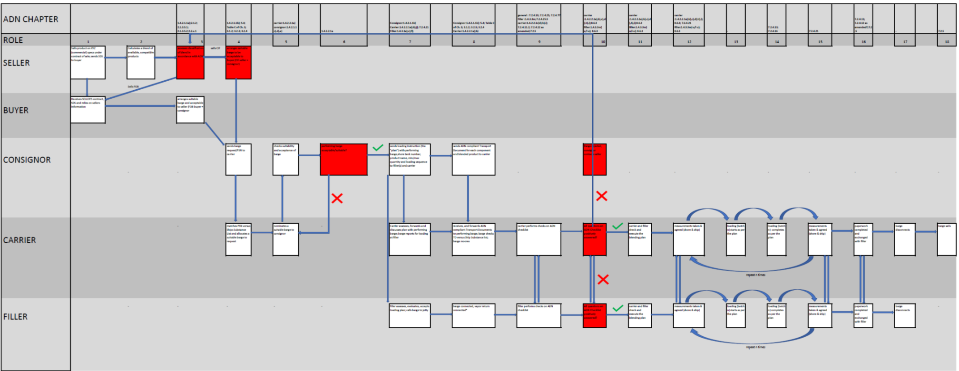

Annex III

Roles and responsibilities for participants in the loading on top operation

1. The key participants in the operation of loading on top in barges are the consignor, the filler and the carrier. Their relevant responsibilities are described in 1.4.1.

2. Their responsibilities do not materially change in the event of a loading on top operation.

3. Notwithstanding the above, the consignor, carrier and filler must comply with their other respective obligations in accordance with ADN.

4. The consignor:

| *For the consignor, it means that he:* | *Action:* | *ADN* |
| --- | --- | --- |
| Ascertain that the dangerous goods are classified and authorized for carriage in accordance with ADN. | Identifies compatible substances and their locations; calculates and classifies the commingled substance | 2.1.2; 2.1.3.5.1; 2.1.3.5.2; 2.1.3.5.3; 1.4.2.1.1 (a); 7.2.4.13.1 3rd paragraph |
| Furnish the carrier with information and data … | Submits a request to the carrier for a barge to be suitable for all substances to be loaded as well as the final commingled substance, provides the transport document (or the required information in a traceable format) in line with requirements of 5.4 and table C | 1.4.2.1.1(b); 5.4.1 |
| Use only approved tank-vessels suitable for the carriage of the goods in question; | For each individual substance and the commingled substance, checks the carrier’s barge suitability against a vetting system (i.e. EBIS) or international regulation. | 1.4.2.1.1(c) |
| Furnish the carrier with information and data … | Communicates to the carrier the loading plan, containing information and ADN proper shipping names per substance and quantity to be loaded | 1.4.2.1.1(b) |

5. The carrier:

| *For the carrier, it means that he must:* | *Action* | *ADN* |
| --- | --- | --- |
| Ascertain that the dangerous goods in question are authorized for carriage; | Assign a suitable barge against consignors request by checking the ADN proper shipping names to be loaded against the ships substance list of the performing barge | 1.4.2.2.1(a); 1.16.1.2.5 |
| Ascertain that all information prescribed in ADN related to the dangerous goods to be carried has been provided by the consignor; | Verify that all transport documents (or the required information in a traceable format), the loading plan and loading sequence has been received from the consignor; he receives, evaluates, forwards the relevant transport documents (or the required information in a traceable format, loading plan to the Master of the performing barge. | 1.4.2.2.1(b) |
| Ascertain that the vessel substance list in accordance with 1.16.1.2.5 complies with Table C of chapter 3.2 including the modifications made to it. | Check by visual inspection that the individual components and the commingled mixture as mentioned on the transport document (or the required information in a traceable format) and accompanying documents are on the ships substance list in accordance with 1.16.1.2.5 and that this list complies with Table C of chapter 3.2 including the modifications made to it. | 1.4.2.2.1(j) |
| Ascertain that during loading, carriage, unloading and any other handling of the dangerous goods in the holds or cargo tanks, special requirements are complied with. | Must ensure that the specific requirements for each substance and the commingled substance are complied with, perform his obligations under 1.4.2.2 and 8.6.3 jointly with the filler | 1.4.2.2.1(i) |

6. The filler

| *For the Filler, it means that he:* | *Action* | *ADN* |
| --- | --- | --- |
| Shall complete his section of the checklist referred to in 7.2.4.10 prior to the loading of the cargo tanks | Informs the carrier about the loading agreement, performs his obligations according to 1.4.3.3, 7.2.4.10 and 8.6.3 jointly with the carrier | 1.4.3.3(m) |
| shall only fill cargo tanks with the dangerous goods accepted in such tanks | Performs his obligations according to 1.4.3.3, 7.2.4.10 and 8.6.3 jointly with the carrier | 1.4.3.3(n) |
| shall ascertain that, when prescribed in 7.2.4.25.5, there is a flame-arrester in the vapor return piping to protect the vessel against detonations and flame-fronts from the landward side | Performs his obligations according to 1.4.3.3, 7.2.4.10 and 8.6.3 jointly with the carrier | 1.4.3.3(r) |

Annex IV

Principles of classification

1. The principles of classification of the commingled substance follows 2.1.2 and 2.1.3.

2. The consignor, in line with 1.4.2.2.1 a), is responsible for the correct classification of the commingled substance according to 2.1.3.5.1, 2.1.3.5.2 and 2.1.3.5.4.

3. The consignor shall ensure that the blended products are compatible and do not react with each other.

Annex V

Loading on top according to IMO

1. Loading on top in seagoing vessels while in port is regulated under IMO[16] and discussed in the IMO Subcommittee on Bulk Liquids and Gases.

2. MEPC.1/Circ. 761 gives guidelines for the carriage of blends or petroleum oil and bio-fuels.

3. In April 2016, the Energy Institute published the “Guidelines for the Blending of Liquid Hydrocarbon cargoes on board tank vessels”. This publication covers vessels as well as barges.[17]

4. MSC325(90) states that blending operations in port are permitted. Blending is distinct from producing and the International Convention for the Safety of Life at Sea (SOLAS) defines physical blending as “the process whereby the ship’s cargo pumps and pipelines are used to internally circulate two or more different cargoes with the intent to achieve a cargo with a new product designation”.

5. SOLAS defines production processes as “any deliberate operation whereby a chemical reaction between a ship’s cargo and any other substance or cargo takes place” .

Annex VI

Inherent safety advantages and public benefits

Public benefit: improved safety on inland waterways and near loading installations: loading on top means less barges means less movements means safer operation

1. According to FETSA, the average barge jetty occupancy in the Amsterdam-Rotterdam-Antwerp range currently amounts to an approximate 55-75%; a number above 65% indicates a loading installation is congested.

2. Jetty occupancy follows the market volatility. If a market is very volatile, trade activity increases and as a result barge traffic and activities at loading/discharge facility increase.

3. Barges are often queued and waiting to be loaded; while they are waiting they must find a lay-by berth and in (the vicinity of) densely populated areas in North West Europe, these lay-by berths can be hours away from the loading installations; traffic to and from these lay-by berths add to the CO2 footprint.

4. Barges moving to and departing from lay-by berth create additional ((un)mooring) movements and add to the congestion on our inland waterways. While mooring and unmooring should always follow the relevant paragraphs in ADN (such as 7.2.5.3; 7.2.5.4 and 1.1.4.6), it should be recognized that less (barge) movement reduces operational risk.

5. Loading on top in barges significantly reduces barge traffic in our already very busy ports and our inland water ways; reduces queues at loading installations and subsequent mooring/unmooring activities and is therefore a safer operation.

Public benefit: global impact: contribution to GHG effect and global warming, climate change, such as direct effects of global temperature increase. significant reduction of greenhouse gas (GHG) emissions

6. (“CO2/CH4: “CO2 – increase of anthropogenic CO2 to the atmosphere with consequential contribution to Greenhouse Gas effect and Global Warming. Climate Change, amongst other direct effects of global temperature increase. CH4 – the same effects of CO2, but with a Greenhouse Gas Potential 25 time higher than CO2 over 100 yrs.” [18]

Public benefit – local / regional impact: significant reduction of air pollution:

7. (“SOx - Local/regional impact. SO2 contributes to acid deposition which, in turn, affects the quality of soils and water. SOx are known as precursors for Particulate Matter formation. NOx – reacts with ammonia to form nitric acid vapour and related particles that can penetrate deeply into sensitive lung tissue and damage it, causing premature death in extreme cases. From the reaction with Volatile Organic Compounds (VOC), in the presence of sunlight, Ozone can cause adverse effects such as damage to lung tissue and reduction in lung function mostly in susceptible populations (children, elderly, and asthmatics). Ozone can be transported by wind currents and cause health impacts far from the original sources.”[19]

8. However, it should be noted that there is uncertainty on the calculation of emissions from transport, as published by the Netherlands Organization for applied scientific research (TNO) on August 7, 2017. [20]

Substantial NOx, SOx, particulate matter (PM) reduction already achieved: carrying industry made greener.

9. In line with our industry’s responsible behavior, and by loading on top, we help achieve substantial reduction of air emissions.

10. Shore optimization and inherent safety advantages:

(a) Different terminals have different products; not all products are conveniently located on one site;

(b) Different refineries produce different products, depending on the refinery’s feed and set-up;

(c) Most barges have less capacity than a shore tank.

Annex VII

Conclusion

1. Loading on top in barges, under strict and clear conditions, can be regulated in ADN.

2. Loading on top is not to be confused with blending, production, formulating nor manufacturing, as referred to in Annex V.

3. The operation must be transparent, traceable and enforceable.

Appendix

Letter of support from the association of Dutch seaports

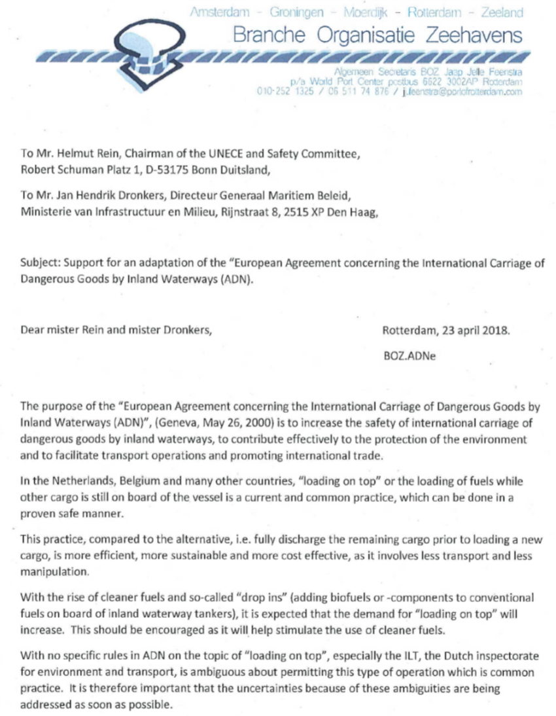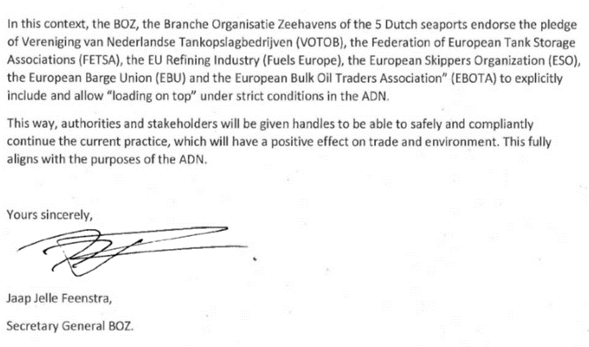

1. * Distributed in German by the Central Commission for the Navigation of the Rhine in document CCNR-ZKR/ADN/WP.15/AC.2/2018/39.
2. ** In accordance with the programme of work of the Inland Transport Committee for 2018-2019 (ECE/TRANS/2018/21/Add.1, cluster 9.3).
3. UNECE White paper on Efficient and Sustainable Inland Water Transport in Europe, http://www.unece.org/fileadmin/DAM/trans/main/sc3/publications/WhitePaper_Inland_Water_Transport_2011e.pdf
4. p.54, items 185-186 of the white paper
5. p.55 item 192 and p.56 item 196 of the white paper
6. p.57, under c) of the white paper
7. p.56-57 item 198 d) of the white paper
8. [ECE/TRANS/SC.3/189](https://www.unece.org/fileadmin/DAM/trans/doc/2017/sc3wp3/ECE-TRANS-SC3-WP3-2017-inf_09e.pdf) as published on https://www.unece.org/fileadmin/DAM/trans/doc/2017/sc3wp3/ECE-TRANS-SC3-WP3-2017-inf_09e.pdf
9. ECE/TRANS/SC.3/189; p. 2-3, Item 10
10. Directive 2009/28/EC of the European Parliament and of the Council of 23 April 2009 on the promotion of the use of energy from renewable sources and amending and subsequently repealing Directives 2001/77/EC and 2003/30/EC;
11. Directive 2009/30/EC of the European Parliament and of the Council of 23 April 2009 amending Directive 98/70/EC as regards the specification of petrol, diesel and gas-oil and introducing a mechanism to monitor and reduce greenhouse gas emissions and amending Council Directive 1999/32/EC as regards the specification of fuel used by inland waterway vessels and repealing Directive 93/12/EEC.
12. ECE/TRANS/WP.15/AC.2/2017/44 as submitted by FETSA with the support of Fuels Europe, EBU and ESO, under I., subsection C.
13. Informal document WP.15/AC.2/32/INF.9 of the thirty-second dated January 2, 2018, report of the first meeting of the informal working group loading on top in barges, Rotterdam November 21st, 2017.
14. <http://www.cdni-iwt.org/wp-content/uploads/2017/03/Art_5.01en.pdf>, Article 5.01 as amended by resolution 2016-I-5
15. Directive 2009/28/EC of the European Parliament and of the Council of 23 April 2009 on the promotion of the use of energy from renewable sources and amending and subsequently repealing Directives 2001/77/EC and 2003/30/EC
16. Publication BLG15/3 - Item 6.2 – Blending on Board, IMO, November 2, 2010.
17. HM 66. Guidelines for the blending of liquid hydrocarbon cargoes on board tank vessels, Energy Institute, April 2016.
18. European Maritime Safety Agency (EMSA) Publication http://www.emsa.europa.eu/main/air-pollution/download/4499/1709/23.html
19. European Maritime Safety Agency (EMSA) Publication http://www.emsa.europa.eu/main/air-pollution/download/4499/1709/23.html
20. TNO Report 2017 R10854 – uncertainty of the NOx, Sox, NH3, PM10, PM2.5, EC2.5 and NMVOC emissions from transport, August 7, 2017 sponsored by RIVM.