Proposal for Supplement 5 to the 01 series of amendments to UN Regulation No. 129 (Enhanced Child Restraint Systems)
Submitted by the expert from France
The text reproduced below was prepared by the expert from Informal Working Group on Enhanced Child Restraint System (IWG ECRS). It introduces amendments to the 01 Series of amendments to UN Regulation No. 139 (Enhanced Child Restraint Systems). The modifications to the existing text of the UN Regulation (including document ECE-TRANS-WP.29-GRSP-2017-43e) are marked in red, bold and underlined for new or strikethrough for deleted characters.
I. Proposal

Paragraph 2.12., amend to read:
"2.12. "Anti-rotation device"
Means a device intended to limit the rotation of the Enhanced Child Restraint System during a vehicle impact and consisting of:
(a) A top-tether strap; or
(b) A support-leg.
Meeting the requirements of this UN Regulation and fitted to an ISOFIX anchorage system and ISOFIX top tether anchorages or vehicle floor contact surface meeting the requirements of UN Regulation No. 14 or UN Regulation No. XX.
An "Anti-rotation device" for a "specific vehicle ISOFIX" Enhanced Child Restraint System may comprise a top tether, a support-leg or any other means capable of limiting the rotation only for Rearward facing Enhanced Child Restraint System, a dashboard and/or ‘lower tether strap(s)."

Paragraph 2.14., amend to read:
2.14. "Tension relieving device"
Means a system which allows to release the device that adjusts and maintains the tension in the ISOFIX top tether strap or in the lower tether strap(s).

Insert new paragraph 2.59., to read:
2.59. “Lower tether strap”,
Means a webbing strap (or equivalent) which extends from the back of an Enhanced Specific Vehicle Child Restraint System to the lower tether anchorage in the vehicle and which is equipped with an adjustment device, a tensioning-relieving device, and a Lower tether connector.

Insert new paragraph 2.59.1., to read:
2.59.1. “Lower tether anchorage”,
Means a feature fulfilling the requirements of ISO 13216, such as a bracket, located in a defined zone, designed to accept a Lower tether connector and transfer its restraint force to the vehicle structure.

Insert new paragraph 2.59.2., to read:
2.59.2. “Lower tether connector”,
Means a device intended to be attached to a Lower tether anchorage.

Insert new paragraph 2.59.3.., to read:
2.59.3. “Lower tether hook”,
Means a Lower tether connector typically used to attach a Lower tether strap to an ISOFIX top tether anchorage as defined in Figure 3 of ISO 13216.

Insert new paragraph 2.59.4.., to read:
2.59.4. “Lower tether attachment”,
Means a device to secure the Lower tether strap to the Enhanced Specific Vehicle Child Restraint System.

Insert new paragraph 6.3.5., to read:
"6.3.5. Lower tether specifications
6.3.5.1. Lower tether connector
The lower tether connector shall be the ISOFIX top tether hook as shown in figure 0(c), or similar devices that fit in the envelope given by Figure 0(c).

6.3.5.2. Lower tether strap features
The lower tether straps shall be supported by webbing (or its equivalent), having a provision for adjustment and release of tension.

6.3.5.2.1. Lower tether strap length
Each lower tether strap length shall be at least 1500 mm.

6.3.5.2.2. No slack indicator
The lower tether strap or the Enhanced Child Restraint System shall be equipped with a device that will indicate that all slack has been removed from the strap. The device may be part of an adjustment and tension relieving device.

6.3.5.2.3. Dimensions
Engagement dimensions for Lower tether hooks are shown in Figure 0(c).

Previous paragraph 6.3.5., renumber as 6.3.6
Paragraph 7.1.3.5.2.1, amend to read:

"7.1.3.5.2.1. Installation of Integral Universal ISOFIX Enhanced Child Restraint Systems (i-Size), or Integral Specific vehicle ISOFIX Enhanced Child Restraint Systems on the test bench.
….
If present, the top tether shall be adjusted to achieve a tension load of
50 +/- 5N. Alternatively, and if present, the support-leg shall be adjusted according to the Enhanced Child Restraint System manufacturer's instructions.
If present, the lower tether shall be adjusted to achieve a tension load of
minimal 50 +/- 5N.

…"

Annex 6, Appendix 2, insert new figure 5:

"Figure 5
Lower strap anchorages (LSA 1, LSA 2, LSA 3 and LSA 4)

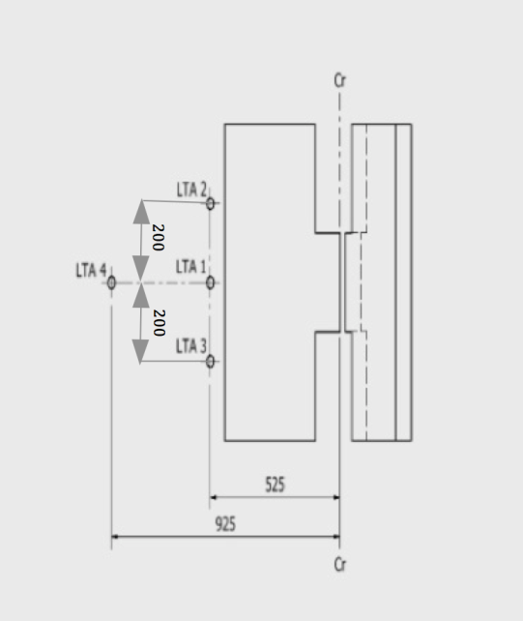"

II. Justification
Proposal to integrate in the regulation provisions for:
- definition and requirements for Lower Tether Strap and
- definition and specification of Lower Tether Anchorages (LTA)

