**Proposal for Draft global technical regulation on electric vehicle safety**

**Proposal of amendments to ECE/TRANS/WP.29/GRSP/2017/02**

The modifications to the current text of ECE/TRANS/WP.29/GRSP/2017/02 are marked in bold or strikethrough characters.

I. Proposal

Table of contents

(1) *Table of contents,* remove all square brackets from the table.

(2) *Table of contents, the following headlines,* amend to read:

"7.3.9. **(Reserved)**~~Overcurrent protection~~

8.2.9. **(Reserved)**~~Overcurrent protection test~~ "

1. Statement of technical rationale and justification

*Figure 9 (paragraph 72), amend the description in the figure to read:*

"Systems > 350 V are subject to IEC60479-**2**~~1~~ as discharge pulses are < 10 ms"

*Paragraph 157.,* amend to read:

"157. Even if the same fuel is used **and the relative position of the object that is exposed to the flame is the same**, the heat flux cannot be the same unless the shape of flame ~~(configuration factor)~~ is also equivalent. Therefore, to reproduce the same heat flux the shape of flame should be appropriately controlled. ~~and is specified to be 0.6 m or more without the tested device in place.~~"

*Figure 22*, modify the entire figure:

"Figure 22

**Test scene photographs and temperature measurements of a gasoline pool fire and an LPG burner fire**

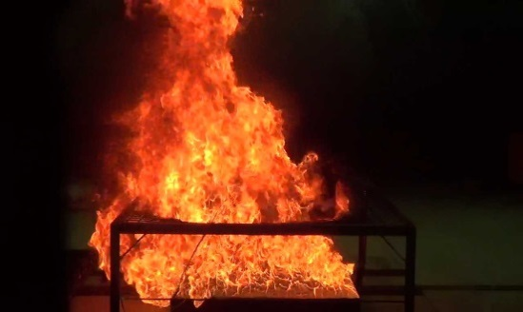 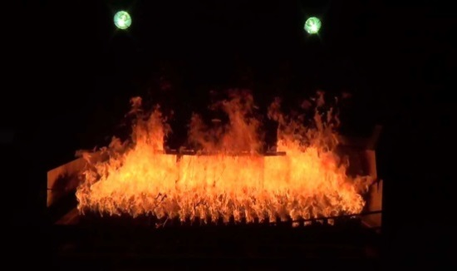

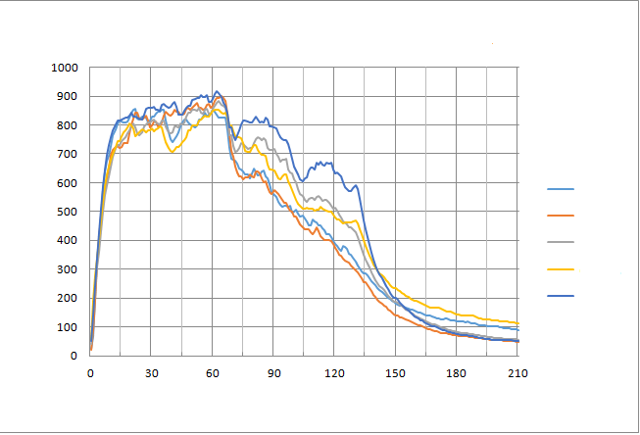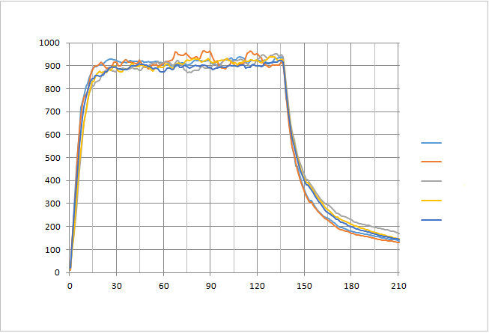

**Temp. 1**

**Temp. 2**

**Temp. 3**

**Temp. 4**

**Temp. 5**

**Temp. 1**

**Temp. 2**

**Temp. 3**

**Temp. 4**

**Temp. 5**

**Temperature, °C**

**Temperature, °C**

**Time, sec.**

**Time, sec.**

**~~Propane~~ LPG burner fire test (200 kg/h)**

**Gasoline pool fire test (phase B,C)**

*"*

*Paragraph 232.,* amend to read and add footnotes:

"232. The risk for direct contact depends on the location of the charging interface on the vehicle. Charging interfaces, located out of reach are exempted from the requirements of direct contact **for all heavy duty vehicles**. **Anthropometric data27, 28 has been used to calculate appropriate distances for Category 1-2 vehicles with roof mounted charging devices to safe-guard vehicle occupants. Calculation of wrap around distance for roof mounted charging devices for Category 2 vehicles will be considered in gtr phase 2 since these operate on different principles and the technology is less mature.** **Until this time, Category 2 vehicles which are professionally operated are exempted. Out of reach conditions for live parts located underneath for all heavy duty vehicles will be investigated in gtr phase 2.**

**(footnote)**

**27 Pheasant, S. (1996) *Bodyspace – Anthropometry, Ergonomics and the Design of Work,* London: Taylor & Francis.**

**28 Gordon, C.C. *et al.* (1989) *Antropometric Survey of U.S. Army Personnel: Interim Report.* United States Army Natick Research, Development and Engineering Center, Natick, Massachussets.** [**http://www.dtic.mil/dtic/tr/fulltext/u2/a209600.pdf**](https://webaccess.scania.com/dtic/tr/fulltext/u2/,DanaInfo=www.dtic.mil+a209600.pdf)"

*Paragraph 233.,* remove square bracket and amend to read:

"~~[~~233. **Overcurrent protection will be considered in gtr phase 2 for heavy vehicles due to time constraints. The current test proposal is vehicle based and was deemed inappropriate for heavy vehicles as it is unclear how to apply on vehicles that have different charging technologies. More discussion is needed in phase 2 to address different charging methodologies.** ~~Water protection will be considered in gtr phase 2 for heavy vehicles due to time constraints in phase 1.]~~"

*Paragraph 240.,* amend to read:

"240. Focus topics for Phase 2 are expected to include:

(a) water immersion test;

(b) long-term fire resistance test;

(c) REESS rotation tests;

(d) REESS vibration profile;

(e) **flammability,** toxicity and corrosiveness of vented gas (~~i.e.~~**e.g.** quantification of venting for tests addressing safety of REESS post-crash, potential risk of 'toxic gases' from non-aqueous electrolyte);

(f) thermal propagation and methods of initiation in battery system;

(g) post-crash REESS safety assessment and stabilization procedures;

(h) light electric vehicles (e.g. categories L6 and L7 [1]);

(i) ~~P~~**p**rotection during AC and DC charging and feeding process. "

*Paragraph 243.,* remove square bracket and amend to read:

"• The United States of America -- FMVSS 305 – Electric-Powered Vehicles: Electrolyte Spillage and Electrical Shock Protection

• UN Regulation No. 12 – Concerning the adoption of uniform conditions of approval and reciprocal recognition of approval for motor vehicle equipment and parts

• UN Regulation No. 94 – Uniform provisions concerning the approval of vehicles with regard to the protection of the occupants in the event of a frontal collision

• UN Regulation No. 95 – Uniform provisions concerning the approval of vehicles with regard to the protection of the occupants in the event of a lateral collision

• UN Regulation No. 100 – Uniform provisions concerning the approval of vehicles with regard to specific requirements for the electric power train

• UN Regulation No. 137 – Uniform provisions concerning the approval of passenger cars in the event of a frontal collision with focus on the restraint system

• Japan – Attachment 101 – Technical Standard for Protection of Occupants against High Voltage in Fuel Cell Vehicles

• Japan – Attachment 110 – Technical Standard for Protection of Occupants against High Voltage in Electric Vehicles and Hybrid Electric Vehicles

• Japan – Attachment 111 – Technical Standard for Protection of Occupants against High Voltage after Collision in Electric Vehicles and Hybrid Electric Vehicles

• Japan – Circular notice for test procedures with Hard-In-the-Loop Simulator system to measure fuel efficiency and emission in Electric Hybrid Heavy-duty Vehicles (H19.3.16, KOKU-JI-KAN No.281)

• ~~[~~China – GB/T 31484:2015 - Cycle life requirements and test methods for traction battery of electric vehicle

• China – GB/T 31485:2015 - Safety requirements and test methods for traction batt**e**ry of electric vehicle

• China – GB/T 31486:2015 - Electrical performance requirements and test methods for traction battery of electric vehicle

• China – GB/T 31467.3:2015 - Lithium-ion traction battery pack and system for Electric vehicles— Part 3: Safety requirements and test methods

• China – GB/T 18384.1:2015 - Electrically propelled road vehicles-Safety specifications-Part 1:On-board Rechargeable Energy Storage System (REESS)

• China – GB/T 18384.2:2015 - Electrically propelled road vehicles-Safety specifications-Part 2:Vehicle operational safety means and protection against failures

• China – GB/T 18384.3:2015 - Electrically propelled road vehicles-Safety specifications-Part 3 Protection of persons against electric shock

• **China – GB/T 31498:2015 – The safety requirement of electric vehicle post crash**

• China – GB/T 24549:2009 - Fuel cell electric vehicles - Safety requirements~~]~~

• Canada – CMVSS 305 – Electric Powered Vehicles: Electrolyte Spillage And Electrical Shock Protection

•Republic of Korea – Motor Vehicle Safety Standard, Article 18-2 – High Voltage System, **Test Procedure Table 1 – Part 47. Safety Test for High Voltage System**

**• Republic of Korea – Motor Vehicle Safety Standard, Article 18-3 – Rechargeable Energy Storage System (REESS), Test Procedure Table 1 – Part 48. Safety Test for REESS**

• Republic of Korea – Motor Vehicle Safety Standard, Article 91-4 **– High Voltage System in Crash Test** ~~Electrolyte Spillage and Electric Shock Protection~~**, Test Procedure Table 1 – Part 47. Safety Test for High Voltage System**

• Recommendations on the Transport of Dangerous Goods, Manual of Tests and Criteria, paragraph 38.3 (LITHIUM METAL AND LITHIUM ION BATTERIES)"

*Paragraph 244.,* amend to read:

"244. List of relevant standards for Electric Vehicle Safety:

…

• IEC 61851-1:~~2010~~**2017** Electric vehicle conductive charging system - Part 1: General requirements ~~(Remark: This standard is under review)~~

…"

II. Text of Regulation

*Paragraph 3.39.*, amend to read:

"3.39. "Rupture" means opening(s) through the casing of any functional cell assembly created or enlarged by an event, large enough for a 12 mm diameter test finger (IPXXB) to penetrate and make contact with live parts (see paragraphs 6.1.3.**,** ~~and~~ **6.1.6.2.4.**~~6.1.5.2.4.~~ **and 8.1.3.**) "

*Paragraph 5.2.2.2.*, the first sentence amend to read:

"5.2.2.2. Low electrical energy.

The Total Energy (TE) ~~of~~ ~~[~~of unidirectional single impulse currents in the form of rectangular and sinusoidal impulses or capacitor discharges from high voltage electrical components~~]~~ shall be less than 0.2 J when measured and calculated in accordance with formula (a) of paragraph 6.1.6.2.3."

*Paragraph 5.2.2.4.*, amend to read:

"5.2.2.4. Isolation resistance.

The criteria specified in the paragraphs 5.2.2.4.1. and 5.2.2.4.2. below shall be met.

The measurement shall be conducted in accordance with paragraph **6.1.6.2.5.**~~6.1.5.2.5.~~ "

*Paragraph 5.3.2.*, remove square bracket.

*Paragraph 5.3.3.*, remove square bracket.

*Paragraph 5.4.10.*, remove square bracket.

*Paragraph 5.4.12.1.*, remove square bracket.

*Paragraph 5.4.12.2.*, remove square bracket.

*Paragraph 5.4.12.2.1.*, amend to read:

"5.4.12.2.1. A risk reduction analysis using appropriate industry standard methodology (for example, IEC 61508, MIL-STD 882E, ISO 26262, ~~[GB/TXXX],~~ AIAG DFMEA, fault analysis as in SAE J2929, or similar), which documents …"

*Table 1 (paragraph 6.1.3.3.),* amend the description in the table to read:

"~~F~~**f**rom bur**r**s"

*Paragraph 6.1.6.2.3.*, amend to read (modify the numbering of subpargraphs and layout):

"6.1.6.2.3. Assessment procedure for low electrical energy.

Prior to the impact a switch S1 and a known discharge resistor Re is connected in parallel to the relevant capacitance (Figure 8).

**(a)** Not earlier than 10 s and not later than 60 s after the impact the switch S1 shall be closed while the voltage Vb and the current Ie are measured and recorded. The product of the voltage Vb and the current Ie shall be integrated over the period of time, starting from the moment when the switch S1 is closed (tc) until the voltage Vb falls to zero (th). The resulting integration equals the total energy (TE) in J**:**~~.~~

~~(a)~~ 

**(b)** When Vb is measured at a point in time between 10 s and 60 s after the impact and the capacitance of the X-capacitors (Cx) is specified by the manufacturer, total energy (TE) shall be calculated according to the following formula:

~~(b)~~ TE = 0.5 x Cx x Vb2

**(c)** When V1 and V2 (see Figure 8) are measured at a point in time between 10 s and 60 s after the impact and the capacitances of the Y-capacitors (Cy1, Cy2) are specified by the manufacturer, total energy (TEy1, TEy2) shall be calculated according to the following formulas:

~~(c)~~ TEy1 = 0.5 x Cy1 x V12

TEy2 = 0.5 x Cy2 x V22

This procedure is not applicable if the test is performed under the condition where the electric power train is not energized. "

*Figure 13 (paragraph 6.2.4.3.3.4.4.) and Figure 28 (paragraph 8.2.4.3.3.4.4.),* modify the figures to include "A-A":



*Paragraph 6.2.4.3.4.2.*, amend to read:

"6.2.4.3.4.2. LPG burner shall be used to produce flame to which the Tested-Device is exposed. The height of the flame shall be ~~m~~ about 60 cm or more, without the Tested-Device. "

*Paragraph 6.2.4.3.4.6.*, amend to read:

"6.2.4.3.4.6. The Tested-Device shall be exposed to flame for 2 minutes after the averaged temperature reach**es** 800 °C within 30 seconds. The averaged temperature shall be maintained at 800-1,100 °C for 2 minutes. "

*Paragraph 7.1.1.1.*, amend to read:

"7.1.1.1. Protection against direct contact.

High voltage live parts shall comply with paragraphs 7.1.1.1.1. and 7.1.1.1.2. for protection against direct contact. Conductive connection devices not energized except during charging of the REESS are exempted from this requirement if located on the roof of the vehicle, out of reach for a person standing outside of the vehicle ~~or standing on the instep of the of the vehicle~~. **For Category 1-2 vehicles the minimum wrap around distance from the instep of the vehicle to the roof mounted charging devices is 3.00 m. In case of multiple steps due to elevated floor inside the vehicle, the wrap around distance is measured from the bottom most step at entry, as illustrated in Figure 16.** ~~(the minimum wrap-around distance from the instep 3.75 m, as illustrated in Figure 16) or underneath the vehicle, and not directly accessible by a person standing on the side of the vehicle.~~

Electrical protection barriers, enclosures, solid insulators and connectors shall not be opened, disassembled or removed e.g. without the use of tools, an operator controlled activation/deactivation device, or equivalent.

However, connectors (including the vehicle inlet) are allowed to be separated without the use of tools, if they meet one or more of the following requirements:

(a) They comply with paragraphs 7.1.1.1.1. and 7.1.1.1.2. when separated; or

(b) They are provided with a locking mechanism (at least two distinct actions are needed to separate the connector from its mating component). Additionally, other components, not being part of the connector, shall be removable only with the use of tools, an operator controlled activation/deactivation device or equivalent, in order to be able to separate the connector; or

(c) The voltage of the live parts becomes equal or below 60V DC or equal or below 30V AC (rms) within 1s after the connector is separated.

Figure 16

**Schematics of how to measure wrap-around distance**

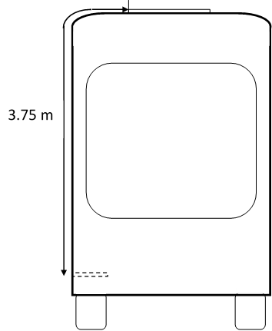

**3.0** m

*Paragraph 7.1.1.3. (and its subparagraphs)*, remove square bracket.

*Paragraph 7.1.1.3.3.*, amend to read:

"7.1.1.3.3. If the test procedures specified in paragraph 8.1.5. are performed, just after each exposure, and with the vehicle still wet, the vehicle shall then comply with isolation resistance test given in paragraph 8.1.1., and the isolation resistance requirements given in paragraph 7.1.1.2.4. shall be met. In addition, after a 24 hour pause, the isolation resistance test specified in paragraph 8.1.1. shall again be performed, and the isolation resistance requirements given in paragraph 7.1.1.2.4. shall be met.

**A representative vehicle shall be selected for testing and a compliant test result for this vehicle shall constitute evidence of compliance for all variations of vehicles, provided that the REESS and the REESS installation on the vehicles are the same.**"

*Paragraph 7.2. (and its subparagraphs)*, remove square brackets.

*Paragraph 7.2.2.*, remove square bracket.

*Paragraph 7.2.3.*, remove square bracket.

*Paragraph 7.3.9. through paragraph 7.3.12.2.4.3.,* remove square bracket.

*Paragraph 7.3.9.*, amend to read:

"7.3.9. **(Reserved)**~~Overcurrent protection.~~

~~The test shall be conducted in accordance with paragraph 8.2.9.~~

~~During the test there shall be no evidence of electrolyte leakage, rupture (applicable to high voltage REESS only), venting (for REESS other than open-type traction battery), fire or explosion.~~

~~The evidence of electrolyte leakage shall be verified by visual inspection without disassembling any part of the Tested-Device. An appropriate technique shall, if necessary, be used in order to confirm if there is any electrolyte leakage from the REESS resulting from the test. The evidence of venting shall be verified by visual inspection without disassembling any part of the Tested-Device.~~

~~The overcurrent protection control of the REESS shall terminate charging or the temperature measured on the casing of the REESS shall be stabilized, such that the temperature gradient varies by less than 4 °C through 2 hours after the maximum overcurrent charging level is reached.~~

~~For a high voltage REESS, the isolation resistance measured after the test in accordance with paragraph 8.1.1. shall not be less than 100 Ω/V.~~ "

*Paragraph 7.3.10.*, remove square bracket.

*Paragraph 7.3.12.1.*, remove square bracket.

*Paragraph 7.3.12.2.*, remove square bracket.

*Paragraph 7.3.12.2.1.*, amend to read:

"7.3.12.2.1. A risk reduction analysis using appropriate industry standard methodology (for example, IEC 61508, MIL-STD 882E, ISO 26262, ~~[GB/TXXX],~~ AIAG DFMEA, fault analysis as in SAE J2929, or similar), which documents …"

*Paragraph 8.1.5. (and its subparagraphs)*, remove square brackets.

*Table 6 (paragraph 8.2.2.3.2.),* replace the unit in the table:

"*Acceleration (m/s2~~)~~)*"

*Paragraph 8.2.4.3.4.2.*, amend to read:

"8.2.4.3.4.2. LPG burner shall be used to produce flame to which the Tested-Device is exposed. The height of the flame shall be ~~m~~ about 60 cm or more, without the Tested-Device. "

*Paragraph 8.2.4.3.4.6.*, amend to read:

"8.2.4.3.4.6. The Tested-Device shall be exposed to flame for 2 minutes after the averaged temperature reach**es** 800 °C within 30 seconds. The averaged temperature shall be maintained at 800-1,100 °C for 2 minutes. "

*Paragraph 8.2.5.2.,* amend to read:

"8.2.5.2. Installations.

This test shall be conducted either with a complete vehicle or with the complete REESS or with the REESS subsystem(s). **If the REESS consists of multiple REESS subsystems, either connected in series or in parallel, the test can be performed on a single REESS subsystem which includes an electronic management unit and (if it exists) a REESS protection device intended to be operational.** If the manufacturer chooses to test with REESS subsystem(s), ~~the Tested-Device shall be able to deliver the nominal voltage of the complete REESS and~~ the manufacturer shall demonstrate that the test result can reasonably represent the performance of the complete REESS with respect to its safety performance under the same conditions. ~~If the REESS consists of multiple battery packs, testing can be performed on a single battery pack.~~ If the electronic management unit for the REESS is not integrated in the casing enclosing the cells, then the electronic management unit may be omitted from installation on the Tested-Device at the request of the manufacturer.

For a test with a complete vehicle, the manufacturer may provide information to connect a breakout harness to a location just outside the REESS that would permit applying a short circuit to the REESS. "

*Paragraph 8.2.9.*, remove square bracket and amend to read:

"8.2.9. **(Reserved)**~~Overcurrent protection test.~~ "

*Paragraph 8.2.9.1. through – paragraph 8.2.9.6.,* delete all sentences.

Annex 2

*Annex 2 opening paragraph*, remove square brackets.

*Figure 2,* modify the entire figure including the notes:

"Figure 2

**Splashing test nozzle**

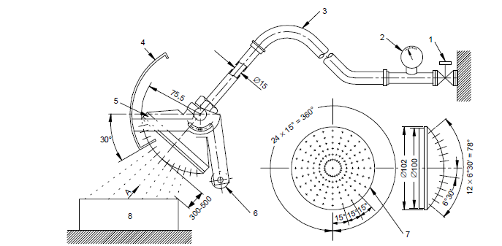

**Viewed according to arrow A (with shield removed)**

***IEC 927/01***

Dimensions in millimetres

*Note*:

|  |  |
| --- | --- |
| 1. Cock | 7. Spray nozzle – brass with 121 holes ∅ 0,5: |
| 2. Pressure gauge | 1. hole in centre |
| 3. ~~Moving shield – aluminium~~ **Hose** | 2. inner circle of 12 holes at 30° pitch |
| 4. Moving shield – aluminium | 4. outer circle of 24 holes at 15° pitch |
| 5. Spray nozzle | 8. Machine under test |
| 6. Counter weight |  |

*"*

*Paragraph 3*, amend to read:

~~[The amount of water which has entered the tested high-voltage component or system is not allowed to interfere with its satisfactory operation. The windings and live parts not designed to operate when wet are not allowed to be wet and no accumulation of water which could have reached them is tolerated inside the high-voltage component or system. It is, however, permissible for parts to be wet and leakage along the shaft is allowable if provision have been made for drainage of this water. ]~~

**The entire high voltage system or each component is checked to comply with the isolation resistance requirement in paragraph 5.1.1.2.4. or paragraph 7.1.1.2.4. with the following conditions:**

**(a) The electric chassis shall be simulated by an electric conductor, e.g. a metal plate, and the components are attached with theirstandard mounting devices to it.**

**(b) Cables, where provided, shall be connected to the component.**

*Paragraph 4*, amend to read:

~~Finally, the entire high voltage system or each component is then checked to comply with the isolation resistance requirement in paragraph 5.1.1.2.4. with the following conditions:~~

~~(a) The electric chassis shall be simulated by an electric conductor, e.g. a metal plate, and the components are attached with their standard mounting devices to it.~~

~~(b) Cables, where provided, shall be connected to the component.~~

**The parts designed not to be wet during operation are not allowed to be wet and no accumulation of water which could have reached them is tolerated inside the high-voltage component or system.**

II. Justification

1. Co-sponsors of the EVS-GTR informal working group reviewed the pending issues on the proposal distributed as ECE/TRANS/WP.29/GRSP/2017/02 and agreed to recommend the changes above mentioned. The majority of these changes are editorial or are intended to further clarify the GTR provisions.

2. In addition, this document contains the final agreement on outstanding issues with respect to heavy duty vehicles such as:

a. The informal working group agreed on adjusting the minimum wrap around distance from the instep of the vehicle to the roof mounted charging devices to 3.00 m for Category 1-2 vehicles only. This is based on anthropometric data from the following sources:

Pheasant, S. (1996) *Bodyspace – Anthropometry, Ergonomics and the Design of Work,* London: Taylor & Francis;

Gordon, C.C. *et al.* (1989) *Antropometric Survey of U.S. Army Personnel: Interim Report.* United States Army Natick Research, Development and Engineering Center, Natick, Massachussets. [http://www.dtic.mil/dtic/tr/fulltext/u2/a209600.pdf](https://webaccess.scania.com/dtic/tr/fulltext/u2/,DanaInfo=www.dtic.mil+a209600.pdf) "

b. The informal working group agreed not to include Category 2 vehicles at this stage because the charging methods are different and further studies are needed.

c. The informal working group agreed not to include charging interfaces underneath the vehicle at this stage due to lower maturity of this technology and further studies are needed.

d. The informal working group agreed not to include "Overcurrent protection" at this stage because:

* it is a vehicle based test applied for socket charging and the informal working group needs to clarify how this applies to alternative charging (e.g. pantographs);
* heavy duty vehicles require a REESS based test that can cater for a wide variety of vehicle configurations.

1. As defined in the Consolidated Resolution on the Construction of Vehicles (R.E.3.), document ECE/TRANS/WP.29/78/Rev.4, para. 2.