|  |  |  |  |
| --- | --- | --- | --- |
|  | United Nations | ECE/TRANS/WP.29/GRSG/2017/9 | |
| _unlogo | **Economic and Social Council** | | Distr.: General  1 February 2017  Original: English and French |

**Economic Commission for Europe**

Inland Transport Committee

**World Forum for Harmonization of Vehicle Regulations**

**Working Party on General Safety Provisions**

**112th session**

Geneva, 24-28 April 2017

Item 9 of the provisional agenda

**Regulation No. 110 (CNG and LNG vehicles)**

Proposal for Supplement 1 to the 02 series of amendments to Regulation No. 110 (CNG and LNG vehicles)

Submitted by the expert from France[[1]](#footnote-2)\*

The text reproduced below was prepared by the expert from France. It proposes to amend UN Regulation No. 110 by incorporating provisions concerning refrigeration systems for cooling the cargo compartment which are connected to the compressed natural gas (CNG) and/or liquefied natural gas (LNG) system. This document is based on document ECE/TRANS/WP.29/GRSG/2016/16 adopted during the 111th session of the Working Party on General Safety Provisions (GRSG) and on Supplement 5 to the 01 series of amendments adopted during the 170th session of World Forum for Harmonization of Vehicle Regulations (WP.29). The modifications to the current text of the Regulation are marked in bold for new or strikethrough for deleted characters.

**I. Proposal**

*Paragraph 7.1.,* correct "paragraphs 8.12. to 8.21." to read "paragraphs **8.12. to 8.22**.".

*Paragraphs 18.1.7.1. and 18.1.7.2.*, amend to read:

"18.1.7.1. Notwithstanding the provisions of paragraph 18.1.7., vehicles may be fitted with a heating system to heat the passenger compartment and/or the load area **or a refrigeration system to cool the cargo compartment** which is connected to the CNG and/or LNG system.

18.1.7.2. The heating **or refrigeration** system referred to in paragraph 18.1.7.1. shall be permitted if, in the view of the Technical Services responsible for conducting type approval, the heating **or refrigeration** system is adequately protected and the required operation of the normal CNG and/or LNG system is not affected."

*Paragraph 18.5.1.3.*, amend to read:

**"18.5.1.3. Notwithstanding the provisions of paragraph 18.5.1.2.,**

**(a) the automatic cylinder valve may stay in an open position during commanded stop phases; and**

**(b) in the case where a fire alarm system is installed in the autonomous CNG and/or LNG heater compartment, the automatic valve(s) may be opened by an GNC/GNL electronic control unit to permit the warming of the engine. Any defect or failure of the system shall cause the automatic valve of the cylinder supplying the heating system to close; and**

**(c) in the case where a fire alarm system is installed in the refrigeration system compartment of the cargo compartment, the automatic valve(s) may be opened by an GNC/GNL electronic control unit to permit the cooling of the cargo compartment. Any defect or failure of the system shall cause the automatic valve of the cylinder supplying the refrigeration system to close."**

*Annex 1A*

*Items 1.2.4.5.15. to 1.2.4.5.15.3.*, amend to read (footnote 1 remains unchanged):

"1.2.4.5.15. Connection to CNG/LNG system for heating system: yes/no1

**or connection to CNG/LNG system for refrigeration system: yes/no1**

1.2.4.5.15.1. Make(s) **of the heating system**:

1.2.4.5.15.2. Type(s) **of the heating system**:

1.2.4.5.15.3. Description and drawings of installation **of the heating system**:"

*Insert new items 1.2.4.5.15.4 to 1.2.4.5.15.6*, to read:

"**1.2.4.5.15.4. Make(s) of the refrigeration system:**

**1.2.4.5.15.5. Type(s) of the refrigeration system:**

**1.2.4.5.15.6. Description and drawings of the installation of the refrigeration system**:"

*Annex 1B*

*Items 1.2.4.5.15. to 1.2.4.5.15.3.*, amend to read (footnote 2 remains unchanged):

"1.2.4.5.15. Connection to CNG/LNG system for heating system: yes/no2

**or connection to CNG/LNG system for refrigeration system: yes/no**2

1.2.4.5.15.1. Make(s) **of the heating system**:

1.2.4.5.15.2. Type(s) **of the heating system**:

1.2.4.5.15.3. Description and drawings of installation **of the heating system**:"

*Insert new items 1.2.4.5.15.4. to 1.2.4.5.15.6.*, to read:

"**1.2.4.5.15.4. Make(s) of the refrigeration system:**

**1.2.4.5.15.5. Type(s) of the refrigeration system:**

**1.2.4.5.15.6. Description and drawings of the installation of the refrigeration system:**"

*Annex 4A, paragraph 4.2.4.,* correct "of Class 1 and Class 2" to read "**of Class 2**".

*Annex 4B, paragraph 1.6.2.2.,* amend to read:

"**1.6.2.2. The interface type for the hose coupling shall be:**

**(a) Sealing cone of swivel-nut type of the type with a half vertical angle of 45°, or**

**(b) Other couplings complying with the tests described in paragraph 1.7., as well as the tests mentioned in Annexes 5A and 5B.**

**In the case of an interface type using a soft seal body (e.g. O-ring), the type of material chosen shall be tested in accordance with Annexes 5D, 5F and 5G.**

**Couplings shall have complementary counterparts.**"

*Annex 4H, paragraph 2.2.,* correct "than 5 seconds" to read "**than 2 seconds**".

*Annex 4J*

*Paragraph 2.2.,* **shall be deleted**.

*Paragraph 3.1.6.,* correct "shall be not be" to read "**shall not be**".

*Insert new paragraphs 4. and 4.1.,* to read:

"**4. LNG filling receptacle dimensions**

**4.1. Figure 1 shows the dimensions of the LNG filling receptacle.**

Figure 1

**Dimensions of the receptacle**

"

all dimensions in millimeters

The 50 mm dimension is the minimum distance to the mounting flange

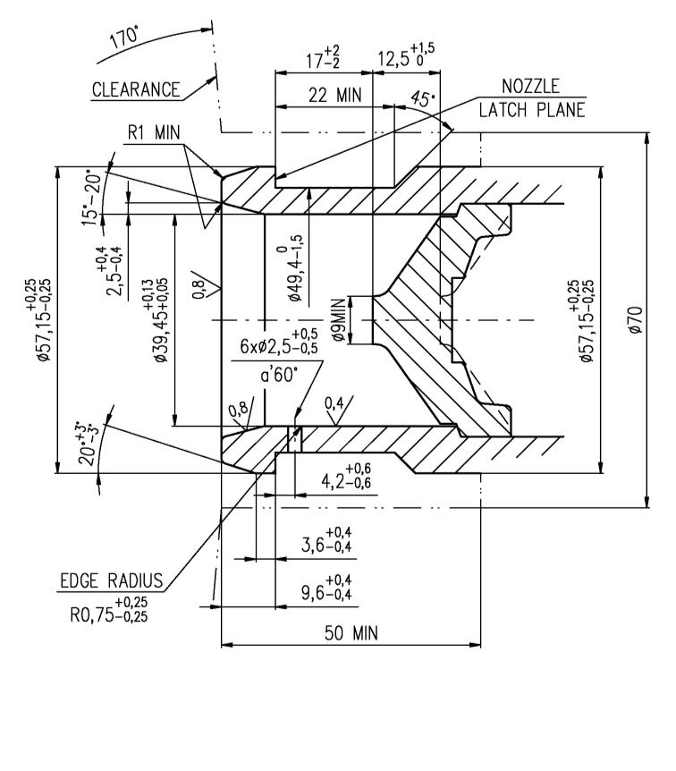

II. Justification

This document summarizes the requirements from ECE/TRANS/WP.29/GRSG/2016/16 (Supplement 6 to the 01 series of amendments) and ECE/TRANS/WP.29/2016/95 (Supplement 5 to the 01 series of amendments) resulting in Supplement 1 to 02 series of amendments to UN Regulation No. 110.

1. \* In accordance with the programme of work of the Inland Transport Committee for 2016–2017 (ECE/TRANS/254, para. 159 and ECE/TRANS/2016/28/Add.1, cluster 3.1), the World Forum will develop, harmonize and update Regulations in order to enhance the performance of vehicles. The present document is submitted in conformity with that mandate. [↑](#footnote-ref-2)