|  |  |
| --- | --- |
| Submitted by the experts from France and Germany | Informal document **GRRF-84-04**  84th GRRF, 19-22 September 2017  Agenda item 3(c) |

**Amendments to the justification part of ECE/TRANS/WP.29/GRRF/2017/12**

It was felt that the current justification could use a more precise description of the approach in the former proposal ECE/TRANS/WP.29/GRRF/2016/26. Furthermore the use of examples based on numbers in position 2. in ECE/TRANS/WP.29/GRRF/2017/12 may give a hint that something is wrong but not only that it appears empirical it also does not explain why it is wrong. Furthermore the assumption as to the actuation force to sB x ig (paragraph 14) is found to be subject to a debate.

*Justification*, to read:

**II. Justification**

The history of the formula to 8.1.2. of annex 12 may be summed up like this:

1.   ECE R13 situation since serie 11, supplement 5 due to UK proposal (ECE/TRANS/WP29/GRRF/2010/5)

The goal of the supplement is to ensure sufficient articulation of the compensator in a situation when the vehicle is stationary, uncoupled and the parking brake applied while a lateral push is exerted on the drawbar. This causes a positive moment on the wheels of one side of the vehicle and a negative one on those of the other side. Following the nature of auto reverse brake assemblies different brake lever travel will occur depending on the direction of the moment:

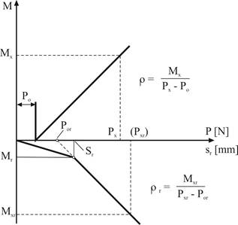

The compensator itself must provide enough articulation capacity to compensate for the difference in travel (scd) plus a 20% safety margin otherwise the cable tension of the wheel with negative braking moment might drop such that this wheel turns freely causing a moment around the vertical vehicle axis if it is situated on a slope. It goes without saying that this is dangerous and in fact the background of the supplement is an accident with lethal aftermath.

Unfortunately the formula to 8.1.2. leads to not very plausible results:

*“cid:image005.png@01D32306.7EC67E70*

*Where:*

*Sc' = S'/iH        (travel at compensator - forward operation) and Sc' = 2 • SB/ig*

*Scr = Sr/iH              (travel at compensator - rearward operation)”*

2.   French proposal (ECE/TRANS/WP.29/GRRF/2016/26)

In the equation *Sc' = S'/iH*, S’ is not defined and any definition doesn’t exist for S’ but only for s’ written in small letter case corresponding to the effective (useful) travel of control in millimeters (see § 2.2.18 of the annex 12 ), nevertheless  using s’ to find the differential travel at the compensator seems not coherent: the control device has no impact and no link with the differential travel at the compensator.

The travel at the compensator is due to the brake characteristic and a possible reduction ratio between the brake and the compensator. So it would be a mistake to take into account this s' value to calculate scd.

Due to that, we tried to consider that S' = 2.SB/ig instead of Sc' = 2.SB/ig. but on that assumption, new inconsistencies appeared :

* Why a factor 2 in the formula? This factor 2 is already taken into account when calculating ig, so for us this value “2” can be removed and then the formula would be S' = SB/ig
* Why to divide by ig? When we start from the brake-shoe to find the lever stroke, we must multiply by ig but not to divide so the formula would be S' = SB . ig
* Note: The correct writing should be sB instead of SB to be in line with the definition in annex 12.

That's why the French proposal was:

**s'cd ≥ 1.2 x scd**

Where:

**scd = scr - scf**

~~S~~~~c~~~~' = S'/i~~~~H~~      **scf = sB × ig** (travel at compensator - forward operation) and ~~S~~~~c'~~~~= 2∙S~~~~B~~~~/i~~~~g~~

~~S~~~~cr~~ ~~= S~~~~r~~~~/i~~~~H~~     **scr = sr**                   (travel at compensator - rearward operation)

In the French proposal the minimum required compensation travel of the balancer is related to sr, which is given in the brake laboratory test report according Annex 12, Appendix 3. So there is no need to take measurements under the trailer. On the other hand taking into account the sB value to calculate the difference travel at the compensator in forward operation is not correct. During the tests the measurements are performed with the brake adjustment device setting so that the running clearance of the brake is close to zero. This means that the stroke at the brake lever from which a braking force is produced in forward direction is close to zero. Then, we can consider that sr travel equals to the differential stroke at the brake between the forward direction and the rearward direction. During the life of the vehicle, the clearance of the brake will increase due to the wear of the brake linings, so that the brake lever stroke will increase both in forward and rearward direction but the difference will always be the same and equaling sr. Thus, you can write: maximum possible differential compensator travel capacity scd must be ≥ 1,2 . sr which corresponds to the new proposal.

The illustration below shows a practical example of the situation at the compensator:

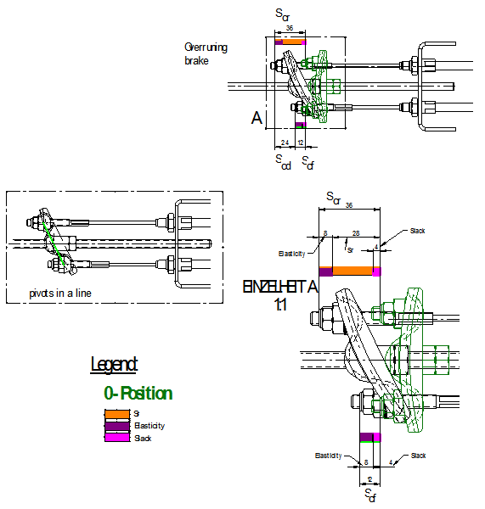

3.   This proposal

The general idea of both documents has been picked-up in this paper.

The illustration above suggests equal tension in both cables and as such equal travel due to elasticity, thus scd **≥** 1,2 (sr – slack). Determining the slack is extra effort, subject to measuring tolerances and assumed to be not very big. Therefore the plead is to waive it, consider it an extra safety margin and say scd **≥**1,2 x sr.