Proposed amendments to ECE/TRANS/WP.29/2017/67
(Draft General Guidelines for regulatory procedures and transitional provisions in UN regulations)
Modifications to ECE/TRANS/WP.29/2017/67 are shown in strikethrough and bold/underline.

As ECE/TRANS/WP.29/2017/67 will not only concern IWVTA but any amendments adopted by the GRs, it would make sense that these new guidelines are reviewed by the GRs before it is adopted by WP29 as it was the case with previous version of the guidelines.

I. Proposal
B.1. Series of Amendments
23. Series of amendments shall be developed to change the technical requirements that the vehicle types, vehicle systems, equipment or parts shall fulfil as from a certain date, in order to obtain UN type-approval according to the new version of the Regulation, even if the amendments consist of minor technical changes and do not affect vehicles/vehicle systems/equipment/parts design drastically. In this procedure, the modification of the approval marking is necessary to differentiate the new approvals to the amended UN Regulation (hereinafter referred to as "the new approvals") from the existing approvals to the preceding amendments or unamended UN Regulation (hereinafter referred to as "the existing approvals").
24. Unless otherwise expressly set out in the transitional provisions of the latest series of amendments, Contracting Parties are not obliged to accept existing approvals from the date of entry into force of these latest series of amendments. Contracting Parties may continue to grant approvals to any previous version(s) of a UN Regulation. However, they may refuse to accept such approvals, subject to the transitional provisions of the later series of amendments.
25. The new series of amendments shall normally contain at least the following:
(a) The date as from which Contracting Parties are entitled to issue a UN type-approval in accordance with the amended UN Regulation and as from which Contracting Parties are obliged to accept such type-approvals (defined as Date (a) in Figure 1). In general, this date should be the date of entry into force of the series of amendments.
(b) The date as from which Contracting Parties are no longer obliged to accept UN type-approvals to the previous version which were first issued after this date (defined as Date (b) in Figure 1);
(c) The date as from which Contracting Parties shall not be obliged to accept type-approvals issued pursuant to the preceding version(s) of the amended UN Regulation, regardless of the date of issue (defined as Date (c) in Figure 1).
(d) An update of the series of amendments used in the marking provisions and updated examples of markings unless such markings are replaced by a Unique Identifier according to Schedule 5 of the 1958 Agreement.
Figure 1
Illustration of a transitional period for a vehicle, or vehicle systems, covered by a UN Regulation and its amendments
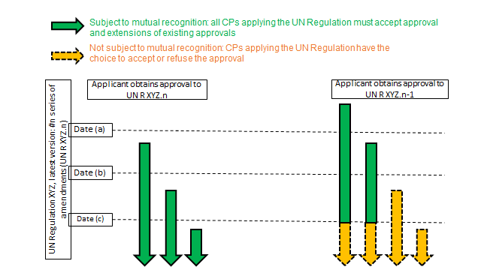
See however special cases 1-1, 1-2 and 1-3 in
Chapter E below

Note: Existing approvals remain valid, but Contracting Parties are not obliged to accept them as from date (c). If (b) and (c) dates are not written in to the transitional provisions, they are regarded as identical to date (a).
26. The new series of amendments may contain a provision on the conditions for granting extensions to existing approvals (i.e. in the case of slight modifications to an existing vehicle type, without affecting the basic definition of type). Such extensions of approvals shall be accepted under the same conditions set out in paragraph 25 above, i.e. such extensions of approvals, which were originally granted before Date (b), shall continue to be accepted by all Contracting Parties until at least Date (c), (if applicable). Furthermore, the new series of amendments may contain a transitional provision for Contracting Parties applying the UN Regulation after the date of entry into force of the amendments, indicating that such Contracting Parties are not obliged to accept the existing approvals.
27. General guidelines on transitional provisions for new series of amendments are set forth in Annex 1 to this document. In the interest of harmonizing the introduction of technical product changes, Dates (b) and (c) shall be set at September 1st of a year whenever feasible.
B.2. Supplements
28. A Supplement addresses an amendment to a UN Regulation which does not entail a modification in the approval marking and is normally used for:
(a) Clarification of test procedures not changing the level of stringency of the UN Regulation or imposing new requirements; or
(b) Regulating new developments which have arisen after the adoption of a UN Regulation (i.e. extension of scope) not changing the level of stringency of the UN Regulation.
29. A Supplement does not entail a modification in the approval marking and shall not be used when it is necessary for Contracting Parties to differentiate the new approvals from the existing approvals.
30. A Supplement becomes applicable as from the date of entry into force, after which tests according to the series of amendments to the UN Regulation, affected by that Supplement, need to take into account the Supplement in question. In the absence of any other date mentioned, Supplements become applicable for all procedures for new approvals issued after the date of its entry into force, taking into account the transitional provisions, if any, of the series of amendments to which the Supplement refers.
31. Unless specifically otherwise foreseen, A supplement shall apply to new extensions of existing approvals may continue to be granted on the basis of the provisions valid at the time of the original approval. The Supplement may however foresee that it will not affect existing approvals
32. Subject to paragraph 28, existing approvals do not need to be extended because of the entry into force of a new supplement and Contracting Parties shall continue to recognize them.
II. Justification

Para. 25 : It is to re-instate a guideline that already exist in the present guidelines (TRANS/WP.29/1044 ) that in the absence of transitional provisions, the new series of amendments apply from the date of entry into force.

Para 28 and 29: the marking issue is moved from 28 to 29 to better fit with the cross reference in para. 32. The marking is not part of the definition of a supplement but only a consequence that a supplement is not a major change.

Para 30, 31 and 32: Supplements shall apply to extensions. If an extension requires a new test, there is no reason why changes brought to the test procedure by the Supplement shall not apply. So it is not acceptable to have general rule that a supplement will not apply to existing approvals. However if the Supplement has no relationship with the extension it is acceptable that that the supplement has no impact with on an approval.

Finally it should be recalled that most of the supplements adopted today go much beyond an extension of scope or a clarification of the test procedure. So in most of the case they create a new version of the Regulation. It is therefore important that the guidelines do not go beyond what is laid down in Article 12 of the Agreement which only requires only Contracting Parties to recognize the latest version of UN Regulations.

