|  |  |  |  |
| --- | --- | --- | --- |
|  | United Nations | ECE/TRANS/2017/3 | |
| _unlogo | **Economic and Social Council** | | Distr.: General  12 December 2016  Original: English |

**Economic Commission for Europe**

Inland Transport Committee

**Seventy-ninth session**

Geneva, 21-24 February 2017  
Item 4 (a) of the provisional agenda  
**Strategic questions of a horizontal policy nature:  
Status of accessions to international United Nations transport agreements and conventions**

Status of accessions to United Nations transport agreements and conventions under the purview of the Inland Transport Committee

Note by the secretariat

|  |
| --- |
| *Summary* |
| This document presents the status of accessions by the United Nations Economic Commission for Europe (UNECE) and non-UNECE member States to the United Nations transport agreements and conventions administered by UNECE. |
| On 1 December 2016, the total number of Contracting Parties to the 58 United Nations legal instruments in the field of transport administered by UNECE was 1,725, with sixteen new Contracting Parties to fourteen legal instruments. The increase was the highest of the past five years. |
| The Committee may wish to **invite** countries, which have not yet done so, to accede to the United Nations conventions and other legal instruments in inland transport administered by the Committee and its subsidiary bodies. |
|  |

I. Overview

1. Figure 1 below shows the growth of the total number of Contracting Parties to legal instruments on inland transport under the purview of the Inland Transport Committee (ITC). On 1December 2016, the total number of Contracting Parties to the 58 United Nations legal instruments in the field of transport administered by UNECE was 1,725, with sixteen new Contracting Parties to fourteen legal instruments (see annex for details). Out of these 58 legal instruments, nine have not yet entered into force. The summary tables on the status of signatures, ratifications and accessions for all legal instruments are available at www.unece.org/trans/conventn/intro.html.

Figure 1

**An increasing annual growth of Contracting Parties to legal instruments on inland transport under the purview of the ITC**



*Source*: UNECE

2. Figure 2 below illustrates the evolution of accessions by UNECE and non-UNECE member States since 1950:

Figure 2

**Number of UNECE and non-UNECE member State accessions to legal instruments on inland transport under the purview of the ITC, per year**



*Legend:* Solid line: UNECE member States - Dotted line: non-UNECE member States

*Source*: UNECE

3. Of the 193 United Nations Member States, 145 States (75 per cent) are Contracting Parties to at least one legal instrument on inland transport. Nine per cent of the United Nations Member States are contracting parties to at least 30 legal instruments, but 24 per cent of countries are not contracting parties to a single legal instrument.

4. In 2016, nine out of the fourteen legal instruments for which new accessions were recorded were related to road safety. This extraordinary result reflects the growing awareness globally of the importance of the issue and coincides with the active promotion of Road Safety Conventions by the United Nations Secretary General’s Special Envoy for Road Safety, Mr. Jean Todt.

**II. Geographical distribution of Contracting Parties**

5. The total number of Contracting Parties to the 58 transport conventions is 1,725 (as of 1 December), of which 1,718 are States. Of these, 1,340 are UNECE Contracting Parties and 378 are non-UNECE Contracting Parties.

6. Of the 145 United Nations Member States that are Contracting Parties, 91 (60 per cent) are non-UNECE member States.

7. Out of the 58 legal instruments under the purview of the ITC, 49 are in force. Non-UNECE member States are Contracting Parties to 29 transport conventions. This means that about 60 per cent of United Nations transport conventions serviced by UNECE and in force have a geographical coverage beyond the territory of the UNECE. On average, each UNECE member State is party to 23 legal instruments, while each non-UNECE member State is party to 13 legal instruments.

Figure 3

**Contracting Parties to United Nations transport conventions**

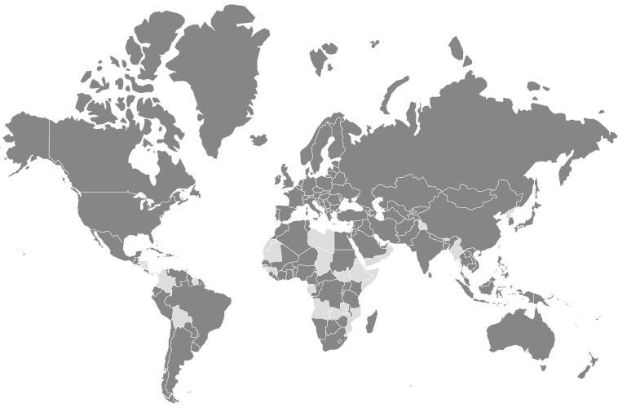

*Legend:* Dark grey: Contracting Parties - Light grey: non-Contracting Parties

*Source:* UNECE

8. The European Union is a Contracting Party to seven legal instruments. In the future, other regional integration initiatives may likely seek to become Contracting Parties as well.

9. For the majority of transport conventions, the number of UNECE Contracting Parties is higher than that of non-UNECE Contracting Parties. The relationship is reversed for some transport conventions. For example, 60 out of the 96 Contracting Parties of the Convention on Road Traffic of 1949 are not UNECE member States. Similarly, for some border crossing facilitation conventions, more Contracting Parties are from outside of the UNECE region: 44 out of 79 Contracting Parties for the Convention concerning Customs Facilities for Touring of 1954 and 42 out of 74 Contracting Parties for its Protocol; and 44 out of 80 Contracting Parties for the Convention on the Temporary Importation of Private Road Vehicles of 1954.

10. Forty-eight United Nations Member States are not Contracting Parties to any legal instruments on inland transport under the purview of the ITC: Angola, Belize, Bhutan, Bolivia (Plurinational State of), Brunei Darussalam, Cabo Verde, Chad, Colombia, Comoros, Democratic People's Republic of Korea, Djibouti, Dominica, Equatorial Guinea, Eritrea, Ethiopia, Gabon, Gambia, Grenada, Guinea, Guinea-Bissau, Honduras, Kiribati, Libya, Maldives, Marshall Islands, Mauritania, Micronesia (Federated States of), Mozambique, Myanmar, Nauru, Nicaragua, Oman, Palau, Panama, Saint Kitts and Nevis, Saint Lucia, Saint Vincent and the Grenadines, Samoa, Sao Tome and Principe, Somalia, South Sudan, Suriname, Swaziland, Timor-Leste, Tuvalu, Vanuatu, Yemen, Zambia.

11. The Committee may wish to consider this information and provide guidance to the Working Parties and the secretariat on ways to increase the number of new accessions to the legal instruments under its purview.

**Annex**

**Accessions registered from 1 January - 1 December 2016**

| *Date* | *Contracting Party* | *Convention* |
| --- | --- | --- |
| 27/11/2016 | Turkmenistan | Convention on Harmonization of Frontier Controls of Goods, 1982 |
| 02/11/2016 | Estonia | Additional Protocol to the CMR concerning the electronic consignment note (e-CMR) |
| 11/10/2016 | Republic of Moldova | Customs Convention on Containers, of 2 December 1972 |
| 06/10/2016 | Georgia | Agreement concerning the Adoption of Uniform Conditions for Periodical Technical Inspections of Wheeled Vehicles and the Reciprocal Recognition of Such Inspections, of 13 November 1997 |
| 05/10/2016 | France | Additional Protocol to the CMR concerning the electronic consignment note (e-CMR) |
| 21/09/2016 | Republic of Moldova | Agreement concerning the Adoption of Uniform Technical Prescriptions for Wheeled Vehicles, Equipment and Parts which can be fitted and /or be used on Wheeled Vehicles and the Conditions for Reciprocal Recognition of Approvals Granted on the Basis of these Prescriptions, of 20 March 1958 |
| 19/09/2016 | Georgia | European Agreement concerning the International Carriage of Dangerous Goods by Road (ADR), of 30 September 1957 |
| 16/08/2016 | Cyprus | Convention on Road Signs and Signals, of 8 November 1968 |
| 16/08/2016 | Cyprus | European Agreement supplementing the Convention on Road Signs and Signals (1968), of 1 May 1971 |
| 16/08/2016 | Cyprus | Protocol on Road Markings, Additional to the European Agreement supplementing the Convention on Road Signs and Signals, of 1 March 1973 |
| 05/07/2016 | China | Customs Convention on the International Transport of Goods under Cover of TIR Carnets (TIR Convention), of 14 November 1975 |
| 17/05/2016 | San Marino | Agreement on the International Carriage of Perishable Foodstuffs and on the Special Equipment to be Used for such Carriage (ATP), of 1 September 1970 |
| 12/05/2016 | Saudi Arabia | Convention on Road Traffic, of 8 November 1968 |
| 16/03/2016 | Serbia | Protocol amending article 1 (a), article 14 (1) and article 14 (3) (b) of the European Agreement of 30 September 1957 concerning the International Carriage of Dangerous Goods by Road (ADR), of 28 October 1993 |
| 29/02/2016 | Turkey | Protocol amending article 1 (a), article 14 (1) and article 14 (3) (b) of the European Agreement of 30 September 1957 concerning the International Carriage of Dangerous Goods by Road (ADR), of 28 October 1993 |
| 03/02/2016 | Russian Federation | Protocol to the Convention on the Contract for the International Carriage of Goods by Road (CMR), of 5 July 1978 |