Proposal for cleaning up to ECE/TRANS/WP.29/GRRF/2016/31
The modifications to the existing text are marked in bold for new or strikethrough for deleted characters.

Proposals in GRRF/2016/31 to regulate articulation angles of couplings as installed have been removed. A working formulation of such regulation has not been possible to agree.
- Proposal
Annex 5,
Figure 12, amend as follow:
"…Change dimension sleeve bore diameter Ø06H8 to Ø60H8…"
Figure 17, amend to read:
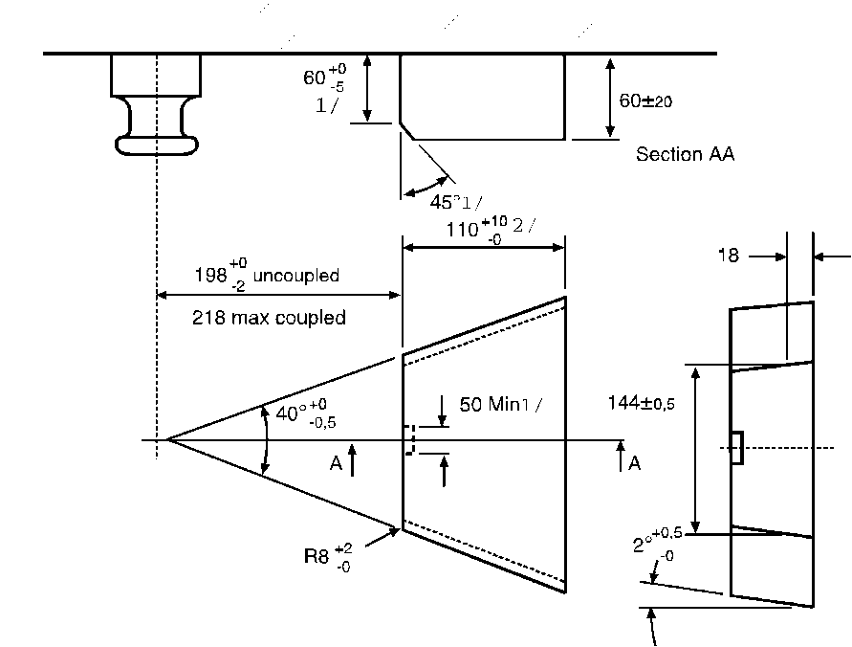
Annex 6
Amend paragraph 1.1. to read:
1.1 Samples of coupling devices shall be tested for both strength and function. Tests shall be performed in relation to worst case conditions.
Theoretical assessment may be carried out to determine worst case conditions Physical testing shall be carried out wherever possible but unless stated otherwise the Type Approval Authority or Technical Service may waive a physical strength test if the simple design of a component makes a theoretical check assessment possible.
Theoretical checks may be carried out to determine worst case conditions. In all cases, theoretical checks assessments shall ensure the same quality of results as with dynamic or static testing. In cases of doubt it is the results of physical testing that are overriding.
See also paragraph 4.8. of this Regulation.
Paragraph 3.6.1., amend to read:
    - Drawbars shall be tested in the same way as drawbar eyes (see paragraph 3.4.). The Type Approval Authority or Technical Service may waive an endurance test if the simple design of a component makes a theoretical check assessment of its strength possible. The design forces for the theoretical verification of the drawbar of centre axle trailers with a mass, C, of up to and including 3.5 tonnes shall be taken from ISO 7641/1:1983. The design forces for the theoretical verification of drawbars for centre axle trailers having a mass, C, over 3.5 tonnes shall be calculated as follows:
Fsp = (g × S/1000) + V
Where the force amplitude V is that given defined in paragraph 2.11.4. of this Regulation.
The permissible stresses based on the design masses for trailers having a total mass, C, over 3.5 tonnes shall be in accordance with paragraph 5.3. of ISO 7641/1:1983. For bent drawbars (e. g. swan neck) and for the drawbars of full trailers, the horizontal force component Fhp = 1.0 × D shall be taken into consideration.
- Justification
1. Currently the way to identify worst case(s) is unclear. Therefore, the text in Annex 6, paragraph1.1. has been amended.
2. In Annex 6, paragraph1.1. and paragraph 3.6.1., the word "check" where applicable has been exchanged for the word "assessment" in order to make clear the action is towards an approval and not just a check.
3. It is proposed to correct two typos in Annex 5, figures 12 and 17.

