Submitted by the expert of the Informal  working group on Regulation 55 | Informal document GRRF-81-07  81st GRRF, 01-05 February 2016  Agenda item 5(a)
Proposal for amendments to the informal document GRRF-81-06 concerning the proposal for amendments to UN Regulation No. 55. This proposal concerns a procedure to identify allowable combinations of performance values Dc and V for drawbar coupling equipment.
I. Proposal
Annex 8
Insert new paragraph 4., to read:
”4. Special Operation
In paragraph 5.3.5.1. the general requirement on the characteristic performance values is stated.
The designations D_{cert}, D_{C-cert}, V_{cert} and S_{cert} used below in this paragraph designate certified performance capacity of a coupling component under consideration. The designation D_{C-req}, V_{req} and S_{req} designate vehicle combination performance requirements calculated in accordance with the rules in this annex. They are to be evaluated against certified performance capacities.
A graphical chart reproducing the result from the formulae below may be included in the product documentation to be approved by the competent technical service.”

Insert new paragraph 4.1. and 4.1.1., to read:
“4.1 Clevis coupling systems including drawbeams and drawbar eyes
For each combination of certified performance capacity values a diagram as shown in the Figure 28 may be drawn and [included in the user’s manual]. Performance requirements D_{C-req} and V_{req} that would fall in the hatched area of the diagram are allowed to be operated in road traffic.
S_{req} shall always be below S_{cert}.
4.1.1 A component manufacturer owning a type approval certificate for a product as given in paragraph 4.1. is entitled to for that product issue a manufactures certificate certifying the safe application with D_{C-req} and V_{req} combinations laying in the hatched area. Such manufacturers certificate shall at all times be carried with the vehicle concerned.

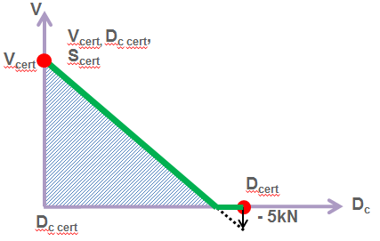
Figure 28 “

II. Justification
- Presently it is not possible to apply coupling equipment in an application where the calculated required performance values D_{C-req}, V_{req} and S_{req} lay in the hatched area of figure 28. I.e. any application with a D_{Creq} higher that D_{Ccert} and a V_{req} above zero is not allowed.
- It is possible to recertify those products for application points in the hatched area. This is also done every now and then. However this procedure result in a number of alternative performance values some of which you may have on the type plate. According to the current proposal recertification would only be called for if you aim for an application above the hatched area in Figure 28.
- This practice has been used on exemption basis with good results. The proposal has also been analysed from a theoretical standpoint applying fatigue analysis involving Haig-formalism. This has shown that the static load shall be kept at the certified value S_{cert}. Any change in S_{req} cannot be traded towards change in V-value limit. I.e. new combinations of S_{cert} shall be handled through recertification.

