|  |  |  |  |
| --- | --- | --- | --- |
|  | United Nations | ECE/TRANS/WP.29/GRRF/2016/12 | |
| Description: Description: _unlogo | **Economic and Social Council** | | Distr.: General  20 November 2015  Original: English |

**Economic Commission for Europe**

Inland Transport Committee

**World Forum for Harmonization of Vehicle Regulations**

**Working Party on Brakes and Running Gear**

**Eighty-first session**

Geneva, 1-5 February 2016

Item 7(c) of the provisional agenda

**Tyres – Regulation No. 54**

Proposal for amendment to Regulation No. 54 (Tyres for Commercial Vehicles and their Trailers) and Regulation No. 117 (Tyres, Rolling Resistance, Rolling Noise and Wet Grip)

Submitted by the experts from the European Tyre and Rim Technical Organisation[[1]](#footnote-2)\*

The text reproduced below was prepared by the experts from the European Tyre and Rim Technical Organisation (ETRTO) in order to amend the tyre marking requirements. This document is a revision of ECE/TRANS/WP.29/GRRF/2015/27 to include the Informal document GRRF-80-10 from ETRTO and the working document ECE/TRANS/WP.29/GRRF/2015/38 from Slovakia. The modifications to the existing text of the regulation are marked in bold for new or strikethrough for deleted characters.

Part A – Amendment to Regulation No. 54

1. Proposal

*Paragraph 3.1.10.,* amend to read:

"3.1.10. An indication, by the "PSI" index, of the inflation pressure to be adopted for the load/speed endurance tests, as explained in Annex 7, Appendix 2. However, this indication, which it is permissible to restrict to one sidewall, shall not be mandatory, on any tyre submitted for approval, until two years after the date of entry into force of this Regulation**.** 5

**For tyres first approved after 1 January 2018, the inflation pressure for the dimension measurement and for the load/speed endurance test, pursuant to paragraph 4.1.12. of this Regulation,** **shall be indicated in kilopascals, replacing the "PSI" index**.

**It is allowed to use kPa marking instead of PSI for tyres first type approved before 1 January 2018.** "

*Annex 3,* replace:

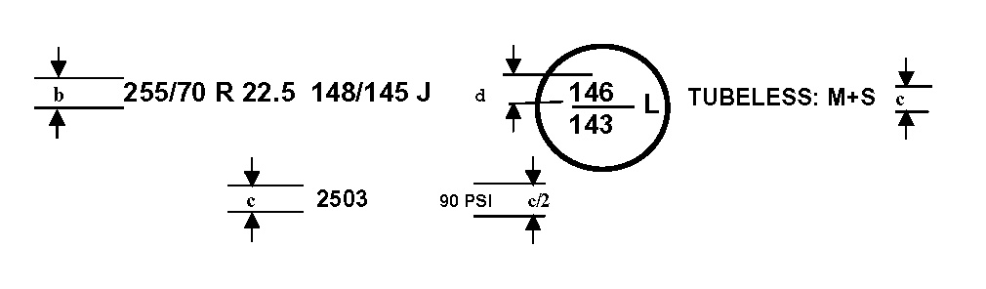"

*“*

*by:*

"

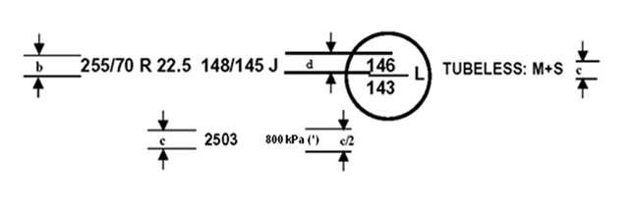

"

**(\*) PSI marking instead of kPa is allowed for tyres first type approved before 1 January 2018.** "

*Paragraph 4.1.12.*, amend to read:

"4.1.12. The **inflation** ~~measuring~~ pressure **for the dimension** **measurement** **and for the load/speed endurance test** **pressure** ~~and test pressure index~~;"

*Header of Annex 6*, amend to read:

"Method of **dimension** **measurement for** measuring pneumatic tyres"

*Paragraph 1. of Annex 6*, amend to read:

"1. The tyre is mounted on the measuring rim specified by the manufacturer pursuant to paragraph 4.1.11. of this Regulation and is inflated to **the** ~~a~~ pressure specified by the manufacturer pursuant to paragraph 4.1.12. of this Regulation."

*Paragraph 1.3. of Annex 7*, amend to read:

"1.3. Inflate the tyre to the pressure corresponding to the pressure ~~index~~ specified by the manufacturer pursuant to paragraph 4.1.12. of this regulation"

*Annex 7, Appendix 1,* amend to read:

"Endurance-test programme

| *Load index* | *Tyre speed category* ***symbol*** | *Test-drum speed* | | *Load placed on the wheel as a percentage of the load corresponding to the load index* | | |
| --- | --- | --- | --- | --- | --- | --- |
| *Radial-ply ~~min~~~~-1~~* ***km.h-1*** | *Diagonal (bias-ply) ~~min~~~~-1~~* ***km.h-1*** | *7 h.* | *16 h.* | *24 h.* |
| 122 or more | F  G  J  K  L  M | ~~100~~ **32**  ~~125~~ **40**  ~~150~~ **48**  ~~175~~ **56**  ~~200~~ **64**  ~~225~~ **72** | ~~100~~ **32**  ~~100~~ **32**  ~~125~~ **40**  ~~150~~ **48**  -  - | 66 % | 84 % | 101 % |
| 121 or less | F  G  J  K | ~~100~~ **32**  ~~125~~ **40**  ~~150~~ **48**  ~~175~~ **56** | ~~100~~ **32**  ~~125~~ **40**  ~~150~~ **48**  ~~175~~ **56** |  |  |  |
|  | L  M  N  P | ~~200~~ **64**  ~~250~~ **80**  ~~275~~ **88**  ~~300~~ **96** | ~~175~~ **56**  ~~200~~ **64**  -  - | 70 %  4 h.  75 %  75 %  75 % | 88 %  6 h.  97 %  97 %  97 % | 106 %  114 %  114 %  114 % |

*Notes:*

(1) "Special-use" tyres (see paragraph 2.1.3. of this regulation) should be tested at a speed equal to 85 per cent of the speed prescribed for equivalent normal tyres.

(2) Tyres with load index 122 or more, speed ~~categories~~ **category symbols** N or P and the additional marking "LT", or "C", referred to in paragraph 3.1.13. of this regulation, shall be tested with the same programme as specified in the above table for tyres with load index 121 or less."

II. Justification

1. It is proposed to replace the PSI Index by indicating the inflation pressure in kilopascals ("kPa"). By this, it will become possible to mark the same pressure as in all major tyre standards and avoid confusion in case of tyres marked according to Regulation No. 54 and, at the same time, according to FMVSS 119 or FMVSS 139.

2. It is proposed to change the measurement units for drum speed from min-1 to km.h-1 to align the requirements with other tyre regulations. The proposed text also aligns wording in Annex 7, Appendix 1 with the text of this regulation.

Part B – Amendment to Regulation No. 117

I. Proposal

*Annex 3, paragraph 2.5.3.*, amend to read:

"2.5.3.Tyre inflation pressure

Each tyre fitted on the test vehicle shall have a test pressure Pt not higher than the reference pressure Pr and within the interval:

25

.

1

25

.

1

1

.

1

















⋅





















⋅

*r*

t

r

t

r

t

r

Q

Q

P

P

Q

Q

P

For Class C2 and Class C3 the reference pressure Pr is the **inflation** pressure corresponding to the pressure **in kPa or to the pressure** index marked on the sidewall.

For Class C1 the reference pressure is Pr = 250 kPa for "standard" tyres and 290 kPa for "reinforced" or "extra load" tyres; the minimum test pressure shall be Pt = 150 kPa."

II. Justification

This proposal maintains coherency with the proposed amendment to Regulation No. 54 (Part A of this document).

1. \* In accordance with the programme of work of the Inland Transport Committee for 2014–2018 (ECE/TRANS/240, para. 105 and ECE/TRANS/2014/26, programme activity 02.4), the World Forum will develop, harmonize and update Regulations in order to enhance the performance of vehicles. The present document is submitted in conformity with that mandate. [↑](#footnote-ref-2)