|  |  |  |  |
| --- | --- | --- | --- |
|  | United Nations | ECE/TRANS/WP.29/GRE/2016/3 | |
| Description: _unlogo | **Economic and Social Council** | | Distr.: General  22 January 2016  Original: English |

**Economic Commission for Europe**

Inland Transport Committee

**World Forum for Harmonization of Vehicle Regulations**

**Working Party on Lighting and Light-Signalling**

**Seventy-fifth session**

Geneva, 5–8 April 2016

Item 4 of the provisional agenda

**Simplification of lighting and light-signalling Regulations**

Proposal for Supplement 12 to the original version of Regulation No. 99 (Gas-discharge light sources)

Submitted by the Informal Working Group "Simplification of the Lighting and Light-Signalling Regulations"[[1]](#footnote-2)\*

The text reproduced below was prepared by the experts from the Informal Working Group "Simplification of the Lighting and Light-Signalling Regulations" (IWG SLR) to simplify the content and amendment process of the light source Regulations. It is based on ECE/TRANS/WP.29/GRE/2015/26 and takes into account comments received at the seventy-fourth session of GRE (ECE/TRANS/WP.29/GRE/74, para. 9). The modifications to the existing text of the Regulation are marked in bold for new or strikethrough for deleted characters.

I. Proposal

*The title,* amend to read:

*"* Uniform provisions concerning the approval of gas-discharge light sources for use in approved ~~gas-discharge~~ lamp**s** ~~units~~ of power-driven vehicles"

*Paragraph 1.,* amend to read:

"1. Scope

This Regulation applies to gas-discharge light sources shown in Annex 1 to this Regulation and intended for use in approved ~~gas-discharg]~~ lamp**s** ~~units~~ of power-driven vehicles."

*Paragraph 2.3.4.*, amend to read:

"2.3.4. In case the ballast is not integrated with the light source, the ballast used for the type approval of the light source shall be marked with type and trade mark identification and with the rated voltage and wattage, as indicated on the relevant **gas-discharge light source** ~~lamp data~~ sheet.

*Paragraph 3.1.*, replace, to read:

"3.1. Definitions

**The definitions given in the Resolution [No. y] or its subsequent revisions, applicable at the time of application for type-approval shall apply.”**

*Insert a new paragraph 3.2.3.*, to read:

**"3.2.3. The discharge arc shall be the only element of the gas-discharge light source that generates and emits light when energised."**

*Paragraph 3.3.3.,* amend to read:

*“*3.3.3.Gas-discharge light sources shall be equipped with standard caps complying with the cap data sheets of IEC Publication 60061, ~~third edition,~~ as specified on the individual data sheets of Annex 1 to this Regulation.”

*Annex 1,* replace by a new Annex 1 to read:

"**Annex 1**

**Sheets\* for gas-discharge light sources**

**The sheets of the relevant gas-discharge light source category and the group in which this category is listed with restrictions on the use of this category shall apply as incorporated in the Resolution [No. y] or its subsequent revisions, applicable at the time of application for type approval of the gas-discharge light source.**

**\* From [date] onwards, the sheets for gas-discharge light sources, the list and group of light source categories with restrictions on the use of this category and their sheet numbers are incorporated in the Resolution [No. y] with symbol ECE/TRANS/WP.29/11XX."**

*Annex 4,*

*Paragraph 3.*, *amend to read:*

"3. Burning position

The burning position shall be horizontal within ±10° with the lead wire down. Ageing and testing positions shall be identical. If the ~~lamp~~ **gas-discharge light source** is accidentally operated in the wrong direction, it shall be re-aged before measurements begin. ….."

*Paragraph 10.*, delete the figure and amend to read:

"10. Colour

The colour of the light source shall be measured in an integrating sphere using a measuring system which shows the CIE chromaticity co-ordinates of the received light with a resolution of ± 0.002.~~The following figure shows the colour tolerance area for colour white and the restricted tolerance area for the gas-discharge light sources D1R, D1S, D2R, D2S, D3R, D3S, D4R, D4S, D5S, D6S, D8R and D8S~~."

*Annex 5,* amend to read:

"....

The gas-discharge light source shall be positioned as shown~~:~~ **in the main drawing of the respective category.**

~~in figure 1 or figure 2 on sheet DxR/1 or sheet DxS/1;~~

~~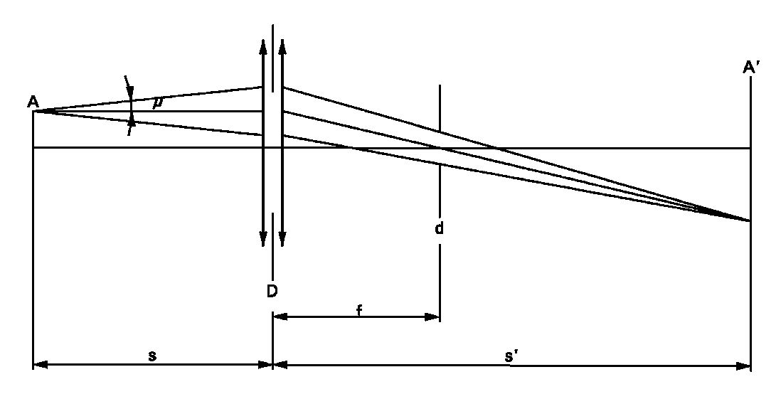in figure 3 or figure 4 on sheet DxR/2 or sheet DxS/2~~.

An optical system shall project …..

…..

D = (1 + 1/M)d + c + (b1 + b2)/2. (c, b1 and b2 are given **in the sheets prescribing the position of the electrodes** ~~on sheet DxS/5, respectively sheet DxR/5~~).

A scale on the screen shall enable to measure ….... The gauge shall show the reference axis and the plane parallel to the reference plane and at distance "e" mm from it ~~(e = 27.1 for D1R, D1S, D2R, D2S, D3R, D3S, D4R and D4S)~~.

In the plane of the screen ……

……. The range of measurable movement shall be such that the required measures of the arc bending r and arc diffusion s can be measured. **For the measurement of the stray light, the size of the receiver shall be circular with a diameter of 0.2M mm diameter."**

*Annex 7,*

*Table 1,* amend to read:

# "...

| *Grouping of characteristics* | *Grouping\* of test records between gas-discharge light source types* | *Minimum 12 monthly sample per grouping\** | *Acceptable level of non-compliance per grouping of characteristics (percentage)* |
| --- | --- | --- | --- |
| … | … | … | … |
| ~~Lamp~~ **Gas-discharge light source** voltage and wattage | All types of the same category | 200 | 1 |
| … | … | … | … |

..."

*Table 3, header row*, amend to read:

"

| *Number of ~~lamps~~* ***gas-discharge light sources*** *in records* | *Qualifying limit* | *Number of ~~lamps~~* ***gas-discharge light sources*** *in records* | *Qualifying limit* | *Number of ~~lamps~~* ***gas-discharge light sources*** *in records* | *Qualifying limit* |
| --- | --- | --- | --- | --- | --- |

"

II. Justification

This amendment is part of the proposal for simplification of the light source Regulations. The justification of this proposal is attached to the justification of the draft Resolution on the common specifications of light source categories (ECE/TRANS/WP.29/GRE/2016/5).

1. \* In accordance with the programme of work of the Inland Transport Committee for 2014–2018 (ECE/TRANS/240, para. 105 and ECE/TRANS/2014/26, programme activity 02.4), the World Forum will develop, harmonize and update Regulations in order to enhance the performance of vehicles. The present document is submitted in conformity with that mandate. [↑](#footnote-ref-2)