|  |  |  |  |
| --- | --- | --- | --- |
|  | United Nations | ECE/TRANS/WP.29/2016/37 | |
| _unlogo | **Economic and Social Council** | | Distr.: General  11 April 2016  Original: English |

**Economic Commission for Europe**

Inland Transport Committee

**World Forum for Harmonization of Vehicle Regulations**

**169th session**

Geneva, 21-24 June 2016

Item 4.6.5 of the provisional agenda

**1958 Agreement – Consideration of draft amendments   
to existing Regulations submitted by GRSP**

Proposal for Supplement 11 to the 04 series of amendments to Regulation No. 44 (Child restraint systems)

Submitted by the Working Party on Passive Safety [[1]](#footnote-2)\*

The text reproduced below was adopted by the Working Party on Passive Safety (GRSP) at its fifty-eighth session (ECE/TRANS/WP.29/GRSP/58, paras. 33 and 34). It is based on ECE/TRANS/WP.29/GRSP/2015/32 and ECE/TRANS/WP.29/GRSP/2015/33, as amended by Annex II to the report. It is submitted to the World Forum for Harmonization of Vehicle Regulations (WP.29) and to the Administrative Committee AC.1 for consideration.

Supplement 11 to the 04 series of amendments to Regulation No. 44 (Child restraint systems)

*Paragraph 2.8.8.,* amend to read:

"2.8.8. "*Guide strap*" means a strap or device which constrains the shoulder strap of the adult seat belt in a position to suit the child and where the effective position at which the shoulder strap changes direction can be adjusted by means of a device which can be moved up and down the strap to locate the wearer's shoulder, and then locked into that position. This guide strap is not meant to carry a significant part of the dynamic load. A guide strap is considered as a part of a child restraint system and cannot be separately approved as a child restraint system under this Regulation."

*Insert a new paragraph 4.9.*, to read:

"4.9. Marking of a booster cushion without backrest.

If the product is a booster cushion without backrest, the following label shall be permanently visible to someone installing the restraint in a vehicle and shall be masked when the booster cushion is used with its removable backrest :

**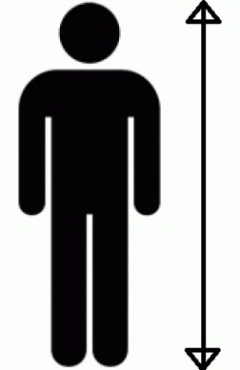**

"

*Insert a new paragraph 6.1.13.*, to read:

"6.1.13. Booster cushion without backrest shall only be type approved as Child Restraint Systems of Group III as defined in paragraph 2.1.1.5. of this Regulation. (Mass range from 22 kg to 36 kg)."

1. \* In accordance with the programme of work of the Inland Transport Committee for 2016–2017 (ECE/TRANS/254, para. 159 and ECE/TRANS/2016/28/Add.1, cluster 3.1), the World Forum will develop, harmonize and update Regulations in order to enhance the performance of vehicles. The present document is submitted in conformity with that mandate. [↑](#footnote-ref-2)