|  |  |  |  |
| --- | --- | --- | --- |
|  | United Nations | ECE/TRANS/WP.29/2016/25 | |
| Description: _unlogo | **Economic and Social Council** | | Distr.: General  23 December 2015  Original: English |

**Economic Commission for Europe**

Inland Transport Committee

**World Forum for Harmonization of Vehicle Regulations**

**168th session**

Geneva, 8-11 March 2016

Item 4.9.10 of the provisional agenda

**1958 Agreement – Consideration of draft amendments**

**to existing Regulations submitted by GRE**

Proposal for Supplement 5 to the original series of amendments to Regulation No. 128 (Light Emitting Diode (LED) light sources)

**Submitted by the Working Party on Lighting and Light-Signalling**[[1]](#footnote-2)\*

The text reproduced below was adopted by the Working Party on Lighting and Light-Signalling (GRE) at its seventy-fourth session (ECE/TRANS/WP.29/GRE/74, para. 12). It is based on ECE/TRANS/WP.29/GRE/2015/30. It is submitted to the World Forum for Harmonization of Vehicle Regulations (WP.29) and to the Administrative Committee AC.1 for consideration at their March 2016 sessions.

*Annex 1,*

*The list of categories of LED light sources and their sheet numbers,* amend to read:

"

|  | *Category* |  | *Sheet number(s)* |  |
| --- | --- | --- | --- | --- |
|  | LR1 |  | LR1/1 to 5 |  |
|  | LW2 |  | LW2/1 to 5 |  |
|  | LR3A |  | L3/1 to 6 |  |
|  | LR3B |  | L3/1 to 6 |  |
|  | LW3A |  | L3/1 to 6 |  |
|  | LW3B |  | L3/1 to 6 |  |
|  | LY3A |  | L3/1 to 6 |  |
|  | LY3B |  | L3/1 to 6 |  |
|  | LR4A |  | LR4/1 to 5 |  |
|  | LR4B |  | LR4/1 to 5 |  |
|  | LR5A |  | L5/1 to 6 |  |
|  | LR5B |  | L5/1 to 6 |  |
|  | LW5A |  | L5/1 to 6 |  |
|  | LW5B |  | L5/1 to 6 |  |
|  | LY5A |  | L5/1 to 6 |  |
|  | LY5B |  | L5/1 to 6 |  |

"

*The list of sheets for LED light sources and their sequence in this annex*, amend to read:

"

|  | *Sheet number(s)* |  |
| --- | --- | --- |
|  | LR1/1 to 5 |  |
|  | LW2/1 to 5 |  |
|  | L3/1 to 6 |  |
|  | LR4/1 to 5 |  |
|  | L5/1 to 6 |  |

"

*Sheets LR3/1 to 5,* replace by new sheets L3/1 to 6, to read (see following pages; one page per sheet):

*Sheet LR4/1,* replace by new sheet LR4/1, to read (see following pages):

*Sheet LR4/4,* replace by new sheet LR4/4, to read (see following pages):

*After sheet LR4/5,* insert new sheets L5/1 to 6, to read (see following pages; one page per sheet):

**Categories LR3A, LR3B, LW3A, LW3B, LY3A and LY3B Sheet L3/1**

The drawings are intended only to illustrate the essential dimensions of the LED light source.

Figure 1\*

**Main Drawing**

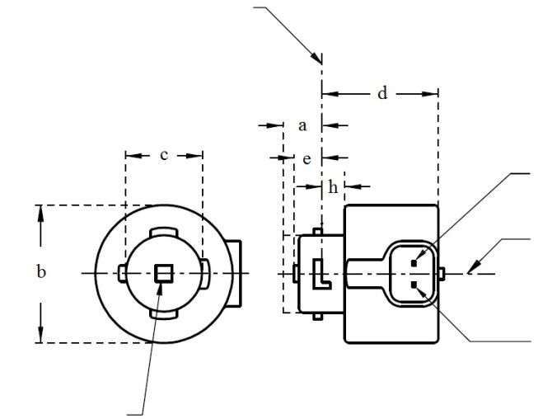

V+

Light emitting area 3

Reference axis 2

Ground

4

**LR3A, LW3A, LY3A**

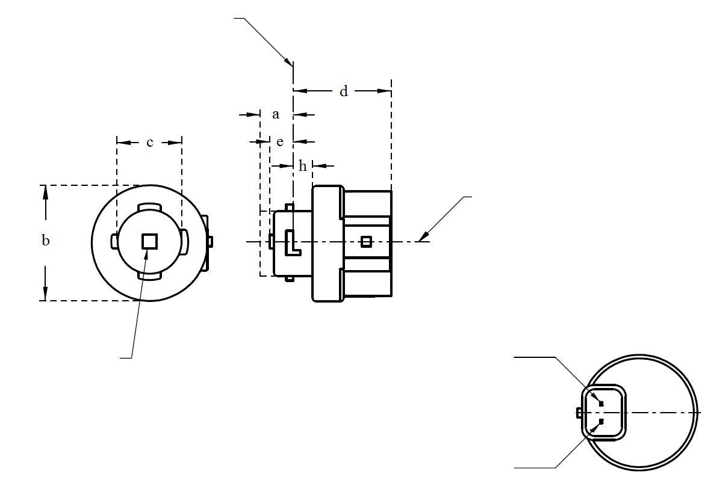

V+

Light emitting area 3

Reference axis 2

Ground

Reference plane 1

4

**LR3B, LW3B, LY3B**

For the notes see sheet L3/2.

\* Projection method:

**Categories LR3A, LR3B, LW3A, LW3B, LY3A and LY3B Sheet L3/2**

Table 1

**Essential dimensional, electrical and photometric characteristics of the LED light source**

|  |  |  |  |  |  |  |  |
| --- | --- | --- | --- | --- | --- | --- | --- |
| *Dimensions* | | | | | | *Production LED light sources* | *Standard LED light sources* |
| a | | | | | mm | 6.0 max. | |
| b | | | | | mm | c + 10.0 min.  38.0 max. | |
| c | | | | | mm | 18.5 ± 0.1 | |
| d | | | | | mm | 28.0 max. | |
| e | | | | | mm | 3.0 ± 0.30 | 3.0 ± 0.15 |
| h | | | | | mm | 5.5 + 0.0/ – 0.1 | |
| Cap | LR3A, LR3B  LW3A, LW3B  LY3A, LY3B | | PGJ18**.**5d-1  PGJ18.5d-24 PGJ18.5d-15 | | in accordance with IEC Publication 60061 (sheet 7004-185-1) | | |
| *Electrical and photometric characteristics* | | | | | | | |
| Rated values | | Volts | |  | | 12 | |
| Watts | |  | LR3A, LR3B | 3 | |
|  | LW3A, LW3B  LY3A, LY3B | 4 | |
| Objective Values8 | | Watts  (at 13.5 V DC) | |  | LR3A, LR3B | 3.5 max. | |
|  | LW3A, LW3B | 5 max. | |
| 12 | LY3A, LY3B |
| Luminous flux  (in lm at 13.5 V DC) | | 5 | LR3A, LR3B | 80 ± 20%9 | 80 ± 10%10 |
| 6 | LW3A, LW3B | 250 ± 20% | 250 ± 10%11 |
| 7, 12 | LY3A, LY3B | 150 ± 20%9 | 150 ± 10%10 |
| Luminous flux  (in lm at 9 V DC) | | 5 | LR3A, LR3B | 19 min |  |
| 6 | LW3A, LW3B | 50 min. |  |
| 7, 12 | LY3A, LY3B | 30 min |  |

1 The reference plane is the plane defined by the contact points of the cap-holder fit.

2 The reference axis is perpendicular to the reference plane and passing through the centre of the bayonet core.

3 Light emitting area: to be checked by means of the box system in Figure 2.

4 A minimum free air space of 5mm around the light source shall be respected for convection.

5 The emitted light shall be red.

6 The emitted light shall be white.

7 The emitted light shall be amber.

8 After continuous operation for 30 minutes at 23 ± 2.5° C.

9 The measured value shall be in between 100 per cent and 70 per cent of the value measured after 1 minute.

10 The measured value shall be in between 85 per cent and 75 per cent of the value measured after 1 minute.

11 The measured value shall be in between 100 per cent and 90 per cent of the value measured after 1 minute.

12 Operated in flashing mode for 30 minutes (frequency = 1.5 Hz, duty cycle 50 per cent ON, 50 per cent OFF). Measured in the ON-state of flashing mode after 30 minutes of operation.

Electrical characteristics

In case of LED light source failure (no light emitted) the max. electrical current draw, when operated between 12 V and 14 V, shall be less than 20 mA (open circuit condition).

**Categories LR3A, LR3B, LW3A, LW3B, LY3A and LY3B Sheet L3/3**

Screen projection requirements

The following test is intended to define the requirements for the apparent light emitting area of the LED light source and to determine whether the light emitting area is correctly positioned relative to the reference axis and reference plane in order to check compliance with the requirements.

The position of the light emitting area is checked by the box system defined in Figure 2, which is aligned to the planes C90 and C180 and shows the projection when viewing along direction γ=0º (C, γ as defined in Figure 3).

The proportion of the total luminous flux emitted into the viewing direction shall be as described in table 3.

Figure 2

**Box definition of the light emitting area with dimensions as specified in table 2**

f/3

Reference axis

perpendicular in the

centre of the light-

emitting area

f/3

f/3

f/3

f/3

f/3

A

B

B

B

B

C

C

C

C

f/2

f/2

Table 2

**Dimensions of the box system in Figure 2**

|  |  |  |
| --- | --- | --- |
| *Dimensions in mm* | *f* | |
| LR3A, LR3B | LW3A, LW3B LY3A, LY3B |
| LED light sources of normal production | 3.0 | 4.5 |
| Standard LED light sources | 3.0 | 4.5 |

**Categories LR3A, LR3B, LW3A, LW3B, LY3A and LY3B Sheet L3/4**

Table 3

**Proportion of the total luminous flux emitted into the viewing direction from the areas specified in figure 2**

|  |  |  |  |
| --- | --- | --- | --- |
| *Category* | *Area(s)* | *LED light sources of normal production* | *Standard LED light sources* |
| LR3A  LR3B | A | ≤ 25% | ≤ 10% |
| Each B individually | ≥ 15% | ≥ 20% |
| Each C individually | - | ≤ 10% |
| A, all B and all C together | ≥ 90% | ≥ 90% |
| LW3A  LW3B  LY3A  LY3B | Each A,B individually | ≥ 6% | ≥ 8% |
| Each A, B individually | < 40% | < 30% |
| All A, B together | ≥ 55% | ≥ 60% |
| Each C individually | < 15% | < 10% |
| All A, B and C together | ≥ 90% | ≥ 90% |

**Categories LR3A, LR3B, LW3A, LW3B, LY3A and LY3B Sheet L3/5**

Normalized luminous intensity distribution

The following test is intended to determine the normalized luminous intensity distribution of the light source in an arbitrary plane containing the reference axis. The intersection of the reference axis and the parallel plane to the reference plane in distance e is used as the coordinate system origin.

The light source is mounted on a flat plate with the corresponding mounting lug features. The plate is mounted to the goniometer table by a bracket, so that the reference axis of the light source lines up with one of the rotating axis of the goniometer. The corresponding measurement set-up is described in Figure 3.

Luminous intensity data is recorded with a standard photo-goniometer. The measurement distance should be chosen appropriately, to make sure that the detector is located in the far field of the light distribution.

The measurements shall be performed in C-planes C0 (C180) and C90 (C270), which contain the reference axis of the light source. The test points for each plane for multiple polar angles γ are specified in Tables 4a and 4b.

The measured luminous intensity values, normalised to the measured luminous flux of the individual light source under test, shall be converted to normalised luminous intensity values of a 1,000 lm light source. The data shall comply with the tolerance band as defined in Tables 4a and 4b.

The drawings are intended only to illustrate the essential set-up for measurement of the LED light source.

Figure 3

**Set-up to measure the luminous intensity distribution**

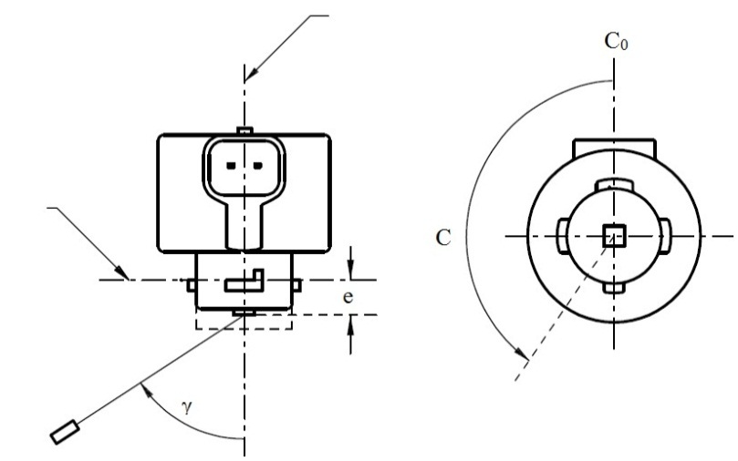

Reference axis

Reference plane

C-plane definition

Viewing direction along reference axis

Photo-Detector of Goniometer

**LR3A, LW3A, LY3A**

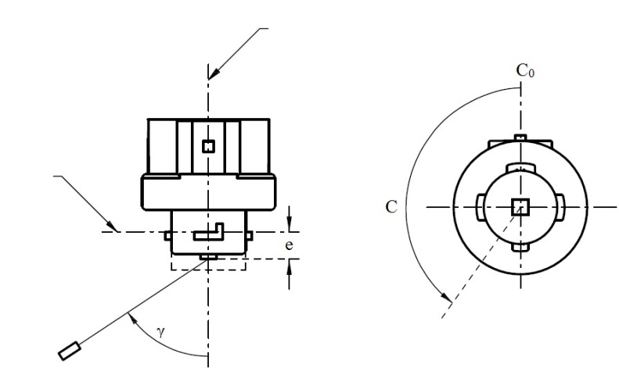

Reference axis

Reference plane

Photo-Detector of Goniometer

C-plane definition

Viewing direction along reference axis

**LR3B, LW3B, LY3B**

**Categories LR3A, LR3B, LW3A, LW3B, LY3A and LY3B Sheet L3/6**

The light pattern as described in Tables 4a and 4b shall be substantially uniform, i.e. in between two adjacent grid points the relative luminous intensity requirement is calculated by linear interpolation using the two adjacent grid points. In case of doubt this may be checked in addition to verification of the grid points given in Tables 4a and 4b.

Table 4a

**Test point values of normalized intensities for categories LR3A and LR3B**

|  |  |  |  |  |
| --- | --- | --- | --- | --- |
|  | *LED light sources of normal production* | | *Standard LED light sources* | |
| *Angle γ* | *Minimum Intensity  in cd /1000 lm* | *Maximum Intensity  in cd/1000 lm* | *Minimum Intensity  in cd /1000 lm* | *Maximum Intensity in cd /1000 lm* |
| -90° | 0 | 38 | 0 | 25 |
| -75° | 0 | 160 | 0 | 140 |
| -60° | 98 | 246 | 127 | 220 |
| -45° | 142 | 305 | 181 | 275 |
| -30° | 169 | 352 | 213 | 315 |
| -15° | 192 | 389 | 239 | 340 |
| 0° | 200 | 401 | 248 | 352 |
| 15° | 192 | 389 | 239 | 340 |
| 30° | 169 | 352 | 213 | 315 |
| 45° | 142 | 305 | 181 | 275 |
| 60° | 98 | 246 | 127 | 220 |
| 75° | 0 | 160 | 0 | 140 |
| 90° | 0 | 38 | 0 | 25 |

Table 4b

**Test point values of normalized intensities for categories LW3A, LW3B, LY3A and LY3B**

|  |  |  |  |  |
| --- | --- | --- | --- | --- |
|  | *LED light sources of normal production* | | *Standard LED light sources* | |
| *Angle γ* | *Minimum Intensity  in cd /1000 lm* | *Maximum Intensity  in cd/1000 lm* | *Minimum Intensity  in cd /1000 lm* | *Maximum Intensity in cd /1000 lm* |
| -90° | 0 | 70 | 0 | 65 |
| -75° | 0 | 160 | 0 | 150 |
| -60° | 85 | 245 | 105 | 220 |
| -45° | 145 | 310 | 180 | 275 |
| -30° | 170 | 380 | 220 | 335 |
| -15° | 190 | 415 | 240 | 370 |
| 0° | 200 | 425 | 250 | 390 |
| 15° | 190 | 415 | 240 | 370 |
| 30° | 170 | 380 | 220 | 335 |
| 45° | 145 | 310 | 180 | 275 |
| 60° | 85 | 245 | 105 | 220 |
| 75° | 0 | 160 | 0 | 150 |
| 90° | 0 | 70 | 0 | 65 |

**Categories LR4A and LR4B Sheet LR4/1**

The drawings are intended only to illustrate the essential dimensions of the LED light source.

Figure 1\*

**Main Drawing**

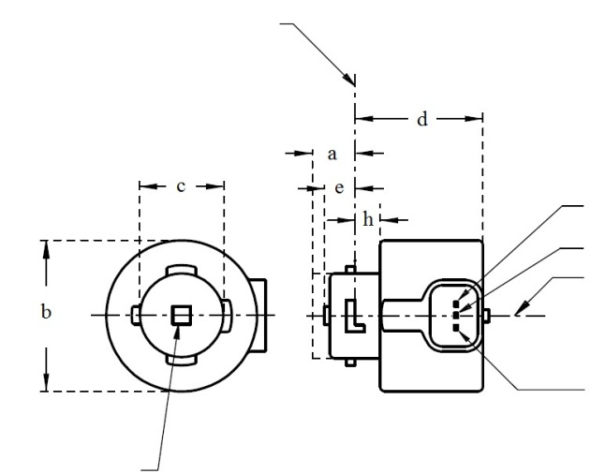

Reference plane 1

Major Function

Light emitting area 3

Reference axis 2

Ground

Minor Function

**LR4A**

4

\* Projection method:

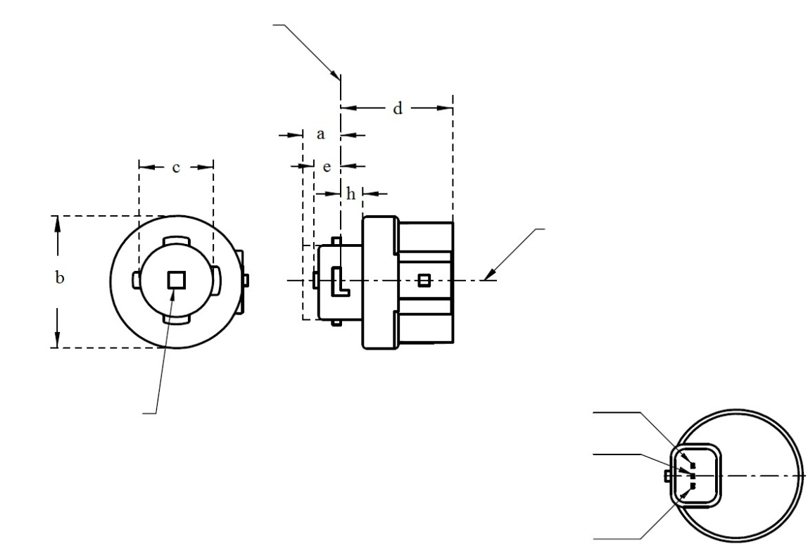

**LR4B**

Major Function

Light emitting area 3

Reference axis 2

Ground

Minor Function

Reference plane 1

4

For the notes see sheet LR4/2.

4

**Categories LR4A and LR4B Sheet LR4/4**

Normalized luminous intensity distribution

The following test is intended to determine the normalized luminous intensity distribution of the light source in an arbitrary plane containing the reference axis. The intersection of the reference axis and the parallel plane to the reference plane in distance e is used as the coordinate system origin.

The light source is mounted on a flat plate with the corresponding mounting lug features. The plate is mounted to the goniometer table by a bracket, so that the reference axis of the light source lines up with one of the rotating axis of the goniometer. The corresponding measurement set-up is described in Figure 3.

Luminous intensity data is recorded with a standard photo-goniometer. The measurement distance should be chosen appropriately, to make sure that the detector is located in the far field of the light distribution.

The measurements shall be performed in C-planes C0 (C180) and C90 (C270), which contain the reference axis of the light source. The test points for each plane for multiple polar angles γ are specified in Table 4.

After measurement the data shall be normalized to 1,000 lm according to paragraph 3.1.11 using the luminous flux of the individual light source under test. The data shall comply with the tolerance band as defined in Table 4.

The drawings are intended only to illustrate the essential set-up for measurement of the LED light source.

Figure 3\*

**Set-up to measure the luminous intensity distribution**

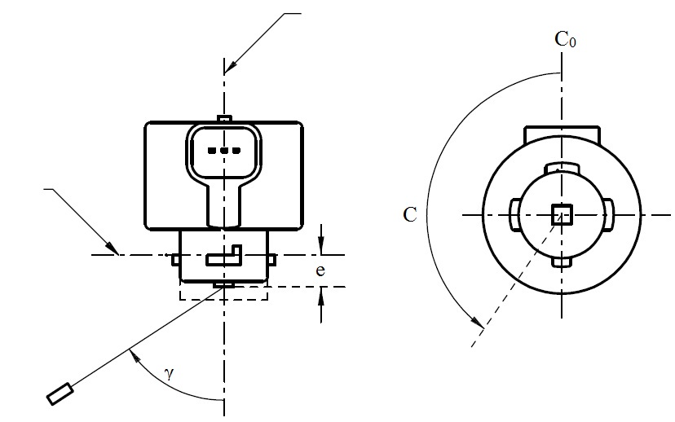

Reference axis

Reference plane

Photo-Detector of Goniometer

C-plane definition

Viewing direction along reference axis

**LR4A**

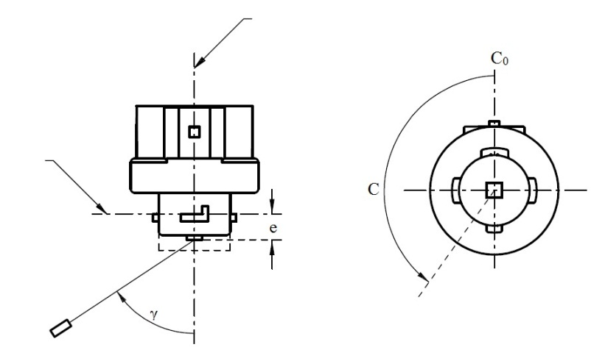

Reference axis

Reference plane

Photo-Detector of Goniometer

C-plane definition

Viewing direction along reference axis

**LR4B**

**Categories LR5A, LR5B, LW5A, LW5B, LY5A, LY5B Sheet L5/1**

The drawings are intended only to illustrate the essential dimensions of the LED light source.

Figure 1\*

**Main Drawing**

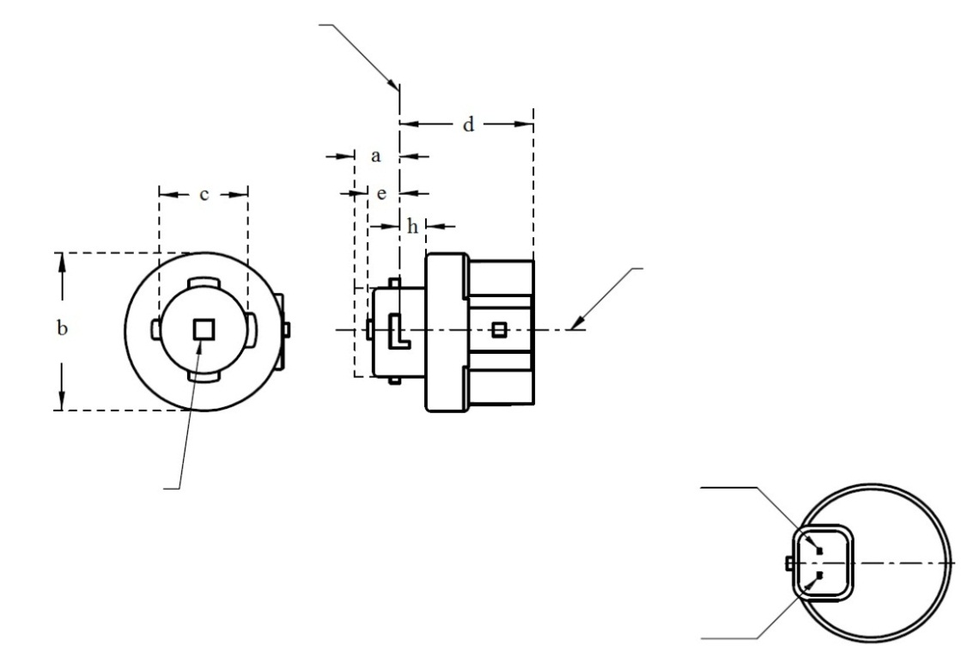

V+Reference plane 1

Ground

Reference plane 1

Light emitting area 3

Reference axis 2

4

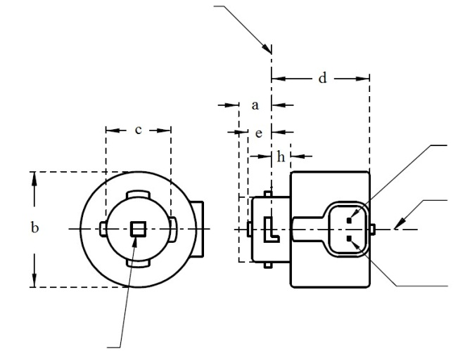

Reference plane 1

V+

Ground

4

Light emitting area 3

Reference axis 2

**LR5A, LW5A, LY5A**

**LR5B, LW5B, LY5B**

\* Projection method:

For the notes see sheet L5/2

**Categories LR5A, LR5B, LW5A, LW5B, LY5A, LY5B Sheet L5/2**

Table 1

**Essential dimensional, electrical and photometric characteristics of the LED light source**

|  |  |  |  |  |  |  |  |
| --- | --- | --- | --- | --- | --- | --- | --- |
| *Dimensions* | | | | | | *Production LED light sources* | *Standard LED light sources* |
| a | | | | | mm | 6.0 max. | |
| b | | | | | mm | c + 10.0 min.  38.0 max. | |
| c | | | | | mm | 18.5 ± 0.1 | |
| d | | | | | mm | 28.0 max. | |
| e | | | | | mm | 3.0 ± 0.30 | 3.0 ± 0.15 |
| h | | | | | mm | 5.5 + 0.0/ – 0.1 | |
| Cap | LR5A, LR5B  LW5A, LW5B  LY5A, LY5B | | PGJ18.5d-10  PGJ18.5d-28  PGJ18.5d-19 | | in accordance with IEC Publication 60061 (sheet 7004-185-1) | | |
| *Electrical and photometric characteristics* | | | | | | | |
| Rated values | | Volts | |  | | 12 | |
| Watts | |  | LR5A, LR5B | 3 | |
|  | LW5A, LW5B  LY5A, LY5B | 6 | |
| Objective Values8 | | Watts  (at 13.5 V DC) | |  | LR5A, LR5B | 3.5 max. | |
|  | LW5A, LW5B | 8 max. | |
| 10 | LY5A, LY5B |
| Luminous flux  (in lm at 13.5 V DC) | | 5 | LR5A, LR5B | 120 ± 15% | 120 ± 5% 9 |
| 6 | LW5A, LW5B | 350 ± 20% | 350 ± 10% 9 |
| 7, 10 | LY5A, LY5B | 280 ± 20% | 280 ± 10% 9 |
| Luminous flux  (in lm at 9 V DC) | | 5 | LR5A, LR5B | 28 min. |  |
| 6 | LW5A, LW5B | 65 min. |  |
| 7, 10 | LY5A, LY5B | 55 min. |  |

1 The reference plane is the plane defined by the contact points of the cap-holder fit.

2 The reference axis is perpendicular to the reference plane and passing through the centre of the bayonet core.

3 Light emitting area: to be checked by means of the box system in Figure 2

4 A minimum free air space of 5mm around the light source shall be respected for convection.

5 The emitted light shall be red.

6 The emitted light shall be white.

7 The emitted light shall be amber.

8 After continuous operation for 30 minutes at 23 ± 2.5° C.

9 The measured value shall be in between 100 per cent and 90 per cent of the value measured after 1 minute.

10 Operated in flashing mode for 30 minutes (frequency = 1.5 Hz, duty cycle 50 per cent ON, 50 per cent OFF). Measured in the ON-state of flashing mode after 30 minutes of operation.

Electrical characteristics

In case of LED light source failure (no light emitted) the max. electrical current draw, when operated between 12 V and 14 V, shall be less than 20 mA (open circuit condition).

**Categories LR5A, LR5B, LW5A, LW5B, LY5A, LY5B Sheet L5/3**

Screen projection requirements

The following test is intended to define the requirements for the apparent light emitting area of the LED light source and to determine whether the light emitting area is correctly positioned relative to the reference axis and reference plane in order to check compliance with the requirements.

The position of the light emitting area is checked by the box system defined in Figure 2, which is aligned to the planes C90 and C180 and shows the projection when viewing along direction γ=0º (C, γ as defined in Figure 3).

The proportion of the total luminous flux emitted into the viewing direction shall be as described in table 3.

Figure 2

**Box definition of the light emitting area with dimensions as specified in table 2**

f/3

Reference axis

perpendicular in the

centre of the light-

emitting area

f/3

f/3

f/3

f/3

f/3

A

B

B

B

B

C

C

C

C

f/2

f/2

Table 2

**Dimensions of the box system in Figure 2**

|  |  |
| --- | --- |
| *Dimensions in mm* | *f* |
| LED light sources of normal production | 4.5 |
| Standard LED light sources | 4.5 |

**Categories LR5A, LR5B, LW5A, LW5B, LY5A, LY5B Sheet L5/4**

Table 3

**Proportion of the total luminous flux emitted into the viewing direction from the areas specified in figure 2**

|  |  |  |  |
| --- | --- | --- | --- |
| *Category* | *Area(s)* | *LED light sources of normal production* | *Standard LED light sources* |
| LR5A  LR5B | Each B individually | ≥ 10% | ≥ 15% |
| Each A, B individually | < 40% | < 30% |
| All B together | ≥ 60% | ≥ 65% |
| Each C individually | - | < 10% |
| All A, B and C together | ≥ 90% | ≥ 90% |
| LW5A  LW5B  LY5A  LY5B | Each A,B individually | ≥ 6% | ≥ 8% |
| Each A, B individually | < 40% | < 30% |
| All A, B together | ≥ 55% | ≥ 60% |
| Each C individually | < 15% | < 10% |
| All A, B and C together | ≥ 90% | ≥ 90% |

**Categories LR5A, LR5B, LW5A, LW5B, LY5A, LY5B Sheet L5/5**

Normalized luminous intensity distribution

The following test is intended to determine the normalized luminous intensity distribution of the light source in an arbitrary plane containing the reference axis. The intersection of the reference axis and the parallel plane to the reference plane in distance e is used as the coordinate system origin.

The light source is mounted on a flat plate with the corresponding mounting lug features. The plate is mounted to the goniometer table by a bracket, so that the reference axis of the light source lines up with one of the rotating axis of the goniometer. The corresponding measurement set-up is described in Figure 3.

Luminous intensity data is recorded with a standard photo-goniometer. The measurement distance should be chosen appropriately, to make sure that the detector is located in the far field of the light distribution.

The measurements shall be performed in C-planes C0 (C180) and C90 (C270), which contain the reference axis of the light source. The test points for each plane for multiple polar angles γ are specified in Table 4.

The measured luminous intensity values, normalised to the measured luminous flux of the individual light source under test, shall be converted to normalised luminous intensity values of a 1,000 lm light source. The data shall comply with the tolerance band as defined in Table 4.

The drawings are intended only to illustrate the essential set-up for measurement of the LED light source.

Figure 3

**Set-up to measure the luminous intensity distribution**



Reference axis

Reference plane

Photo-Detector of Goniometer

C-plane definition

Viewing direction along reference axis

**LR5A, LW5A, LY5A**



Reference axis

Photo-Detector of Goniometer

Reference plane

C-plane definition

Viewing direction along reference axis

**LR5B, LW5B, LY5B**

**Categories LR5A, LR5B, LW5A, LW5B, LY5A, LY5B Sheet L5/6**

The light pattern as described in Table 4 shall be substantially uniform, i.e. in between two adjacent grid points the relative luminous intensity requirement is calculated by linear interpolation using the two adjacent grid points. In case of doubt this may be checked in addition to verification of the grid points given in Table 4.

Table 4

**Test point values of normalized intensities for categories LR5A, LR5B, LW5A, LW5B, LY5A and LY5B**

|  |  |  |  |  |
| --- | --- | --- | --- | --- |
|  | *LED light sources of normal production* | | *Standard LED light sources* | |
| *Angle γ* | *Minimum Intensity  in cd /1000 lm* | *Maximum Intensity  in cd/1000 lm* | *Minimum Intensity  in cd /1000 lm* | *Maximum Intensity in cd /1000 lm* |
| -90° | 0 | 70 | 0 | 65 |
| -75° | 0 | 160 | 0 | 150 |
| -60° | 85 | 245 | 105 | 220 |
| -45° | 145 | 310 | 180 | 275 |
| -30° | 170 | 380 | 220 | 335 |
| -15° | 190 | 415 | 240 | 370 |
| 0° | 200 | 425 | 250 | 390 |
| 15° | 190 | 415 | 240 | 370 |
| 30° | 170 | 380 | 220 | 335 |
| 45° | 145 | 310 | 180 | 275 |
| 60° | 85 | 245 | 105 | 220 |
| 75° | 0 | 160 | 0 | 150 |
| 90° | 0 | 70 | 0 | 65 |

"

1. \* In accordance with the programme of work of the Inland Transport Committee for 2014–2018 (ECE/TRANS/240, para. 105 and ECE/TRANS/2014/26, programme activity 02.4), the World Forum will develop, harmonize and update Regulations in order to enhance the performance of vehicles. The present document is submitted in conformity with that mandate. [↑](#footnote-ref-2)