|  |  |  |  |
| --- | --- | --- | --- |
|  | United Nations | ECE/TRANS/2016/7 | |
| _unlogo | **Economic and Social Council** | | Distr.: General  14 December 2015  Original: English |

**Economic Commission for Europe**

Inland Transport Committee

**Seventy-eighth session**

Geneva, 23–26 February 2016  
Item 4 (d) (ii) of the provisional agenda  
**Strategic questions of a horizontal policy nature:  
Environment, climate change and transport –   
Mitigation of environmentally harmful effects of inland transport**

Progress of the application of ForFITS in countries in the United Nations Economic Commission for Europe region as well as the regional ForFITS study

Note by the secretariat

|  |
| --- |
|  |
| The Inland Transport Committee was informed at its February 2015, session that the Transport Division, at the invitation of the Environment Division, would participate in up-coming Environmental Performance Review (EPR) in Belarus and Georgia and that the For Future Inland Transport Systems (ForFITS) tool would be used for analysis in the transport chapter of the EPR. In addition, the ForFITS tool would also be used to project baseline CO2 emission levels for the United Nations Economic Commission for Europe (UNECE) member States. |
| The UNECE Sustainable Transport Division[[1]](#footnote-2) carried out each implementation of ForFITS in 2015. The summary results are presented in this document. |
| The Committee is requested to **consider** how it wishes to continue benefiting from and contributing to the use and development of the ForFITS tool in light of its timeliness and relevance to sustainable development and climate change mitigation, particularly in light of the results of COP21 held in Paris in December 2015. |
| The Committee is requested to consider how it wishes to continue to benefit from and contribute to the use and development of the ForFITS tool in light of its timeliness and relevance with regard to sustainable development. |

I. Background

1. First initiated in 2008, ForFITS was developed in a three-year project that began in 2011. The goal was enhancing international cooperation and planning towards sustainable transport policies, with a particular aim to facilitate climate change mitigation. The project was funded by the United Nations Development Account (UNDA) and it involved all United Nations Regional Commissions.

2. To achieve its goal, the project included:

* the development and implementation of a tool to monitor and assess CO2 emissions from the transport sector, consisting of a model capable of assessing policy impacts;
* the preparation and implementation of awareness-raising events for stakeholders involved in activities concerning transport, energy and CO2 emissions; and
* the organization and roll-out of training activities/capacity-building workshops for policymakers and technical experts.

3. ECE developed the model following the 2012 preparation of a global review on existing statistical data, policy measures and assessment tools on CO2 emissions in transport and the discussions on draft methodology at an International Expert Meeting (April 2012). The first prototype was developed in late 2012. Significant improvements came in 2013. The UNDA project also foresaw the development of both a global status report at the start and a follow-up based on ForFITS results at the end of the project.

4. The model and its user manual are available free-of-charge on the ECE website ([www.unece.org/trans/theme\_forfits.html](http://confapps01.unog.ch/Users/Molnar/AppData/Local/Temp/notes256C9A/www.unece.org/trans/theme_forfits.html)). The latter provides details on the methodology of the model; the model structure, gives information on each step of calculation; the input data required, including explanations on how to use the input file; and instructions on how to perform model runs, illustrating how to visualize the results and extract them from the software application which hosts ForFITS.

5. The tool’s primary focus is CO2 emissions from inland transport, including road, rail and inland waterways, and predicts future emissions based on current patterns. CO2 emissions from aviation and maritime transport are included, but in a simplified manner in comparison to the other transport modes. Non-motorized transport and pipelines are also addressed by the model.

II. 2015 Implementation Activities

6. 2015 saw ForFITS used in several different ways as an instrument for the assessment, monitoring and planning of sustainable transport policies. While independent users were in contact with ECE for technical issues while using the tool in locations such as Lyon (France), Egypt, Poland and Lebanon, this report will focus on use of the tool by the Sustainable Transport Division in three studies:

(a) Georgia Environmental Performance Review;

(b) Belarus Environmental Performance Review;

(c) ECE-wide regional study.

A. Georgia

7. The ECE carried out a study in support of a review of transport generated CO2 emissions in Georgia, as part of an Environmental Performance Review (EPR) led by the ECE Environment Division. Analyses were led by the ECE Transport Division and supported by local consultants. Realistic scenarios were analysed to account for possible reductions in CO2 emissions and results were presented in an annex to the final EPR report.

8. The primary conclusion was that projections of future emission levels depend most strongly on population and Gross Domestic Product (GDP) changes; policy decisions are clearly relevant as well. Georgia’s challenges are that its expected future economic growth would typically correspond to an increase in CO2 emissions from an increased motorization rate. However, improvements in the composition of its transport fleet could help mitigate these issues.

# Figure 1

**Projected well-to-wheel CO2 emissions for transport in Georgia, 2010–2030**

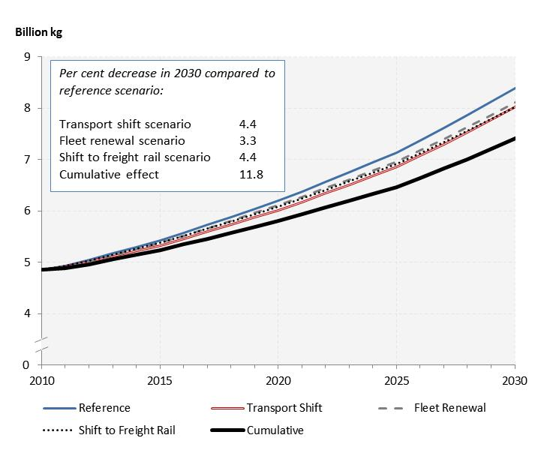

*Notes:* Well-to-wheel = CO2 emissions from both vehicle operation and emissions from production and distribution of fuel used operation. Reference = No major policy changes. Transport shift = decrease of gap between the current and maximum values of ECE passenger transport system index by 20 per cent by 2040. Fleet renewal = average vehicle life for personal passenger cars was reduced by half by 2040. Shift to freight rail = 5 percentage point shift in shared of large freight transported by rail versus heavy duty trucks by 2040. Cumulative = combined effect of all scenarios.

9. The results demonstrated the potential impact of improving public transport infrastructure and increasing the efficiency of the transport sector by a shift to transporting freight by rail more frequently and by increasing turnover in personal vehicles. Projections generated by ForFITS based on these scenarios showed that pursuing such policies can adjust downward the current trend of increasingly high emissions from the transport sector in Georgia. With an aim toward mitigating the impact of future CO2 emissions from its transport sector, the Sustainable Transport Division suggested that Georgia may wish to further investigate the relative cost of implementing the following measures:

(a) Developing infrastructure necessary to support a shift towards an increased use of public transport by residents;

(b) Creating conditions that encourage freight carriers to shift from road to rail transport in order to take advantage of the energy efficiency of the rail sector;

(c) Encouraging increased turnover in passenger vehicles to ensure faster adoption of new and more energy efficient technologies.

B. Belarus

10. The Sustainable Transport Division projected CO2 emissions from the transport sector in Belarus for this EPR study (also led by the UNECE Environment Division). Analyses were also by the Sustainable Transport Division and supported by local consultants. Realistic scenarios were analysed to account for possible reductions in CO2 emissions and results were presented in an annex to the final EPR report.

11. The results of this study demonstrated the potential impact of improving transport infrastructure and increasing the efficiency of the transport sector by a shift to an increased transport of freight by rail and by, specifically, the use of electric rail. ForFITS projections based on these scenarios show that pursuing such policies can adjust the current trend of increasingly high CO2 emissions stemming from the transport sector of Belarus downward. With an aim to mitigating the impact of future CO2 emissions from its transport sector, the Sustainable Transport Division suggested that Belarus may wish to further investigate the relative cost of implementing the following measures:

(a) The known risks associated with nuclear energy notwithstanding, nuclear energy generation would have beneficial effects from the point of view of the emission of greenhouse gases from the transport sector. In light of this, consider the development of nuclear energy with a goal of decreasing upstream CO2 emissions;

(b) Develop infrastructure necessary to support a shift toward an increased use of freight rail transport;

(c) Electrify rail as necessary to support a shift that would increase the use of freight rail transport and to maximize the environmental benefits of decreased CO2 emission rates;

(d) Consider increasing fuel prices with an aim of further rationalizing overall transport activity, while keeping in mind the need to mitigate impacts on the economically weaker/vulnerable social groups.

# Figure 2

**Projected well-to-wheel CO2 emissions for transport in Belarus, 2010-2030**

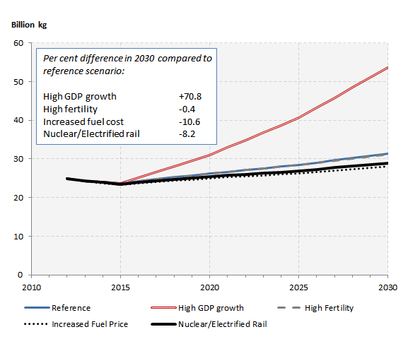

*Notes:* Well-to-wheel = CO2 emissions from both vehicle operation and emissions from production and distribution of fuel used operation. Reference = No major policy changes. High GDP growth = 5 per cent annual growth compared to less than 2 per cent in the reference scenario. High fertility = High fertility scenario from UN World Population Prospects. Increased fuel cost = doubling of fuel costs by 2030. Nuclear/electrified rail = combined scenario with an increase in nuclear power availability, the electrification of rail lines and higher usage of freight rail.

C. Regional study

12. The final study undertaken by the UNECE secretariat in 2015 was built on the ForFITS input data from 2014 on UNECE member States. Of the 40 member States with sufficient data, the Sustainable Transport Division projected CO2 emissions from inland transport under a baseline (or "steady-state") scenario using ForFITS. Results for individual member States were aggregated to provide overall results for the UNECE region and identified differences between geographic regions and countries with differing income levels.

13. Based on UNECE projections, freight transport is likely to be the main driver of increases in CO2 emissions in the next decades for the countries analysed due to continued economic growth – the primary driver of freight transport activity – and comparatively moderate to low population growth – which will minimize increases in passenger transport activity. Though projected freight transport activity is closely correlated to economic growth, the overall intensity of emissions (as measured by emissions per GDP) is expected to decrease over this time, possibly due to improvements in the efficiency of various powertrains. The countries analysed seem to have reached a plateau in per capita CO2 emissions as very little growth or decrease is projected in future years. However, this overall trend masks differences such as increasing per capita emissions for countries in low and middle income countries. This change for these countries is expected as economic output in these countries begins to approach average levels in the UNECE region.

# Figure 3

**Projected well-to-wheel CO2 emissions per capita from passenger and freight inland transport in selected UNECE member States, by income level, 2012–2040**

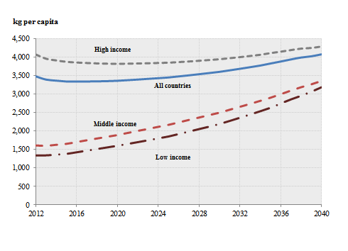

*Notes:* Vessels and aircraft not included due to lack of reliable data. Well-to-wheel = CO2 emissions from both vehicle operation and emissions from production and distribution of fuel used operation. Low income = 2013 GDP per capita < 10 000 USD. Middle income = 2013 GDP per capita 10 000 – 25 000 USD. High income = 2013 GDP per capita > 25 000 USD.

14. Similarly, there are also clear regional differences within the UNECE. Projections of the levels of emissions for European Union and European Free Trade Agreement member States converge over time with those of other UNECE member States not including North America, while projections of CO2 emissions from the transport sector in North America remain substantially higher than other UNECE regions. A more detailed analysis of the region-wide study will be available in an informal document.

# Figure 4

**Projected well-to-wheel CO2 emissions per capita from passenger and freight inland transport in selected UNECE member States, by region, 2012–2040**

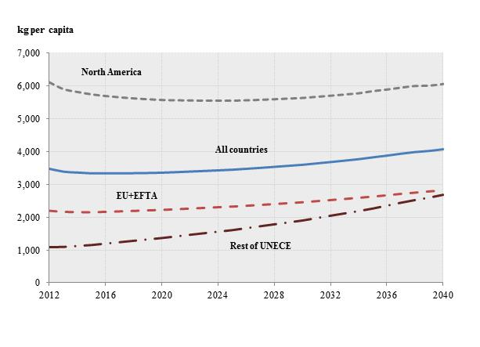

*Notes:* Vessels and aircraft not included due to lack of reliable data. Well-to-wheel = CO2 emissions from both vehicle operation and emissions from production and distribution of fuel used operation. North America = United States and Canada. EU+EFTA = European Union and European Free Trade Agreement member States. Rest of UNECE = other UNECE member States analysed which do not fall into other regional categories.

III. Conclusion and Recommendations

15. The Committee is requested to consider how it wishes to continue benefiting from and contributing to the use and development of the ForFITS tool in light of its timeliness and relevance with regard to sustainable development and climate change mitigation.

16. There remains the question of how to scale up the use of the ForFITS tool and for this "train the trainer" programmes would be warranted. However, this can happen only if extra-budgetary funding is available. The Sustainable Transport Division will explore the feasibility of developing partnerships towards this end with both UNITAR and other private parties.

17. In 2016, ECE also expects to complete two specific activities that investigate the extension of the scope of ForFITS. The first aims at filling a gap in the coverage of the tool with regard to emissions from agricultural tractors and mobile construction machinery. With funding from Environment Canada, the ECE is currently investigating the feasibility of adding a module to ForFITS to account for this non-road mobile machinery. More details on this project are available in the annex to this document.

18. The second activity of extension concerns road safety. Some of the variables driving CO2 emission levels are relevant to road safety (namely ‘vehicle activity’ and ‘modal choice’) and the ECE is investigating the possibility of leveraging the work already completed in the development of ForFITS to assist in the development of a new tool to assess road safety policies. The International Road Transport Union has supported this activity and provided funds to develop this tool – *SafeFITS* – using the available and relevant data.

19. In addition to these ongoing tasks, ECE has also discussed the possibility to consider the development of an additional module to assess local pollutants, which would require developing a new methodology not related to energy consumption but to engine technology. Further studies of the feasibility of a new model will depend on funding availability.

Annex

Status of the extra-budgetary project funded by Environment Canada on the feasibility study to develop a ForFITS module assessing CO2 emissions from Non-Road Mobile Machinery (NRMM)

I. Background information

1. ForFITS covers a large number of transport modes (rail, vessels, air, pipelines, non-motorized and road), vehicle classes, powertrain technologies and fuel blends. However, one sector not included in the initial development phase of ForFITS was Non-Road Mobile Machinery (NRMM), such as agricultural tractors and construction machinery.

2. For some countries, the contribution of NRMM to total transport CO2 emissions could be substantial depending on their characteristics and economic orientation. This is the case in Canada where the NRMM sector is considerable. Environment Canada (EC) expressed interest in the feasibility to expand the ForFITS tool to include NRMM and reached an agreement with UNECE in September 2014 to investigate this option further. Specifically, EC agreed to provide a maximum contribution of $196,000 CAD for additional research in a two-year project.

II. Objective

3. The project investigates the feasibility of assessing CO2 emissions from NRMM. This includes not only the calculation of historical CO2 emissions, but also the possibility to project emissions in future years. The project outcome will determine the feasibility of developing a new ForFITS module or a new model dealing specifically with NRMM CO2 emissions.

4. The core of the project focuses on desk research, data collection and analytical work to study possible methodologies for calculating CO2 emissions from NRMM according to available statistics and existing information. This includes the identification of key variables likely to influence CO2 emissions levels and an analysis of how these variables could be considered and quantified when making projections in future years.

III. State of play

5. An interim report was completed in November 2015 consisting of the results of a literature review, main concepts behind an eventual new model and a clarification of the scope. It also included the identification of sectorial indicators likely to be the main drivers of NRMM activity in each economic sector.

6. In concurrence with this first phase of the project a database was developed which includes worldwide data collected on machinery activity used in different sectors (agricultural, forestry, mining and construction) and on identified sectorial indicators (economic and non-economic). Lack of data availability, poor data quality and inconsistency between different sources were noted in some cases.

7. Data analysis is currently ongoing to identify historical trends and potential correlations between machinery activity and identified sectorial indicators that would be used to project machinery activity, energy use and CO2 emissions in an eventual new model. In this respect, the project team noted concerns on time constraints and limited budget for the above mentioned data purchase.

IV. Project outcome and next steps

8. The future results of the data analysis will determine the feasibility of developing a new ForFITS module or a new model assessing NRMM CO2 emissions.

9. The Sustainable Transport Division would like to follow-up on the feasibility project, subject to final conclusion after data analysis and to the availability of further funding. The follow-up project could then include:

(a) further collection of appropriate data to broaden the current NRMM sector database, including an in-depth analysis of that data and a review of any changes in the feasibility conclusion;

(b) the organization of a global workshop, if deemed appropriate, aimed at presenting the results of the feasibility study and to further discuss possible actions; and

(c) the development of a new model on NRMM CO2 emissions, subject to the feasibility conclusion.

1. The Division became the Sustainable Transport Division as of 7 August 2015. [↑](#footnote-ref-2)