Economic Commission for Europe
Inland Transport Committee
Working Party on the Transport of Dangerous Goods 16 September 2016
Joint Meeting of the RID Committee of Experts and the
Working Party on the Transport of Dangerous Goods
Geneva, 19–23 September 2016
Item 4 of the provisional agenda
Interpretation of RID/ADR/ADN
Supporting information for ECE/TRANS/WP.15/AC.1/2016/32
Transmitted by the European Industrial Gases Association (EIGA)
To support ECE/TRANS/WP.15/AC.1/2016/32.6.2.15, the following photographs show examples of pressure drums as well as the location of where marks are applied. From these photographs, it will be seen that the marking of pressure drums is not always easy to accomplish due to the location of the where the marks are needed to be applied, for example on the inside face of the pressure drum shroud.
By having the information engraved on a ring that is affixed to the cylinder when the valve is installed means that the marks can be applied in conditions that assist in the clarity of the marks.
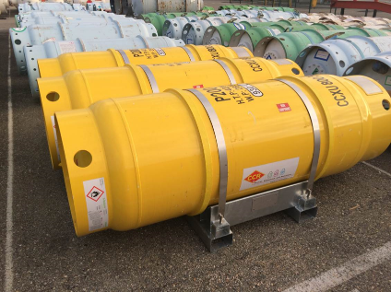
Examples of pressure drums
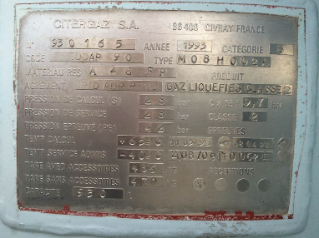
Example of a nameplate
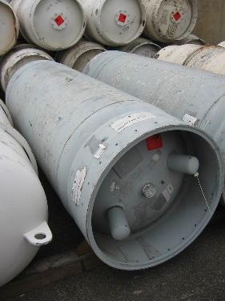
Example of location of pressure drum nameplate
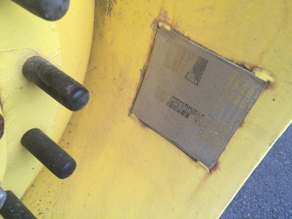
Example of location of a nameplate on the inner face of the pressure drum shroud

