UN/SCEGHS/32/INF.19
Committee of Experts on the Transport of Dangerous Goods
and on the Globally Harmonized System of Classification
and Labelling of Chemicals
Sub-Committee of Experts on the Globally Harmonized
System of Classification and Labelling of Chemicals 24 November 2016

Thirty-second session
Geneva, 7-9December 2016
Item 3 (a)of the provisional agenda
Hazard communication issues: Labelling of small packagings
Labelling of sets or kits
Transmitted by the European Chemical Industry Council (CEFIC) on behalf of the informal correspondence group
Introduction
1. At its 31st session the Sub-Committee noted that the informal correspondence group suggested some amendments to the third example addressing additional labelling issues and their possible solutions.
Development of examples for sets or kits
2. The proposed third set of examples to be presented during the 32nd session is to address the issues surrounding sets or kits.
3. The proposed examples, taking into account all recommendations of the last two meetings, are to be reviewed by the informal correspondence group on labelling of small packaging at its meeting scheduled for 8 December 2016.
Definition of sets or kits
4. A set or kit is a combination package, which includes two or more individual inner packages or single compartments with different components. Because of the variety they are divided as follows:
(a) sets or kits with removable and different number of single containers
(b) sets or kits with different numbers of single containers or individual chambers
5. Set or kits are subject to the provisions of the GHS if the combination package contains at least one hazardous substance or mixture or hazardous article.
Recommended procedure for sets or kits (combination packages)
6. The number of hazardous single components contained within the set or kit relative to the physical size of the outer package is an important first step in determining the feasibility of labelling. If possible, the label of the set or kit has to be divided into as many pieces as are necessary for enabling a labelling of each hazardous individual component. All labelling information for each hazardous substance or mixture should be displayed on the outer package.
7. The supplier information need only appear once.
8. The GHS required labelling elements should be clearly and prominently displayed on a surface that is visible under normal conditions of use, easily legible without the aid of any device other than corrective lenses and contrasted with any other information on the hazardous product or the container.
9. To ensure a clear readability and understanding of all safety-relevant information it is recommended to extend section 1.4.10.5.4.1 “Location of GHS information on the label” as follows (proposed new text is shown in bold):
“The GHS hazard pictograms, signal word and hazard statements should be located together on the label. The competent authority may choose to provide a specified layout for the presentation of these and for the presentation of precautionary statements information, or allow supplier discretion.
Example for a specific layout:
To maintain readability, especially for the outer label of combination packages (set or kit) it might, in individual cases, for example if a lot of precautionary statements are required, be necessary to locate the precautionary statements separately. They should be displayed on a surface that is visible under normal conditions of use. Redundant precautionary statements need only appear once.
Specific guidance and examples are provided in the chapters on individual hazard classes.”
10. If it is not possible to affix all appropriate labelling elements for each hazardous single component directly on the outer label (due to technical reasons such as the size and shape) additional options, always carried out with maximum care and with regard to the nature of the set or kit, can be chosen, one option might be to include fixed slip sheets.
Minimum information on the outer label
11. Possibility 1:
(a) supplier information (see 1.4.10.5.2(e))
(b) product identifier (see 1.4.10.5.2.(d)ii))
(c) pictograms of each hazardous single component, a clear allocation has to be ensured (see 1.4.10.5.3.1)
(d) signal word (see1.4.10.5.2(a))
(e) hazard statements of each hazardous single component, a clear allocation has to be ensured (see1.4.10.5.2(b))
(f) supplemental information of each hazardous single component, a clear allocation has to be ensured) (see1.4.10.5.4.2)
(g) precautionary statements of each hazardous single component, a clear allocation has to be ensured (see 1.4.10.5.2.(c); 1.4.10.5.4.1)
12. Possibility 2:
(a) supplier identification (see 1.4.10.5.2 (e))
(b) product identifier (see 1.4.10.5.2 (d) (ii))
(c) pictograms of each single hazardous component without duplication (see 1.4.10.5.3.1)
(d) signal word (see1.4.10.5.2 (a))
(e) full labelling information of each hazardous single component affixed in the inside of the combination package (see 1.4.10.5.2 (a) to1.4.10.5.2 (d) (ii))
Minimum information on the inner label
13. If single containers are designed to be taken out of the combination package, and there is no technical possibility to label them completely, then it is sufficient to use:
(a) supplier information (see 1.4.10.5.2(e))
(b) product identifier (see 1.4.10.5.2(d) (ii))
(c) hazard pictogram
(d) signal word (see1.4.10.5.2(a))
(e) “Read outer label”
14. Labelling of the single components can be omitted if it can be assured that they cannot be removed from the combination package.
Example 1 based on possibility 1
Reagent-Kit for water analysis, consisting of two different products in a small size outer package, which is used to store the immediate containers until ready for use and throughout the lifecycle of the Reagent-Kit.

Packaging description and size:
Cardboard box containing 4 glass ampoules, each ampoule filled with 3.5 ml of the same mixture, and two bottles each filled with 5 ml of another mixture.
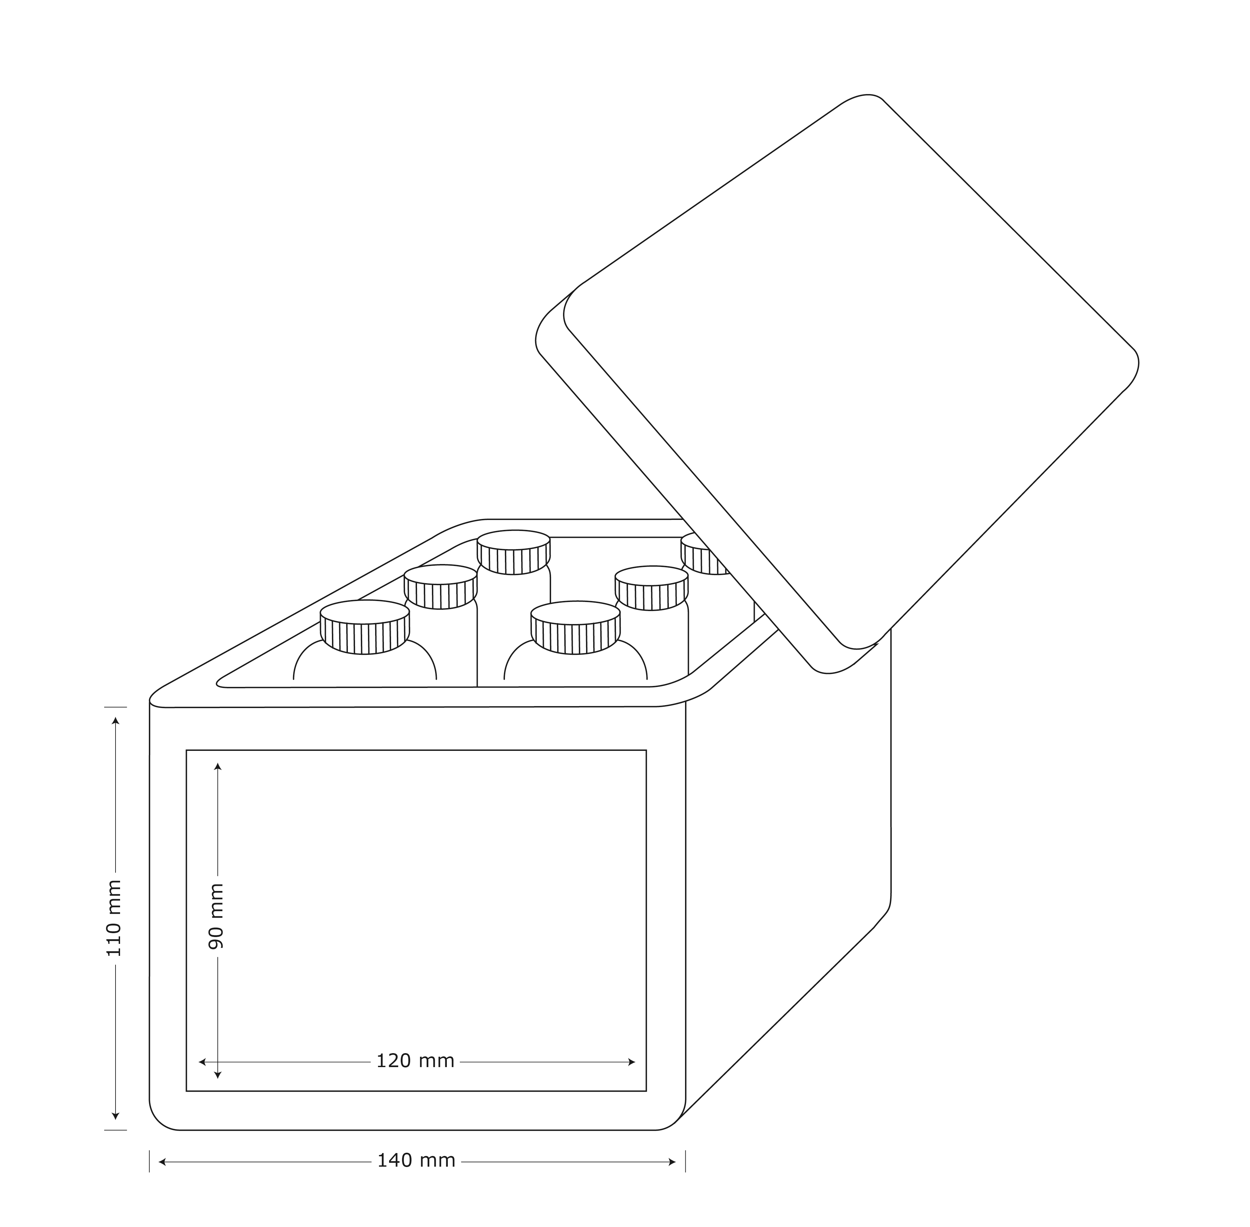

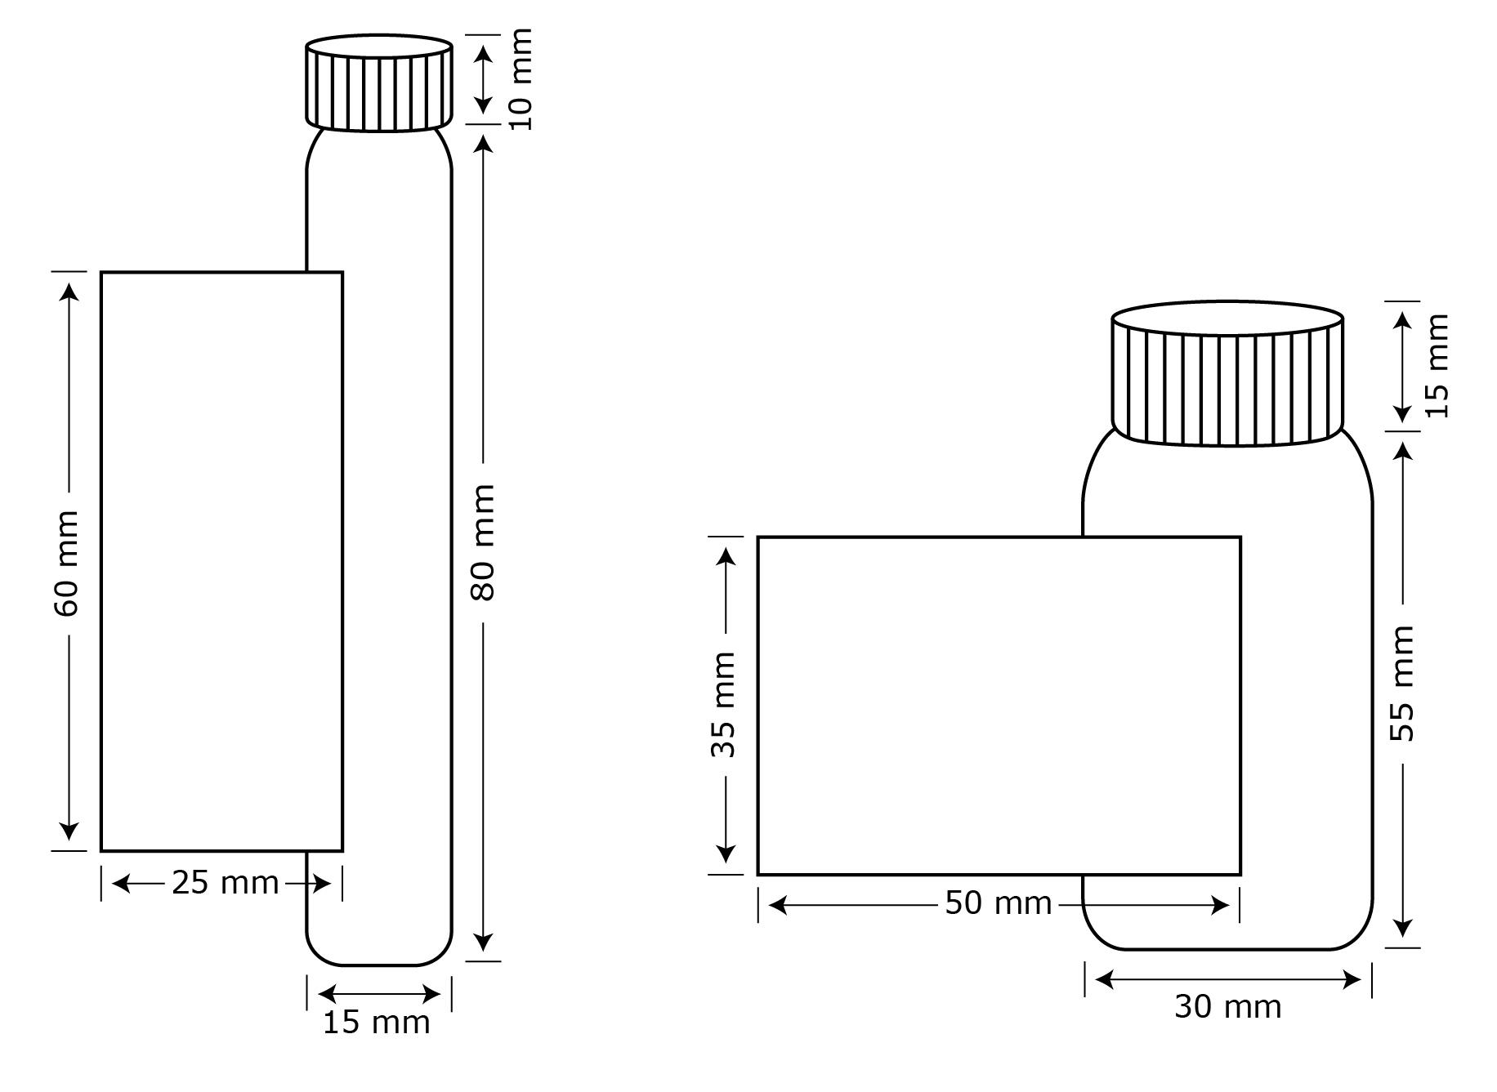
Inner kit-label
The inner packaging label contains the minimum required information:
(a) supplier information (see 1.4.10.5.2(e))
(b) product identifier (see 1.4.10.5.2(d)(ii))
(c) hazard pictogram
(d) signal word (see1.4.10.5.2(a))
(e) “Read outer label”

Reagent 2
Product ident. (see 1.4.10.5.2(d))
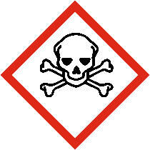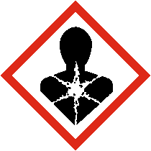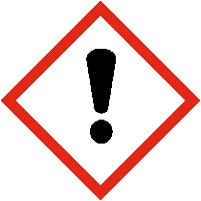
Signal word (see1.4.10.5.2(a))
Read outer label
Supplier ident. (see 1.4.10.5.2(e))
Reagent 1
Product ident.
(see 1.4.10.5.2(d))
Signal word
(see 1.4.10.5.2(a))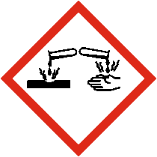

Read outer label

Supplier ident.
(see 1.4.10.5.2(e))

Outer kit label
(a) supplier information (see 1.4.10.5.2(e))
(b) product identifier (see 1.4.10.5.2(d) (ii))
(c) pictograms of each hazardous single component (see 1.4.10.5.3.1)
(d) signal word for each hazardous single component
(e) hazard statements of each hazardous single component (see 1.4.10.5.2(b))
(f) supplemental information of each hazardous single component (see 1.4.10.5.4.2)
(g) precautionary statements of each hazardous single component (see 1.4.10.5.4.1 and 1.4.10.5.2 (c))
(h) summary of all doublet precautionary statements of all hazardous single components (see 1.4.10.5.4.1 and 1.4.10.5.2 (c))

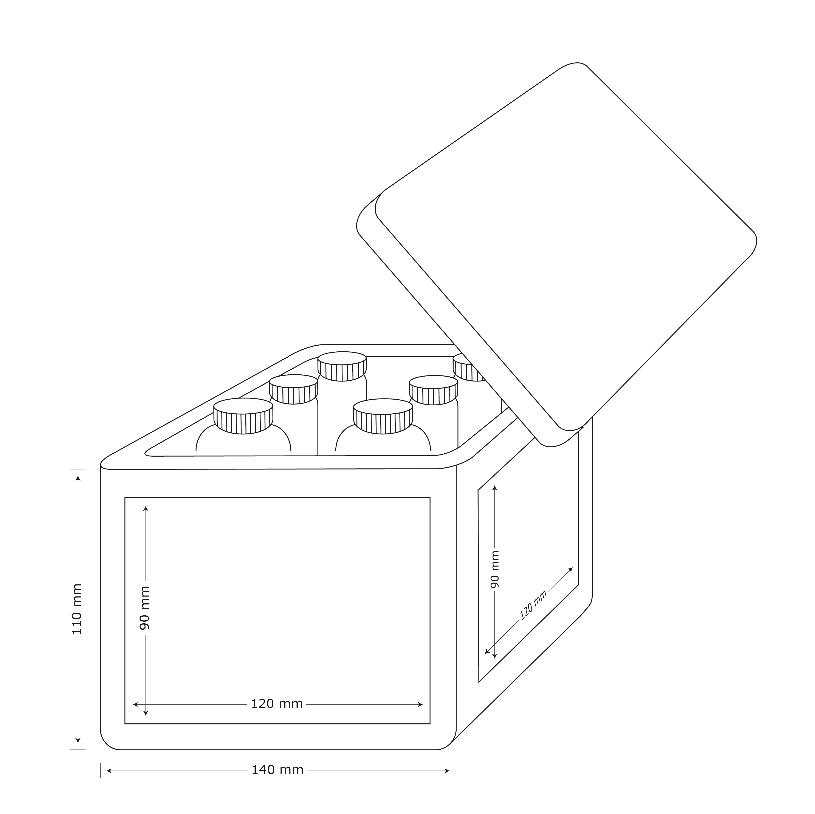

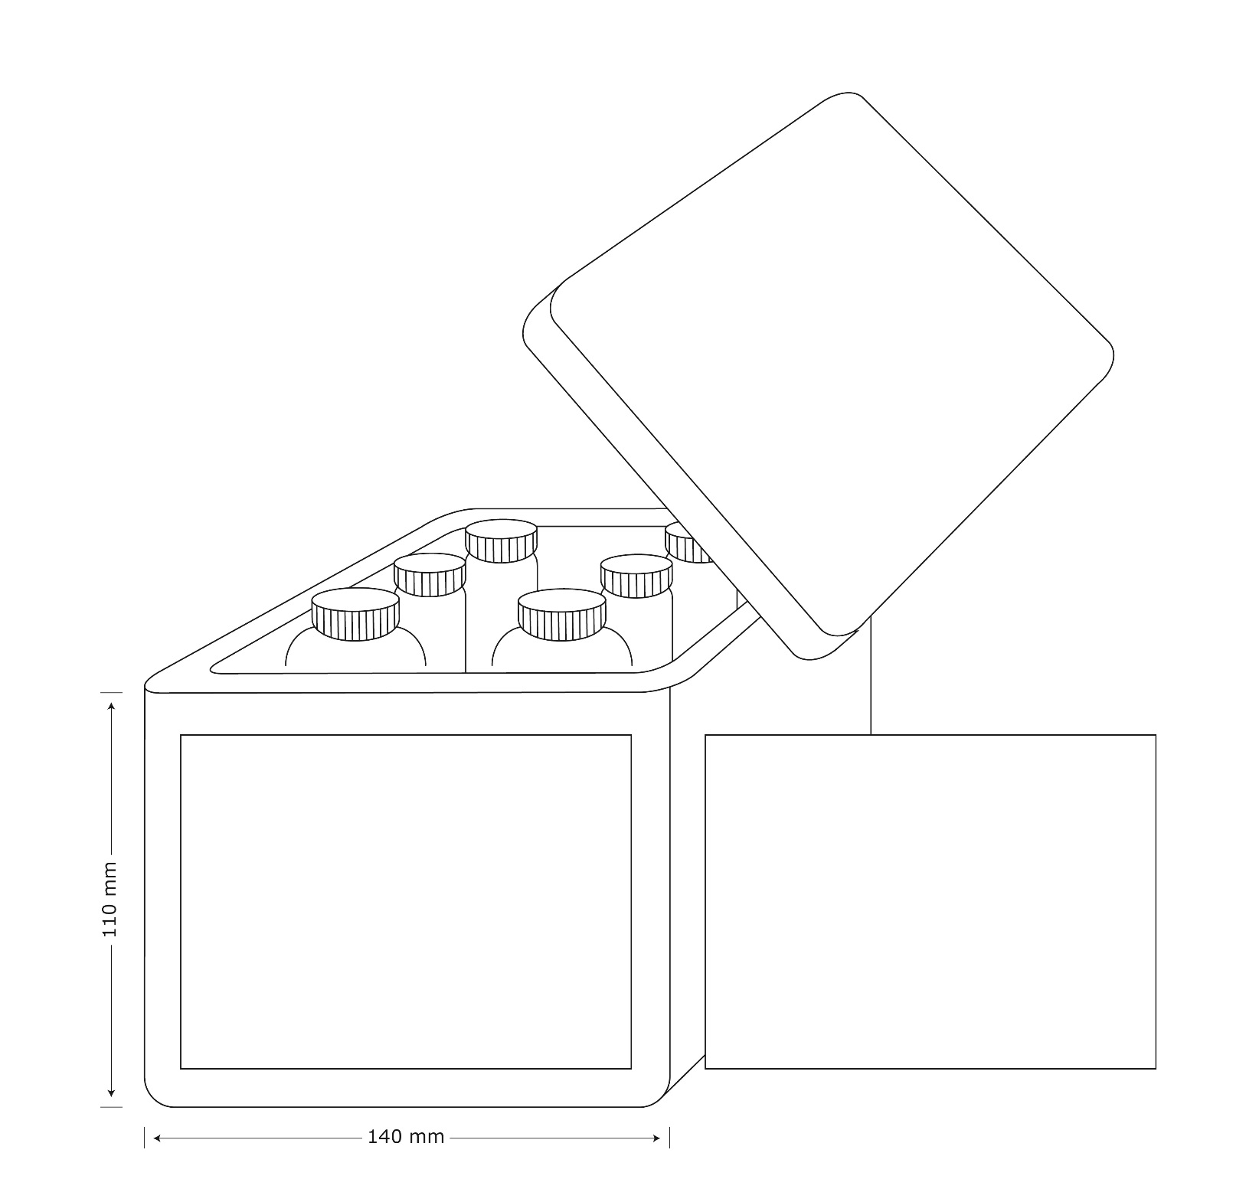
Reagent Kit for water analysis
Supplier identification(see 1.4.10.5.2(e))
Reagent 1
Signal word
(see 1.4.10.5.2(a))
Hazard statements
(see 1.4.10.5.2.(b))
Product identifier
(see 4.10.5.2(d))
Reagent 2
Signal word
(see 1.4.10.5.2(a))
Hazard statements
(see 1.4.10.5.2.(b))
Product identifier
(see 4.10.5.2(d))
Reagent 1
Precautionary statements (see 1.4.10.5.2(b))
Reagent 1+Reagent 2
Precautionary statements (see 1.4.10.5.2(b))(1.4.10.5.4.1)
Reagent 2
Precautionary statements (see 1.4.10.5.2(b))

Example 2 based on possibility 2
Sample Kit: Used for marketing purposes and consists of 156 different products in individual 10 ml bottles presented in an outer package. The inner bottles are stored in the outer package throughout the lifecycle of the Sample Kit. Customers may select individual bottles and remove them from the box to check clarity, color or odor and then replace it into the open slot within the outer box.
Packaging description and size
Each sample test kit is constructed of a plastic outer box containing 156 bottles with different mixtures. Depending upon the product mix, some or all of the 156 different materials may be considered hazardous.
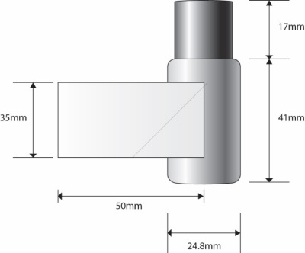 | 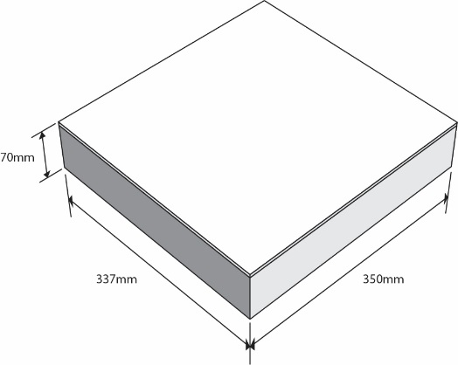
Inner packaging  (sample bottle) | Outer packaging

Inner kit-label
The inner packaging label contains the minimum required information:
(a) supplier information (see 1.4.10.5.2(e))
(b) product identifier (see 1.4.10.5.2 (d)ii)
(c) pictogram
(d) signal word (see1.4.10.5.2 (a))
(e) “Read full label information”

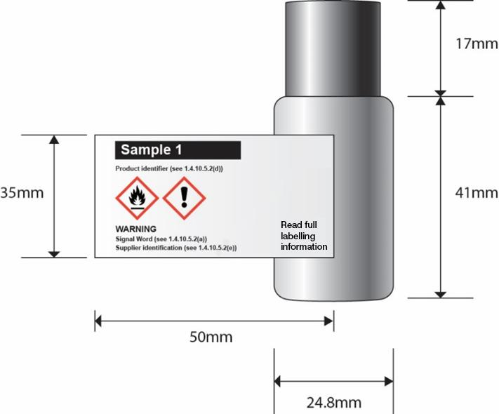

Full label information
Attached to the inside of the kit is the full GHS label information for each inner packaging. The content of the full label information is as shown below.
Product identifier  (see 1.4.10.5.2.(d)(ii) | Pictogram(s)  (see 1.4.10.4) | Signal word  (see1.4.10.5.2(a)) | Hazard statement(s)  (see1.4.10.5.2(b)) | Precautionary statement(s)  (see 1.4.10.5.2.(c)) | Supplemental information  (see 1.4.10.5.4.2)

Although each inner may not be classified as a hazardous material, and thus would not need to be identified, it may be identified as “Not classified as a hazardous material” so as to eliminate confusion on the part of the user.

As shown to the right, full label information regarding each hazardous single component is contained within the outer packaging.  The sheets of full label information are permanently connected to the inside of the combination package using a secure method of attachment  (e.g. fold out label adhered to box tie on tag as shown. | 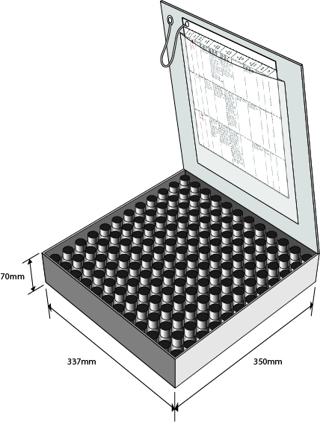

Outer kit label
The outer box, given the limited area for labelling, will display;
(a) supplier identification (see 1.4.10.5.2 (e))
(b) product identifier (see 1.4.10.5.2 (d))
(c) pictograms of each single hazardous component without duplication (see 1.4.10.4)
(d) signal word (see1.4.10.5.2 (a))
