|  |  |  |  |
| --- | --- | --- | --- |
|  | United Nations | ST/SG/AC.10/C.4/2016/8 | |
| _unlogo | **Secretariat** | | Distr.: General  18 April 2016  Original: English |

**Committee of Experts on the Transport of Dangerous Goods  
and on the Globally Harmonized System of Classification  
and Labelling of Chemicals**

**Sub-Committee of Experts on the Globally Harmonized  
System of Classification and Labelling of Chemicals**

**Thirty-first session**

Geneva, 5 – 8 July 2016

Item 4 (a) of the provisional agenda

**Hazard communication issues:   
Labelling of small packagings**

Labelling of small packagings

Transmitted by the European Chemical Industry Council (CEFIC) on behalf of the informal correspondence group[[1]](#footnote-2)

Introduction

1. At its 30th session the Sub-Committee noted that the correspondence group suggested some amendments to the proposed second example illustrating some of the general principles applicable to the labelling of small packagings (see document ST/SG/AC.10/C.4/2015/14) which had been proposed for inclusion in Annex 7 of the GHS.

Development of an example for fold-out labels

2. The amendments that were still required have been implemented in the example. The explanations have been removed, to just show the example as it should be implemented.

Proposal

3. Add a new example in annex 7 of the GHS as set out hereafter.

“Example 9: Example for fold-out label

Metal container with 100 ml capacity

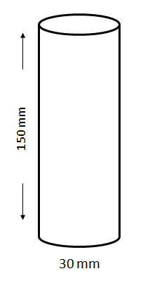

A fold-out label is securely affixed to the immediate container (i.e. the fold-out label is attached so that it remains affixed during the foreseeable conditions and period of use). The fold-out label is produced in such a way that the front part cannot be detached from the remainder of the label and the label can be closed again so it is not hanging loose.

The information is structured as follows and is provided, if applicable, in all the languages used for the label:

Front page

Information to be provided on the front page of the multilayer/fold-out label should contain at least:

GHS information:

* Product identifier[[2]](#footnote-3)\*
* Hazard pictogram(s)
* Signal word
* Supplier identification (name, address and telephone number of the company)

Additional information:

* A symbol to inform the user that the label can be opened to illustrate that additional information is available on inside pages.
* If more than one language is used on the fold-out label: the country codes or language codes

Text pages/Pages inside

GHS information:

* Product identifier including, as applicable, hazardous components contributing to the classification
* Signal word
* Hazard statements
* Precautionary statements
* Additional information (e.g. directions for use, information required by other regulations, etc.)

Additional information:

* If more than one language is used on the fold-out label: the country codes or language codes

Back page (affixed to the immediate container):

* Product identifier[[3]](#footnote-4)\*
* Hazard pictogram(s)
* Signal word
* Supplier identification (name, address and telephone number of the company)

The product identifier (if applicable) and the signal words on the front page and the back page are in all languages used on the label.

If there is enough space on the front or on the back page, these pages can also be used to display text.

The text on the inside pages (text pages) can also be distributed on more than one page, if the available space is not sufficient. In general it is better to spread the text across more than one page than to have smaller letters that make the text difficult to read. In all cases, the visibility and easy legibility of the label elements should be ensured without the aid of any device other than corrective lenses and contrasted with any other information on the hazardous product or the container.

It is recognized that some regulatory systems (e.g. pesticides) may have specific requirements for the application of labels using a multilayer or booklet style format. Where this is the case, labelling would be undertaken in accordance with the competent authority’s requirements.

The size of the fold-out label and the number of folds should be in a rational relationship to the size of the container. This may limit the number of languages, which can be displayed on the fold-out label.

Examples of formats for multilayer booklet format/fold-out labels which could be used are shown below. These include, accordion style, book style, order book style and window style labels. Any other style which meets the requirements for a fold-out label is also applicable.

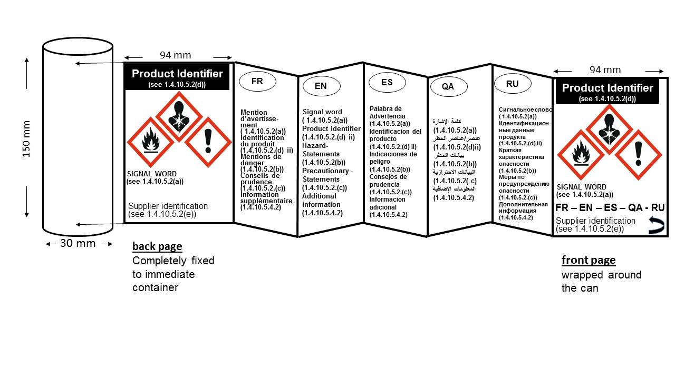 Accordion style

The following is an example of a multilingual fold-out label.

Book style

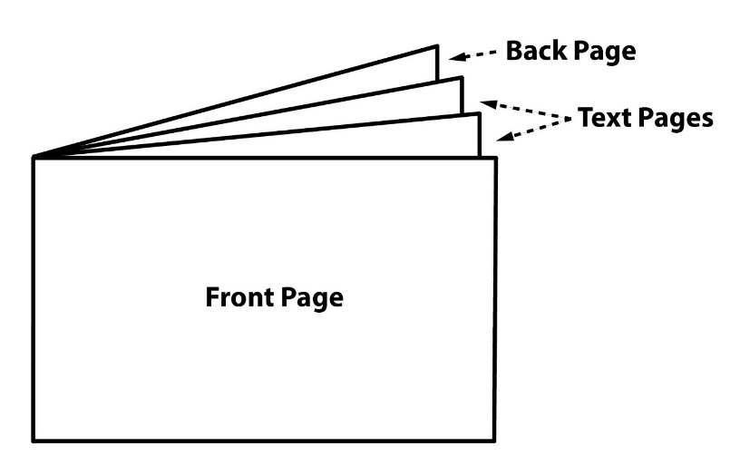

Order book style

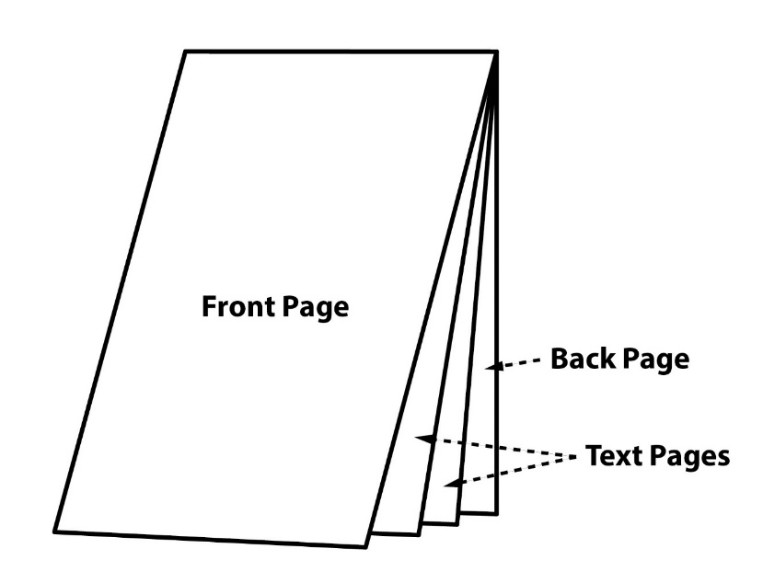

Window style

**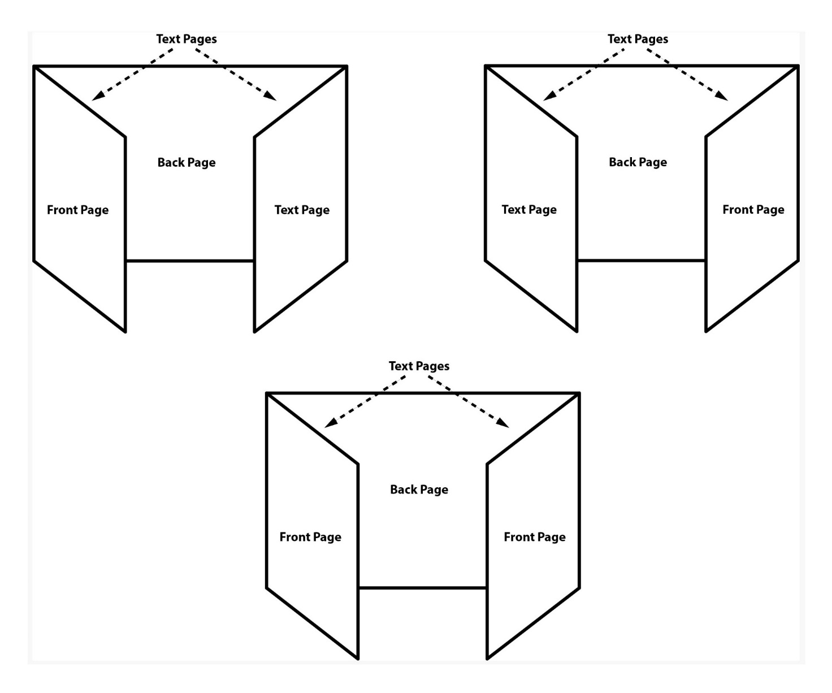”**

1. In accordance with the programme of work of the Sub-Committee for 2015–2016 approved by the Committee at its seventh session (see ST/SG/AC.10/C.4/56, annex III and ST/SG/AC.10/42, para. 15). [↑](#footnote-ref-2)
2. \* The product identifier on the front and back page does not include hazardous components. If hazardous components are required on the label they are displayed in the appropriate languages on the text pages. [↑](#footnote-ref-3)
3. \* The product identifier on the front and back page does not include hazardous components. If hazardous components are required on the label they are displayed in the appropriate languages on the text pages. [↑](#footnote-ref-4)