|  |  |  |  |
| --- | --- | --- | --- |
|  | United Nations | ECE/TRANS/WP.29/GRE/2015/4 | |
| Description: _unlogo | **Economic and Social Council** | | Distr.: General  23 January 2015  Original: English |

**Economic Commission for Europe**

Inland Transport Committee

**World Forum for Harmonization of Vehicle Regulations**

**Working Party on Lighting and Light-Signalling**

**Seventy-third session**

Geneva, 14 – 17 April 2015

Item 6 (a) of the provisional agenda  
**Regulation No. 48 (Installation of lighting and light-signalling devices) –**

**Proposal for amendments to the 05 and 06 series of amendments**

**Proposal for Supplement 9 to the 05 series of amendments and Supplement 7 to the 06 series of amendments to Regulation No. 48 (Installation of lighting and light-signalling devices)**

**Submitted by the expert from the International Automotive Lighting and Light Signalling Expert Group (GTB)**[[1]](#footnote-2)\*

The text reproduced below was prepared by the expert from the GTB to introduce variable daytime running lamps into the Regulations. The modifications to the existing text of the Regulation are marked in bold for new or strikethrough for deleted characters.

**I.** **Proposal**

*Paragraph 5.11.1.3.*, amend to read:

“5.11.1.3. When a light-signalling system operates according to 6.2.7.6.2. **or 6.19.7.6.1. or 6.19.7.6.2.”**

*Paragraph 5.26.*, amend to read:

5.26. ~~Rear direction-indicator lamps, rear position lamps, stop lamps (except stop lamps of category S4) and rear fog l~~ **L**amps with variable luminous intensity control **listed in paragraphs 5.26.1., 5.26.2., and 5.26.3. below** are allowed, which respond simultaneously to at least one of the following external influences: ambient lighting, fog, snowfall, rain, spray, dust clouds, contamination of the light emitting surface ~~provided that their prescribed intensity relationship is maintained throughout variation transitions~~.

No sharp variation of intensity shall be observed during transition.

~~Stop lamps of category S4 may produce variable luminous intensity independent from the other lamps.~~

It may be possible for the driver to set the **lamps below** ~~functions above~~ to luminous intensities corresponding to their steady category and to return them to their automatic variable category.

**5.26.1. Rear direction indicator lamps (category 2b), rear position lamps (category R2), stop lamps (category S2) and rear fog lamps (category F2) may ~~vary~~ produce variable luminous intensity, provided that their prescribed intensity relationship is maintained throughout variation transitions.**

**5.26.2. Stop lamps of category S4 may produce variable luminous intensity independent from the lamps in 5.26.1. and 5.26.3.**

**5.26.3. Daytime running lamps of category RLV may produce variable luminous intensity independent from the lamps in 5.26.1. and 5.26.2.**

*Paragraph 6.19.7.4.,* amend to read:

6.19.7.4. The lamps referred to in paragraph 5.11. may be ~~switched ON when~~ **activated in conjunction with** the daytime running lamps **of category RL** ~~are switched ON~~, except if daytime running lamps are operating according to Paragraph 6.2.7.6.2., where at least the rear position lamps shall be activated.

Insert new *paragraphs 6.19.7.5. to 6.19.7.6.* to read:

“**6.19.7.5. The different levels of daytime running lamps of category RLV are operated automatically relative to the ambient lighting according to the requirements of Annex 13.**

**6.19.7.6. When daytime running lamps of category RLV are present, the lamps referred to in paragraph 5.11. or at least the rear position lamps**

**6.19.7.6.1. may be activated in conjunction with the daytime running lamps when intermediate levels of intensity of the daytime running lamps are activated or adverse weather conditions, e.g. rain or fog are detected, and**

**6.19.7.6.2. shall be activated when the ambient lighting, according to the conditions described in Annex 13, is less than 1,000 lux.**”

Former *paragraph 6.19.7.5.* renumber as *6.19.7.****7****.*

Former *paragraph 6.19.7.6.* renumber as *6.19.7.****8****.*

*Annex 13,* amend to read:

**“Annex 13**

**Operating conditions for daytime-running lamps and automatic switching conditions for dipped-beam headlamps**

|  |  |  |  |
| --- | --- | --- | --- |
| **OPERATING CONDITIONS FOR DAYTIME-RUNNING LAMPS AND AUTOMATIC SWITCHING CONDITIONS FOR DIPPED-BEAM HEADLAMPS1/** | | | |
| **Ambient light outside the vehicle 2/** | **Dipped beam in combination with daytime running lamps of category RL** | **Dipped beam in combination with daytime running lamps of category RLV** | **Dipped Beam Response time** |
| **less than 500 lux** | **Dipped beam ON** | **Dipped beam ON** | **no more than 2 seconds** |
| **between 500 lux and 1,000 lux** | **Dipped beam ON** | **Dipped beam or daytime running lamps (low level) ON 3/** | **at manufacturer’s discretion** |
| **between 1,000 lux and 7,000 lux** | **Dipped beam or daytime running lamp ON** | **Dipped beam or daytime running lamps ON(intermediate levels)** | **at manufacturer’s discretion** |
| **more than 7,000 lux** | **Dipped beam OFF**  **Daytime running lamp ON** | **Dipped beam OFF**  **Daytime running lamps (intermediate/high level) 4/** | **more than 5 seconds, but no more than 300 seconds** |

1/ Compliance with these conditions shall be demonstrated by the applicant, by simulation or other means of verification accepted by the Type Approval Authority.

2/ The illuminance shall be measured on a horizontal surface, with a cosine corrected sensor on the same height as the mounting position of the sensor on the vehicle. This may be demonstrated by the manufacturer by sufficient documentation or by other means accepted by the Type Approval Authority.

**3/ See also paragraph 6.19.7.6.2.**

**4/ At the discretion of the vehicle manufacturer.”**

II. Justification

1. This proposal is submitted in association with a proposal to amend Regulation No. 87 that introduces Variable Intensity Daytime Running Lamps (DRL).

2. The current provisions for DRLs are based upon one level of performance between 400 – 1,200 cd for all ambient conditions. However, it has been shown that under certain ambient light conditions this fixed level can either be too bright (at dusk) or too dim (at southern latitudes on bright sunny days).

3. An optional category of DRL is proposed that permits variation according to the ambient light levels. The variable intensity level commences at 200 cd to avoid any glare annoyance in dusk and dawn traffic conditions and also prevent giving the impression to the driver that they are already driving with the normal head lighting ON, as can presently occur due to some visible illumination of the road surface or by reflections on the preceding car.

4. The new limit of 2,000 cd is higher than the current maximum of 1,200 cd but, according to the proposed amendment, this higher limit cannot occur in dim ambient conditions because it is controlled by switching requirements to be introduced by the associated proposal to Regulation No. 48. (For reference, the United States of America and Canada allows much higher maximum values for the intensities (3,800 to 7,000 cd) of devices used for DRL purposes).

5. The main changes introduced by this amendment concern:

1. Paragraph 5.11., adding the reference to new paragraphs 6.19.7.6. and 6.19.7.7., both giving derogation to normally prescribed electrical connections for positions lamps, as already present for paragraph 6.2.6.7.2., to avoid any misinterpretation.
2. Paragraph 5.26., rearranged with subparagraphs for better understanding and readability.
3. Paragraphs 6.19.7.4., to 6.19.7.7., aligning the terminology of the paragraphs to each other and with paragraph 5.26. The whole text is also simplified.
4. Annex 13, re-written to differentiate between daytime running lamps of category RL and RLV as illustrated below.

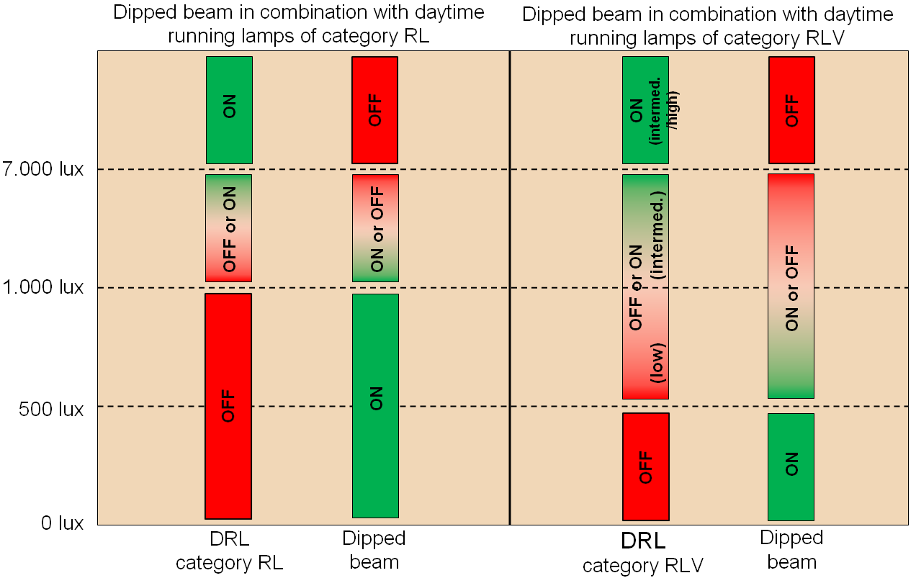

1. \* In accordance with the programme of work of the Inland Transport Committee for 2012–2016 (ECE/TRANS/224, para. 94 and ECE/TRANS/2012/12, programme activity 02.4), the World Forum will develop, harmonize and update Regulations in order to enhance the performance of vehicles. The present document is submitted in conformity with that mandate. [↑](#footnote-ref-2)