Transmitted by the expert from The International Automotive Lighting and Light Signalling Expert Group (GTB) | Informal document GRE-70-25  (70th GRE, 21-23 October 2013,  agenda item 10

Proposal for Correction to ECE/TRANS/WP.29/GRE/2013/49
The text reproduced below was prepared by the expert from The International Automotive Lighting and Light Signalling Expert Group (GTB) to correct editorial mistakes that have been identified since the submission of the formal document. The corrections to the text of the original proposal are identified by comments in the right-hand column.
I. Proposal
Insert a new paragraph 2.10., to read:
"2.10. Fluorescent retro-reflecting material
Means a material with retro-reflecting properties which, when excited by daylight, exhibits the phenomenon of photo-luminescence ceasing rather shortly after excitation."
Annex 3, figure 1., amend to read:
"Figure 1
Shape and dimensions of the advance-warning triangle of type 1 and of the support
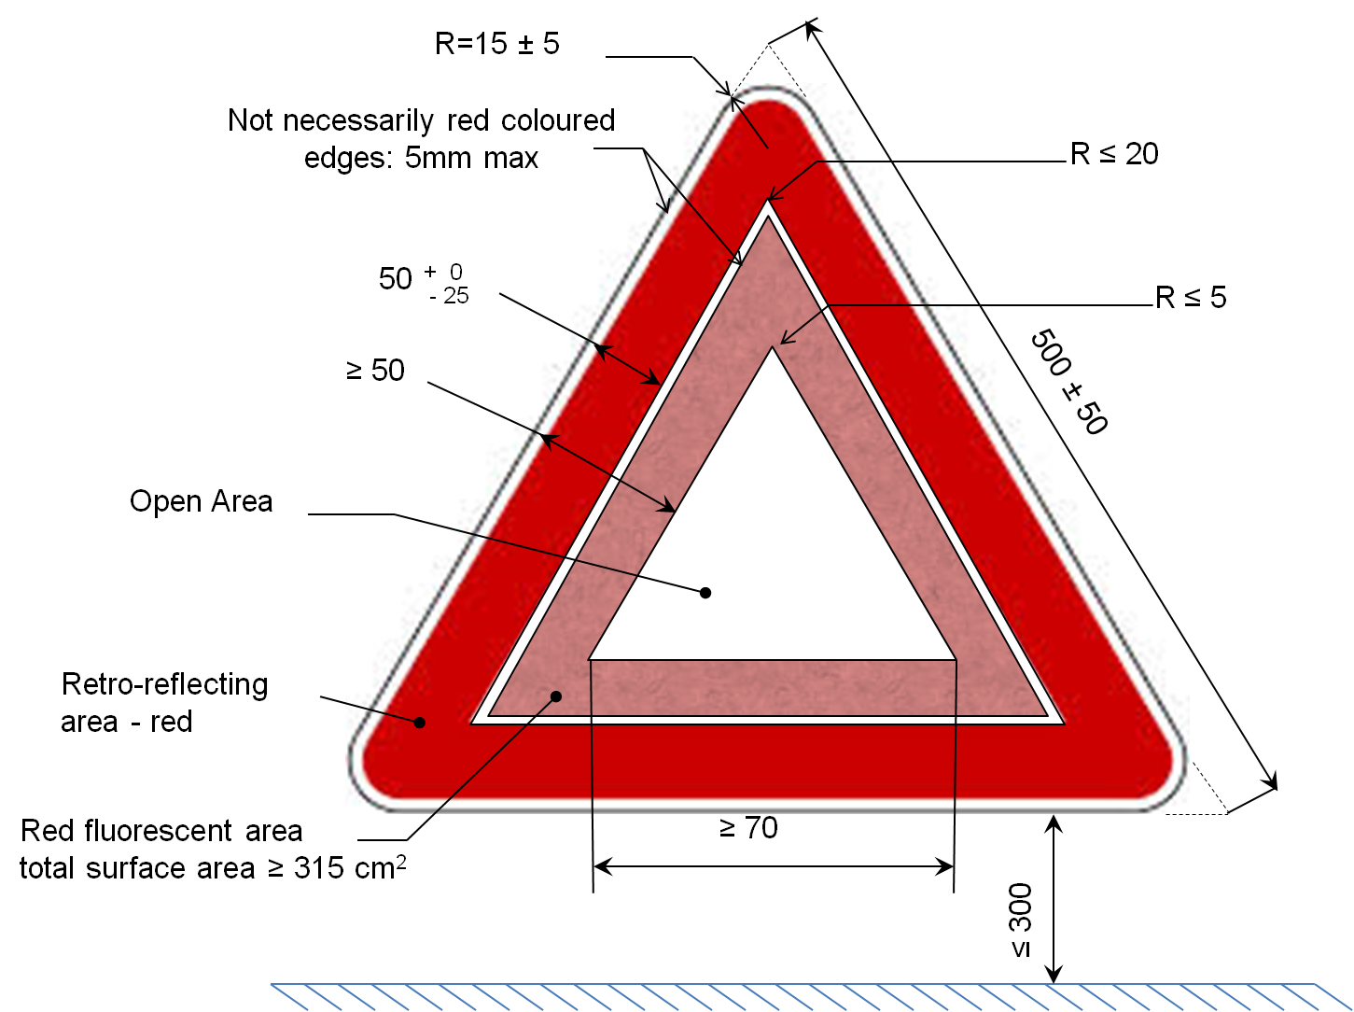

Annex 3, Insert a new Figure 2., to read
"Figure 2
Shape and dimensions of the advance-warning triangle of type 2 and of the support




