 | United Nations | ECE/TRANS/WP.15/AC.1/2012/10
 | Economic and Social Council |  | Distr.: General  4 January 2012  Original: English
Economic Commission for Europe
Inland Transport Committee
Working Party on the Transport of Dangerous Goods
Joint Meeting of the RID Committee of Experts and the
Working Party on the Transport of Dangerous Goods
Bern, 19-23 March 2012
Item 2 of the provisional agenda
Tanks
Limitation of volumes of fixed tanks (tank-vehicles) and tank-wagons,
Transmitted by the Government of Sweden
Summary
Executive summary: The aim of this proposal is to limit the compartment capacity of fixed tanks (tank-vehicles) and tank-wagons in order to reduce the consequences and effects of accidents.
Action to be taken: Add a new section 6.8.2.1.xx
Related documents: Informal document INF.5 of the September 2009 session of the Joint Meeting (Sweden) and ECE/TRANS/WP.15/AC.1/116/Add.2, paras. 24-25 (Report of the Working Group of Tanks, September 2009 session).
Background
1. In November 2005 a tank-vehicle was involved in a severe accident in Sweden. After a collision with some passenger cars the tank-vehicle overturned and ended up hanging between two bridges (the photos are selected from the report RO 2008:03, published by the Swedish Accident Investigation Board, photographer: Leif Hylander).
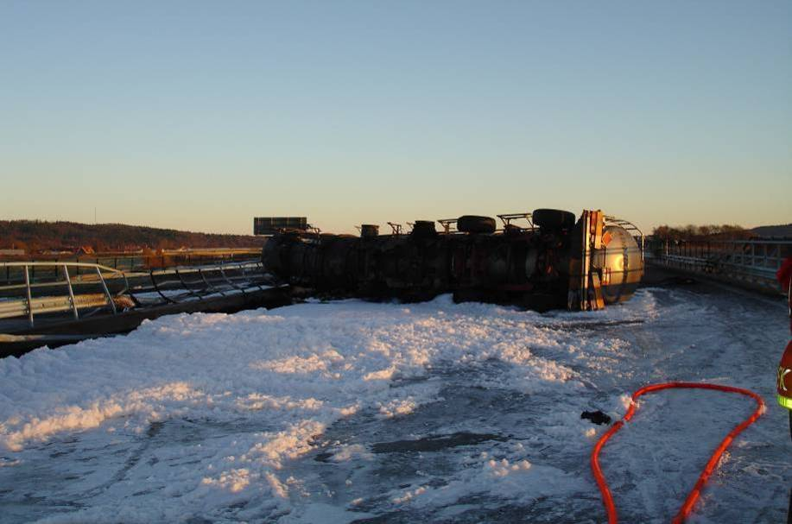


Hytt
The driver’s cab

2. The tank shell was punctured at several places when crashing into the bridges, see picture below. The tank was loaded with 42 600 kg flammable liquid of class 3 in one single tank compartment and within only 15 minutes the entire content had poured out fuelling the fire that had started in the initial phase of the accident. The maximum capacity of this specific tank vehicle was 56 600 litres contained in one single compartment.

3. This very severe accident led to the tragic death of the driver of the tank-vehicle. In addition, the two bridges were destroyed due to the very extensive and intensive fire. Furthermore, a considerable damage to the environment was caused by the amount of liquid that poured out of the tank.
4. The Swedish Accident Investigation Board investigated the accident and recommended a number of actions to be taken by the competent authority. One being to evaluate if tanks used for carriage of dangerous goods should be divided into smaller compartments in order to reduce the possible consequences of accidents such as the above mentioned.
Introduction
5. One of the reasons why the accident resulted in very severe consequences was the fact that the tank content fuelled and intensified the fire that had started. If the tank had been divided into smaller compartments and thus not been able to fuel the fire in the same extent, the consequences could have been less severe. Sweden therefore believes it is of great importance to limit the maximum capacity permitted for a single tank compartment. We are aware of the fact that Sweden allows longer vehicle combinations than in most other ADR countries, however, the risks with unlimited tank volumes applies to all tanks.
6. With the background described above kept in mind, Sweden submitted a document to the Joint Meeting in September 2009 (see informal document INF.5 submitted at that session) to discuss the possibility to require future limitation of tank volumes. The document was discussed in the Working Group of Tanks and the outcome was the following (see: ECE/TRANS/WP.15/AC.1/116/Add.2 para. 25):
"The outcome of the discussion was that in the working group’s opinion, limiting the capacity of the compartment for certain tanks should be supported in principle, but some aspects should be considered:
- for higher quality tanks (definition still to be drafted) and double wall tanks with vacuum insulation, the capacity need not be limited;
- for gas tanks, classification would be difficult because of the different types of construction;
- tanks with several compartments have more openings with more pieces of equipment; for this reason, it would not lead to an improvement in safety in the event of an accident;
- for unpressurised tanks made of aluminium alloys, some countries have volume limitations (7 500 to 7 600 litres);
- it would be difficult to include portable tanks;
- in some cases, a risk assessment would be recommended.".
7. Sweden has considered the outcome of the Working Group of Tanks and has also taken the following conditions into account:
- Approximately 80 % of all dangerous goods carried on Swedish roads and railways consist of flammable liquids of Class 3. However, Sweden believes the limitation requirements should apply to tanks intended for all carriages of liquids, irrespective of classification.
- The proposed limitation should not apply to tank-containers because they are considered to be protected by the frame. Tank-containers do not usually have a capacity of such large volumes.
8. Due to the large costs related to rebuilding existing tanks and the fact that the tank manufacturing process usually takes a long time, Sweden also proposes new transitional measures.
Proposal
9. Under "Other construction requirements", introduce a new paragraph 6.8.2.1.xx in RID/ADR to read:
“6.8.2.1.xx (left column only) Fixed tanks (tank-vehicles) / Tank-wagons intended for carriage of liquids shall be divided into leakproof compartments of not more than 15 000 litres capacity.
However, the capacity needs not to be limited for:
- Tanks having a calculation pressure of 4 bars or more,
- Tanks with double walls, and
- Vacuum isolated tanks.".
10. Introduce transitional measures in 1.6.3.xx in RID/ADR to read:
"1.6.3.xx Fixed tanks (tank-vehicles) / Tank-wagons constructed before 1 January 2016, which do not conform to the requirements of 6.8.2.1.xx in force from 1 January 2015, may still be used unless restricted by specific transitional measures.".
Justification
11. The proposal reduces the consequences of such accidents described in the document.

? In accordance with the programme of work of the Inland Transport Committee for 2010-2014 (ECE/TRANS/208, para.106, ECE/TRANS/2010/8, programme activity 02.7(c)).
? Circulated by the Intergovernmental Organisation for International Carriage by Rail (OTIF) under the symbol OTIF/RID/RC/2012/10.

