Submitted by the expert from Canada | Informal document No. GRE-66-13  (66th GRE, 4-6 October 2011  agenda item 6)

Regulation No. 87

UNIFORM PROVISIONS CONCERNING THE APPROVAL OF DAYTIME RUNNING LAMPS FOR POWER-DRIVEN VEHICLES

CONTENTS

Page
1. Scope 5
2. Definitions 5
3. Application for approval 5
4. Markings 6
5. Approval 7
6. Specifications 10
Intensity of light 11
Illuminating surface 11
Colour of light emitted 11
7. Test procedures 11
Heat resistance test 12
8. Modifications of a type of daytime running lamp
and extension of approval 13
9. Conformity of production 13
10. Penalties for non-conformity of production 14
11. Production definitely discontinued 14
12. Names and addresses of Technical Services
responsible for conducting approval tests,
and of Administrative Departments 14

CONTENTS (continued)

ANNEXES

Annex 1 - Communication concerning the approval or refusal or extension or withdrawal of approval or production definitely discontinued of a type of daytime running lamp, pursuant to Regulation No. 87

Annex 2: - Example of arrangement of the approval mark

Annex 3: - Photometric measurements

Annex 4: - Colour of light – Trichromatic coordinates

Annex 4 - Minimum requirements for conformity of production control procedures

Annex 5 - Minimum requirements for sampling by an inspector

Annex 6 - Minimum angles required for light distribution in space

1. SCOPE

This Regulation applies to daytime running lamps for vehicles of category L, M, N and T /.

2. DEFINITIONS

For the purpose of this Regulation:

2.1. "Daytime running lamp" means a lamp facing in a forward direction used to make the vehicle more easily visible when driving during daytime;

2.2. The definitions given in Regulation No. 48 and its series of amendments in force at the time of application for type approval and definitions given in the Horizontal Reference Document (HRD) shall apply to this Regulation;

3. APPLICATION FOR APPROVAL

3.1. The applicant shall follow instructions stated in paragraph 3. of the HRD.

3.2. The drawings required by paragraph 3.2.1. of the HRD shall also identify the illuminating surface of the device.

4. MARKINGS

4.1. The applicant shall follow instructions stated in paragraph 4. of the HRD.

5. APPROVAL

5.1. General

The applicant shall follow instructions stated in paragraph 5.1. of the HRD.

5.2. Composition of the approval mark

5.2.1. The applicant shall follow instructions stated in paragraph 5.2. of the HRD.

5.2.2. The approval mark has also include letters "RL", identifying the device as daytime running lamp.

5.3. Arrangement of the approval mark

5.3.1. Independent lamps

5.3.1.1. Follow instructions in paragraph 5.3.1. of the HDR.

[5.3.1.2. Annex 2, Figure 1, to this Regulation gives an example of arrangement of the approval mark with the above-mentioned additional symbols.]

5.3.2. Grouped, combined or reciprocally incorporated lamps

5.3.2.1. Follow instructions of paragraph 5.3.2. of the HDR.

[5.3.2.2. Annex 2, Figure 2, to this Regulation gives examples specific to this regulation of arrangements of approval marks for grouped, combined or reciprocally incorporated lamps with all the above-mentioned additional symbols.]

5.3.3. Lamps reciprocally incorporated with other lamps, of which the lens may also be used for other types of devices

5.3.3.1. Follow instructions in paragraph 5.3.3 of the HDR.

[5.3.3.2. Annex 2, Figure 3, to this Regulation gives examples of arrangements of approval marks relating to the above case.]

6. GENERAL SPECIFICATIONS
Follow instructions in paragraph 6. of the HRD.
7. INTENSITY OF LIGHT

7.1. The luminous intensity of the light emitted by each lamp shall not be less than 400 cd in the axis of reference.

7.2. Outside the reference axis and within the angular fields defined in the arrangement diagram in Annex 7 to this Regulation, the intensity of the light emitted by each lamp must:

7.2.1. In each direction corresponding to the points in the table of standard light distribution reproduced in Annex 3 to this Regulation, be not less than the minimum specified in paragraph 7.1. above, multiplied by the percentage specified in the said table of the direction in question, and

7.2.2. not exceed 1,200 cd in any direction the lamp is visible.

7.3. Moreover, throughout the field defined in the diagram in Annex 7, the intensity of the light emitted must not be less than 1.0 cd.

7.4. In the case of a lamp containing more than one light source the lamp shall comply with the minimum intensity required when any one light source has failed and when all light sources are illuminated the maximum intensity shall not be exceeded.

A group of light sources, wired so that the failure of any one of them causes all of them to stop emitting light, shall be considered to be one light source.

8. APPARENT SURFACE

The area of the apparent surface in the direction of the axis of reference of the lamp shall be not less than 25 cm² and not more than 200 cm².

9. COLOUR OF LIGHT
9.1. Follow instructions in paragraph 6. of the HRD.
9.2. The colour must be white.

10. TEST PROCEDURE

Follow instructions in paragraph 7. of the HRD.

11. HEAT RESISTANCE TEST

Follow instructions in paragraph 8. of the HRD.

12. MODIFICATIONS OF A TYPE OF DAYTIME RUNNING LAMP AND EXTENSION OF APPROVAL

Follow instructions in paragraph 9. of the HRD.

13. CONFORMITY OF PRODUCTION

Devices approved in accordance with this Regulation and the referred HDR shall be so manufactured as to conform to the type approved and to meet the requirements set forth by this Regulation and the Horizontal Reference Document.

14. PENALTIES FOR NON-CONFORMITY OF PRODUCTION

See paragraph 11. of the HDR.

15. PRODUCTION DEFINITELY DISCONTINUED

See paragraph 12. of the HDR.

16. NAMES AND ADDRESSES OF TECHNICAL SERVICES RESPONSIBLE FOR CONDUCTING APPROVAL TESTS AND OF ADMINISTRATIVE DEPARTMENTS

Follow instructions in paragraph 13. of the HRD.

Annex 1

COMMUNICATION

(Maximum format: A4 (210 x 297 mm))

issued by : Name of administration:
......................................
......................................
......................................


concerning: 2/ APPROVAL GRANTED
APPROVAL EXTENDED
APPROVAL REFUSED
APPROVAL WITHDRAWN
PRODUCTION DEFINITELY DISCONTINUED

of a type of daytime running lamp pursuant to Regulation No. 87

Approval No. Extension No.

1. Trade name or mark of the device:

2. Manufacturer’s name for the type of device:.

3. Manufacturer’s name and address:

- If applicable, name and address of the manufacturer’s representative:

- Submitted for approval on:

- Technical Service responsible for conducting approval tests:

- Date of test report issued by that service:

- Number of test report issued by that service:

9. Concise description:
By category of lamp:
Number, category and kind of light source(s): 3/
Voltage and wattage:

Application of an electronic light source control gear:
(a) being part of the lamp yes/no 2/
(b) being not part of the lamp yes/no 2/

Input voltage supplied by an electronic light source control gear:

Electronic light source control gear manufacturer and identification number (when the light source control gear is part of the lamp but is not included into the lamp body):

10. Position of the approval mark:

11. Reason (s) for extension (if applicable):

12. Approval granted/refused/extended/withdrawn: 2/

13. Place:

14. Date:

15. Signature:

- The following documents, bearing the approval number shown above, are available on request:

_______________________
1/ Distinguishing number of the country which has granted/extended/refused/withdrawn approval (see approval provisions in the Regulation).
2/ Strike out what does not apply.
3/ For daytime running lamps with non-replaceable light sources indicate the number and total wattage of the light sources used.

Annex 2

EXAMPLE OF ARRANGEMENT OF THE APPROVAL MARK

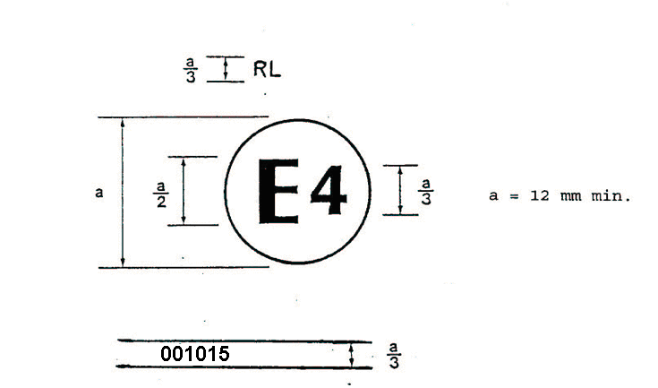

Figure 1

The daytime running lamp bearing the approval mark shown above has been approved in the Netherlands (E4) under number 001015. The approval number indicates that the approval was granted according to the requirements of this Regulation in its original (unamended) form.

Note: The approval number and the additional symbol must be placed close to the circle and either above or below the "E" or to the left or right of that letter. The digits of the approval number must be on the same side of the "E" and face the same direction. The use of roman numerals as approval numbers should be avoided so as to prevent any confusion with other symbols.

Examples of possible markings for grouped lamps situated at the front of the vehicle

Figure2

The vertical and horizontal lines schematize the shape of the lighting device. These are not part of the approval mark.

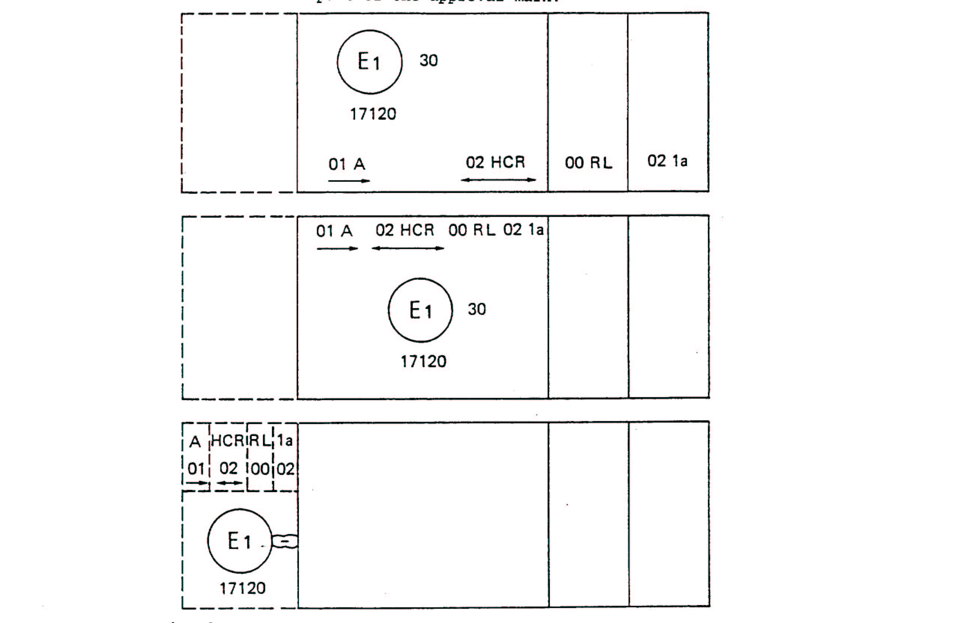

Note: The three examples shown above correspond to a lighting device bearing an approval mark relating to:
A front position lamp approved in accordance with the 01 series of amendments to Regulation No. 7;
A headlamp with a passing beam designed for right-hand and left-hand traffic and a driving beam with a maximum intensity comprised between 86,250 and 101,250 candelas, approved in accordance with the 02 series of amendments to Regulation No. 8;
A daytime running lamp approved in accordance with Regulation No. 87 in its original form;
A front direction indicator lamp of category la approved in accordance with the 02 series of amendments to Regulation No. 6.
Lamp reciprocally incorporated with a headlamp

Figure 3

The above example corresponds to the marking of a lens intended to be used in different types of headlamps, namely:
either: a headlamp with a passing beam designed for right-hand and left-hand traffic and a driving beam with a maximum intensity comprised between 86,250 and 101,250 candelas, approved in Germany (E1) in accordance with the requirements of Regulation No. 8 as amended by the 02 series of amendments,
which is reciprocally incorporated with
a daytime running lamp approved in accordance with Regulation No. 87 in its original form;
or: a headlamp with a passing beam designed for right-hand and left-hand traffic and a driving beam, approved in Germany (E1) in accordance with the requirements of Regulation No. 1 as amended by 01 series of amendments,
which is reciprocally incorporated with
the same daytime running lamp as above;
or even: either of the above-mentioned headlamps approved as a single lamp.
The main body of the headlamp shall bear the only valid approval number, for instance:

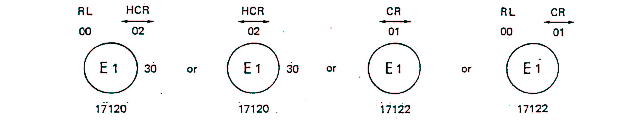

Annex 3

PHOTOMETRIC MEASUREMENTS

1. When photometric measurements are taken, stray reflections shall be avoided by appropriate masking.

2. In the event that the results of measurements are challenged, measurements shall be taken in such way as to meet the following requirements:

2.1. the distance of measurement shall be such that the law of the inverse of the square of the distance is applicable:

2.2. the measuring equipment shall be such that the angle subtended by the receiver from the reference centre of the light is between 10' and 1°:

2.3. the intensity requirement for a particular direction of observation shall be satisfied if the required intensity is obtained in a direction deviating by not more than one-quarter of a degree from the direction of observation.

3. In the case where the daytime running lamp may be installed on the vehicle in more than one or in a field of different positions the photometric measurements shall be repeated for each position or for the extreme positions in the field of the reference axis specified by the manufacturer.

4. Photometric measurement of lamps

The photometric performance shall be checked:

  - For non-replaceable light sources (filament lamps or other):

with the light sources present in the lamp, in accordance with paragraph 10. of this Regulation.

  - For replaceable filament lamps:

when equipped with filament lamps at 6.75 V, 13.5 V or 28.0 V the luminous intensity values produced shall be corrected. The correction factor is the ratio between the reference luminous flux and the mean value of the luminous flux found at the voltage applied (6.75 V, 13.5 V or 28.0 V). The actual luminous fluxes of each filament lamp used shall not deviate more than ± 5 per cent from the mean value. Alternatively a standard filament lamp may be used in turn, in each of the individual positions, operated at its reference flux, the individual measurements in each position being added together.
4.3. For any daytime running lamp except those equipped with filament lamp(s), the luminous intensities, measured after one minute and after 30 minutes of operation, shall comply with the minimum and maximum requirements. The luminous intensity distribution after one minute of operation can be calculated from the luminous intensity distribution after 30 minutes of operation by applying at each test point the ratio of luminous intensities measured at HV after one minute and after 30 minutes of operation.

5. Table of standard light distribution
H
20
20
20
20
20
20
20
25
25
70
70
70
70
100
10
10
10
10
90
90
H
V
V
5°
10°
20°
5°
10°
20°
5°
5°
10°

5.1. The direction H = 0° and V = 0° corresponds to the reference axis. (On the vehicle, it is horizontal, parallel to the median longitudinal plane of the vehicle and oriented in the required direction of visibility). It passes through the centre of reference. The values shown in the table give, for the various directions of measurement, the minimum intensities as a percentage of the minimum required in the axis for each lamp (in the direction H = 0° and V = 0°).

5.2. Within the field of light distribution of paragraph 3. above schematically shown as a grid, the light pattern should be substantially uniform, i.e. in so far as the light intensity in each direction of a part of the field formed by the gird lines shall meet at least the lowest minimum value being shown on the gird lines surrounding the questioned direction as a percentage.

Figure 4

Light source modules

MD E3 17325

The light source module bearing the identification code shown above has been approved together with a lamp approved in Italy (E3) under approval number 17325.
Figure 1

Annex 6

MINIMUM ANGLES REQUIRED FOR LIGHT DISTRIBUTION IN SPACE

In all cases, the minimum vertical angles of light distribution in space are 10° above and 5° below the horizontal for DRL devices included in the Regulation.

Minimum horizontal angles of light distribution in space:

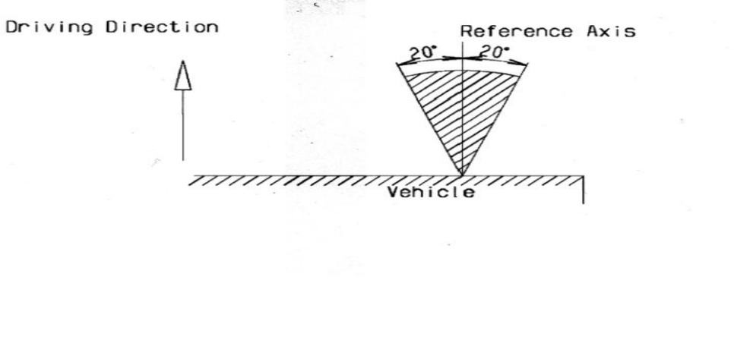

- - - - -

/ As defined in Annex 7 to the Consolidated Resolution on the Construction of Vehicles (R.E.3), (document TRANS/WP.29/78/Rev.1/Amend.2 as last amended by Amend.4).

