ETRTO comments on document ECE/TRANS/WP29/GRRF/2009/10(TPMS)

During the past two years the tyre industry actively participated in the preparation of a European Regulation on Tyre Pressure Monitoring Systems, since an essential tyre requirement is that tyres be operated at the correct inflation pressure.
A first draft has now been proposed to GRRF, unfortunately with many “square brackets” where no agreement could be reached within the working group.
Tyre Industry wishes to restate its position.

The key element of this regulation is to prescribe when a driver must be informed that one or more tyres are under-inflated.

For every vehicle the tyre industry defines the minimum cold inflation pressure (P_{min}) in accordance with vehicle characteristics and the tyre standards from ETRTO, TRA, JATMA. This pressure is the minimum acceptable to guarantee tyre main performances, especially tyre integrity, but also tread wear, braking …; on the other hand the OEMs prescribe a recommended (“placard”) pressure (P_{rec}) to optimize other requirements such as handling, comfort, fuel consumption. P_{rec} can be different from the previously mentioned value, but never lower.

A tyre is “under-inflated” when its cold inflation pressure is below the inflation pressure recommended by the vehicle manufacturer. The worse case is when the cold inflation pressure is below both P_{rec} and the minimum cold inflation pressure.

In summary, two main notions -- safety and economy-- need to be considered, and it can be said in a few words that small deviations from the recommended pressure impact economy of tyre usage and tyre integrity (safety) when tyres are driven for a long period, while large deviations directly impact safety.
Tyre Industry expresses a strong concern that the draft proposal of the new regulation on TPMS imperfectly addresses the issues of tyre integrity and general performances.

To assure tyre integrity and general performances, two situations have been distinguished and two approval tests have been agreed on to prove the worthiness of a TPMS:
- the first represents the incidental case of a one-tyre puncture,
- the second represents the situation of a four-tyres significant pressure loss.

We support the definitions and specifications already given for the first case and test method, where a warning must appear with a delay not longer than 10 min when a single tyre is running 25% below warm tyre pressure or when the pressure of this tyre falls below 150 kPa, because such a pressure drop has a direct impact on vehicle handling, or tyre bead unseating, or hydroplaning, and may lead to a loss of control of the vehicle and an accident.

For the second test, pressure loss on four-tyres, the same figure “-25%” has been proposed but cannot be accepted by Tyre Industry.
In this case, the same deflation for all four tyres would come from natural air permeation, a puncture on all tyres at the same time being very unlikely. Given a normal permeation rate of 3 to 12 kPa/month from an average recommended pressure of 220 kPa, one calculates a period of 5 to 18 months before a warning would occur. The consequence of this is that tyres may remain and be run during several months with pressures below or even largely below their minimum cold inflation pressure, causing fatigue damage, because users will tend to rely on their TPMS for prompting them to refill their tyres as the experience with US customers has already shown.

Here Tyre Industry is very concerned over the issue of tyre integrity, especially under the driving conditions in Europe with denser traffic and higher speeds.

An under-inflated tyre will not fail immediately. It is a matter of time and magnitude of under-inflation and over-loading, until the over-deflection entails cracks in the inner-liner and sidewall. See photo 1.

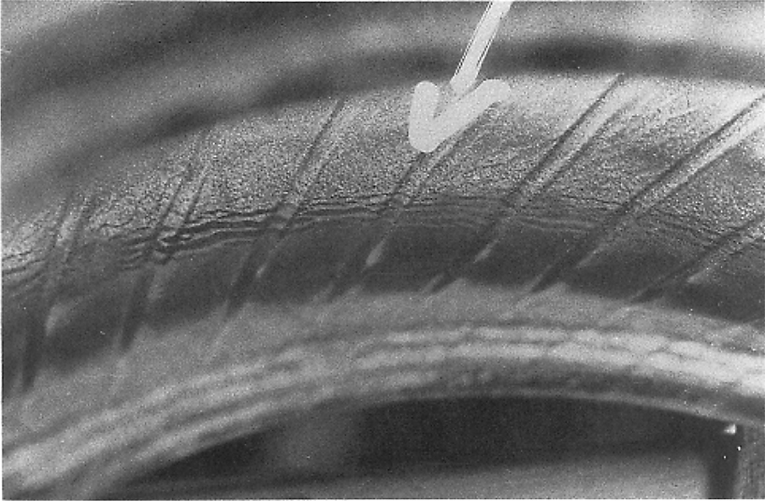
Photo 1: Fatigue cracks on a tyre inner liner, irreversible deterioration of the tyre not visible from outside, resulting from driving on an under-inflated tyre.

But after a longer time the sidewall may eventually break, see photo 2, and lead to loss of vehicle control.

To control such risks, ETRTO wishes that the second test method for TPMS approval specifies that (1) the test pressure shall not be lower than the minimum cold inflation pressure of the tyre, and (2) the TPMS shall alert in less than 20 minutes.

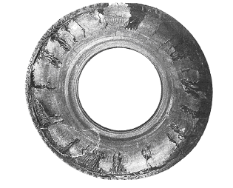
Photo 2: Ultimate tyre failure, resulting from driving on an under-inflated tyre.

Tyre Industry also expresses concerns over the environmental consequences of tyre under-inflation:

The value “-25% of P_{rec}” would mean a tyre pressure of 45 to 90 kPa below the recommended value of 180 to 350 kPa of passenger car tyres.
Let us then remind that the investigation of the GRRF WG TPM (data gathered in the Netherlands) showed that a TPM System can only be beneficial for CO₂ saving if it detects an under-inflation not greater than 40 kPa. It was also obvious that a threshold of -25% would have no influence on CO2 saving at all. One reason for this is: drivers who rely on the TPMS alert will reduce or abandon their periodic pressure checks; also, diligent drivers will wait for the information of under-inflation; if this alert is triggered only by a very large drop of tyre pressure, the eventual consequence will be that the average tyre pressure distribution of all vehicles in Europe will be worse than in the current situation.

We hope that these arguments will make you aware of our concerns and help your decision on approval / disapproval of the proposal.

Annex: Extract of the CIDAUT report.

documents TPM-03-06 and TPM-03-02

