UNITED NATIONS |  | ST
 | Secretariat | Distr.  GENERAL  ST/SG/AC.10/36/Add.2/Corr.1  2 September 2009  ENGLISH  Original: ENGLISH AND FRENCH

COMMITTEE OF EXPERTS ON THE
TRANSPORT OF DANGEROUS GOODS AND ON THE
GLOBALLY HARMONIZED SYSTEM OF CLASSIFICATION
AND LABELLING OF CHEMICALS

REPORT OF THE COMMITTEE OF EXPERTS ON THE TRANSPORT OF DANGEROUS GOODS AND ON THE GLOBALLY HARMONIZED SYSTEM OF CLASSIFICATION AND LABELLING OF CHEMICALS ON ITS FOURTH SESSION
(Geneva, 12 December 2008)

Addendum

Annex II

Amendments to the fourth revised edition of the Recommendations on the Transport of Dangerous Goods, Manual of Tests and Criteria (ST/SG/AC.10/11/Rev.4)

Corrigendum

1. Page 7, 16.6.1.4.6

Not applicable to English

2. Page 8, 16.7.1.4 (b)

For 80 ± 3 g/m² read 80 ± 10 g/m²

3. Page 10, 32.4.1, under National standards

The four ASTM standards should read

ASTM D3828-07a, Standard Test Methods for Flash Point by Small Scale Closed Cup Tester
ASTM D56-05, Standard Test Method for Flash Point by Tag Closed Cup Tester
ASTM D3278-96(2004)e1, Standard Test Methods for Flash Point of Liquids by Small Scale Closed-Cup Apparatus
ASTM D93-08, Standard Test Methods for Flash Point by Pensky-Martens Closed Cup Tester
4. Page 11, footnote 2

Insert of the European Parliament and of the Council after No 1907/2006

5. Page 16, paragraph 2.6, first sentence

For substance contained within the cone read top of the cone

6. Page 16, paragraph 3.1

Delete the third sentence.

7. Page 16, paragraph 3.1, fifth sentence

For aluminium bursting disc read brass or aluminium bursting disc

8. Page 17, Figure A7.1

Replace Figure A7.1 with the figure below.

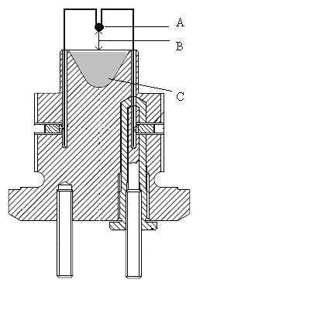

(A) Fusehead
(B) 10 mm gap
(C) Substance under test

9. Page 18, Figure A7.2

Replace Figure A7.2 with the figure below.

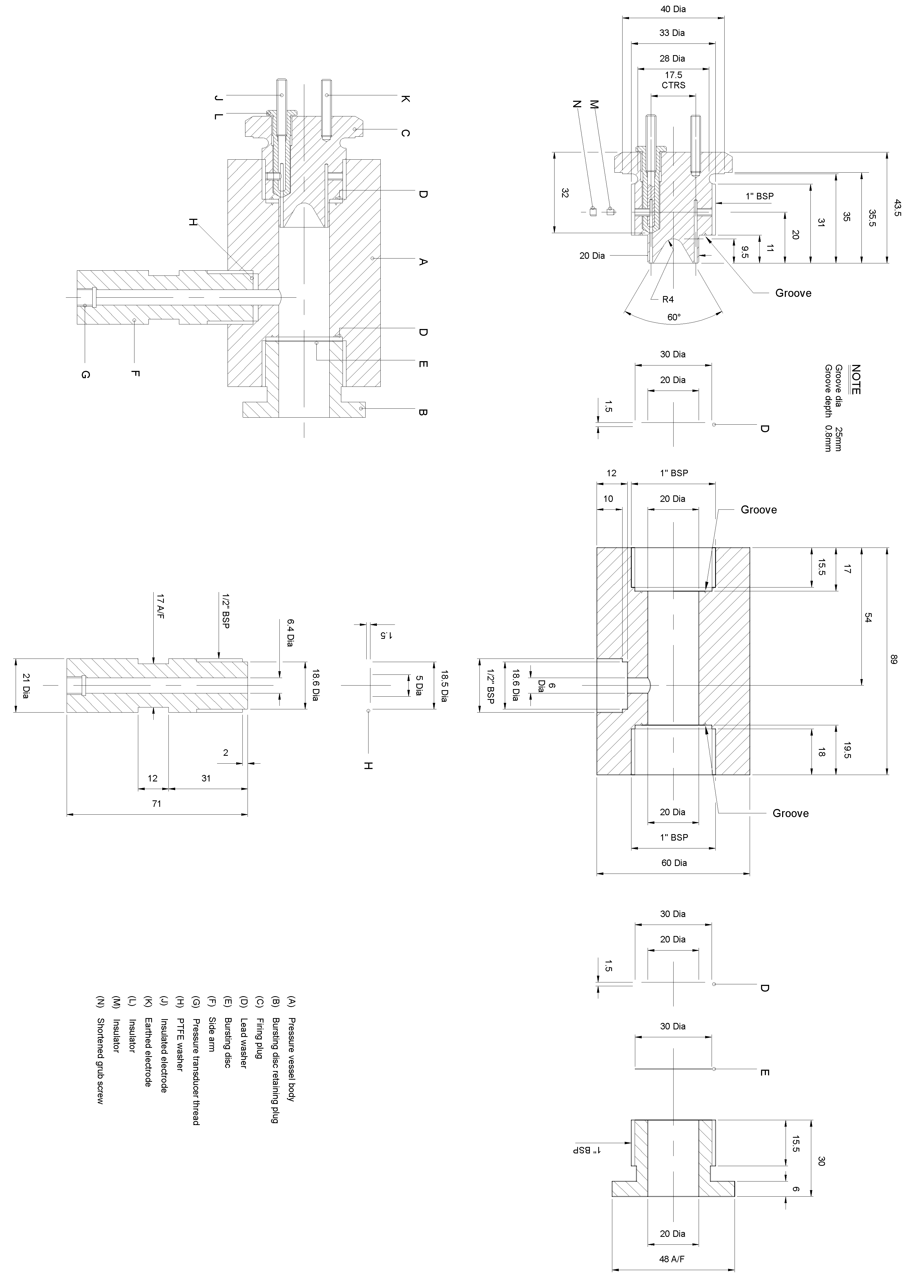
17A/F
17.5
CTRS
1" BSP
NOTE
Groove dia 25 mm
Groove depth 0.8 mm
½" BSP
48 A/F
(A)Pressure vessel body
(B)Bursting disc retaining plug
(C)Firing plug
(D)Lead washer
(E)Bursting disc
(F)Side arm
(G)Pressure transducer thread
(H)PTFE washer
(J)Insulated electrode
(K)Earthed electrode
(L)Insulator
(M)Insulator
(N)Shortened grub screw
Groove
Groove
1" BSP
Groove
1" BSP
½" BSP
1" BSP
∅40
∅28
∅33
∅20
∅20
∅30
∅20
∅20
∅60
∅6
∅18.6

∅18.5

∅5

∅6.4

∅21

∅30
∅20
∅30
∅20
∅18.6

ST/SG/AC.10/36/Add.2/Corr.1
page 4
10. Page 19, Figure A7.3

Replace Figure A7.3 with the figure below.
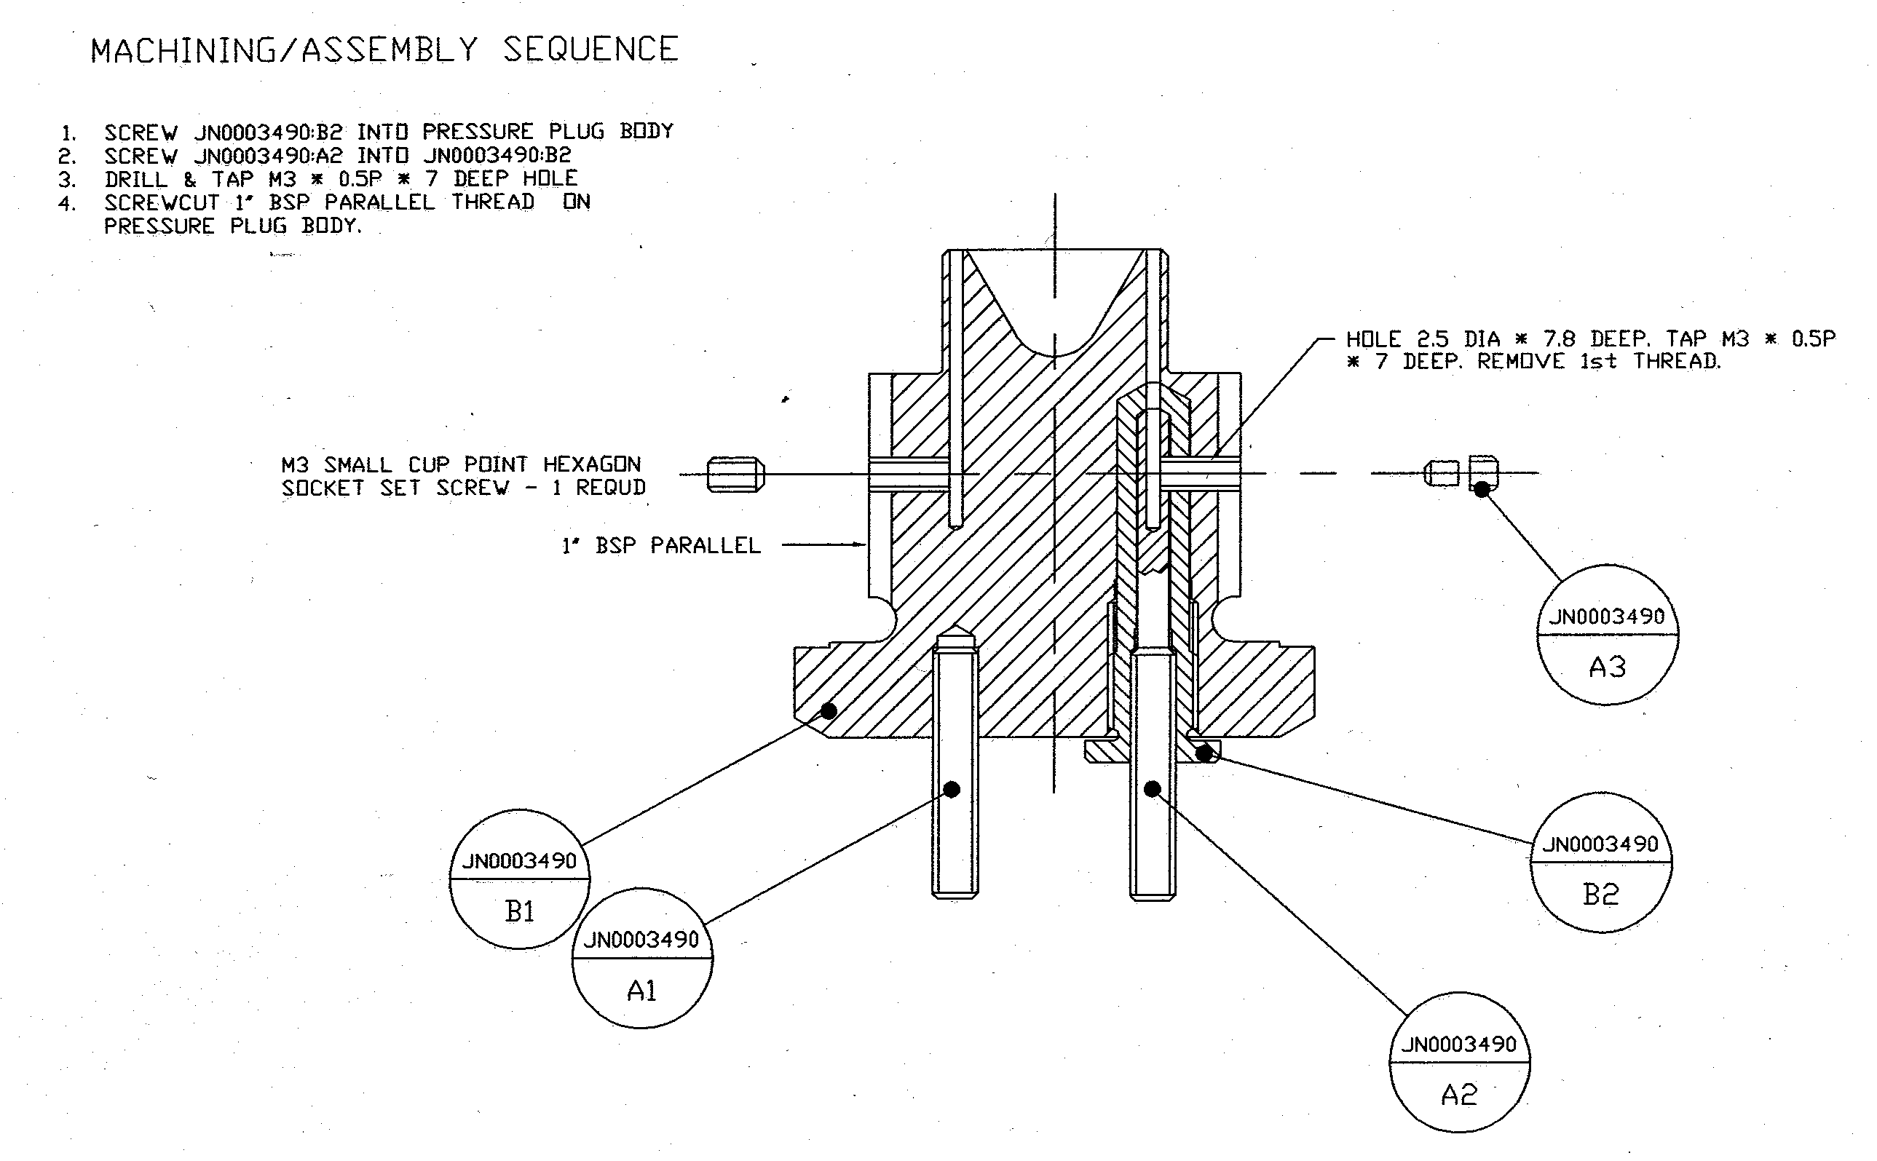
MACHINING/ASSEMBLY SEQUENCE
1.SCREW JN0003490:B2 INTO PRESSURE PLUG BODY
2.SCREW JN0003490:A2 INTO JN0003490:B2
3.DRILL & TAP M3 ∗ 0.5P ∗ 7 DEEP HOLE
4.SCREWCUT 1" BSP PARALLEL THREAD ON
PRESSURE PLUG BODY
M3 SMALL CUP POINT HEXAGON
SOCKET SET SCREW – 1 REQUD
1" BSP PARALLEL
HOLE 2.5 DIA ∗ 7.8 DEEP.
TAP M3 ∗ 0.5P ∗ 7 DEEP.
REMOVE 1st THREAD.

11. Page 20, Figure A7.4

Replace Figure A7.4 with the figure below.

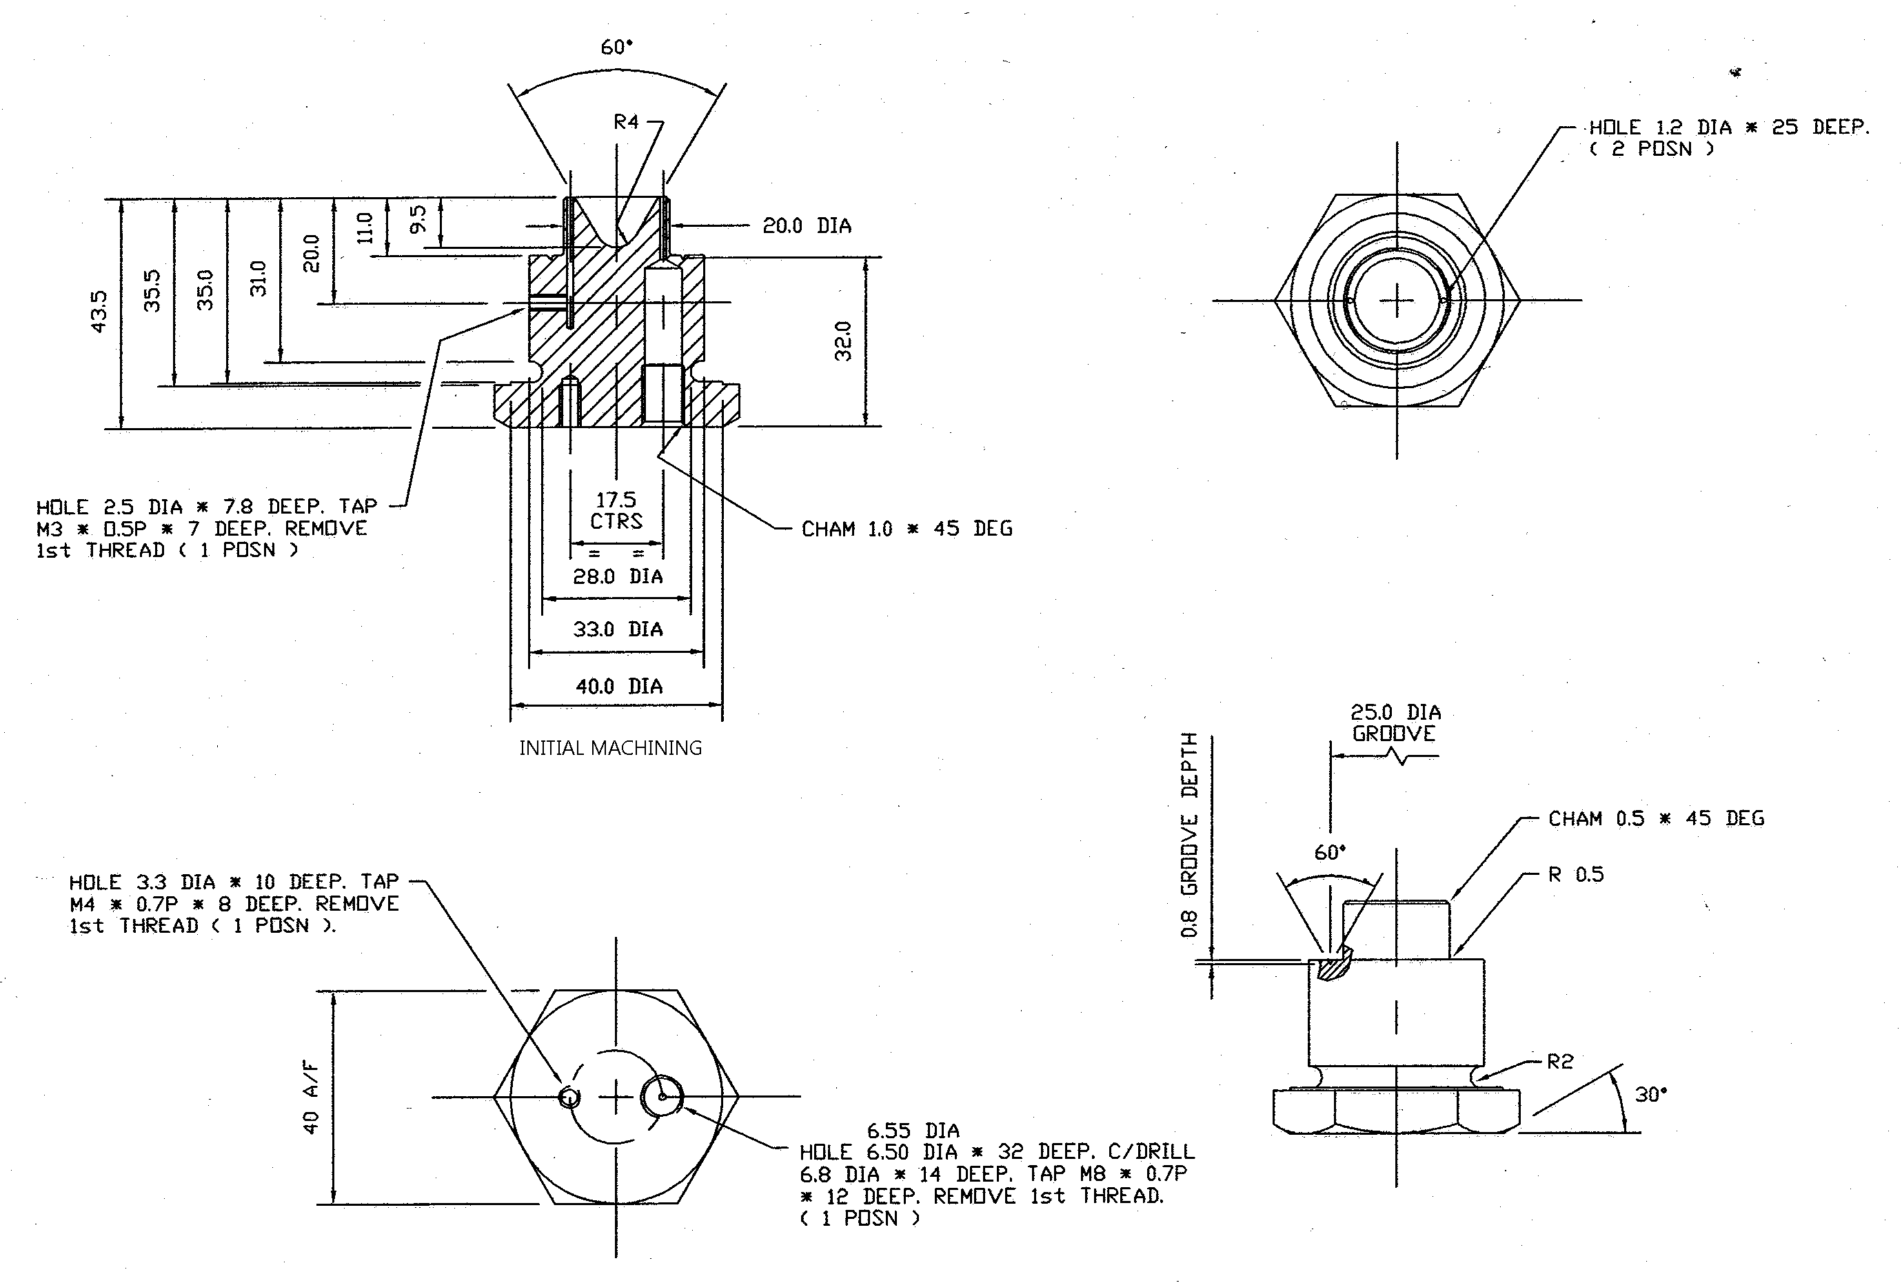
HOLE 3.3 DIA ∗ 10 DEEP.
TAP M4 ∗ 0.7P ∗ 8 DEEP. REMOVE 1st THREAD (1 POSN)
HOLE 2.5 DIA ∗ 7.8 DEEP.
TAP M3 ∗ 0.5P ∗ 7 DEEP. REMOVE 1st THREAD (1 POSN)
17.5
CTRS
INITIAL MACHINING
CHAM 1.0 ∗ 45 DEG
40 A/F
∅6.55
HOLE 6.50 DIA ∗ 32 DEEP.
C/DRILL 6.8 DIA ∗ 14 DEEP.
TAP M8 ∗ 0.7P ∗ 12 DEEP.
REMOVE 1st THREAD (1 POSN)
0.8 groove depth
HOLE 1.2 DIA ∗ 25 DEEP.
(2 POSN)
25.0 DIA
GROOVE
CHAM 0.5 ∗ 45 DEG
∅20
∅28
∅33
∅40

12. Page 21, Figure A7.5

Replace Figure A7.5 with the figure below.

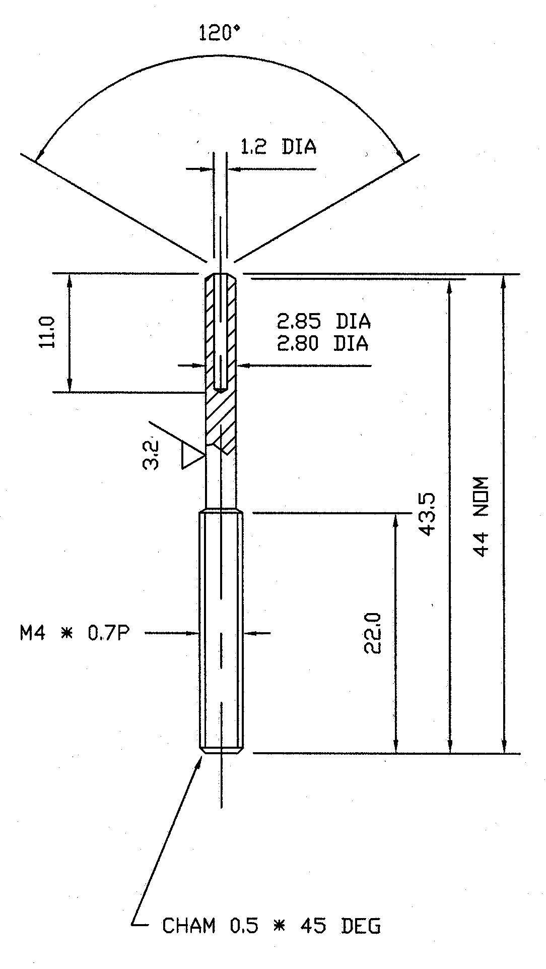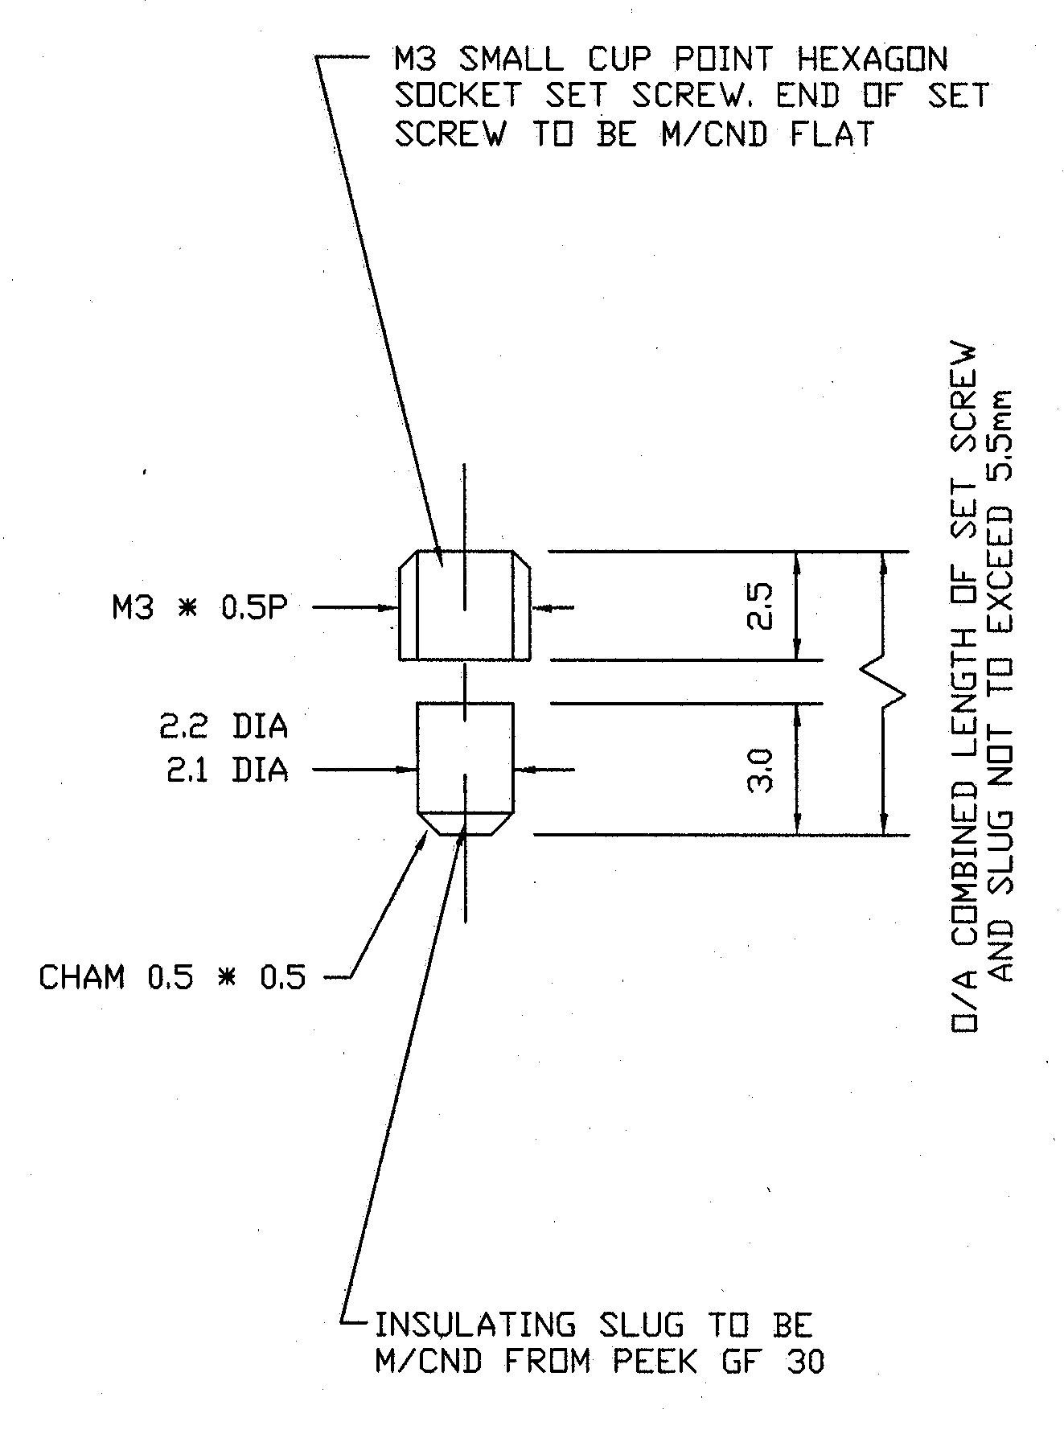
M3 SMALL CUP POINT HEXAGON
SOCKET SET SCREW.
END OF SET SCREW TO BE M/CND FLAT
CHAM 0.5 ∗ 0.5
INSULATING SLUG TO BE
M/CND FROM PEEK GF 30
O/A COMBINED LENGTH OF SET SCREW
AND SLUG NOT TO EXCEED 5.5 mm
CHAM 0.5 ∗ 45 DEG
44 NOM
∅2.2
∅2.1
∅1.2
∅2.85
∅2.80
A3 A2
13. Page 22, Figure A7.6

Replace Figure A7.6 with the figure below.

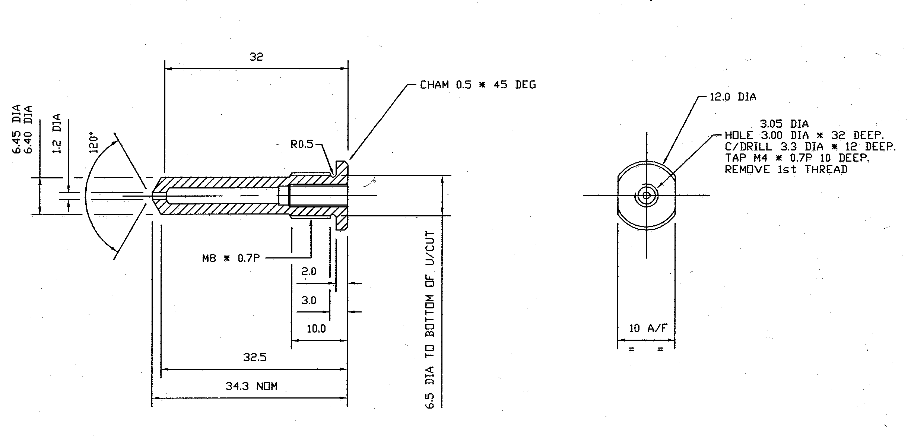
34.3 NOM
CHAM 0.5 ∗ 45 DEG
6.5 DIA TO BOTTOM OF U/CUT
10 A/F
∅3.05
HOLE 3.00 DIA ∗ 32 DEEP.
C/DRILL 3.3 DIA ∗ 12 DEEP.
TAP M4 ∗ 0.7P ∗ 10 DEEP.
REMOVE 1st THREAD
∅6.45
∅6.40

∅1.2

∅12

14. Page 22, Figure A7.7

Replace Figure A7.7 with the figure below.

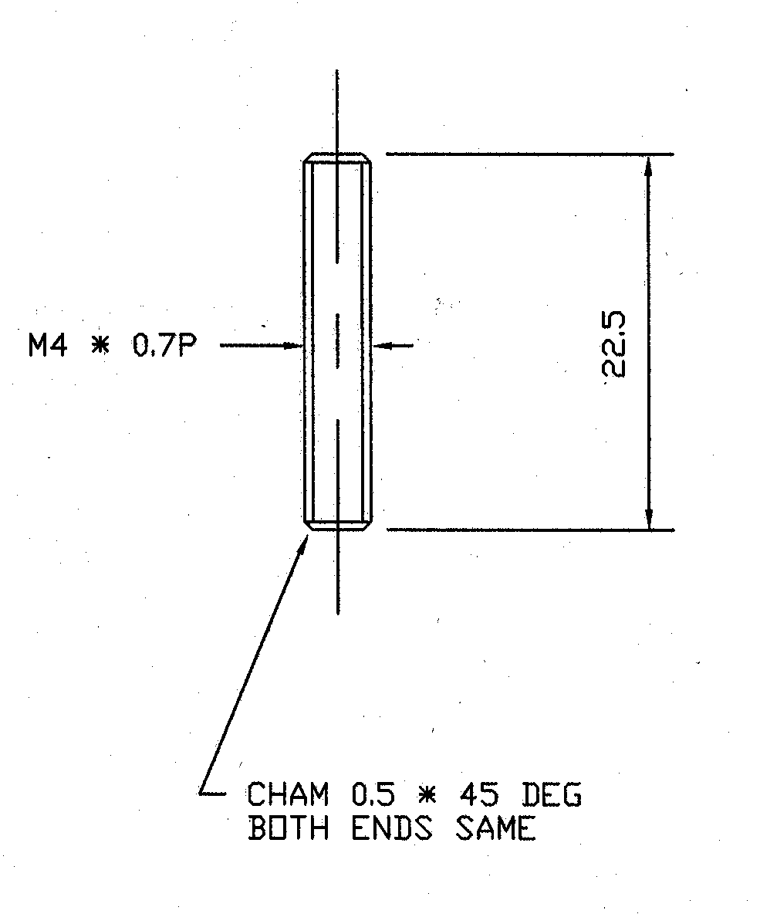
CHAM 0.5 ∗ 45 DEG
BOTH ENDS SAME

15. Page 23, before existing Figure A7.8

Insert a new Figure A7.8 reading

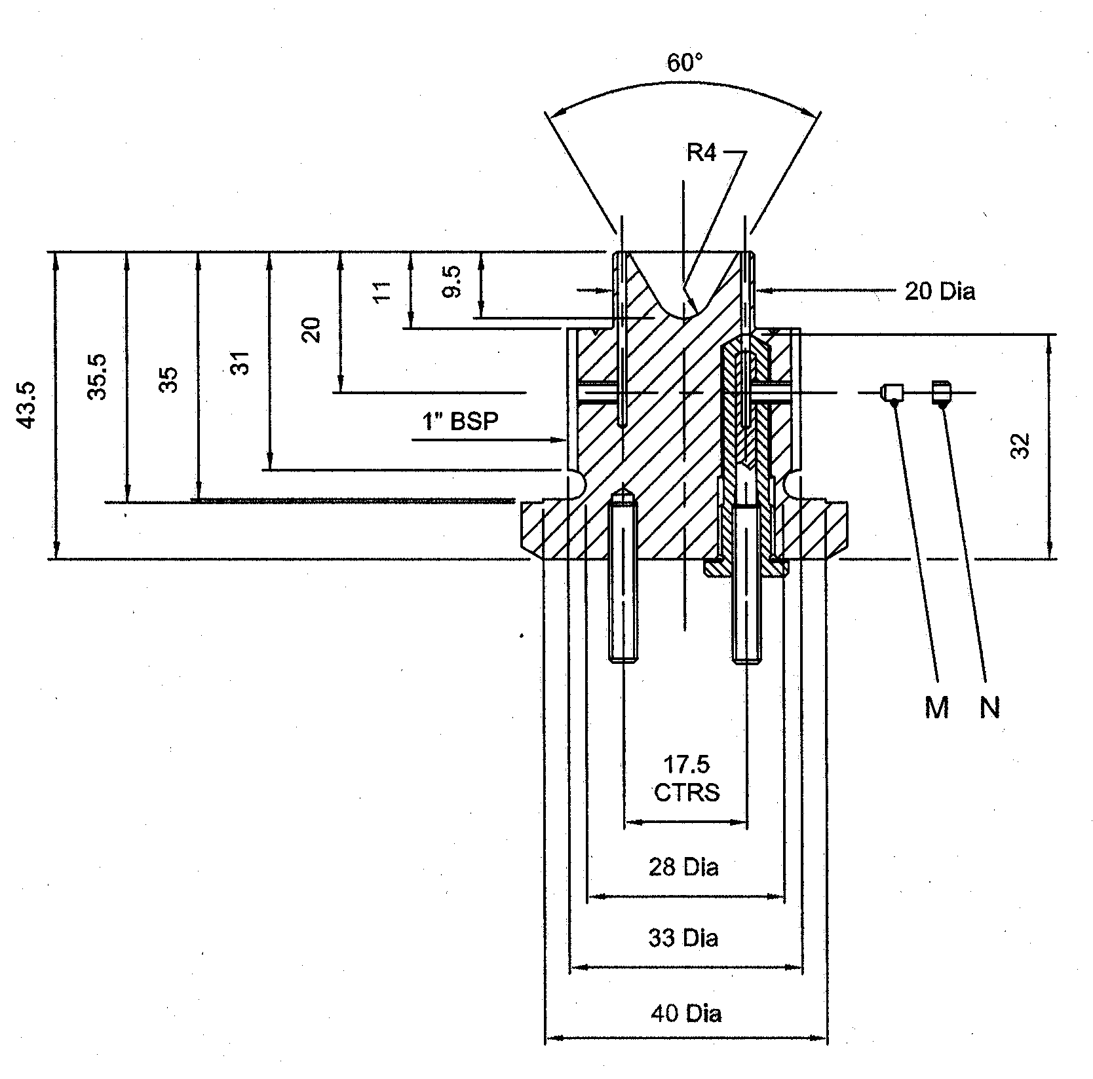
1" BSP
17.5
CTRS
∅20
∅28
∅33
∅40

Figure A7.8: ASSEMBLED CONE IN PLUG

16. Page 23, existing Figure A7.8

Renumber as Figure A7.9.

- - - - -

