Presented by Informal document No. GRSG-93-07
Hungary (93rd GRSG, 23-26 October, 2007
Agenda item 12)

Proposed amendments and comments to
ECE/TRANS/WP.29/GRSG/2006/R.34/Rev.2.
(Draft of Horizontal Regulation)

3.1.9. “Seating position”…. To seat one adult person…..

3.1.10. S = number of adult seating and standing position excluding the driver
(Similarly to the EU frame directive 2007/46/EC)

A. If the vehicle is a category M, one passenger may have different “luggage” mass (pay mass; m) depending on the total number of passengers (N)
One passenger N=1 m=150 kg
Two passengers N=2 m=75 kg
Three or more passengers N≥3 m=68 kg
Question: is that a correct understanding and if so, what is the reason of that? Is there any kind of vehicle (train, airplane, car, bus, etc.) where the passengers are considered with a luggage mass of 68 kg?
- In Budapest there are so called “Airport Minibuses”. The smaller category has 7-8 passenger seats, it is derived from a normal minibus taking out one row of seats (3-4 seats) providing bigger luggage space.

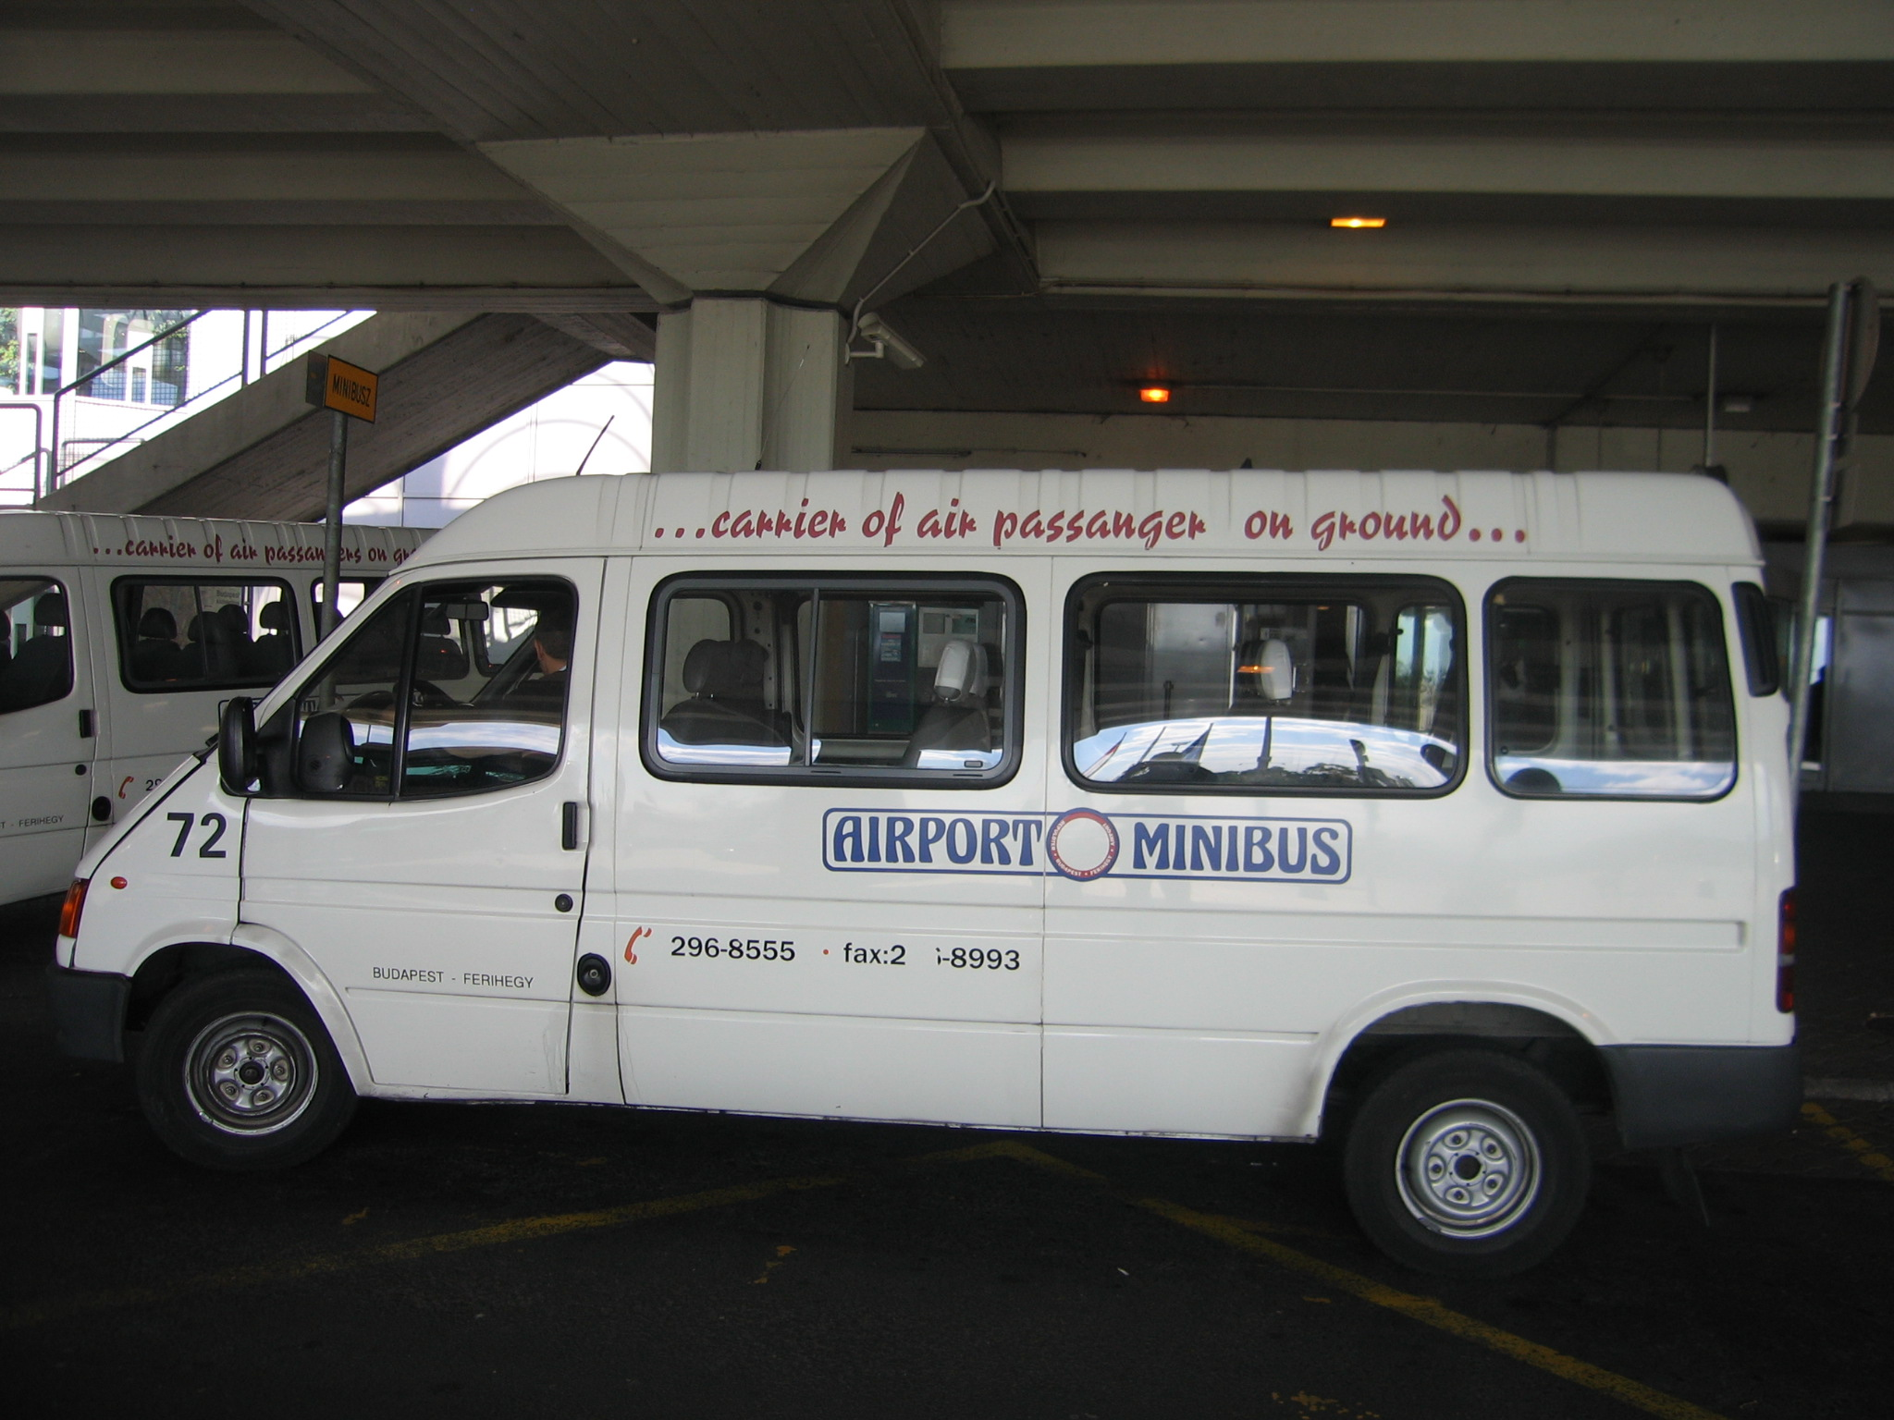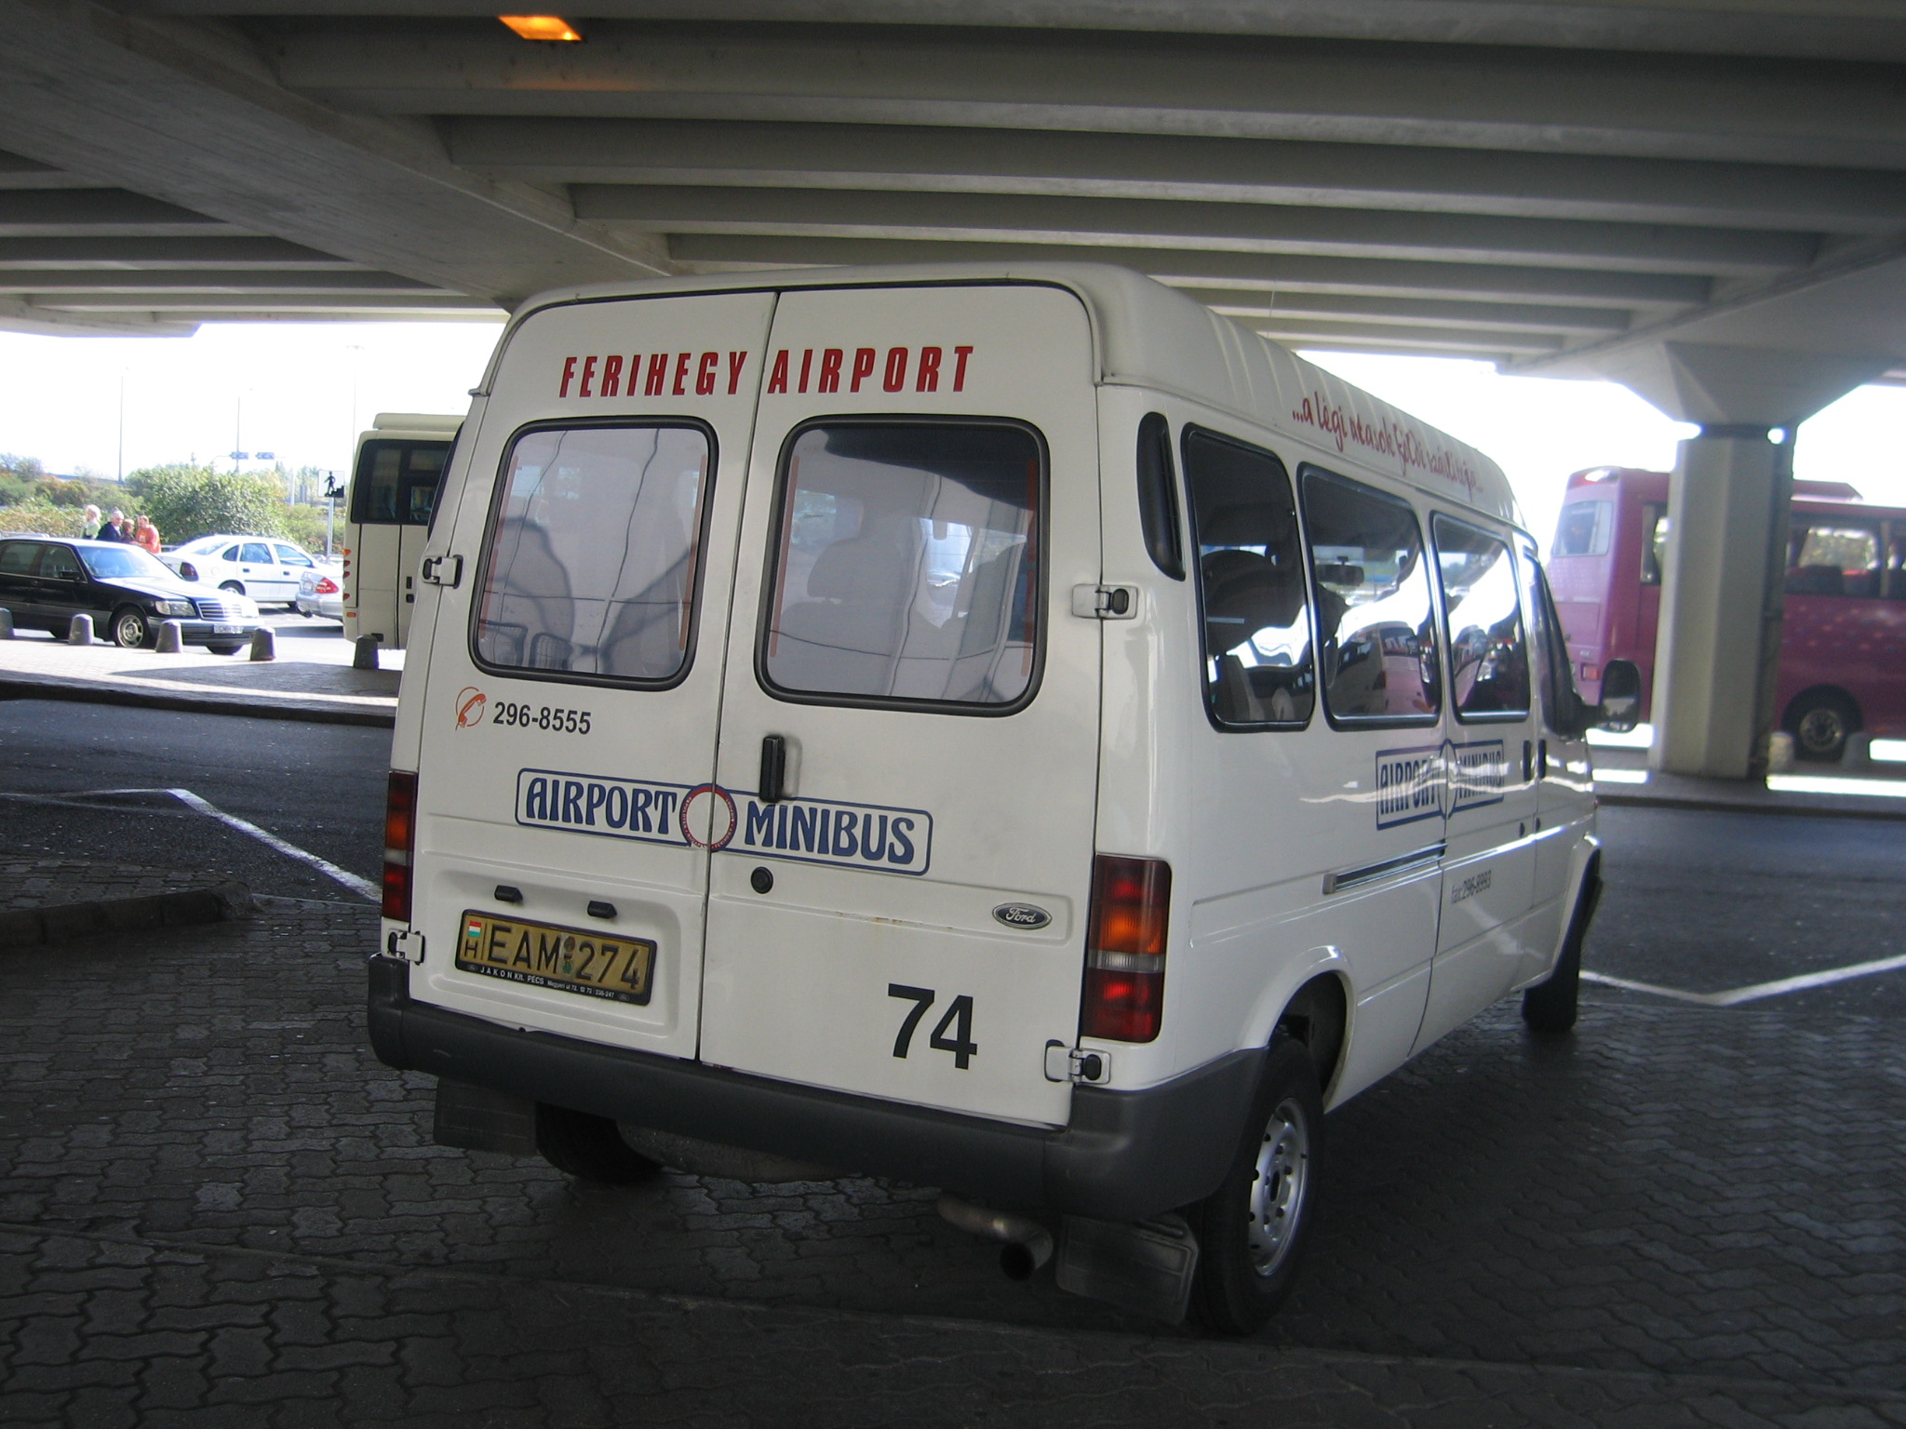

One concrete example: Ford Transit 2,4TD
Passenger seats S=7
Total mass P= 2900 kg
Empty mass R= 1810 kg
2900-(1810+7x68) > 7x68
614 > 476
Question: is this vehicle a goods vehicle (N1)?

3.1.11. (See para. 3.1.10.)

4.2. (See para. 3.1.12.)

4.2.2. Fact: There are small city buses, operating on narrow streets of old downtowns, having 7-8 seats and 8-12 standing positions.

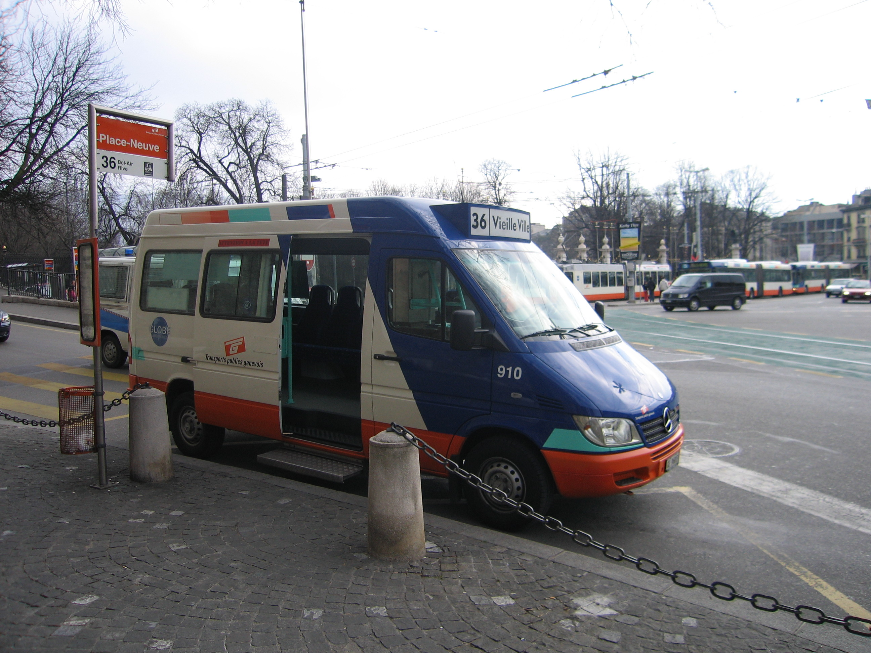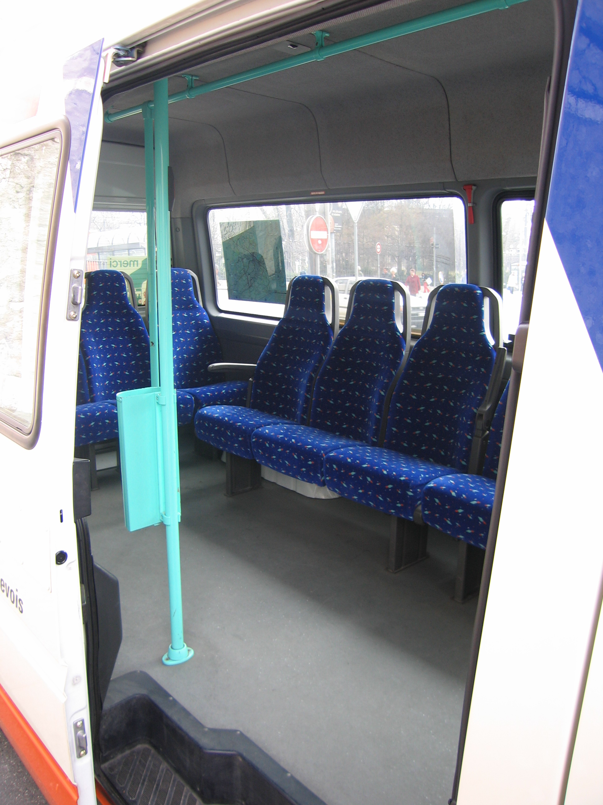

Question: What is the category of these vehicles? Do they belong to M₁?
Proposal: do not delete the words in brackets

4.2.4.1.1. …and constructed with seats and areas for standing ….

4.5. Category S – special purpose vehicle (similarly to other categories)

4.4.5.3. … a load of 1.000 kg (whichever is the lesser) …

4.7.1.
4.7.2. These paragraphs should be structured in the same way. The best way seems to 4.7.3. be used in para.

4.7.2. The vehicles specified in this paragraph should also need geometrical requirements (angles, clearances) similarly to para. 4.7.1 and 4.7.2.

      - Wrong paragraph reference number in the text

4.7.4.4. This statement is reasonable only, if the U.P.D.-s are easily removable with normal, simply tools.
5.1. Mobile machinery is also a vehicle category (Category P) It would have a better place after the Special purpose vehicles as paragraph 4.6. Renumber the following paragraphs!

General remark:
In para 3.2.3 the “Gross vehicle mass” and the “maximum mass” are parallel used and accepted. It is understandable, because in the existing regulations both terms are used. But here, in the Horizontal Regulation, to be consistent, only one term should be used, the “maximum mass” (This is used in the following paragraphs 3.2.4 and 3.2.5 and in many others

