UNITED  NATIONS |  | E
 | Economic and Social  Council | Distr.  GENERAL  TRANS/SC.2/2005/6/Add.1  24 August 2005  Original: ENGLISH

ECONOMIC COMMISSION FOR EUROPE

INLAND TRANSPORT COMMITTEE

Working Party on Rail Transport
(Fifty-ninth session, Paris (France), 24-25 November 2005,
agenda item 6)

STUDY OF THE SITUATION OF RAILWAYS IN MEMBER COUNTRIES

Transmitted by the Governments of Hungary, Ireland and Lithuania

HUNGARY

Data on past and future developments of rail passenger and goods traffic

Performances of passenger traffic
Service |  | 2003 | 2004 | 2005 (plan)
Inland | No. of passengers (thousand) | 155,103 | 157,806 | 152, 028
Inland | Passenger-kilometre (thousand) | 9,759,483 | 10,025,210 | 8, 919,380
Inland | Average distance of journey (km) | 62.9 | 63.5 | 58.7
International | No. of passengers (thousand) | 2,056 | 1,906 | 2,000
International | Passenger-kilometre (thousand) | 397,521 | 383,484 | 386,000
International | Average distance of journey (km) | 193.4 | 201.2 | 193.0
Sum total | No. of passengers (thousand) | 157,158 | 159,712 | 154,028
Sum total | Passenger-kilometre (thousand) | 10,157,004 | 10,408,694 | 9,305,380
Sum total | Average distance of journey (km) | 64.6 | 65.2 | 60.4

Performances of goods traffic
 | 2003 |  | 2004 |  | 2005 (plan)
 | thousand tonnes | thousand  tonne-kilometres | thousand tonnes | thousand  tonne-kilometres | thousand tonnes | thousand  tonne-kilometres
Inland | 13,536 | 1,573,664 | 14,995 | 1,700,395 | 14,771 | 1,705,919
Export | 9,808 | 1,650,753 | 9,702 | 1,652,392 | 10,343 | 1,654,316
Import | 14,480 | 2,661,666 | 15,253 | 2,784,744 | 14,655 | 2,672,216
Transit | 5,116 | 1,727,642 | 6,117 | 2,172,973 | 6,761 | 2,369,997
Total | 42,940 | 7,613,725 | 45,567 | 8,310,504 | 46,530 | 8,402,448

New developments to be observed subsequent to the reorganization of the rail sector with special attention to the setting-up of new railway companies;

The elaboration of State strategy for the railway sector has begun. The discussion about the Government’s proposal is continuing for the time being (March 2005). The draft strategy has set a target to strengthen the neutral and free competition on the State-owned railway network, to divide MÁV Co. into companies, to privatize freight transportation. As for developments, the strategy sets the full modernization of international main lines as an aim by making use of EU sources. The objective of track modernization is to achieve attractive transportation times for as many railway undertakings as possible, to exploit track capacities as much as possible.
By restructuring the official organizations that are active for the time being, the work on establishing a new regulatory body will be started this year. As well as the regulation of railway traffic, this body will also supervize the competition.

Investments in (i) rail infrastructure, and (ii) railway rolling stock
Rail infrastructure
After the accession to EU, the main sources of rehabilitation works are the infrastructural support of the European Union, credits provided by the European Investment Bank (EIB) and domestic budget share, supplementing the mentioned amounts.
Besides the nearly HUF 140 billion ISPA programme started in 2001, tender procedures were launched for a new HUF 60 billion programme of EIB and will soon be launched for the HUF 34 billion EU Cohesion Fund programme. The new project planning works will start with significant sources.
Development of Pan-European Corridor IV within Hungary has the absolute priority in development plans, and development of corridor V has also priority.

Projects started in previous years:
- Rehabilitation works from EIB I credit are continued:

- Budapest-Újszász-Szolnok line (work started in 1998, provided €50 million EIB credit in addition to national sources, expected completion in 2007),
- Cegléd-Kiskunfélegyháza-Szeged lines (completed Cegléd-Kecskemét section in 2003, Kecskemét-Városföld section in 2004, speed limit 120 km/h, within the project it is planned to increase the capacity of the one-track line by building a second track on the most critical section).
- In the case of EIB IV project, in summer 2005 further new public procurement procedures will be launched for the electrification of Győr-Pápa-Celldömölk line and the modernization of Rákospalota-Újpest railway station.
- Reconstruction of the stations of Székesfehérvár and Érd, and the modernization of the Óbuda-Piliscsaba line section – depending on the available sources – will be implemented in 2006-2008.
- Modernization carried out with EU-ISPA support:

Budapest-Cegléd-Szolnok section (technical renewal, increased speed, reconstruction of central station Cegléd and stations Vecsés, Üllő, Monor and Pilis),
Budapest-Hegyeshalom (Phase II) line (reconstruction of section Budaörs-Biatorbágy for 140 km/h speed, implementation of ETCS system on the section Komárom-Ács, complex reconstruction of stations Komárom, Győr, etc.),
Zalalövő-Zalaegerszeg-Boba section (electrification of the total length, installation of ETCS system, speed 100-120 km/h, technical improvements),
Phase I of the modernization of Szolnok-Békéscsaba-Lökösháza line:
- Szajol-Mezőtúr section (reconstruction),
- Békéscsaba-Lökösháza section (permitted speed increased from 80 km/h to 100 km/h)

New projects
- The Cohesion Fund sources became available to Hungary after the accession to EU. The first railway projects, starting with EU support were the construction works of Budapest/Ferencváros-Vecsés and Mezőtúr-Békéscsaba lines.
- Building out of ETCS system – as phase II on the Budapest-Szolnok-Lökösháza railway line can also be implemented with EU support – during 2007-2008.
- In order to prepare further Cohesion Fund projects, the planning of the Szolnok-Debrecen-Záhony railway line is continued, and the planning work of the Budapest/Kelenföld-Tárnok and Székesfehérvár-Boba line will start.
System investments
- In 2005 investment projects will be continued. These projects include the modernization of loading and unloading places, renovation of railway weighing bridges, development of signalling equipment, traffic control and outdoor monitoring systems. The “level crossing modernization programme” will be continued, and the planned two-year programme of modernization of the Vasvári Rába bridge is handled as a priority project.
- Several smaller demolition, development and reconstruction works affecting only one station or facility/site will also be carried out.
- Purchase, implementation, system integration of information technology, maintenance, office and administration technical means, equipment and services for the different business and functional units of MÁV also compose parts of the investment plans.

Investments in railway real estates
Project | 2003  (million HUF) | 2004  (million HUF)
Main investments
- Reconstruction of Budapest Keleti Railway station,
- Renewal of the building of MÁV’s Archives,
- Renewal of the passenger building of station Szombathely,
- Formation of Schengen borders,
Other investments
Total | 1,946 | 1,107

Investments in rolling stock
Business Sector of Passenger Transport
Project | 2003  (million HUF) | 2004  (million HUF) | 2005 (planned)  (million HUF)
Purchase of carriages | 0 | 0 | -
Renewal of carriages | 5,129 | 3,167 | -
Purchase of multiple unit trains | 15,511 | 12,157 | -
Renewal of multiple unit trains | 4,867 | 1,511 | -
Sum total | 25,507 | 16,835 | 26,203

Business Sector of Freight Transport
Main investments in rolling stock and rail infrastructure
Project | 2003  (million HUF) | 2004  (million HUF) | 2005 (planned)  (million HUF)
Transformation of 150 pieces of Eams wagons into Taems wagons | 0 | 340 | 410
Renewal of industrial sidings | 808 | 91 | 860
Total | 808 | 431 | 1,270

Business Sector of Machinery (Traction and maintenance)
The major investment of the sector is the simultaneous renewal and major repair of diesel locomotives (‘re-motorization’) that run on the network of MÁV Co. This modernization improves not only the reliability of the vehicles, but also reduces the maintenance and energy consumption. Sorting out old vehicles and purchasing new vehicles is a much more expensive solution to cover needs for traction units than re-motorization. Having done such renewals, the lifetime of the locomotives is increased by 10-15 years. However, Business Sector of Machinery is looking for solutions to finance the purchase of 200 one-current-system electric locomotives, 15 multi-system electric locomotives and 80 universal diesel locomotives.

Project - Renewal of traction units
 | 2003 |  | 2004 |  | 2005 (planned)
Type of locomotives | No of  units | HUF  (million) | No of  units | HUF  (million) | No of  units | HUF  (million)
M41 | 0 | 0 | 5 | 1,228 | 12 | 3,123
M47 | 14 | 606 | 10 | 1,239 | 4 | 1,280
M62 | 1 | 132 | 14 | 3,042 | 10 | 3,150
In all: | 15 | 739 | 29 | 5,510 | 26 | 7, 553

Information on research activities in the field of railway transport

Under the authority of the Ministry of Economy and Transport, the Transport Automation Department of Budapest University of Technology and Economics prepared a study with the cooperation of MÁV Information Technology LLC in March 2004. The title of the study is “The application of satellite positioning and its integration into the processes of railway traffic.”

Practical experiences with the application of Global Positioning Systems in rail freight transport
For the time being, MÁV Co. uses no Global Positioning Systems, so concerning GPS, MÁV has no practical experience available. In 2004, MAV Co. decided to launch a project on the application of GPS that shall be incorporated into the information technology strategy of the company and a feasibility study shall also be elaborated. The launch of the project for the renewal of Business Sector Machinery by means of GPS technology is scheduled for the fourth quarter of 2005.
- A local positioning system for the protection of railway consignments is being developed at Budapest Ferencváros station. The objective of the system is to protect freight wagons loaded with goods of high value from the moment of the arrival at the station till the moment of their departure from the station. Electronic padlocks put on the wagons are in permanent connection with the control centre, so there is always information available about the exact place of the wagon loaded with goods of high value. If a padlock is being picked, the system gives an immediate alarm signal for the dispatcher in the control centre.
The system is expected to commence operation during the summer of 2005. The extension of the system has already been started. Having made the next developments, it will be possible to follow up the precious consignments on the whole route.
- As an experiment, the electronic protecting system has also been installed on two diesel locomotives. The system provides exact information on the place of locomotives and on the quantity of fuel used. Having summarized and estimated the experience gained, the decision on the extension of application will be taken later.

- Another solution ensures the protection of wagons during the forwarding of the train on the route. This system only contains positioning in an indirect way, because an alarm signal is forwarded to the locomotive hauling the wagons, if the padlocks are opened. MÁV Co. has designated some trains for the experimental application of the system.
- A central traffic control system has been established on the lines that belong to the trunk railway network that provides full information about the traffic of a given section, about the place of the trains on the track. Computers record extraordinary situations, different interruptions of train movement.

Railway safety: Risk assessment techniques
- Experts of MAV Co. have established a modern, computerized recording and database system.

The purpose of the system is to analyse risks of operational safety, to ensure an effective overview of the requirements from a personal, objective, material, legal, control, inspection and management point of view, to provide exact data, to promote technical development, support and decisions. In order to prevent accidents, the business sectors of the company make use of risk assessment.

The accomplishment of a similar system is continuing for extraordinary events such as fires, uncontrolled spill-out or flow-out of dangerous goods.

- The growing number of accidents on the fault of third parties made it reasonable to involve external organizations into the preventive work.

- Every year, in order to reduce and prevent accidents, level crossings are put into a sequence according to their dangerous character. Taking into account the analysis of accidents and traffic data, permitted speed on the railway track and road, the way in which security is provided, environmental circumstances, significant work is carried out under the coordination of the Transport Science Institute (Közlekedéstudományi Intézet) that serves as the basis for the revision of the security system of level crossings, for executing necessary modifications.
- Having been charged, the Transport Science Association (Közlekedéstudományi Egyesület) elaborates some transport safety topics from a scientific, international aspect. The studies are presented in its conferences. It submits proposals to ministries, authorities concerned.
- The Railway Accident Prevention Committee established by MÁV Co. that is an Ad hoc committee of the National Accident Prevention Committee (OBB) has been formulated by the involvement of professionals of other transport modes. Analysing and elaborating certain topics on transport safety, the role of the Committee is to submit proposals for taking measures.
- Full-scale screenings were executed at main railway stations, other stations with considerable traffic and marshalling yards and having pointed out facts, having assessed and analysed events, proposals were made for taking measures to support prevention.

- According to § 54 of Law CVIII/1993, risks jeopardizing health and safety of employees must be assessed in both quantitative and qualitative respect. The practice applied is harmonized with methods of the European Union.
The evaluation extends to the work environment, working tools, dangerous materials, products and burdens on the employee in the examined field of activity. The person performing risk assessment specifies the levels of risk on the basis of the examinations. This level is determined, according to the method applied, by the frequency and gravity of the possible consequence. Depending on the gravity of the risk, the specialist executing examination makes proposals for the manager entitled to take preventive measures. This means simultaneously a preference sequence as well. A computerized database and the software that runs it support the work of the expert carrying out risk assessment.
Due to the risk assessment system, the consequences of the expected damage to the health and safety of persons can be forecasted with adequate accuracy. The costs of prevention and realization can be planned, therefore all these constitute a relevant part of the economic management system.

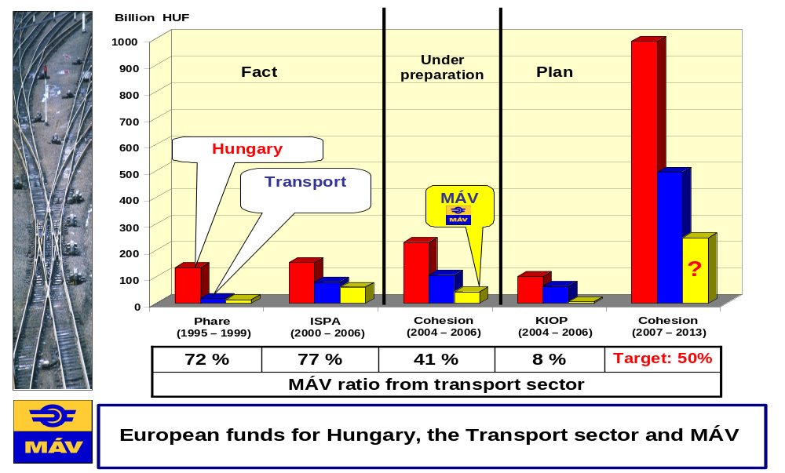

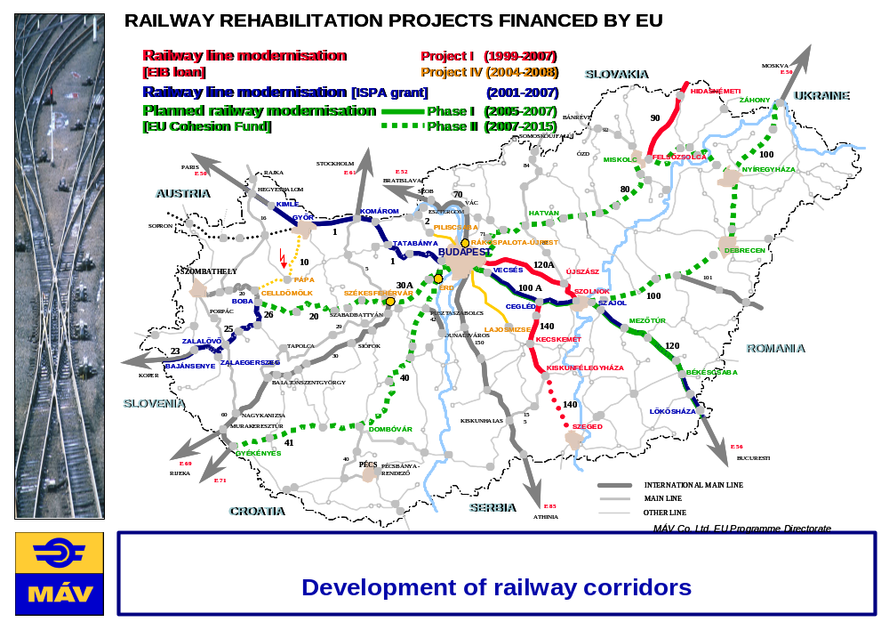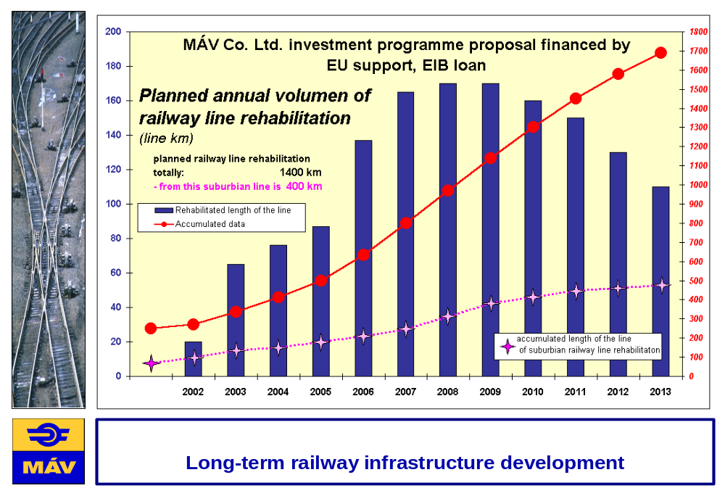

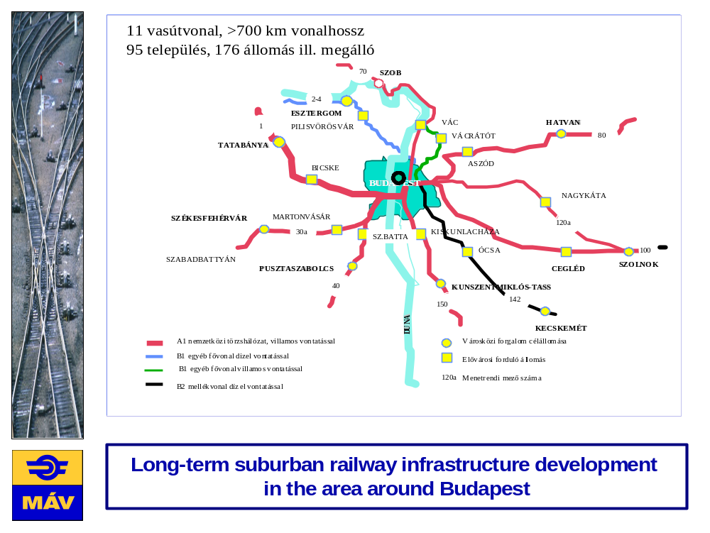

IRELAND

Data on past and future developments of rail passenger and goods traffic

Passenger journeys have been increasing steadily over the past decade. Total journeys by rail have increased from 25.8 m in 1994 to 34.5 m in 2004. The 2004 figure is understated by up to 2.5 m because of DART(Dublin area coastal rail line) weekend closures. A major upgrading and rebuilding programme is under way and will continue over the coming 5 years. All infrastructure has been upgraded, all rolling stock will soon be modernized and additional capacity provided.

Iarnród Éireann(Irish Rail) has been reshaping its freight business and ceasing the carriage of loss-making traffics. Volumes have reduced from 3.0 m tonnes in 1994 to 2.0 m in 2004.

New developments

The European Communities (licensing of railway undertakings) Regulations, S.I. 537 of 2003, which transposed the European Union Directive 2001/13/EC, provides for the licence of railway undertakings. These regulations require applicants to provide proof of their good repute, financial fitness and other requirements in order to be licensed by the Minister as a railway undertaking. However, possession of a licence does not in itself entitle a railway undertaking to access the State’s railway infrastructure. Clearly, access to the existing railway infrastructure will require examination of a range of operational and safety issues. Such access will require an arrangement to be entered into by a railway undertaking with Iarnrod Éireann. To date, there have been no new applications, to set up a new railway company.

Investments in rail infrastructure and railway rolling stock

Actual figure for 2004 and estimates for 2005 (€ 000’s)

Rolling Stock: 2004 - 90,883 2005 - 94,200 Total - 185,083
Railway Infrastructure: 2004 - 254,294 2005 - 297,200 Total - 551,494

Railway safety: Risk assessment techniques
A Risk Model, employing modern risk assessment techniques, has been constructed for the railway system by the Infrastructure Manager of the Irish railway. This model is used to inform and support management investment decisions on the railway.
When a risk is first assessed, the failure frequency (F), the probability of an undesirable outcome (P) and the likely severity of the outcome (S) are scored. The score for each risk is the sum F+P+S. Risks above a predetermined score are treated in detail in the risk model.
The risk model employs modern risk assessment techniques, e.g.
- Event tree analysis
- Fault tree analysis
- Failure modes, effects and consequences analysis
- Task-error analysis and HAZID approach.
The risk is quantified and is compared with the tolerability thresholds. Calibration of results can be achieved using recorded incident and accident data. The larger UK database for accidents is used to proportion risks.
Upper tolerability limits and broadly acceptable limits have been set using ISO lives lost per annum.
Risks exceeding the upper limit of tolerability are prioritized for treatment. Risks falling within the ALARP region, which falls between the intolerable and the broadly acceptable regions, are treated on the basis of a cost/benefit analysis. When investments to mitigate risk are being considered, remedies with a maximum benefit to cost ratio are given priority.
The model is being integrated with the infrastructure asset management system, and is location specific. It allows risk to be proportioned against asset condition.Risk can be displayed in terms of collective risk and individual risk.
The model has been expanded to include rolling stock, and is being further extended to cover worker accidents. The outcome from the model allow management to prioritize and apportion safety investment in the railway system.

LITHUANIA

Data on past and future developments of rail passenger and goods traffic

Year | 2003 | 2004 | 2005 | 2006
Passenger transport (mill. of pass.) | 7.0 | 7.0 | 7.0 | 7.1
Freight transport (mill. of tons) | 43.4 | 45.5 | 44.5 | 44.9

New developments to be observed subsequent to the reorganization of the rail sector with special attention to the setting-up of new railway companies

Lithuania joined the European Union in 2004 and adopted several legal acts transposing EU law into national law. The following laws and other legal acts concerning the railway transport sector have been passed: Law on railway transport sector reform of the Republic of Lithuania (8 April 2004), Railway transport code of the Republic of Lithuania (22 April 2004), Law on railway transport traffic safety of the Republic of Lithuania (16 December 2003), Resolution of the Government of the Republic of Lithuania No. 783 of 17 June 2003 concerning Rules on licensing the provision of railway transport services for passengers, luggage and freight, Resolution of the Government of the Republic of Lithuania No. 610 of 19 May 2004 concerning approval of the rules on the levying of charges for the use of railway infrastructure, Resolution of the Government of the Republic of Lithuania No. 611 of 19 May 2004 concerning Rules on allocation of public railway infrastructure capacity. These legal acts have implemented the main purpose of EU requirements and gave a basis for new railway undertakings to enter the railway transport market of Lithuania. After having obtained a licence and safety certificate in accordance with the procedure established by the law and after having concluded a contract for the use of public railway infrastructure with the public railway infrastructure manager, a railway undertaking (operator) shall have the right to use the public railway infrastructure. The railway transport sector reform is being implemented, infrastructure management functions are being separated from the railway transport activities.

Investments in railway transport sector

Table 1. Investments in railway transport sector (million LTL)
Source of investment | 2003 | 2004 | 2005 | 2006
JSC “Lithuanian railways” own resources | 287.4 | 239.1 | 196.7 | 218.0
State budget | 20.7 | 26.9 | 31.3 | 52.6
Loan | 54.5 | 60.7 | 85.9
EU financial support | 20.0 | 26.3 | 133.3 | 247.4
TOTAL | 382.6 | 353.0 | 447.2 | 518.0

Table 2 shows investment of the total investment that was assigned to railway infrastructure and rolling stock

Table 2. Investment in railway infrastructure and rolling stock (million LTL)

Year | Railway infrastructure | Rolling stock
2003 | 294.9 | 31.5
2004 | 242.7 | 68.0
2005 | 308.2 | 127.6
2006 | 431.2 | 29.0

Practical experiences with the application of global positioning systems

Global positioning systems are not used in Lithuania. However, studies of possible EU funds availability for development of traffic management and other systems are performed.

Information on research activities carried out in the field of railway transport which are financed by the State

Analysis of technical specifications for interoperability of trans-European conventional rail system telematic applications and control, operation and signalling subsystems was carried out in 2004. It is planned to perform analysis of technical specifications for interoperability of telematic applications for freight services subsystem of trans-European conventional rail system in 2005.

Information on new developments related to risk assessment techniques

The State Railway Inspectorate under the Ministry of Transport and Communications performs auditing of railway transport sector actors’ activities in compliance with requirements applied to traffic safety and identifies shortcomings which may be of essential impact on risk of accidents. Railway transport traffic safety is analysed annually in Lithuania. All accidents and incidents are investigated and examined to determine reasons for the accident or incident and provide preventive measures that have to be taken. During the investigation circumstances, reasons and consequences are determined. According to the analysis of railway transport traffic safety analysis and material of accident or incident investigation, preventive measures aimed to increase safety of railway transport are developed.

---------

Diagrams on the present situation and plans for future investments are presented below: - European funds for Hungary, the transport sector and MÁV; - Development of Railway Corridors; - Long-term railway infrastructure development; - Long-term infrastructure development in the area around Budapest.

