Informal Document No. GRSP-35-14
(35th GRSP, 3-7 May 2004,
agenda item A.3.)

ECONOMIC COMMISSION FOR EUROPE

INLAND TRANSPORT COMMITTEE

World Forum for Harmonization of Vehicle Regulations (WP.29)

Working Party on Passive Safety (GRSP)

PROPOSAL FOR A GLOBAL TECHNICAL REGULATION ON
DOOR LOCKS AND DOOR RETENTION COMPONENTS

REVISION 1

Transmitted by the Expert from the United States of America

_____________

Note: This document is distributed to the Experts on Passive Safety only.
- Statement of Technical Rationale and Justification

I. Introduction
Current regulations were designed to test for door openings in vehicles that were built in the 1960s. Aside from changes made to U.S. and Canadian requirements in the early to mid-1990s to address rear door openings, no significant changes have been made to any of the current regulations. While existing regulations governing door openings have proven largely effective, doors openings continue to present the risk of serious injury or death to vehicle occupants, particularly when an occupant is unbelted.
The precise size of the safety problem posed by inadvertent door openings is difficult to quantify because very few jurisdictions gather the type of crash data needed to evaluate the problem. This task is further compounded by the effect of occupant belt use on injury risk. Notwithstanding the difficulty in quantifying the overall benefit associated with the establishment of a global technical regulation internationally, the types of changes to door retention components needed to upgrade existing regulations and standards appear to be quite small. Additionally, vehicle manufacturers, and the ultimate consumers of motor vehicles, can expect to achieve further cost savings through the formal harmonization of differing sets of standards that already largely replicate each other.
Research conducted by the United States indicates that there are approximately 42,000 door openings during a crash in the United States per year. While this number corresponds to less than one percent of the roughly six million crashes that occur in that country each year, the majority of those crashes do not occur at speeds where a door opening is likely. Rather, door failures appear to be most common in moderate- to high-speed crashes.
Structural failures of the latch and striker are the leading cause of door openings. The United States’ evaluation of its data indicates that about two-thirds (64.5 %) of door openings involve damage to the latch or striker, either alone or in combination with damage to one or more hinges. The next most likely causes of a door opening are the failure of the vehicle structure holding the door in place or the door itself. In 8.37 % of the evaluated cases, the door support, e.g., B-pillar or C-pillar, was damaged; while in 9.68 % of the evaluated cases, the door structure caused the door to open without damaging the actual door retention components. Only rarely did a door open with no damage to the door whatsoever (2.15 %).
The type of crash also has an impact on the likely type of door failure. The primary source of failure in side impact crashes was damage to the latch/striker assembly, while damage to the door supports was a distant secondary source. In rollover crashes, non-structural failures, i.e., those where there is no damage to the door, are more common. Side door openings constitute approximately 90 percent of all door ejection fatalities and 93 percent of the serious injuries.
In 1991, the United States conducted an engineering analysis of door latch systems in cases involving vehicle side door openings to determine the loading conditions and failure modes of door latch systems in crashes. This analysis revealed the following four distinct failure modes:

Structural Failures. Structural failures are characterized as physical damage to the latch, striker, or hinges. Other types of structural failures include broken attachment hardware or separation of a latch, striker, or hinge from its support structure.

Detent Lever-Fork Bolt Misalignment (Bypass) Failures. Detent lever-fork bolt misalignment (bypass) failures may occur when the striker is subjected to longitudinal forces in conjunction with lateral forces. These forces cause the fork bolt to move and become misaligned with the detent lever, causing the latch to open. These forces most typically occur in frontal and oblique frontal impacts.

Linkage Actuation Failures. Linkage actuation failures are caused by forces being transmitted to the door’s linkage system (i.e., the connection between the door handle and the door latch) due to vehicle deformation during a crash. It may be possible to observe some bowing of the door after a linkage actuation failure.

Inertial Force Failures. Inertial force failures are latch openings due to acceleration of latch system components relative to each other, which produce sufficient inertial force to activate the latch. Often, there is no visible damage to the latch or striker system. Inertial loading typically occurs in rollover crashes or when a portion of the vehicle other than the door is impacted at a high speed.
These four failure modes can be categorized as either structural failures or actuation failures. Structural failures usually leave clear evidence of the component failure and result in an inoperable door retention system. Actuation failures consist of latch by-pass, linkage actuation, and inertial force failures. Often a door opening caused by an actuation failure will not leave any readily visible evidence that the crash caused the door to open and will not affect the retention system’s subsequent ability to open and close correctly. Thus, many of the failures associated with a latch by-pass, linkage actuation, or inertial force failure will be represented by the 2.15 % of crashes where no damage to the door was observed.
According to the U.S. statistics, less than one percent of occupants who sustain serious and fatal injuries in tow-away crashes are ejected through doors. Yet, despite the relatively rare occurrence of door ejections in crashes, the risk of serious or fatal injury is high when ejection does occur. Door ejections are the second leading source of ejections in all crashes in the U.S. They are particularly likely in rollover crashes. Door ejections constitute 19 percent (1,668) of ejection fatalities and 22 percent (1,976) of ejection serious injuries in the United States each year.
The rate of ejections through doors is heavily dependent on belt use. 94 % of serious injuries and fatalities attributable to ejections through doors in the United States involve unbelted occupants. While the risk of ejection will likely vary from jurisdiction to jurisdiction, based on differing rates of belt use, the incidence of door openings should be relatively constant among various jurisdictions given the similarity in door designs and the lack of occupant behaviour patterns as a factor in door failures.
II. Procedural Background
During the 126th session of WP.29 of March 2002, the Executive Committee of the 1998 Global Agreement (1998 Agreement) adopted a Program of Work, which includes the development of a Global Technical Regulation (GTR) to address inadvertent door opening in crashes. The Executive Committee also charged the Working Party on Passive Safety (GRSP) to form an informal working group to discuss and evaluate relevant issues concerning requirements for door locks and door retention components to make recommendations regarding a potential GTR.
The United States volunteered to lead the group’s efforts and develop a document detailing the recommended requirements for the GTR. The U.S. presented an informal document WP29/2003/6 in March 2003, formally proposing the work and highlighting the relevant issues to be addressed in the GTR. The GTR was formally submitted to the GRSP during the May 2004 meeting.
III. Existing Regulations, Directives, and International Voluntary Standards
There are several existing regulations, directives, and standards that pertain to door locks and door retention components. All share similarities. The Canadian and US regulations are very similar to each other and the Japanese and ECE regulations are very similar to each other. The Australian regulation has commonalities to both of the above-mentioned pairs. A preliminary analysis has been made to identify the differences in the application, requirements, and test procedures of the North American and ECE R11 regulations (TRANS/WP.29/GRSP/2002/15). There are no apparent conflicts between the GTR and other existing international standards. However, the GTR does incorporate aspects of the existing regulations, directives and standards that are not common to all existing requirements. Given the minor variability in the door retention designs among these jurisdictions that currently regulate door design, it is not expected that the additional requirements imposed by the GTR are likely to drive major, costly changes to existing door retention designs.

IV. Discussion of Issues Addressed by the GTR

The proposed GTR provides that certain door retention components on any door leading directly into an occupant compartment, i.e., a compartment containing one or more seating accommodations, must comply with the requirements of the GTR. Tractor trailers are excluded because they do not meet this criterion. Likewise, doors leading into cargo compartments that are separated by a barrier would not be regulated since an individual could not access the occupant compartment through those doors. The GTR excludes folding doors, roll-up doors, detachable doors, and doors that provide emergency egress, as these types of doors would require entirely new test procedures and are not in such common use as to justify the development of new requirements and test procedures. Thus, for certain vehicle designs, some, but not all doors would be regulated by the GTR.
During the development of the GTR, thorough discussions were had on all sections. The following discussions reflect the evaluation of the issues that lead to the final recommendations.
a. Applicability
The application this GTR uses, to the extent possible, the revised vehicle classification and definitions that the Working Party on General Safety (GRSG) Common Task Group has prepared. Difficulties were encountered in determining which vehicles would be covered. Currently, ECE regulations only apply to M1 and N1 vehicles that have 9 seats or less and weight 3,500 kg or less. It was illustrated that it would be difficult to apply full door tests, such as the proposed inertial load, to large trucks and specialized vehicles. With the decision not to propose the inclusion of two full door tests, discussed in greater detail below, these were largely resolved. Likewise, the retention of a calculation for meeting the inertial load requirements would allow a jurisdiction to avoid applying a full-door inertial load test for doors on heavier vehicles. To address concerns about the applicability of door retention requirements on heavier vehicles, it was proposed that the GTR only apply to passenger cars, light commercial vehicles, and vans and that other vehicles be excluded initially, then added in the future after further evaluation of various door designs. The argument in favor of a more inclusive GTR focuses attention on the current U.S., Canadian, and Australian requirements that already apply to all vehicles other than buses (M2 and M3 vehicles) and that the applicability of existing requirements to commercial trucks has not proven problematic for vehicle manufacturers. This argument supports the exclusion of specific door types rather than entire classes of vehicles.
Heavy trucks in the U.S. have been subject to that country’s door retention requirements since 1972. The U.S. requirement was extended to trucks because researchers from a major U.S. university determined in a study published in 1969 that the rate of door ejection from truck doors was approximately twice that from doors on passenger cars that met the door retention requirements. The authors of the study concluded that at 40.3 %, the level of door failure in the truck fleet was approximately four times the failure rate of regulated passenger cars and roughly equivalent to the rate of failure in passenger cars manufactured before 1956. They also concluded that sufficient door retention was a problem across vehicle weight classifications, with pick-up trucks, medium-weight trucks and tractor trailers all exhibiting a door failure rate in excess of 33%.
[To accommodate both positions, the GTR will apply to all vehicles except buses, with exceptions for specific door designs. The GTR incorporates the definitions of Category 1-1 vehicles and category 2 vehicles developed in draft GTR 0, which has yet to be finalized. If a jurisdiction determines that its domestic regulatory scheme is such that full applicability is inappropriate, it may limit domestic regulation to vehicles with a gross vehicle weight of 3,500 kg or less. The jurisdiction could also decide to phase-in the door retention requirements for heavier vehicles, delay implementation for a few years, or even to impose only some of the GTR requirements to these heavier vehicles. For example, it is unlikely that a jurisdiction would want to require heavier, truck doors meet the dynamic inertial test rather than the calculation. On the other hand, the longitudinal and transverse load requirements have been applicable to heavy trucks in the U.S. and Canada for over thirty years without imposing any hardship on vehicle manufacturers.]
b. General Requirements
The GRSP agreed to recommend that the GTR should specify requirements for side and back doors, door retention components and door locks. U.S., Canadian, and Australian regulations have provisions for back doors and door locks, the ECE regulations do not.
Currently, ECE regulations require that the sliding door systems be tested in a fully latched position and an intermediate latched position. If there is no intermediate position, when unlatched, the door must move into an apparent open position. The U.S and Canadian regulations have no latching system requirements for the sliding doors. The working party decided it was appropriate to regulate the sliding side door latching system, but recognized that the existing ECE requirement to determine whether a sliding side door was unlatched was too subjective. Accordingly, the GTR specifies a door closure warning system that activates when the sliding side door is not latched and there is no intermediate/secondary latching position.
The inclusion of a requirement in the GTR that side doors remain shut during vehicle dynamic crash tests, as well as a requirement that at least one door per row be operable following a crash test, was considered. Existing ECE standards with dynamic crash test components already require the door stay closed during the test and be able to be open afterwards. It is believed that it is unnecessary to repeat this requirement in the GTR and its inclusion would make the certification process under this standard very difficult. However, recognizing the value of such a requirement, non-ECE countries have agreed to consider including a similar requirement in their domestic regulations. This will result in a harmonized requirement outside of the context of the GTR.
Force levels identified in the current component static tests for latches and hinges have been harmonized to eliminate variations due to rounding of unit conversions.
- Performance Requirements
i. Hinged Doors Issues
Currently, ECE R11 has similar hinged door requirements to FMVSS No. 206, although ECE R11 does not distinguish between cargo and non-cargo door latches. The working party agreed to recommend that cargo doors (i.e., double doors) meet the same requirements as hinged doors if they provide access to the occupant seating compartment. Additionally, the term “cargo door” has been eliminated to clarify that doors that do not lead into an occupant compartment with one or more seat positions are not regulated by the GTR.
ii. Load Tests
Both standards require load tests of the hinge systems in the longitudinal and transverse directions. These tests remain, but have been reworded such that the loads are applied based on the alignment of the hinge system and not the alignment of the vehicle. A load test in the vertical direction was evaluated and ultimately rejected except for back doors. Since a large number of door openings occur during vehicle rollovers, it was suggested that perhaps a load test in the vertical direction would help reduce these types of openings. However, it was ultimately determined that the addition of a load test conducted in a direction orthogonal to the existing tests could not be justified at the present time. Those countries concerned about protecting against rollover crash door openings may determine that such a test would be useful outside the context of the GTR.
iii. Inertial Test
A dynamic inertial test requirement was added to the GTR, as an option to the inertial calculation. There are provisions for this type of testing in both the ECE and North American regulations, but there is no specified test procedure. A test procedure was developed based on the testing currently conducted for the ECE requirement and validated by the US and Canada. In addition to the longitudinal and transverse tests, tests in the vertical direction were considered. Conducting the inertial test in the vertical direction is feasible, but its much more difficult to conduct than the tests in the longitudinal and transverse directions. Since the most common failure mode demonstrated in the inertial tests conducted by Canada was in the direction of door opening, the committee determined that a test in the vertical direction appeared to be beneficial only for back door designs, which commonly open in the vertical direction. However, those countries concerned about protecting against rollover crash door openings may determine that such a test would be useful outside the context of the GTR.
[iv. New Combination Component Test
The GTR adds a new combination test procedure for hinged side doors that is representative of the combination of longitudinal compressive and lateral tensile forces that occur in real-world latch failures. Currently, no regulation, directive, or international voluntary standard has such a requirement. Examples of the types of crashes in which such forces could occur are crashes in which either the front or the rear of the vehicle is impacted (including in an offset mode). The proposed combination test procedure is a static bench test capable of evaluating the strength of the latching systems and designed to detect fork bolt detent bypass failures. No other test procedure within the GTR simulates these types of latch failure conditions.
In the combination test, the latch is mounted on a flat steel plate that moves horizontally and the striker is mounted on a vertically moving ram device. During the test, the latch and striker, while in their primary coupled position, are simultaneously moved such that lateral tension (i.e., force applied perpendicularly to the coupled latch and striker) and longitudinal compressive forces (i.e., force applied against the latch toward the striker) are applied at their interface.
The required forces for the primary position of the hinged side door latching systems would be simultaneous forces of 16,000 N longitudinal compressive force and 6,650 N lateral tensile force. The longitudinal force application device is moved at a rate of one centimeter per minute until the longitudinal force is achieved.
The force levels for the lateral load was based on two series of tests conducted in 1993. In the first series, a lateral load of 4450 N was applied to the latches. Under this level of lateral force, the latches did not fail in the longitudinal direction until approximately 16,790 N of force was applied. When the lateral load was increased to 6,650 N, the latches failed, on average, under a longitudinal load 14,677 N. Accordingly, all subsequent testing was conducted with a constant applied lateral load of 6,650 N.
In 1998 and 2001, the U.S. conducted two more series of tests. In both sets the latches were tested to failure in the longitudinal compressive direction. The average failure load in the 1998 tests was 16,186 N. The average failure load in the 2001 tests was 14,145 N. At present, it is unclear why there was an approximately 2,000 N reduction in the average load level required for latch failure. Whatever the reason, a load level of at least 16,000 N is required to regain the loss in load-bearing capability of latches seen in the 1998 tests. Evaluation of U.S. crash data in 2004 suggests that the minimum average failure load among doors subjected to combination tensile/compressive loading in the real world is approximately 17,000 N, with the maximum average failure load of 19,000 N. Thus, while a 16,000 N load has been proposed, it appears that a greater reduction in door openings would be possible if the longitudinal load were increased to the 17,000 N or 19,000 N level. No evaluation has been conducted as yet regarding the cost and design practicability associated with a longitudinal load greater than 16,000 N. Accordingly, the U.S. is not sufficiently confident that these higher load levels can be justified at this time.
In order to assure an upgrade sufficient to address door failures in the compressive mode under a combination of forces, it was decided to propose a 16,000 N load in the longitudinal direction. A load less than 16,000 N is unlikely to yield the benefits associated with the combination test discussed later in this document.]
v. Door Hinges
Both the ECE and FMVSS regulations have the same load testing requirements for door hinges. The current side door requirements for hinges, which are based on SAE Recommended Practice J934, Vehicle Passenger Door Hinge Systems, appear to test adequately the strength and design of door hinges. The United States’ comprehensive analysis of its data and possible failure modes has not revealed problems with door hinges. Accordingly, these requirements have been included in the GTR. The current ECE requirements only allow for the hinges to be mounted on the forward edge in the direction of travel. This requirement was based on the safety concern of a possible inadvertent opening while the vehicle is in motion. This requirement, as stated, was found to be design restrictive and the safety concerns were resolved by developing text to regulated the design and not prohibit it.
- Hinged Side Door System Tests (Full Door Tests)

A new series of test procedures was designed to simulate real world door opening in crashes. These tests consist of door-in-frame quasi-static (full door) tests in both longitudinal and lateral directions, independent from the door system.
The lateral full door test is designed to simulate latch failures in crashes that produce outwards forces on the door (i.e., through occupant loading or inertial loading) such as side crashes that result in vehicle spin and rollover. The longitudinal full door test is designed to simulate a collision in which the side of the vehicle is stretched, leading to the possibility that the striker could be torn from its mated latch (i.e., far side door in side impacts, and front and rear offset crashes on the opposite side door).
The inclusion of the full door tests in the GTR was not supported because the tests raise concerns about unduly restricting door designs, developing a repeatable and enforceable test procedure, and addressing door openings under real world conditions. Because of the current EU requirement for both the component tests and a door closure requirement in dynamic tests, there is some question as to whether a full door test provides any additional value. In an analysis of the proposed tests using its FARS and NASS databases, the United States was unable to correlate the proposed tests with a reduction on door openings in real world crashes at a level that was statistically significant.
The contemplated test procedures were evaluated and concerns were expressed that the new procedure will end up being unduly design restrictive, given the limitations of the test frame. For example, it may be that multiple test frames would be required to ensure an appropriate "fit" between the door and the test frame. This is because placement of the test load relative to the latch mechanism may be sufficiently different to produce significantly different results, and because door specific holes must be drilled into the test frame. Additionally, the test frame may not adequately address new latch designs that may be mounted in non-traditional locations. Likewise, the procedure does not allow manufacturers the benefit of non-latch attachments that are primarily used for side impact purposes but also may have a positive effect on door closure.
Concerns were voiced that conducting the proposed tests on a test frame rather than on the full vehicle is impractical because not all loads can be applied to a closed door. However, it may be possible to cut the door frame and attach it to the test frame, although such an approach may not fully replicate the actual door-in-frame as installed in the vehicle since cutting the door frame may change its characteristics. Such an approach may address the fit between the latch and striker, as well as the physical characteristics of the door and the doorframe.
vii. Side Sliding Doors Issues
The requirements and test procedures in both ECE R11 and the North American standards for the track and slide combinations of side sliding doors are included in the GTR. The latch/striker system requirements of ECE R11 are also included. However, neither regulation had a detailed full vehicle sliding door test procedure that simulates real world door openings in crashes.
Simply testing the strength of the latch fails to fully account for the design of a sliding door. The current regulations for hinged doors adequately address door retention components because they test both the latch system and the hinge system. Since a sliding door has no hinges, only the latch is evaluated. The lack of a test for retention components other than the latch is an obvious weakness in the existing standards. Yet evaluating these components through a bench test would be impossible. The retention components simply are not amenable to a component test. The full-door test overcomes the lack of a component test similar to the hinge test for other doors by evaluating all retention components while the door interfaces with the doorframe.
The procedure involves a full vehicle test in which a sliding door is tested by applying force against the entire door. The test setup is initiated by placing two loading plates against the interior of the door at its forward and aft edges. The loading plates are placed adjacent to the latch/striker system located at the door edge. If the door edge has two latch/striker systems, the loading plate is placed between the two systems. If a door edge does not have a latch/striker system, the loading plate is placed at a point midway along the length of the door edge. An outward lateral force of 18,000 N is then applied to the loading plates, placing force against the two door edges. A test failure would be indicated by a 100 mm separation of the interior of door from the exterior of the vehicle’s doorframe at specified points, or the breakage of any latch or striker prior to the end of the test. The GTR requires that there be no more than 100 mm of separation, even if the latch system does not fail, because, unlike hinged doors, the configuration of sliding doors allows for separation of the door from the frame without the latch system failing. The 100 mm limit is based on the size of an infant’s head and is a commonly used measurement for maximum allowable open space in building code restrictions designed to address the risk of injury due to excessive gaps.
The sliding door test procedure specifies that the test be conducted with a ram that, when installed as part of the test setup, is capable of extending at least 300 mm after placement of the loading plates against the interior of the door. This is not a performance requirement for the sliding door. Rather, it is a means for determining when the test is over in the event the required force levels cannot be achieved before separation. Originally the test procedure required the ram be capable of at least 460 mm displacement. Such a length is not needed because a door would always fail the 100 mm separation requirement if the ram extended a full 460 mm. The important distance, in terms of overall ram displacement, is the level required to achieve a test failure, i.e., 100 mm separation from the doorframe. Under the test, the ram displacement must be sufficiently large to permit a test failure. Assuming the distance between the interior of the door and the its outside skin of approximately 100 mm, the ram must be capable of displacing at least 200 mm. Additionally, because one ram may displace (typically on a door edge without a latch system) while the other holds a constant steady force, some additional displacement may be required to move the failing edge of the door at least 100 mm. Accordingly, the test procedure has been changed to specify the use of rams capable of at least 30 mm displacement. Longer rams may be used, but are not required.
The test procedure has been further refined by adding a nominal post-test load to hold the door away from the doorframe in the event of door separation. This load need only be retained if measurement of separation is done via a drop test, or some other static measurement, after the load or minimum displacement has been met. Concerns were raised regarding the sustained application of an 18,000 N load while measuring the gap between the door and its frame. The safety of the technicians conducting the test is a paramount concern. However, the complete release of a load prior to measuring gaps could result in a door sagging back against the doorframe such that a 100 mm sphere could not be passed through the gap, even though the door separated from the frame by at least that amount. It is likely that many test facilities may choose to measure separation during the application of load by some means other than attempting to pass an item through the door opening. Such a technique would not require the application of any load after the required force/displacement levels have been achieved.
viii. Door Locks
Unlike the door lock and door retention component requirements in North America, ECE R11 does not have provisions for door locks. It was agreed to recommend the North American requirements for front door locks of having the outside handle be inoperative when the locking mechanism is engaged, since this is already standard practice in Europe and Japan. There was more debate over the requirements for rear door locks.
The North American standards require that when the door lock is engaged, both the inside and outside release controls shall be inoperative. Concerns were expressed over including such requirements in the GTR, because it might hamper egress from the vehicle in a post crash environment. It was conversely argued that such requirements are necessary for the protection of children in the rear seat. In discussing this issue, several recommendations were made for inclusion in the GTR: i) a door that can be opened with a single movement of the door handle when the door is in a locked position must be fitted with a child safety lock, ii) automatic door locks that allow the driver to engage or disengage the child safety locks from the front seat would be acceptable, iii) doors that require some action other than the release of the door with a single movement of the door handle when the door is in a locked position may have child locks, but would not be required to have such locks; these doors could be required to have a manual door-lock release that would allow rear-seat passengers to open the door in the event of a crash. The U.S. indicated that child locks are not regulated in the current North American standards, and that it is important that doors not be allowed to open from the interior with a single movement of the door handle when the door is locked.
The philosophical difference in opinion on how to best address the need for egress from a rear seat against the need to prevent children from opening a locked door precluded a single solution to rear door lock requirements. Instead, it was agreed to recommend that the interior door locking mechanism on a rear door, when engaged, must be releasable by an action other than the simple, single pull on the interior door handle. A jurisdiction may require that the separate action be directly available to either the driver of the vehicle or an occupant immediately adjacent to the locked door, or that the vehicle be equipped with either an automatic or manual child lock system. Currently ECE and Japanese regulations have no requirements for door locks. However, based on comments from working party delegates and representatives, it appears that Japanese manufacturers could meet the first option while European manufacturers could meet the second option without any changes in vehicle design. Neither type of system would be prohibited as a supplemental safety device, and a jurisdiction could determine that either system was acceptable as the primary safety device.
- Regulatory Impact and Economic Effectiveness
The adoption of the GTR will result in an overall reduction in door openings, and associated injuries and fatalities, while maximizing economic effectiveness of door retention regulations globally. In order to estimate the potential costs and benefits associated with a harmonized GTR on door retention components, an economic analysis of the new requirements was conducted. First, those requirements that would be new to the U.S. and Canadian regulations were evaluated. Second, those requirements that would be new to ECE R11 were evaluated. Since the Australian regulation contains requirements similar to both sets of regulations, no separate analysis was conducted. Finally, those requirements that are new to both sets of regulations were considered.
It is estimated that the addition of secondary latching requirements to double doors and sliding doors not equipped with a telltale would not constitute an additional cost to manufacturers for the U.S. and Canadian market (ECE R11 already has such a requirement). This is because a cursory survey of vehicles equipped with double doors in the United States revealed that all such doors were already equipped with latches with both a fully and secondary latch position. The same was true of sliding doors. However, inclusion of a secondary latch requirement for these doors will insure that future design changes will not eliminate latches with a secondary latch position. Additionally, it is possible that there are some vehicles manufactured in two or more stages that have double or sliding doors without a secondary latch position. Many of the double doors on these vehicles may be outside of the scope of the GTR because they do not lead directly into an occupant compartment. Others may need to have a secondary latch position added. Based on a 1995 evaluation of its new back door requirements, the U.S. estimates that the cost of adding a secondary latch position is not more than $1.20 (U.S.) per latch, when adjusted for inflation.
The GTR also proposes to offer an option for inertial testing, while retaining a calculation for determining whether a latch has been designed to sufficiently withstand inertial forces. While ECE R11 already provides an abbreviated test requirement that may be conducted in lieu of the calculation, the U.S. and Canadian standards do not. Because the GTR allows for a calculation rather than testing, it is possible that this addition will have no corresponding cost. Even if the U.S. and Canada were to require inertia testing for some door latch systems, there is no indication that existing latches would need to be redesigned. This is because the calculation requirements should already insure that sufficient countermeasures have already been taken to address inertial loading. In the event some redesigns are required, the cost of such redesigns cannot be quantified at this time.
The primary new requirement impacting only manufacturers producing vehicles under the aegis of ECE R11 is the addition of new back door requirements. Back door retention systems have been regulated in the U.S., Canada and Australia since the mid-1990s. These requirements apply to hatchbacks, station wagons, vans, and sport utility vehicles. In the final rule establishing new back door requirements in the United States, the U.S. estimated that by 1998 there would be approximately 160 fatalities and 200 serious injuries in the United States each year resulting from back door ejections. Adding new back door requirements was expected to reduce these numbers by 13 fatalities and 17 serious injuries per year. The U.S. determined that the cost of needed door upgrades would amount to no more than $5.00 (U.S.) per affected vehicle. These costs are further broken down by the addition of a secondary latch position ($0.00-1.00 (U.S.)), the addition of an interior door handle and latch release mechanism ($0.00-1.00 (U.S.)), and improvements required to meet hinge force requirements ($0.00-3.00 (U.S.)). The cost associated with meeting the new latch force requirements in three directions was too nominal to be calculated. When adjusted for the inflation rate in the United States, the overall cost of back door requirements would be no more than $6.00 (U.S.) per door.
Those requirements new to manufacturers under both the ECE system and the U.S./Canadian systems are the new sliding door test requirement and the combination test for hinged side doors.
The new sliding door requirement is designed to address ejections related to door retention components on sliding doors other than the latch. U.S. data indicates that there are approximately 926 sliding door failures each year. These failures cause 44 ejections per year, resulting in 8 fatalities and 28 serious injuries. Testing indicates that the easiest way to meet the new sliding door test is to install two latches on a sliding door, one at each end. In general, those doors equipped with two latches performed well, while those with only one latch did not. This is likely because the door retention components other than latches are insufficient to retain the door. The cost of adding a second latch is estimated to be between $5.00-10.00 (U.S.). To the extent the new test requires an upgrade to latches already installed in sliding doors, that cost is estimated to be $0.25 (U.S.).
The new combination test is designed to address door openings that are due to simultaneous forces acting between the latch and striker in offset crashes. No existing tests account for compressive longitudinal loading with a tensile lateral force, even though such loading is relatively common in crashes. It is anticipated that latch upgrades needed to meet the requirements of the combination tests would be no more than $0.21 (U.S.). If tested with a longitudinal compressive force of 15,000 N, it is anticipated that 39% of the existing fleet would require some upgrade in order to pass the new test procedure. That failure rate increase to 43% and 67% when the longitudinal forces are increased to 17,00 N and 19,000 N, respectively. At the proposed 16,000 N load, the reduction in door openings is estimated to be between 8.9% and 13.3%. Based on the number of ejections through side hinged doors in the crash modes represented by the combination test, the new requirement would result in an annual reduction of 28 to 41 fatalities and 17 to 27 serious injuries in the United States alone.

B. REGULATORY LANGUAGE

1. Scope and Purpose. This regulation specifies requirements for vehicle door locks and door retention components, including latches, hinges, and other supporting means, to minimize the likelihood of occupants being thrown from a vehicle as a result of impact.

2. Application. This regulation applies to the components on side or back doors and door retention components that lead directly into a compartment that contains one or more seating accommodations in [Category 1-1 vehicles, or Category 2 vehicles [<3,500 kg], as defined by gtr 0.]

2. Application. This regulation applies to the components on side or back doors and door retention components that lead directly into a compartment that contains one or more seating accommodations in Category 1-1 vehicles, or Category 2 vehicles, as defined in annex 6.
[USA]

3. Definitions:

3.1. "Auxiliary Door Latch" is a latch, other than the primary door latch, fitted to a door or door system that is equipped with more than one latch.

3.1. "Auxiliary Door Latch System" is a latch system, other than the primary door latch system, fitted to a door or door system that is equipped with more than one latch system.
[USA]

3.2. "Back Door" is a door or door system on the back end of a motor vehicle through which passengers can enter or depart the vehicle. [or cargo can be loaded or unloaded.] It does not include:
(a) A trunk lid; or
(b) A door or window that is composed entirely of glazing material and whose latches and/or hinge systems are attached directly to the glazing material.

  - "Child Safety Lock System" is a locking mechanism which can be engaged and released independently of other locking mechanisms and which, when engaged, prevents operation of the interior door handle or other release mechanism. The lock release/engagement mechanism may be manual or electric and may be located anywhere on or in the vehicle.

3.3. "Child Safety Lock System" is a locking device which can be engaged and released independently of other locking devices and which, when engaged, prevents operation of the interior door handle or other release device. The lock release/engagement device may be manual or electric and may be located anywhere on or in the vehicle.
[OICA]

[OICA – add definition from FMVSS 206]
3.4. “Detachable Door” is a door designed to be easily attached to or detached from a vehicle manufactured for operation without doors.

3.5. "Door Closure Warning System" is a system that will activate a visual signal located where it can be clearly seen by the driver when a door latch system is not in its fully latched position and while the vehicle ignition is activated.

3.6. "Door Hinge System" is the complete set of hinges on a door and its surrounding doorframe.

3.6. "Door Hinge System" is one or more hinges used to support a door.
[OICA]

3.7. "Door Latch System" consists, at a minimum, of a latch and a striker.

3.8. "Door System" is the door, latch, striker, hinges, sliding track combinations and other door retention components on a door and its surrounding doorframe. The door system of a double door includes both doors.

3.8. "Door System" is the door, latch, striker, hinges, sliding track combinations and other door retention components on a door and on its surrounding doorframe. The door system of a double door includes both doors.
[USA]

3.9. "Double Door" is a system of two doors where the front door or wing door opens first and connects to the rear door or bolted door, which opens second.

[OICA –Delete definition of a folding door]
3.9. ["Folding Door" is a movable barrier, which will close off an entranceway to a bus, multipurpose passenger vehicle or truck, consisting of two or more hinge panels that swing, slide, or rotate; does not have a striker and latch assembly; and is normally controlled from a location adjacent to the vehicle’s driver seat.]

3.10. "Fork-bolt" is the part of the latch that engages and retains the striker when in a latched position.

3.11. "Fork-bolt Opening" is the direction opposite to that in which the striker enters to engage the fork-bolt.
3.11. "Fork-bolt Opening Direction" is the direction opposite to that in which the striker enters to engage the fork-bolt.
[USA]

3.12. "Fully Latched Position" is the coupling condition of the latch that retains the door in a completely closed position.

  - "Latch" is a mechanical device employed to maintain the door in a closed position relative to the vehicle body with provisions for deliberate release (or operation).

3.13. "Latch" is a device employed to maintain the door in a closed position relative to the vehicle body with provisions for deliberate release (or operation).
[OICA]

3.14. "Primary Door Latch" is a latch equipped with both a fully latched position and a secondary latched position.

3.15. "Primary Door Latch System" consists, at a minimum, of a primary door latch and a striker.

3.16. "Secondary Latched Position" refers to the coupling condition of the latch that retains the door in a partially closed position.

3.17. "Side Front Door" is a door that, in a side view, has 50 per cent or more of its opening area forward of the rearmost point on the driver’s seat back, when the seat back is adjusted to its most vertical and rearward position.

3.18. "Side Rear Door" is a door that, in a side view, has 50 per cent or more of its opening area to the rear of the rearmost point on the driver’s seat back, when the driver’s seat is adjusted to its most vertical and rearward position.

3.19. "Striker" is a mechanical device with which the latch engages on the opposing member of the latch system.

3.19. "Striker" is a device with which the latch engages on the opposing member of the latch system.
[OICA]

3.20. "Trunk Lid" is a movable body panel that provides access from outside the vehicle to a space wholly partitioned from the occupant compartment by a permanently attached partition or fixed or fold-down seat back.

4. General Requirements

4.1. The requirements apply to all side and back doors and door components except for those on folding doors, roll-up doors, detachable doors, and doors that are designated to provide emergency egress.

4.2. Door Latches

4.2.1. Each hinged door system shall be equipped with at least one primary door latch.

4.2.2. Each sliding door system shall be equipped with either a:

a) a primary door latch, or
b) a latch system with a fully latched position and a door closure warning system.

5. Performance Requirements

5.1. Hinged doors

5.1.1. Load Test One. Each primary door latch system, when in the fully latched position, shall not separate when a load of 11,000 N is applied in the direction perpendicular to the face of the latch such that the latch and the striker anchorage are not compressed against each other. When in the secondary latched position, the primary latch system shall not separate when a load of 4,500 N is applied in the same direction when tested in accordance with paragraph 7.1.1.1.

5.1.1. Load Test One. Each primary door latch system and auxiliary door latch, when in the fully latched position, shall not separate when a load of 11,000 N is applied in the direction perpendicular to the face of the latch such that the latch and the striker anchorage are not compressed against each other. When in the secondary latched position, the primary latch system shall not separate when a load of 4,500 N is applied in the same direction when tested in accordance with paragraph 7.1.1.1.
[USA]

5.1.2. Load Test Two. Each primary door latch system, when in the fully latched position, shall not separate when a load of 9,000 N is applied in the direction of the fork-bolt opening and parallel to the face of the latch. When in the secondary latched position, the primary latch system shall not separate when a load of 4,500 N is applied in the same direction when tested in accordance with paragraph 7.1.1.1.

5.1.2. Load Test Two. Each primary door latch system and auxiliary door latch, when in the fully latched position, shall not separate when a load of 9,000 N is applied in the fork-bolt opening direction and parallel to the face of the latch. When in the secondary latched position, the primary latch system shall not separate when a load of 4,500 N is applied in the same direction when tested in accordance with paragraph 7.1.1.1.
[USA]

5.1.3. Load Test Three. The primary door latch system on back doors shall not disengage from the fully latched position when a load of 9,000 N is applied in a direction orthogonal to the directions specified in paragraphs 5.1.1 and 5.1.2 when tested in accordance with paragraph 7.1.1.1.

5.1.3. Load Test Three. The primary door latch system and auxiliary door latches on back doors shall not disengage from the fully latched position when a load of 9,000 N is applied in a direction orthogonal to the directions specified in paragraphs 5.1.1 and 5.1.2 when tested in accordance with paragraph 7.1.1.1.
[USA]

5.1.4. Inertia Load.

5.1.4. Inertia Load. Each primary door latch system shall meet the dynamic requirements of either 5.1.4.1 and 5.1.4.2 or the calculation of inertia requirements of 5.1.4.3.
[OICA]

5.1.4.1. The primary door latch on each hinged door shall not disengage from the fully latched position when an inertia load of 30 g - 36 g is applied to the door latch system, including the latch and its activation mechanism, in the directions parallel to the vehicle's longitudinal and transverse axes with the locking mechanism disengaged and when tested in accordance with paragraph 7.1.1.2.

5.1.4.1. The primary door latch on each hinged door shall not disengage from the fully latched position when an inertia load of 30 g is applied to the door latch system, including the latch and its activation device, in the directions parallel to the vehicle's longitudinal and transverse axes with the locking device disengaged and when demonstrated in accordance with paragraph 7.1.1.2.
[OICA & USA]

5.1.4.2. The primary door latch on each hinged back door shall also not disengage from the fully latched position when an inertia load of 30 g - 36 g is applied to the door latch system, including the latch and its activation mechanism, in the direction parallel to the vehicle’s vertical axis, with the locking mechanism disengaged and when tested in accordance with paragraph 7.1.1.2.

5.1.4.2. The primary door latch on each hinged back door shall also not disengage from the fully latched position when an inertia load of 30 g is applied to the door latch system, including the latch and its activation device, in the direction parallel to the vehicle’s vertical axis, with the locking device disengaged and when demonstrated in accordance with paragraph 7.1.1.2.
[OICA]

[OICA – Add 5.1.4.3]
5.1.4.3 Each component or subassembly can be calculated for its minimum inertia load resistance in a particular direction. The combined resistance to the unlatching operation must assure that the door latch system, when properly assembled in the vehicle door, will remain latched when subjected to an inertia load of 30 g in the vehicle directions specified in 5.1.4.1 or 5.1.4.2, as applicable.

5.1.5. [Combination Force Application for Hinged Side Doors, except double doors. Each primary door latch system, shall not separate from the fully latched position under simultaneous forces of 16,000 N applied in the direction perpendicular to the face of the latch such that the latch and striker anchorage are in compression and 6,650 N applied in the direction of the fork bolt opening and parallel to the face of the latch when tested in accordance with paragraph 7.1.1.3.]

5.1.5. [Combination Force Application for Hinged Side Doors, except double doors. Each primary door latch system, shall not separate from the fully latched position under simultaneous forces of 16,000 N applied in the direction perpendicular to the face of the latch such that the latch and striker anchorage are in compression and 6,650 N applied in the fork bolt opening direction and parallel to the face of the latch when tested in accordance with paragraph 7.1.1.3.]
[USA]

5.1.6. Auxiliary Door Latches. Each auxiliary latch system shall be provided with a fully latched position and shall comply with the requirements specified in paragraphs 5.1.1., 5.1.2., and 5.1.4.

5.1.6. Auxiliary Door Latches. Each auxiliary door latch system shall be provided with a fully latched position and shall comply with the requirements specified in paragraphs 5.1.1., 5.1.2., and 5.1.4.

5.1.7. Door Hinges.

5.1.7.1. Each door hinge system shall:

(a) Support the door,
(b) Not separate when a longitudinal load of 11,000 N is applied,
(c) Not separate when a transverse load of 9,000 N is applied, and
(d) On back doors only, not separate when a vertical load of 9,000 N is applied.

5.1.7.2. All tests required by paragraph 5.1.7.1 are conducted in accordance with paragraph 7.1.2.

[USA – Deleted and moved to annex 4]
5.1.7.3. In the event that a single hinge within the hinge system is tested, the hinge must bear a load proportional to the total number of hinges in the hinge system.

5.1.7.3. On side doors with rear mounted hinges that can be operated independently of other doors,

(a) The interior door handle shall be inoperative when the speed of the vehicle is greater than or equal to 4 km/h, and
(b) A door closure warning system shall be provided for those doors.

5.2. Sliding Side Doors

5.2.1. Load Test One. The door latch system, when in the fully latched position, shall not separate when a load of 11,000 N is applied in the direction perpendicular to the face of the latch when tested in accordance with paragraph 7.2.1.1.

5.2.1. Load Test One. At least one door latch system, when in the fully latched position, shall not separate when a load of 11,000 N is applied in the direction perpendicular to the face of the latch when tested in accordance with paragraph 7.2.1.1. If a primary door latch system, when in the secondary latched position, the door latch system shall not separate when a load of 4,500 N is applied in the same direction when tested in accordance with 7.2.1.1.
[USA]

5.2.2. Load Test Two. The door latch system, when in the fully latched position, shall not separate when a load of 9,000 N is applied in the direction of the fork-bolt opening and parallel to the face of the latch when tested in accordance with paragraph 7.2.1.1.

5.2.2. Load Test Two. At least one door latch system, when in the fully latched position, shall not separate when a load of 9,000 N is applied in the direction of the fork-bolt opening and parallel to the face of the latch when tested in accordance with paragraph 7.2.1.1. If a primary door latch system, when in the secondary latched position, the primary latch system shall not separate when a load of 4,500 N is applied in the same direction when tested in accordance with 7.2.1.1.
[USA]

5.2.3. Inertia Load

5.2.3. Inertia Load. Each door latch system meeting the requirements of 5.2.1 and 5.2.2 shall meet the dynamic requirements of either 5.2.3.1 or the calculation of inertia requirements of 5.2.3.2.
[USA]

Each door latch system shall not disengage from the fully latched position when an inertia load of 30 g – 36 g is applied to the door latch system, including the latch and its activation mechanism, in the directions parallel to the vehicle's longitudinal and transversal axes with the locking mechanism disengaged and when tested in accordance with paragraph 7.2.1.2.

5.2.3.1. The primary door latch system on each hinged door shall not disengage from the fully latched position when an inertia load of 30 g is applied to the door latch system, including the latch and its activation device, in the directions parallel to the vehicle's longitudinal and transversal axes with the locking device disengaged and when tested in accordance with paragraph 7.2.1.2.
[OICA & USA]

[USA – Add section 5.2.3.2]
5.2.3.2 Each component or subassembly can be calculated for its minimum inertia load resistance in a particular direction. Their combined resistance to the unlatching operation must assure that the door latch system, when properly assembled in the vehicle door, will remain latched when subjected to an inertia load of 30 g in the vehicle directions specified in 5.2.1 or 5.2.2, as applicable.

5.2.4. Door System

5.2.4.1. The track and slide combination or other supporting means for each sliding door, while in the closed primary latched position, shall not separate from the door frame when a total force of 18,000 N along the vehicle transverse axis is applied to the door in accordance with paragraph 7.2.2.

5.2.4.1. The track and slide combination or other supporting means for each sliding door, while in the closed fully latched position, shall not separate from the door frame when a total force of up to 18,000 N along the vehicle transverse axis is applied to the door in accordance with paragraph 7.2.2.
[OICA & USA]

5.2.4.2. The sliding door fails this requirement if any one of the following occurs:

5.2.4.2. The sliding door fails this requirement if a separation of 100 mm occurs between the interior of the door and the exterior edge of the doorframe during the test.
[USA]

[USA – Delete sections 5.2.4.2.1 and 5.2.4.2.2]
5.2.4.2.1. The separation between any point on the door edge and the doorframe exceeds 100 mm, as measured by passing a 100 mm diameter sphere completely through the gap between the door and the body of the vehicle after completion of the test.

5.2.4.2.2. Either ram reaches a total displacement of 460 mm.

5.3. Door Locks

5.3.1. Each door shall be equipped with at least one locking mechanism which, when engaged, shall prevent operation of the exterior door handle or other exterior latch release control and which has an operating means and a lock release/engagement mechanism located within the interior of the vehicle.

5.3.1. Each door shall be equipped with at least one locking device which, when engaged, shall prevent operation of the exterior door handle or other exterior latch release control and which has an operating means and a lock release/engagement device located within the interior of the vehicle.
[OICA]

5.3.2. Rear side doors
Each rear side door shall be equipped with at least one locking mechanism which, when engaged, prevents operation of the interior door handle or other interior latch release control and requires separate actions to unlock the door and operate the interior door handle or other interior latch release control.

5.3.2. Rear side doors. Each rear side door shall be equipped with at least one locking device which, when engaged, prevents operation of the interior door handle or other interior latch release control and requires separate actions to unlock the door and operate the interior door handle or other interior latch release control.
[OICA]

5.3.2.1. This may be achieved, in agreement with the relevant approval authorities, by:

5.3.2.1. Based on a determination by each contracting party or regional economic integration organization, the locking device shall be:
[USA]

(a) a child safety lock system, or
(b) a lock release/engagement mechanism located within the interior of the vehicle and readily accessible to the driver of the vehicle or an occupant seated adjacent to the door.
(b) a lock release/engagement device located within the interior of the vehicle and readily accessible to the driver of the vehicle or an occupant seated adjacent to the door.
[OICA]

5.3.2.2. Either system described in paragraph 5.3.2.1 (a) and (b) shall be permitted as an additional locking feature.

5.3.3. Back doors

Each back door equipped with an interior door handle or other interior latch release control, shall be equipped with at least one locking mechanism which, when engaged, prevents operation of the interior door handle or other interior latch release control and requires separate actions to unlock the door and operate the interior door handle or other interior latch release control.

5.3.3. Back doors. Each back door equipped with an interior door handle or other interior latch release control, shall be equipped with at least one locking device located within the interior of the vehicle which, when engaged, prevents operation of the interior door handle or other interior latch release control and requires separate actions to unlock the door and operate the interior door handle or other interior latch release control.
[OICA & USA]

6. Test Conditions

(no general test conditions specified)

(Reserved)
[USA]

7. Test Procedure

7.1. Hinged Doors

7.1.1. Door Latches

7.1.1.1. Load Test One, Two, and Three Force Application. Compliance with paragraphs 5.1.1., 5.1.2. and 5.1.3. is demonstrated in accordance with annex 1.

7.1.1.2. Inertia Force Application. Compliance with paragraph 5.1.4. is demonstrated in accordance with annex 2.

7.1.1.3. Combination Force Application. Compliance with 5.1.5. is demonstrated in accordance with annex 3.

7.1.2. Door Hinges. Compliance with paragraph 5.1.7. is demonstrated in accordance with annex 4.

7.2. Sliding Side Doors.

7.2.1. Door Latches

7.2.1.1. Longitudinal and Transverse Force Application. Compliance with paragraphs 5.2.1. and 5.2.2., is demonstrated in accordance with annex 1.

7.2.1.2. Inertia Force Application. Compliance with 5.2.3. is demonstrated in accordance with annex 2.

7.2.2. Door System. Compliance with paragraph 5.2.4. is demonstrated in accordance with annex 5.

Annex 1

Latch Test for Load Test One, Two, and Three Force Applications

1. Purpose. These tests are intended to establish minimum performance requirements and test procedures for evaluating and testing passenger car side door latch systems for their ability to resist force load perpendicular to the latch face, in the direction of door opening and for back doors, orthogonal to the first two directions, while in the fully and secondary latched positions. It is limited to tests that can be conducted on uniform test fixtures and equipment in commercially available laboratory test facilities.

1. Purpose. These tests are intended to establish minimum performance requirements and test procedures for evaluating and testing passenger car door latch systems for their ability to resist force load perpendicular to the latch face, in the direction of door opening while in the fully and secondary latched positions and for back doors only, orthogonal to the first two directions, while in the fully latched positions. It is limited to tests that can be conducted on uniform test fixtures and equipment in commercially available laboratory test facilities.
[USA]

2. Definitions.

2.1. Latch—A mechanical device employed to maintain the door in a closed position relative to the vehicle body with provisions for deliberate release (or operation).

2.1. Latch—A device employed to maintain the door in a closed position relative to the vehicle body with provisions for deliberate release (or operation).
[OICA]

2.2. Basic latch components (nomenclature) are:

2.2.1. Plate—The main body or frame for supporting working components, appendages, and transmitting or distributing loads to the door structure.

2.2.2. Ratchet—A member of the latch connected to the fork bolt to provide an abutment or abutments which, when properly indexed, become engaged with a related pawl to inhibit motion of the fork bolt in one direction.

2.2.3. Pawl—A member of the latch that can be caused to engage the abutments of the ratchet to inhibit relative motion between the two parts except in one direction.

3. Basic Requirements

3.1. Load Test One. The primary door latch and striker assembly, when in the fully latched position, shall not separate when a load of 11,000 N is applied in the direction perpendicular to the face of the latch such that the latch and the striker anchorage are not compressed against each other. When in the secondary latched position, the primary latch and striker assembly shall not separate when a load of 4,500 N is applied in the same direction.

3.1. Load Test One. Each primary door latch system and auxiliary door latch, when in the fully latched position, shall not separate when a load of 11,000 N is applied in the direction perpendicular to the face of the latch such that the latch and the striker anchorage are not compressed against each other. When in the secondary latched position, the primary latch system shall not separate when a load of 4,500 N is applied in the same direction.
[USA]

3.2. Load Test Two. The primary door latch and striker assembly, when in the fully latched position, shall not separate when a load of 9,000 N is applied in the direction of the fork-bolt opening and parallel to the face of the latch. When in the secondary latched position, the primary latch and striker assembly shall not separate when a load of 4,500 N is applied in the same direction.

3.2. Load Test Two. Each primary door latch system and auxiliary door latch, when in the fully latched position, shall not separate when a load of 9,000 N is applied in the fork-bolt opening direction and parallel to the face of the latch. When in the secondary latched position, the primary latch system shall not separate when a load of 4,500 N is applied in the same direction.
[USA]

3.3. Load Test Three. The primary door latch and striker assembly shall not disengage from the fully latched position when a load of 9,000 N is applied in a direction orthogonal to the directions specified in paragraphs 3.1 and 3.2.

3.3. Load Test Three. The primary door latch system and auxiliary door latches on back doors shall not disengage from the fully latched position when a load of 9,000 N is applied in a direction orthogonal to the directions specified in paragraphs 3.1 and 3.2.
[USA]

4. Test Operation

4.1. Load Test One

4.1.1. Equipment. Tensile testing machine (see Figure 1).

4.1.2. Procedures

4.1.2.1. Fully Latched Position

4.1.2.1.1. Attach the test fixture to the mounting provisions of the latch and striker. Align the direction of engagement parallel to the linkage of the fixture. Mount fixture with latch and striker in fully latched position in the test machine so as to apply a load in the direction specified in paragraph 3.1.

4.1.2.1.2. Locate weights to apply a 900 N load tending to separate the latch and striker in the direction of the door opening.

4.1.2.1.3. Apply the test load at a rate not to exceed 5 mm/min until failure. Record maximum load.

4.1.2.1.3. Apply the test load at a rate not to exceed 5 mm/min until the required load has been surpassed. Record the maximum load achieved.
[OICA & USA]

4.1.2.2. Secondary Latched Position

4.1.2.2.1. Attach the test fixture to the mounting provisions of the latch and striker. Align the direction of engagement parallel to the linkage of the fixture. Mount fixture with latch and striker in secondary latched position in the test machine so as to apply a load in the direction specified in paragraph 3.1.

4.1.2.2.2. Locate weights to apply an 900 N load tending to separate the latch and striker in the direction of the door opening.

4.1.2.2.3. Apply the test load at a rate not to exceed 5 mm/min until failure. Record maximum load.

4.1.2.2.3. Apply the test load at a rate not to exceed 5 mm/min until the required load has been surpassed. Record the maximum load achieved.
[OICA & USA]

4.1.2.2.4. The test plate to which the door latch is mounted will have a striker cut-out configuration similar to the environment in which the door latch will be mounted on normal vehicle doors.

4.2. Load Test Two and Three

  - Load Test Two
[USA]

4.2.1. Equipment. Tensile testing machine (see Figure 2).

4.2.2. Procedures

4.2.2.1. Fully Latched Position

4.2.2.1.1. Adapt the test fixture to the mounting provisions of the latch and striker. Mount fixture with the latch and striker in fully latched position in the test machine so as to apply a load in the directions specified in paragraph 3.2 and, for back doors also paragraph 3.3.

        - Adapt the test fixture to the mounting provisions of the latch and striker. Mount fixture with the latch and striker in fully latched position in the test machine so as to apply a load in the directions specified in paragraph 3.2.
[USA]

4.2.2.1.2. Apply the test load at a rate not to exceed 5 mm/min until failure. Record the maximum load.

4.1.2.2.3. Apply the test load at a rate not to exceed 5 mm/min until the required load has been surpassed. Record the maximum load achieved. [OICA & USA]

4.2.2.2. Secondary Latched Position

4.2.2.2.1. Adapt the test fixture to the mounting provisions of the latch and striker. Mount fixture with the latch and striker in secondary latched position in the test machine so as to apply a load in the directions specified in paragraph 3.2.

4.2.2.2.2. Apply the test load at a rate not to exceed 5 mm/min until failure. Record the maximum load.

4.1.2.2.3. Apply the test load at a rate not to exceed 5 mm/min until the required load has been surpassed. Record the maximum load achieved.
[OICA & USA]

[USA – add Load Test Three to address vertical testing per the regulation]
  - Load Test Three (Back Doors Only)

4.3.1. Equipment. Tensile testing machine (see Figure 3).
4.3.2. Procedure

4.3.2.1. Adapt the test fixture to the mounting provisions of the latch and striker. Mount fixture with the latch and striker in fully latched position in the test machine so as to apply a load in the directions specified in paragraph 3.3.
      - Apply the test load at a rate not to exceed 5 mm/min until the required load has been surpassed. Record the maximum load achieved.

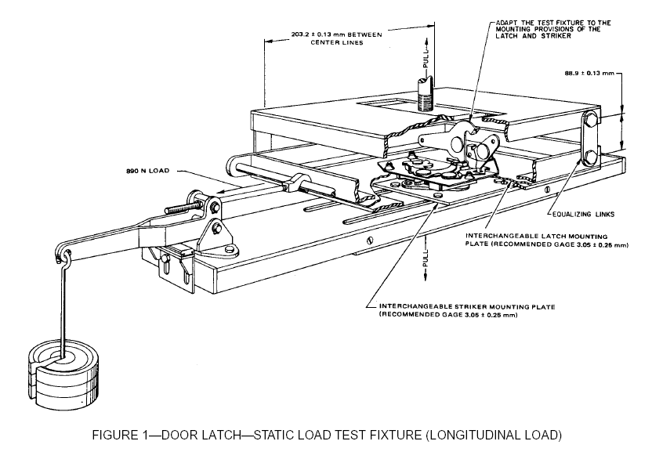
Figure 1 – Door Latch - Tensile Testing Fixture (Longitudinal Load)

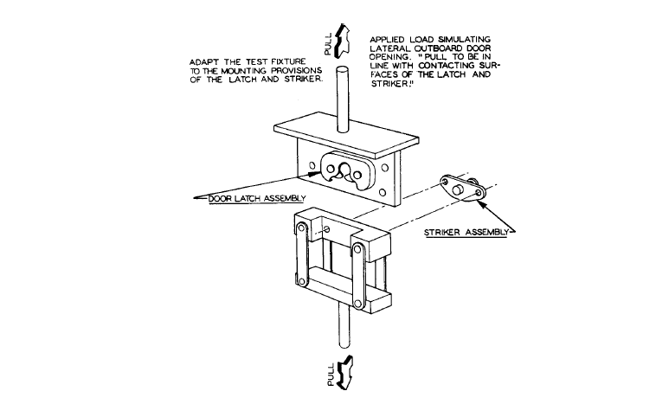
Figure 2 – Door Latch – Static Load Test Fixture (Lateral Load)

Figure 2 – Door Latch – Tensile Testing Fixture (Transversal Load)
[OICA & USA]
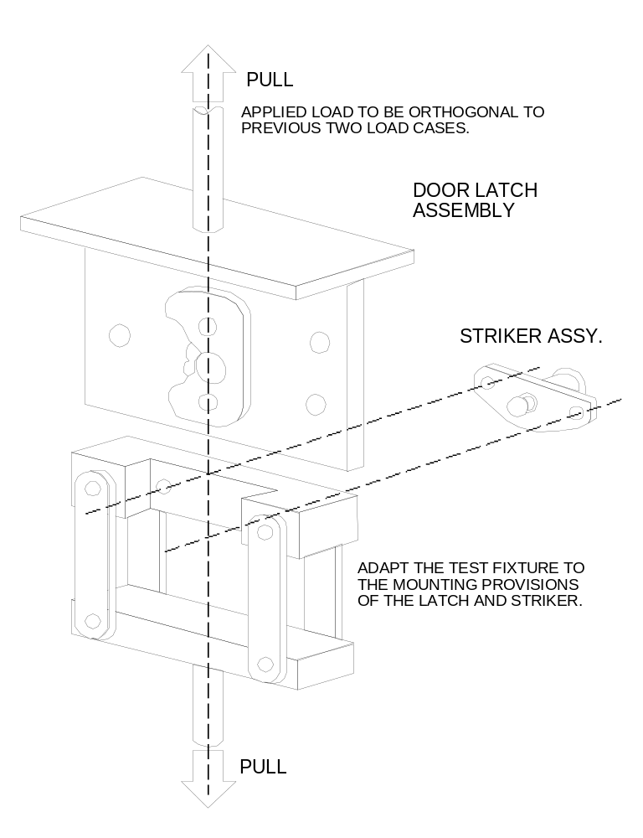
Figure 3 - Door Latch – Tensile Testing Fixture (Vertical Load)
[USA – entire figure 3]

Annex 2

Inertial Test Procedures

1. Purpose. To determine the ability of the vehicle latch system to resist inertia loading by means of a mathematical analysis of the component parts in their true car relationship or by evaluation using a dynamic test.

2. Test Requirements
[Delete entire Section 2 and replace with revised Section 2 below]
2.1. The primary door latch on each hinged door shall not disengage from the fully latched position when an inertia load of 30 g - 36 g is applied to the door latch system, including the latch and its activation mechanism, in the directions parallel to the vehicle's longitudinal and transverse axes with the locking mechanism disengaged.

2.2. The primary door latch on each hinged back door shall also not disengage from the fully latched position when an inertia load of 30 g – 36 g is applied to the door latch system, including the latch and its activation mechanism, in the direction parallel to the vehicle’s vertical axis, with the locking mechanism disengaged.

2.3. Validate the requirements using either by mathematical calculation or by a dynamic test (see items 3.1. and 3.2., and Figure 1).

2. Test Requirements. A side or primary back door latch shall not disengage from the fully-latched position when an inertia load of 30g is applied to the door latch system (including the latch and its actuating mechanism with the locking mechanism disengaged) in the directions of the vehicle’s longitudinal, transverse and vertical axis. Validate the requirement for each door by mathematical calculation (Option 1, see Section 3.1), by a full vehicle dynamic test (Option 2, see Section 3.2), or by a door-on-sled dynamic test (Option 3, see Section 3.3).
[Informal Working Group Correction]

3. Test Procedures

[USA - calculation consideration moved to 3.1.2]
3.1 Option 1

3.1.1 . The procedure described in this section provides a means for analytically determining the ability of a door latch system to withstand inertia loading. Spring forces are the average of the minimum spring output in the installed position and the minimum spring output in the release position. Friction effects and work to be done are not considered in the calculations. Gravitational pull on components may also be omitted if it tends to restrict unlatching. These omissions from the calculations are permissible because they provide additional factors of safety.
[OICA]

3.1.2. Calculation Consideration—Each component or subassembly can be calculated for its minimum inertia load resistance in a particular direction. Their combined resistance to the unlatching operation must assure that the door latch system (when properly assembled in the vehicle door) will remain latched when subjected to an inertia load of 30 g in any direction. Figure 2 is an example of the components and combinations of components to be considered.
[USA – reorganized and renumbered to accommodate OICA suggestion]

[USA - Delete rest of test procedure (sections 3.2 – 3.2.3.4.2) and replace with Informal Working Group test procedure provided below]

3.2. Option 2, Dynamic Test (allows for evaluation using full vehicle or door-on-sled)

3.2.1. Full Vehicle Test

3.2.1.1. Test Equipment

3.2.1.1.1. An acceleration device

3.2.1.1.2. A vehicle or a vehicle body in white (i.e., vehicle frame, doors and other door retention components) including door(s), door latch(es), exterior door handles with mechanical latch operation, interior door opening lever and the locking device (to be attached to the sled device).

3.2.1.1.3. A device or means for recording door opening / /

3.2.1.1.4. Equipment for measuring and recording accelerations.

3.2.1.2. Test Setup

3.2.1.2.1. Close the door and ensure that the latch is in the primary position

3.2.1.2.2. Mount the high speed camera to the exterior of each side and the back of the vehicle facing the doors

3.2.1.2.3. Ensure doors are shut in the primary latched position, tethered and unlocked

3.2.1.2.4. Attach the device for record door openings

3.2.1.2.5. Rigidly secure the full vehicle or vehicle body in white to a device that when accelerated together assure that all points on the crash pulse curve are within the corridor defined in Figure 2.

3.2.1.2.6. Longitudinal Setup. Orient the acceleration device in the direction of a frontal impact.

3.2.1.2.7. Transverse Setup. Orient the acceleration device in the direction of a side impact.

3.2.1.2.8. For vehicles that have asymmetrical doors on each side, two tests will be conducted from each side of the vehicle

3.2.2. Door Deceleration Test

3.2.2. Door Test
[OICA]

3.2.2.1. Test Equipment

3.2.2.1.1. The door assembly including all its door-retention and load-bearing components (i.e., latch, striker and hinges)

3.2.2.1.2. A buck to mount the door(s)

3.2.2.1.3. An acceleration device

3.2.2.1.4. A tether

3.2.2.1.5. A means for recording door opening /

3.2.2.1.6. Equipment for measuring and recording accelerations

3.2.2.2. Test Setup

3.2.2.2.1. Ensure that the latch and striker are engaged in the primary position and that the door is tethered and unlocked

3.2.2.2.2. Mount the door assemblies either separately or combined to the buck. The doors should be mounted to correspond to their orientation in the vehicle and to the direction required for inertial load tests (see below)

3.2.2.2.3. Attach the device for recording door openings

3.2.2.2.4. Mount the buck to the acceleration device

3.2.2.2.5. Longitudinal Setup. Orient the door subsystem(s) on the acceleration device in the direction of a frontal impact (the door(s) should be configured similar to their in-vehicle-position)

3.2.2.2.6. Transverse Setup. Orient the door subsystem(s) on the acceleration device in the direction of a side impact (the door(s) should be configured similar to their in-vehicle-position)

3.2.2.2.7. Vertical/Orthogonal (for back doors only). Orient the door subsystem(s) on the acceleration device in the direction of a side impact (the door(s) should be configured similar to their in-vehicle-position)

3.2.3. Test Operation

3.2.3.1. The test acceleration pulse corridor is defined in Table 1 and graphically shown in Figure 3.

3.2.3.2. Accelerate the test fixture to 30 g’s over a period of 16 to 20 ms and hold the acceleration within the pulse corridor (defined in Figure 1) for at least 20 ms in the following directions:

3.2.3.2.1. In both horizontal directions parallel to the vehicle longitudinal axis (positive and negative X-direction)

3.2.3.2.2. In both horizontal transverse directions (positive and negative Y-direction)

3.2.3.2.3. Table 1 and Figure 2 presents the pulse corridors for the acceleration of the test

3.2.3.3. Then decelerate the device over a period of 20 to 40 ms.

3.2.3.4. When the test is complete, verify whether that the door latch(es) are still in either the primary or secondary latched position. Perform the following validation test:

3.2.3.4.1. Apply a horizontal (+5 degrees) force of 250 N perpendicular to the longitudinal centreline of the vehicle in the door opening direction. The force shall be applied at a point on the door that is 5 cm (+1 cm) from the centre of the exterior door. The door shall not open from the secondary latched position

3.2.3.4.2. Ensure that the door did not open and close during the test.

[USA - Replace sections 3.2 – 3.2.3.4.2 (listed above) with Informal Working Group test procedure provided below.]

3.2 Option 2, Full Vehicle Dynamic Test

3.2.1 Test Equipment

3.2.1.1 An acceleration (or deceleration) device.

3.2.1.2 A sled gun.

3.2.1.3 A vehicle or a vehicle body in white (i.e., vehicle frame, doors and other door retention components) including door(s), door latch(es), exterior door handle(s) with mechanical latch operation, interior door opening lever(s), the locking device(s), interior trim and door seal.

3.2.1.4 A device or means for recording door opening.

3.2.1.5 Equipment for measuring and recording sled accelerations.

3.2.2 Test Setup

3.2.2.1 Mount the full vehicle or vehicle body in white on the sled. If the sled cannot accommodate the full vehicle, the following may be removed: engine, transmission, axles, exhaust, and seats. To ensure that all points on the crash pulse curve are within the corridor defined in Figure 3, fluids, batteries and unsecured components may be removed.

3.2.2.2 The doors may be tethered to avoid damaging the equipment used to record door opening.

3.2.2.3 Install the equipment used to record door opening.

3.2.2.4 Close the door(s) to be tested and ensure that the door latch(es) are in the fully-latched position, that the door(s) are unlocked, and that all windows, if provided, are closed.

3.2.3 Test Directions

3.2.3.1 Longitudinal Setup 1. Orient the vehicle or body in white so that its longitudinal axis is aligned with the axis of sled acceleration, simulating a frontal impact.

3.2.3.2 Longitudinal Setup 2. Orient the vehicle or body in white so that its longitudinal axis is aligned with the axis of sled acceleration, simulating a rear impact.

3.2.3.3 Transverse Setup 1. Orient the vehicle or body in white so that its transverse axis is aligned with the axis of sled acceleration, simulating a driver-side impact.

3.2.3.4 Transverse Setup 2 (Only for vehicles having asymmetrical doors on each side). Orient the vehicle or body in white so that its transverse axis is aligned with the axis of sled acceleration, simulating a side impact in the direction opposite to that described in 3.2.3.3.

3.3 Option 3, Door Dynamic Test

3.3.1 Test Equipment

3.3.1.1 The door assembly(ies) including door latch(es), exterior door handle(s) with mechanical latch operation, interior door opening lever(s), the locking device(s) and interior trim.

3.3.1.2 A test fixture to mount the door(s).

3.3.1.3 An acceleration (or deceleration) device.

3.3.1.4 A sled gun.

3.3.1.5 A tether.

3.3.1.6 A device or means for recording door opening ².

3.3.1.7 Equipment for measuring and recording sled accelerations.

3.3.2 Test Setup

3.3.2.1 Mount the door assemblies either separately or combined to the test fixture. Each door and striker should be mounted to correspond to its orientation on the vehicle and to the direction required for inertial load tests (see Section 3.3.3).

3.3.2.2 Mount the test fixture to the acceleration device.

3.3.2.3 Install the equipment used to record door opening.

3.3.2.4 Ensure that the door latch is in the fully-latched position, that the door is tethered, unlocked, and that the window, if provided, is closed.

3.3.3 Test Directions

3.3.3.1 Longitudinal Setup 1. Orient the door subsystem(s) on the acceleration device in the direction of a frontal impact.

3.3.3.2 Longitudinal Setup 2. Orient the door subsystem(s) on the acceleration device in the direction of a rear impact.

3.3.3.3 Transverse Setup 1. Orient the door subsystem(s) on the acceleration device in the direction of a driver-side impact.

3.3.3.4 Transverse Setup 2. Orient the door subsystem(s) on the acceleration device in the direction opposite to that described in 3.3.3.3.

3.3.3.5 Vertical Setup 1. (Only for back doors). Orient the door subsystem(s) on the acceleration device so that its vertical axis (when mounted in a vehicle) is aligned with the axis of sled acceleration, simulating a rollover impact where the force is applied in the direction from the top to the bottom of the door (when mounted in a vehicle).

3.3.3.6 Vertical Setup 2. (Only for back doors). Orient the door subsystem(s) on the acceleration device so that its vertical axis (when mounted in a vehicle) is aligned with the axis of sled acceleration, simulating a rollover impact where the force is applied in the direction opposite to that described in 3.3.3.5.

3.4 Test Operation for Options 2 and 3

3.4.1 A minimum acceleration level of 30g shall be maintained over a period of at least 30 ms, while keeping the sled’s acceleration within the pulse corridor as defined in Table 1 and graphically shown in Figure 2.

3.4.2 Accelerate the test fixture(s) in the following directions:

3.4.2.1 For Option 2 tests:

3.4.2.1.1 In the direction specified in 3.2.3.1.

3.4.2.1.2 In the direction specified in 3.2.3.2.

3.4.2.1.3 In the direction specified in 3.2.3.3.

3.4.2.1.4 In the direction specified in 3.2.3.4.

3.4.2.2 For Option 3 tests:

3.4.2.2.1 In the direction specified in 3.3.3.1.

3.4.2.2.2 In the direction specified in 3.3.3.2.

3.4.2.2.3 In the direction specified in 3.3.3.3.

3.4.2.2.4 In the direction specified in 3.3.3.4.

3.4.2.2.5 In the direction specified in 3.3.3.5.

3.4.2.2.6 In the direction specified in 3.3.3.6.

    - If at any point in time the pulse exceeds 36g and the test requirements are fulfilled, the test shall be considered valid.

    - Ensure that the door did not open and close during the test.

+X  +Z  +Y  +X  -Y  -X  -Z  -X | 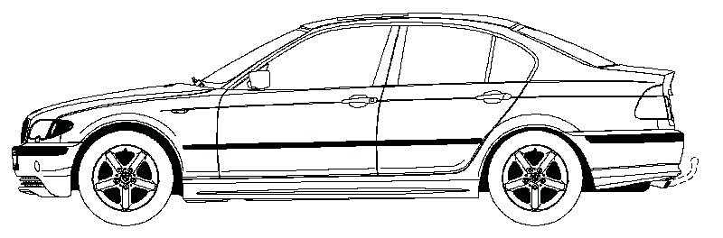
 | 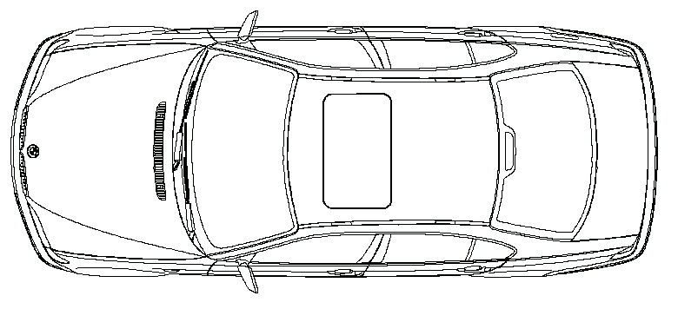
X = longitudinal direction
Y = transversal direction
Z = vertical direction

Figure 1 - Vehicle Coordinate Reference System for Inertia Testing
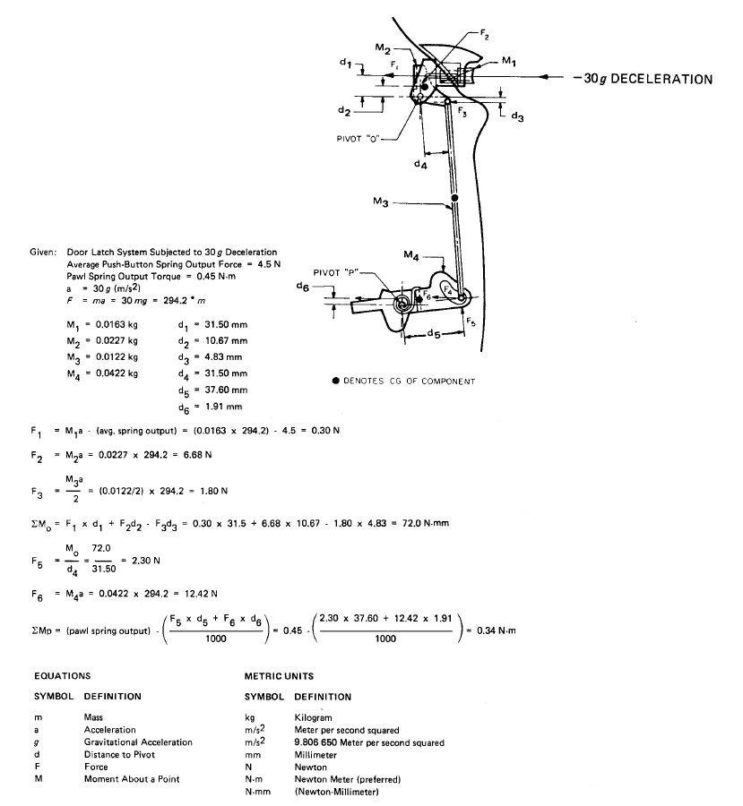

Figure 2 – Inertial Loading – Sample Calculation

Upper Bound |  |  | Lower Bound
Point | Time (ms) | Acceleration (g) | Point | Time (ms) | Acceleration (g)
A | 0 | 6 | E | 5 | 0
B | 20 | 36 | F | 25 | 30
C | 60 | 36 | G | 55 | 30
D | 100 | 0 | H | 70 | 0

Table 1 - Sled Pulse Corridor

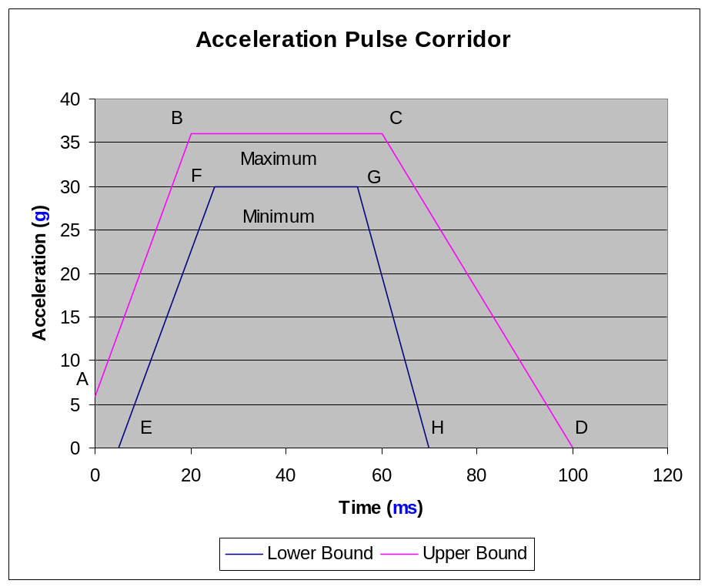

Figure 3 – Sled Pulse
[Annex 3
Combination Loading Test
The test is conducted with the latch and striker in their fully latched position, and loaded such that:

(1) a constant tension force as specified in paragraph 5.1.5. of this regulation is applied by a transverse loading device in the direction of the fork bolt opening, and parallel to the face of the latch, and

(2) while maintaining the constant transverse load, a compression load through the striker and perpendicular to the face of the latch is then applied at a rate of 10 mm per minute as specified in paragraph 5.1.5 of this regulation.

Test Equipment

The test equipment consists of:

A test device is prepared for mounting the latch mechanism. [This involves cutting a notch in the rigid plate so that the striker and longitudinal shaft can apply load to the latch mechanism without interfering with the rigid plate. Holes must be drilled and tapped into the plate to allow mounting of the latch mechanism, and the striker attached to the loading device.] An illustration of the device is shown in [Figure 1].

Pre-test Conditions

1. The trolley with the latch is positioned and the longitudinal ram is run down to engage the striker with the latch in the primary latched position.

2. Movement of the latch is constrained in a direction parallel to the face of the latch.

Test Procedure

1. The transverse ram loads the latch to 6,650 N and maintains this load throughout the course of the test.

2. When the transverse load of 6,650 N is reached, the longitudinal ram applies a compressive load on the latch at a displacement rate of 10 mm/min.

3. After reaching the longitudinal load of 16,000 N, compliance is achieved by maintaining the load and not separating for at least 10 seconds]

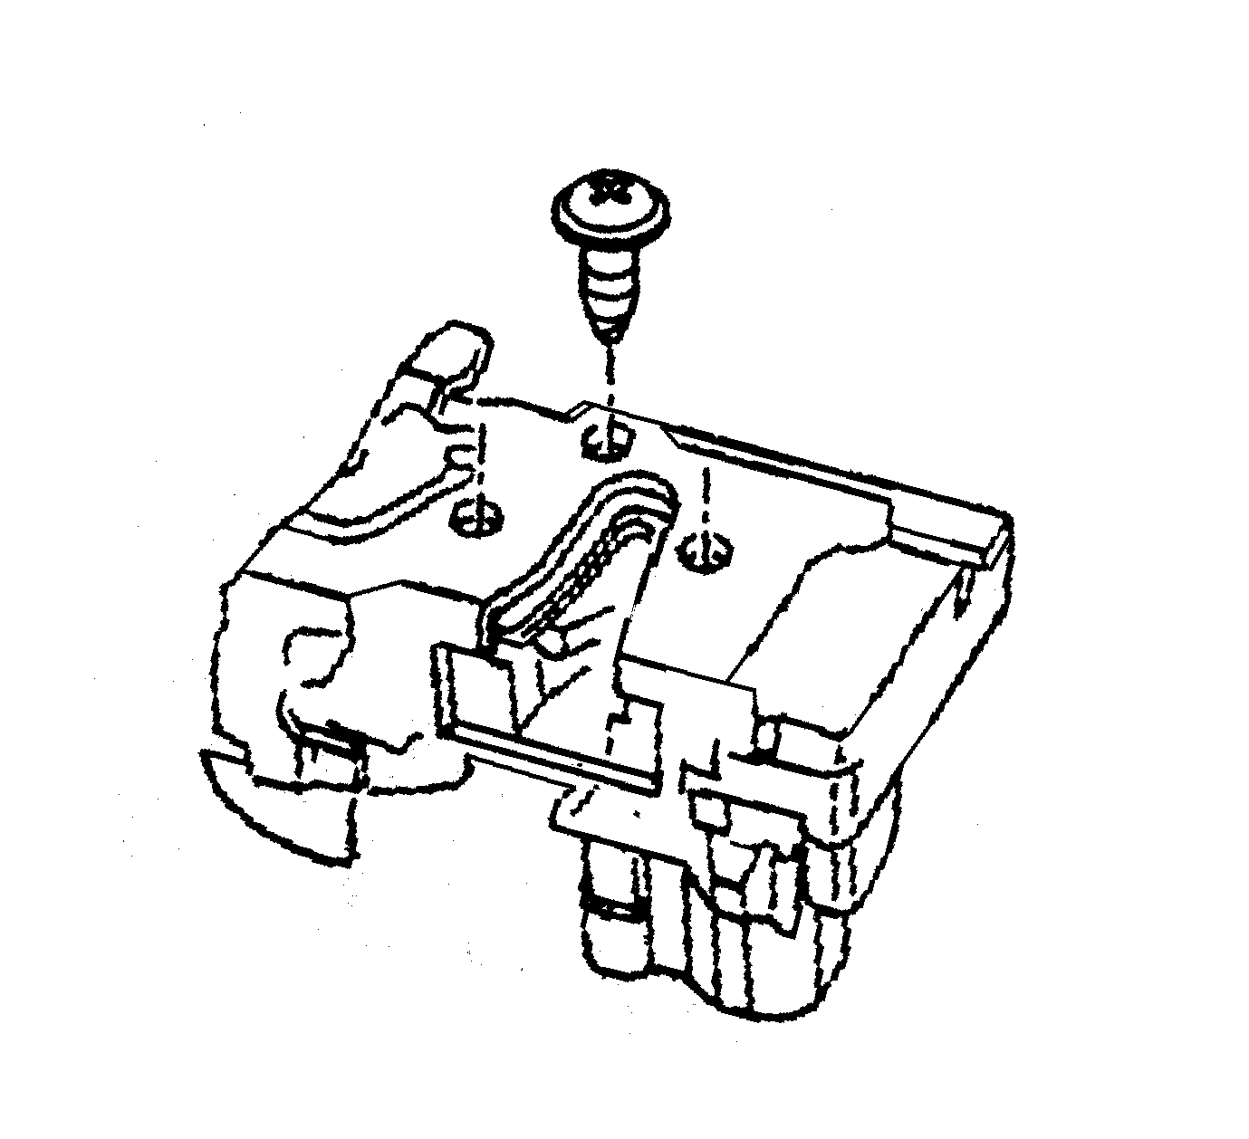
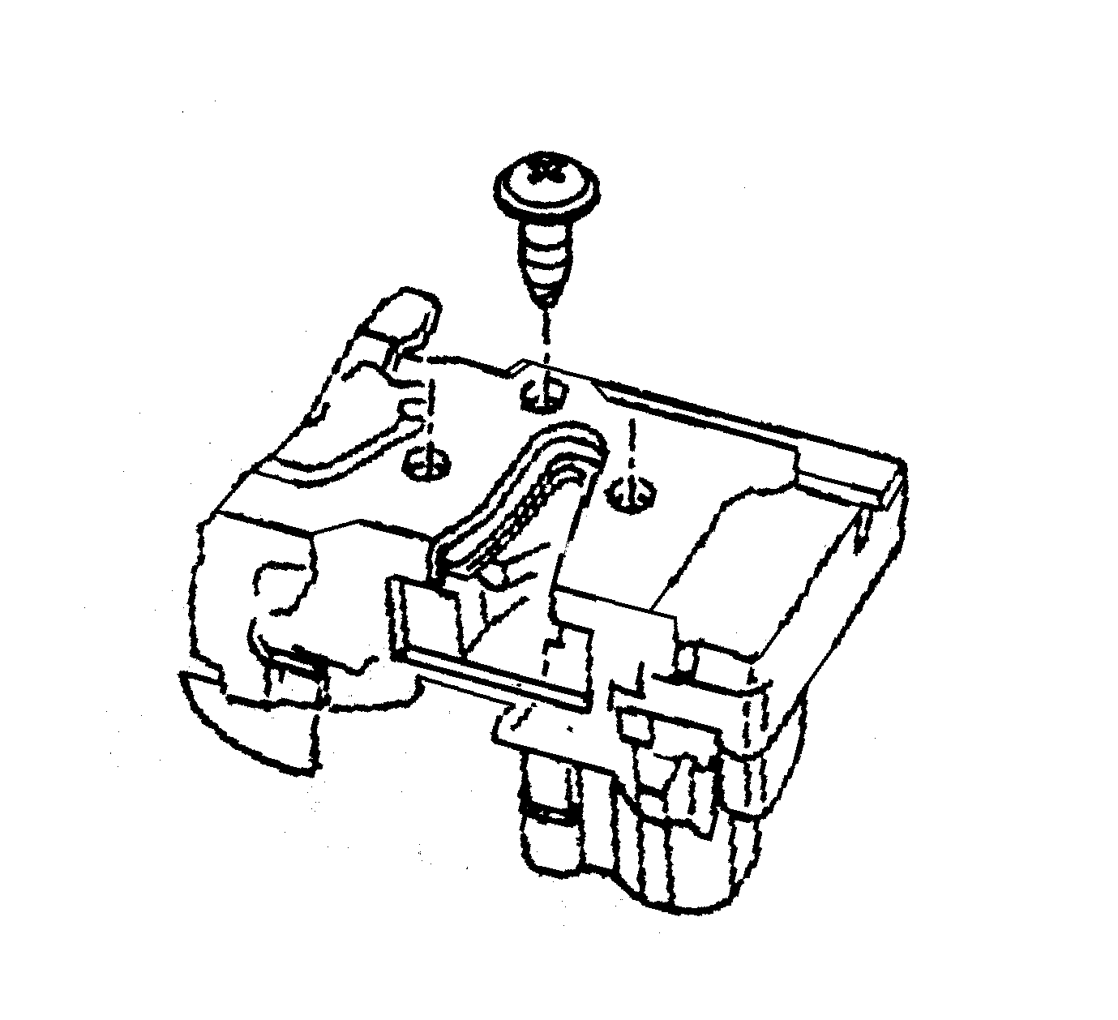
DIRECTION OF APPLIED FORCE (Simulating force parallel to the latch face along the vehicle’s transverse axis.)
DIRECTION OF APPLIED FORCE
(Simulating force perpendicular to
latch face along vehicle’s longitudinal axis.)
LATCH
STRIKER
TRANSVERSE CONSTRAINT
Figure 1 – Combination Loading Test

LONGITUDINAL LOADING DEVICE
TRANSVERSE LOADING DEVICE
Movement of loading device to mate the latch with the striker
LATCH
OPENING
Annex 4

Hinge Test Procedure

1. Purpose. These test are conducted to determine the ability of the vehicle hinge system to withstand a test load in the longitudinal and transversal vehicle directions.

1. Purpose. These test are conducted to determine the ability of the vehicle hinge system to withstand a test load in the longitudinal, transversal, and vertical vehicle directions.
[OICA]

2. Definitions

2.1. Hinge—That system used to position the door relative to the body structure and control the path of the door swing for passenger ingress and egress.

2.2. Hinge Components

2.2.1. Door Member—That portion of the hinge normally affixed to the door structure and constituting the swinging member.

2.2.2. Body Member—That portion of the hinge normally affixed to the body structure and constituting the fixed member.

2.2.3. Hinge Pin—That portion of the hinge normally interconnecting the body and door members and establishing the swing axis.

3. Basic Requirements

3.1. Longitudinal Load—A vehicle passenger door hinge system, when tested as described in paragraph 4, must be capable of withstanding an ultimate longitudinal load of 11,000 N.

3.2. Transverse Load—A vehicle passenger door hinge system, when tested as described in paragraph 4, must be capable of withstanding an ultimate transverse load of 9,000 N.

[USA – Add sections 3.3 and 3.4]
3.3 Vertical Load—A vehicle back door hinge system, when tested as described in paragraph 4, must be capable of withstanding an ultimate vertical load of 9,000 N.

3.4 If a single hinge within the hinge system is tested instead of the entire hinge system, the hinge must bear a load proportional to the total number of hinges in the hinge system.

4. Test Procedure

4.1. Multiple Hinge Evaluation

4.1.1. Longitudinal Load Test

4.1.1.1. Equipment

4.1.1.1.1. Tensile testing machine

4.1.1.1.2. A typical static test fixture is illustrated in Figure 1.

4.1.1.2. Procedure

4.1.1.2.1. Attach a test fixture to the mounting provision of the hinge system. Hinge attitude must simulate vehicle position (door fully closed) relative to the hinge centreline. For test purposes, the distance between the extreme ends of one hinge in the system to the extreme end of another hinge in the system is to be set at 406 mm. The load is to be applied equidistant between the linear centre of the engaged portions of the hinge pin and through the centreline of the hinge pin in the longitudinal vehicle direction.

4.1.1.2.1. Attach a test fixture to the mounting provision of the hinge system. Hinge attitude must simulate vehicle position (door fully closed) relative to the hinge centreline. For test purposes, the distance between the extreme ends of one hinge in the system to the extreme end of another hinge in the system is to be set at 406 ± 4 mm. The load is to be applied equidistant between the linear centre of the engaged portions of the hinge pin and through the centreline of the hinge pin in the longitudinal vehicle direction.
[OICA]

4.1.1.2.2. Apply the test load at a rate not to exceed 50 mm/min until failure. Failure to consist of separation of either hinge. Record maximum load.

4.1.1.2.2. Apply the test load at a rate not to exceed 50 mm/min until the required load has been surpassed. Failure consists of separation of either hinge. Record the maximum load achieved.
[OICA & USA]

4.1.2. Transverse Load Test

4.1.2.1. Equipment

4.1.2.1.1. Tensile testing machine

4.1.2.1.2. A typical static test fixture is illustrated in Figure 1.

4.1.2.2 Procedure

4.1.2.3 Attach the test fixture to the mounting provisions of the vehicle hinge system. Hinge attitude must simulate vehicle position (door fully closed) relative to the hinge centreline. For test purposes, the distance between the extreme ends of one hinge in the system to the extreme opposite end of another hinge in the system is to be set at 406 mm. The load is to be applied equidistant between the linear centre of the engaged portions of the hinge pins and through the centreline of the hinge pin in the transverse vehicle direction.

4.1.2.2.1 Attach the test fixture to the mounting provisions of the vehicle hinge system. Hinge attitude must simulate vehicle position (door fully closed) relative to the hinge centreline. For test purposes, the distance between the extreme ends of one hinge in the system to the extreme opposite end of another hinge in the system is to be set at 406 ± 4 mm. The load is to be applied equidistant between the linear centre of the engaged portions of the hinge pins and through the centreline of the hinge pin in the transverse vehicle direction.
[OICA & USA]

4.1.2.4 Apply the test load at a rate not to exceed 50 mm/min until failure. Failure to consist of separation of either hinge. Record maximum load.

4.1.2.2.2 Apply the test load at a rate not to exceed 50 mm/min until the required load has been surpassed. Failure consists of separation of either hinge. Record the maximum load achieved.

[USA/OICA – Add Section 4.1.3 - Vertical Load Test per main regulation text]

4.1.3. Vertical Load Test

4.1.3.1. Equipment

4.1.3.1.1. Tensile testing machine

4.1.3.1.2. A typical static test fixture is illustrated in Figure 2.

4.1.3.2 Procedure

4.1.3.2.1 Attach the test fixture to the mounting provisions of the vehicle hinge system. Hinge attitude must simulate vehicle position (door fully closed) relative to the hinge centreline. For test purposes, the distance between the extreme ends of one hinge in the system to the extreme opposite end of another hinge in the system is to be set at 406 ± 4 mm. The load is to be applied centerline of the hinge pin in a direction orthogonal to the longitudinal and transverse loads.

4.1.3.2.2 Apply the test load at a rate not to exceed 50 mm/min until the required load has been surpassed. Failure consists of separation of either hinge. Record the maximum load achieved.

4.2. Single Hinge Evaluation. In some circumstances, it may be necessary to conduct evaluations of individual hinges in a hinge system. In such cases, the results for an individual hinge, when tested in accordance with the procedures below, shall be such as to indicate that system requirements in paragraphs 3.1 and 3.2 are met. (For example, an individual hinge in a two-hinge system must be capable of withstanding 50 per cent of the load requirements of the total system.)

4.2. Single Hinge Evaluation. In some circumstances, it may be necessary to conduct evaluations of individual hinges in a hinge system. In such cases, the results for an individual hinge, when tested in accordance with the procedures below, shall be such as to indicate that system requirements in paragraphs 3.1, 3.2, and 3.3 are met. (For example, an individual hinge in a two-hinge system must be capable of withstanding 50 per cent of the load requirements of the total system.)
[USA]

4.2.1. Test Procedures

4.2.1.1. Longitudinal Load—Attach a test fixture to the mounting provision of the hinge. Hinge attitude must simulate the vehicle position (door fully closed) relative to the hinge centreline. For test purposes, the load is to be applied equidistant between the linear centre of the engaged portions of the hinge pin and through the centreline of the hinge pin in the longitudinal vehicle direction. Apply the test load at a rate not to exceed 50 mm/min until failure (failure to consist of separation of either hinge). Record maximum load.

4.2.1.1. Longitudinal Load—Attach a test fixture to the mounting provision of the hinge. Hinge attitude must simulate the vehicle position (door fully closed) relative to the hinge centreline. For test purposes, the load is to be applied equidistant between the linear centre of the engaged portions of the hinge pin and through the centreline of the hinge pin in the longitudinal vehicle direction. Apply the test load at a rate not to exceed 50 mm/min until the required load has been surpassed. Failure consists of separation of either hinge. Record the maximum load achieved.
[OICA & USA]

4.2.1.2. Transverse Load—Attach the test fixture to the mounting provision of the vehicle hinge. Hinge attitude must simulate the vehicle position (door fully closed) relative to the hinge centreline. For test purposes, the load is to be applied equidistant between the linear centre of the engaged positions of the hinge pin and through the centreline of the hinge pin in the transverse vehicle direction. Apply the test load at a rate not to exceed 50 mm/min until failure (failure to consist of separation of either hinge). Record maximum load.

4.2.1.2. Transverse Load—Attach the test fixture to the mounting provision of the vehicle hinge. Hinge attitude must simulate the vehicle position (door fully closed) relative to the hinge centreline. For test purposes, the load is to be applied equidistant between the linear centre of the engaged positions of the hinge pin and through the centreline of the hinge pin in the transverse vehicle direction. Apply the test load at a rate not to exceed 50 mm/min until the required load is surpassed. Failure consists of separation of either hinge. Record the maximum load achieved.
[OICA & USA]

[USA/OICA – Add Section 4.2.1.3 - Vertical Load Test per main regulation text]

4.2.1.3. Vertical Load—Attach the test fixture to the mounting provision of the vehicle hinge. Hinge attitude must simulate the vehicle position (door fully closed) relative to the hinge centreline. For test purposes, the load is to be applied centerline of the hinge pin in a direction orthogonal to the longitudinal and transverse loads. Apply the test load at a rate not to exceed 50 mm/min until the required load is surpassed. Failure consists of separation of either hinge. Record the maximum load achieved.

4.3. For piano-type hinges, the hinge spacing requirements are not applicable and arrangement of the test fixture is altered so that the test force is applied to the complete hinge.

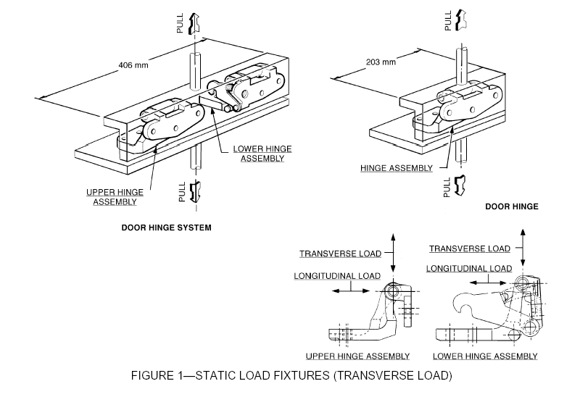
Figure 1 – Static load fixtures (transverse and longitudinal load)

[USA – Add Figure 2]
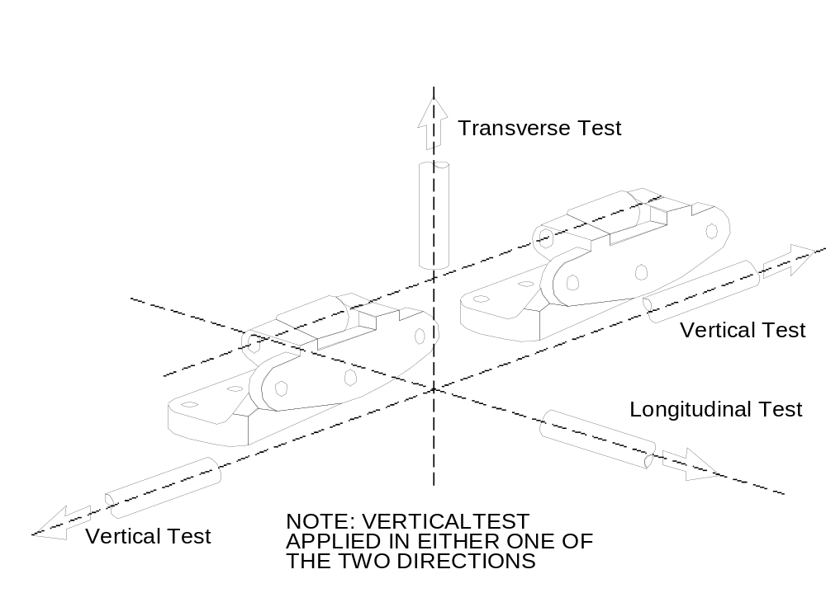

Figure 2 – Static load test directions for back doors
Annex 5
Sliding Side Door
Full Door Test

1. General Provisions

1.1. Tests are conducted using a full vehicle or a body in white with the sliding door and its retention components.

1.2. The test is conducted using two force application devices capable of applying the outward transverse forces specified in paragraph 5.2.4. The force application system shall consist of two plates, two load cells capable of measuring the applied force specified in paragraph 5.2.4., two linear displacement measurement devices, and equipment for recording the applied force and displacement rate. The test setup is shown in Figure 4.

1.2. The test is conducted using two force application devices capable of applying the outward transverse forces specified in paragraph 5.2.4 of this regulation. The force application system shall consist of two plates, two load cells capable of measuring the applied force specified in paragraph 5.2.4. of this regulation, two linear displacement measurement devices, and equipment for recording the applied force and displacement rate. The test setup is shown in Figure 1.
[USA]

[USA – Sections 1.2.1 – 1.2.4 moved from Test Equipment section listed later in Annex]
1.2.1 Two loading devices, or rams, capable of applying the outward transverse load requirements [for a minimum displacement of 460 mm]

1.2.1 Two loading devices, or rams, capable of applying the outward transverse load requirements [for a minimum displacement of 300 mm].
[USA]

1.2.2. Two load cells of sufficient capacity to measure the applied load

1.2.3. Two linear displacement measurement devices required for measuring ram displacement during the test. [Note: Deflection measurements are necessary if the load is to be applied at a constant displacement rate, or if maximum displacement is a criterion.]

1.2.4 Equipment for measuring and recording the applied load and the ram displacement rate.

1.2.5. Equipment for measuring at least 100 mm of separation between the interior of the door and the exterior edge of the doorframe.
[USA - new]

2. Test Setup

2.1. Remove all interior trim and decorative components from the sliding door assembly.

2.2. Remove seats and any interior components that may interfere with the mounting and operation of the test equipment.

2.3. Mount the force application devices and associated support structure to the floor of the test vehicle.

2.4. Determine the forward and aft edge of the sliding door, or its adjoining vehicle structure, that contains a latch/striker.

2.5. For any tested door edge that contains one latch/striker, the following set-up procedures are used:

2.5.1. The force application plate is 150 mm in length and 50 mm in width.

2.5.2. Place the force application device and force application plate against the door so that the applied force is horizontal and normal to the vehicle’s longitudinal centreline, and vertically centred on the door-mounted portion of the latch/striker.

2.5.3. The force application plate is positioned as close to the edge of the door as possible. It is not necessary for the force application plate to be vertical.

2.6. For any tested door edge that contains more than one latch/striker, the following set-up procedures are used:

2.6.1. The force application plate is 300 mm in length and 50 mm in width.

2.6.2. Place the force application device and force application plate against the door so that the applied force is horizontal and normal to the vehicle’s longitudinal centreline, and vertically centred on a point mid-way between the outermost edges of the latch/striker.

2.6.3. The force application plate is positioned as close to the edge of the door as possible. It is not necessary for the force application plate to be vertical.

2.7. For any tested door edge that does not contain at least one latch/striker, the following set-up procedures are used:

2.7.1. The force application plate is 300 mm in length and 50 mm in width.

2.7.2. Place the force application device and force application plate against the door so that the applied force is horizontal and normal to the vehicle’s longitudinal centreline, and vertically centred on a point mid-way along the length of the door edge ensuring that the loading device avoids contact with the window glazing.

2.7.3. The force application plate is positioned as close to the edge of the door as possible. It is not necessary for the force application plate to be vertical.

2.8. The door is unlocked. No extra fixtures or components may be welded or affixed to the sliding side door or any of its components.

[USA – Section 2.9 moved from Section 3.1]
2.9. Close the sliding door, ensuring that all door retention components are fully and properly engaged.

2.10. Attach any equipment used for measuring door separation that will be used to determine separation levels during the dynamic portion of the test procedure.
[USA – new]

[USA – Section 2.11 moved from Section 3.2]
2.11 Place the load application structure so that the force application plates are in contact with the interior of the sliding door.

3. Test Procedure

[USA - Section 3.1 and 3.2 moved to section 2.9 and 2.11 respectively]

3.3. Move both force application devices at a rate of [5 mm per minute] until a force of 9,000 N is achieved on each ram [or until the ram displaces 460 mm from their initial position].

3.1 . Move both force application devices at a rate of [20-90 mm per minute as specified by the manufacturer] until a force of 9,000 N is achieved on each ram [or until the ram displaces 300 mm from their initial position].
[USA]

3.4. If one of the force application devices reaches the target force of 9,000 N prior to the other, maintain the 9,000 N force with that force application device until the second force application device reaches the 9,000 N force [or 460 mm of displacement].

3.2. If one of the force application devices reaches the target force of 9,000 N prior to the other, maintain the 9,000 N force with that force application device until the second force application device reaches the 9,000 N force [or 300 mm of displacement].
[USA]

3.5. Once the combined target force of 18,000 N is achieved, hold the force minimum of 10 seconds.

3.3. Once each ram achieves 9,000 N or a displacement of 300 mm, stop forward movement of the ram and hold under the resulting load for a minimum of 10 seconds.
[USA]

[USA-add]
3.4 Maintain the ram position in 3.3. and measure the separation between the exterior edge of the doorframe and the interior of the door along the perimeter of the door at least every 300 mm. Compliance is achieved when the separation at any of the evaluated locations on the perimeter of the door is no greater than 100 mm.

[USA - Test Equipment section moved up to Section 2]
Test Equipment

The test equipment consists of:

1. A vehicle structure, complete with sliding door(s) assembly and all door-retention and load-bearing components.

2. Two loading devices, or rams, capable of applying the outward transverse load requirements [for a minimum displacement of 460 mm]

3. Two load cells of sufficient capacity to measure the applied load

4. Two linear displacement measurement devices required for measuring ram displacement during the test. [Note: Deflection measurements are necessary if the load is to be applied at a constant displacement rate, or if maximum displacement is a criterion.]

5. Equipment for measuring and recording the applied load and the ram displacement rate.

[USA – Pre-test Setup section deleted, duplicate requirements]

Pre-test Setup

1. Remove all interior trim and decorative components from the sliding door assembly.

2. Remove seats and any interior components, which may interfere with the mounting and operation of test equipment.

3. The rams and associated support structure are mounted rigidly to the floor of the test vehicle.

4. The load application structure shall consist of two loading plates.

5. Determine the forward and aft edge of the sliding door (or its adjoining vehicle structure), which contains a compliant latch/striker. The door edge containing such a latch/striker, and the opposite door edge, are to be tested. If adjacent door edges contain a compliant latch/striker, both sides are to be tested.

6. For forward and aft door edge to be tested that contains exactly one compliant latch/striker, the following set-up procedures are to be used:
a. The loading plate shall be 150 mm in length and 50 mm in width.
b. Locate the loading device and loading plate such that the applied load will be horizontal, normal to the vehicle’s longitudinal centreline, and centred on the door-mounted portion of the compliant latch/striker. Any non-compliant door retention components on this door edge are to be ignored in this set-up.
c. The loading plate should be positioned as close to the edge of the door as possible. It is not necessary for the loading plate to be vertical.

7. For any door edge to be tested that contains more than one compliant latch/striker, the following set-up procedures are to be used:
a. The loading plate shall be 300 mm in length and 50 mm in width.
b. Locate the loading device and loading plate such that the applied load will be horizontal, normal to the vehicle’s longitudinal centreline, and centred on a point mid-way between the outermost compliant latch/strikers. Any non-compliant door retention components on this door edge are to be ignored in this set-up.
c. The loading plate should be positioned as close to the edge of the door as possible. It is not necessary for the loading plate to be vertical.

8. For any door edge to be tested that does not contain at least one compliant latch/striker, or that contains only non-compliant door retention components, the following set-up procedures are to be used:
a. The loading plate shall be 300 mm in length and 50 mm in width.

[USA – Test procedure section deleted, duplicated above]
Test Procedure

1. After the sliding door is closed, and the load application structure is placed so that the force application plates are in contact with the interior of the sliding door, both force application devices are moved at a rate of [5 mm per minute] until a force of 9,000 N is achieved on each ram [or until the rams displace 460 mm from their initial position.]

2. If one of the force application devices reaches the target force of 9,000 N prior to the other, 9,000 N force is maintained with that force application device until the second force application device reaches the 9,000 N force [or 460 mm of displacement]. After reaching the combined target force of 18,000 N, compliance is achieved by maintaining the load and not separating for at least 10 seconds.

Figure 1 – Sliding Door Full Vehicle Test Procedure
(Note: Sliding door is shown separated from the vehicle)
Loading rams 9000 N at the fore and aft ends of the doors

[USA – new annex]
Annex 6
Category 1-1 and Category 2 Definitions

1. Definitions

1.1. “Category 1 vehicle" means a power driven vehicle with four or more wheels designed and constructed primarily for the carriage of (a) person(s).

1.2. "Driver Mass" means the nominal mass of a driver that shall be 75 kg (subdivided into 68 kg occupant mass at the seat and 7 kg luggage mass in accordance with ISO standard 2416–1992).

1.3. "Gross vehicle mass" of a vehicle means the maximum mass of the fully laden solo vehicle, based on its construction and design performances, as declared by the manufacturer. This shall be less than or equal to the sum of the maximum axles’ (group of axles) capacity.

1.4. "Mass in running order" means the nominal mass of a vehicle as determined by the sum of unladen vehicle mass and driver’s mass.

1.5. "Pay mass" means the goods-carrying capacity of the vehicle which is the figure obtained by subtracting the unladen vehicle mass and the driver and passenger masses from the gross vehicle mass.

2.

2.1. "Category 1-1 vehicle" means a category 1 vehicle comprising not more than eight seating positions in addition to the driver’s seating position. A category 1-1 vehicle cannot have standing passengers.

2.2. "Category 2 vehicle" means a power driven vehicle with four or more wheels designed and constructed primarily for the carriage of goods. This category shall also include:
i) tractive units
ii) chassis designed specifically to be equipped with special equipment.

2.2.1. To determine whether a vehicle is to be regarded as a category 1-1 vehicle or a category 2 vehicle, the following shall apply in cases where it is not immediately apparent whether a vehicle is a category 1-1 or 2 vehicle:

2.2.2. If a vehicle meets all of the following conditions:
P-(M+Nx68)> Nx68,
N ≤ 6 and
Pay mass exceeds 150 kg for the vehicle, as configured with the maximum mass of factory fitted optional equipment, the vehicle shall be deemed to be a category 2 vehicle. In all other cases, the vehicle shall be deemed to be a category 1-1 vehicle.
Where,
P= Gross vehicle mass
M= Mass in running order
N= Maximum number of simultaneous seating and standing positions excluding the driver seating position

2.2.2.1. If there is a seat anchor for a removable seat, the removable seat is to be counted in the determination of the number of seating positions and of the pay mass. Seating position means any individual seat or any part of a bench seat intended to seat one person.

2.2.2.2. Until the entry into force of a GTR on seats, Contracting Parties can use their own criteria to decide the number of seating positions.

___________

At the request of the Working Party on Passive Safety, the U.S. provided data on the magnitude of the door ejections and door openings based on 1994-99 National Automotive Sampling System (NASS) and Fatal Analysis Reporting System (FARS) annual estimates. No data from other jurisdictions were presented.
In the United States the average delta V for crashes where a door opens is approximately 30.5 km/h; the average delta V for crashes where there is no failure of the door retention system is approximately 21 km/h.
Door Latch Integrity Study: Engineering Analysis and NASS Case Review, December, 1991, Docket No. NHTSA-1998-3705.
It is important to note that a failure of the inertial dynamic test only constitutes the latch system releasing from both the primary and secondary positions. Thus, a door system that fails in the primary latched position but retains the secondary position can still pass compliance.
/ It is important to note that a failure of the inertial dynamic test only constitutes the latch system releasing from both the primary and secondary positions. Thus, a door system that fails in the primary latched position but retains the secondary position can still pass compliance.
/ The purpose of this device is to record a door opening during that rebounds off the tether and closes again. Possible devices can include a high speed camera speed with a rate of 500 frames per second or higher or a marker stick which is placed 100 mm from the door end and used to visibly mark the door if an opening occurs.
/ The purpose of this device is to record a door opening during that rebounds off the tether and closes again. Possible devices can include a high speed camera speed with a rate of 500 frames per second or higher or a marker stick which is placed 100 mm from the door end and used to visibly mark the door if an opening occurs.
1 The purpose of this device is to ensure that door opening is recorded if a door opens and re-closes during the test.

