UNITED  NATIONS | E

 | Economic and Social  Council | Distr.  GENERAL  TRANS/WP.29/GRSP/2003/12  5 September 2003  Original: ENGLISH  ENGLISH AND FRENCH ONLY

ECONOMIC COMMISSION FOR EUROPE

INLAND TRANSPORT COMMITTEE

World Forum for Harmonization of Vehicle Regulations (WP.29)

Working Party on General Safety Provisions (GRSP)
(Thirty-fourth session, 8-12 December 2003,
agenda item B.1.1.)

PROPOSAL FOR DRAFT AMENDMENTS TO REGULATION No. 14
(Safety-belt anchorages)

Transmitted by the Expert from Germany

Note: The text reproduced below was transmitted by the expert from Germany in order to align some provisions of the Regulation to FMVSS as well as some further clarifications. It is based on a document distributed without a symbol (informal document No. 1) during the thirty-third session (TRANS/WP.29/GRSP/33, para. 16). The amendments to the current text of the Regulation are marked in bold.

________________

______________
Note: This document is distributed to the Experts on Passive Safety only.
A. PROPOSAL

Paragraph 6.3.2., amend to read:

"6.3.2. The tractive force shall be applied in a direction corresponding to the seating position at an angle of 10 degrees ± 5° above the horizontal in a plane parallel to the median longitudinal plane of the vehicle.
A preload of 10 % with a tolerance of [± 30%] of the target load shall be applied; the load shall be increased to 100% of the relevant target load."
Paragraph 6.3.3., amend to read:

"6.3.3. Full application of the load shall be achieved as rapidly as possible, and within a maximum load application time of 30 seconds.
With the agreement of the manufacturer the application of the load may be achieved within 4 seconds.
The belt anchorages must withstand the specified load for not less than 0.2 second."

Paragraph 6.3.4., amend to read:

"6.3.4. Traction devices to be used in the tests described in paragraph 6.4. below are shown in annex 5. The devices shown in annex 5, figure 1 are placed onto the seat cushion and then pushed back into the seat back while the belt strap is pulled tight around it. The device shown in annex 5 figure 2 is placed in position, the belt strap is fitted over the device and pulled tight.
Instead of the lap belt traction device a similar device with a width of 254 mm shown in annex 5, figure 1a may also be used.

The positioning of the traction device shall avoid any mutual influences during the pull test which adversely affects the load and load distribution."

Annex 5,

Insert a new figure 1a, to read:

"
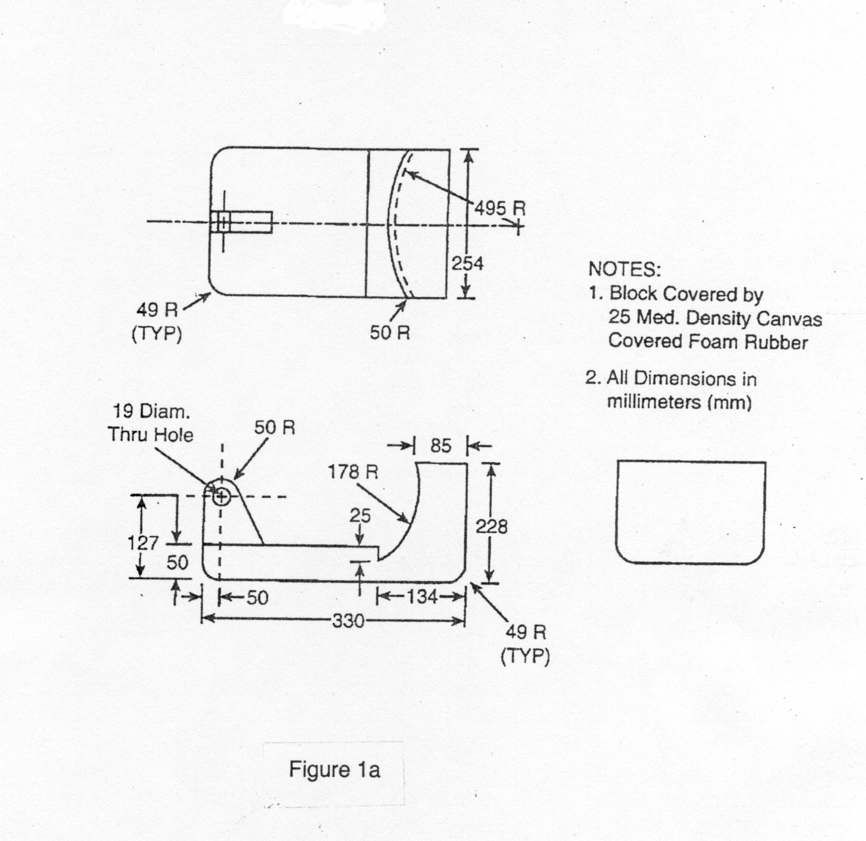
"

Figure 2, amend to read:
"
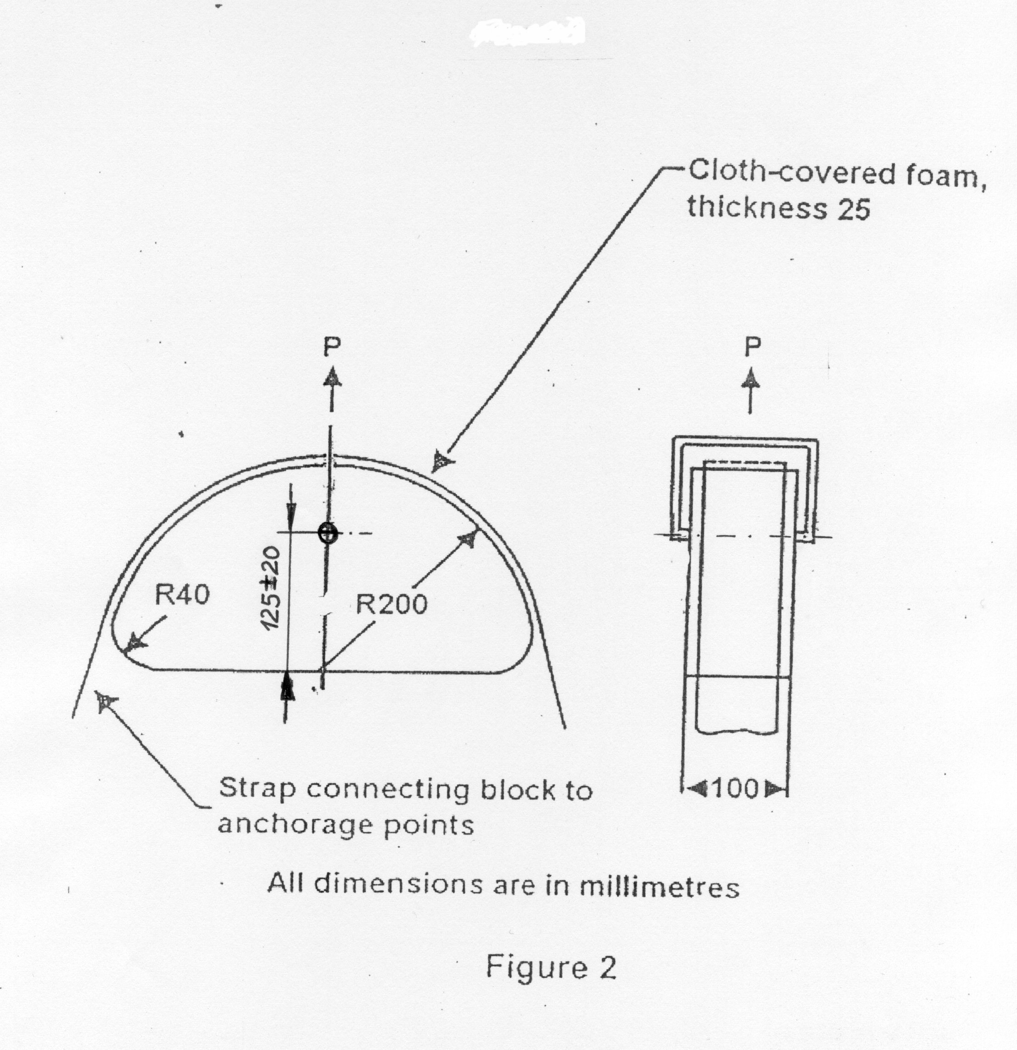

For the fixing of the strap the shoulder belt traction device may be modified by adding of two land edges and /or some bolts to avoid any drop off of the strap during the pull test."

* * *

B. JUSTIFICATION

Re. Paragraph 6.3.2.:

Regulation No. 14 requires loads depending on the different vehicle classes in a range as described in the following table:

Vehicle category | 3 point belt | Lap belt | Additional seat load, if at least one anchorage is fixed to the seat structure
M1/N1 | 13500 N | 22250 N | 20 x mass of the seat
M2/N2 | 6750 N | 11100 N | 10 x mass of the seat
M3/N3 | 4500 N | 7400 N | 6,6 x mass of the seat
Respecting the large range of loads and avoiding conflicts with the control of existing loads.

Regulation No. 14 hydraulic testing machines it is recommended to align the text of the Regulation with the FMVSS procedure.

Re. Paragraph 6.3.3.:

The existing text of Regulation No. 14 requires in paragraph 6.3.3. the following load application: "Full application of the load shall be achieved as rapidly as possible. The belt anchorages must withstand the specified load for not less than 0.2 second."

The proposed load application within a maximum of 4 seconds may be useful for the test of anchorages of real passenger cars, but the vehicle classes other than M1/N1 should also be kept in mind.

There are doubts if the proposed load speed is useful for vehicles other than real passenger cars. Therefore, it is recommended to align Regulation 14, in a first step, with the requirements of FMVSS.

Re. Paragraph 6.3.4. and annex 5:

The proposal requires a placement of the shoulder traction device using the phrase "pushed back into the seat back".
But in order to avoid interaction between the lap belt traction device and the shoulder belt traction device and to avoid that the lap belt traction device can be used as a support of the back rest during the pull test. It is to be made clear that the technical service should observe such kind of manipulations.

The proposed shoulder belt traction device with a hole, located 65 mm from the rear side leads to an unstable situation during the pull test and the traction device will change the position during the test. The reproducibility of the test is not so good and therefore it is recommended to locate the pivot point 125 mm from the rear face of the traction device.
For a proper fixing of the strap and to avoid any drop off of the straps during the pull test, it may be permitted to add two land edges and /or bolts to the shoulder belt traction device.

In case of the use of the lap belt traction device, it should be allowed to use also a smaller traction device as shown in FMVSS with a width of 10" or 254 mm. This modification is helpful in case of the test of anchorages of a seat bench, where three or four traction devices cannot be installed in the tested vehicle. In addition, it is recalled that a width of effective anchorages of 240 mm has been introduced for special seating positions and this can be tested using the smaller traction device too.

______________

