UNITED  NATIONS | E

 | Economic and Social  Council | Distr.  GENERAL  TRANS/WP.29/GRSG/2003/22/Rev.2  20 August 2004  ENGLISH ONLY

ECONOMIC COMMISSION FOR EUROPE

INLAND TRANSPORT COMMITTEE

World Forum for Harmonization of Vehicle Regulations (WP.29)

Working Party on General Safety Provisions (GRSG)
(Eighty-seventh session, 12-15 October 2004,
agenda item 3.)

PROPOSAL FOR SUPPLEMENT 1 TO THE DRAFT 02 SERIES OF AMENDMENTS TO REGULATION No. 107

(M2 and M3 vehicles)

Transmitted by the expert from the International Organization
of Motor Vehicle Manufacturers (OICA)

Note: The text reproduced below was prepared by the expert from OICA, following the request of GRSG (TRANS/WP.29/GRSG/65, para. 9). in order to consolidate the amendments to Regulation No. 107, agreed at the eighty-fourth, eighty-fifth and eighty-sixth sessions, with the remainder of the amendments proposed by OICA in document TRANS/WP.29/GRSG/2003/21. It is based on, and replaces documents TRANS/WP.29/GRSG/2003/22/Rev.1, TRANS/WP.29/GRSG/ 2004/9 and informal documents Nos. GRSG-86-30 and GRSG-86-33. The modifications to the existing text are marked in bold characters.

________________

Note: This document is distributed to the Experts on General Safety Provisions only.
Paragraph 2.1.4., replace "Low floor bus" by "Low floor vehicle".

Paragraph 2.15.2., amend to read:

"2.15.2. the space above the surface of any step or staircase (except where the surface of the step is contiguous with that of a gangway or access passageway), or"

Paragraph 2.16., amend to read:

"2.16. "Access passage" means the space extending inwards into the vehicle from the service door up to the outermost edge of the upper step (edge of the gangway), intercommunication staircase or half-staircase. Where there is no step at the door, the space to be considered as access passage shall be that which is measured according to Annex 3, paragraph 7.7.1. up to a distance of 300 mm from the starting position of the inner face of the test gauge."

Paragraph 2.38., amend to read:

"2.38. "Separate compartment" means a space in the vehicle which may be occupied by passengers or crew and which is separated from any other passenger or crew space, except where any partition allows passengers to see into the next passenger space, and is connected by a gangway without doors."

Annex 3

Paragraph 7.2.2.2.5., amend to read:

"7.2.2.2.5. the area 300 mm in front of all seats other than folding seats, except in the case of a sideways-facing seat, in which case this dimension may be reduced to 225 mm. In the case of variable seating arrangements, of any seat when considered to be in use, see paragraph 7.2.2.4."

Paragraph 7.2.3.2., amend to read:

"7.2.3.2. (Reserved)."

Note: Regarding paragraph 7.5., as agreed at the eighty-sixth session of GRSG, OICA will, in due course, make detailed proposals to transfer fire risk provisions to Regulation No. 34.

Paragraph 7.6.1.5., amend to read:

"7.6.1.5. Each rigid section of an articulated vehicle shall be treated as a separate vehicle for the purpose of determining the minimum number and the position of exits. The connecting passage between them shall not be considered as an exit. Toilet compartments or galleys are not considered to be separate compartments for the purposes of defining the number of emergency exits. The number of passengers shall be determined for each rigid section. The plane, which lies through the geometric centre of the turning section floor, and perpendicular to the longitudinal axis of a vehicle, when it moves straight, shall be considered as the border between sections."
Note: CLCCR amendments are awaited for the eighty-seventh session of GRSG.

Paragraph 7.6.1.7.2., amend to read:

"7.6.1.7.2. One or two seats are permitted alongside the driver for additional people, in which case both of the exits referred to in paragraph 7.6.1.7.1. shall be doors.

The driver's door shall be accepted as the emergency door for the occupants of those seats, provided that it is possible to move a test gauge from the occupants’ seats to the exterior of the vehicle through the driver’s door (see Annex 4, Figure 27).

Verification of the access to the driver’s door shall be subject to the requirements of paragraph 7.7.3.2., by using the test gauge having a dimension of 600 x 400 mm, as described in paragraph 7.7.3.3.

The door provided for the passengers shall be in the side of the vehicle opposite to that containing the driver’s door and shall be accepted as the emergency door for the driver.

Up to five additional seats may be fitted in a compartment incorporating the driver's compartment, provided that the additional seats and the space for these seats comply with all requirements of this Regulation and at least one door giving access to the passenger compartment complies with the requirements of paragraph 7.6.3. for emergency doors."

Paragraphs 7.6.1.9.1. and 7.6.1.9.2., amend to read:

"7.6.1.9.1. it satisfies the requirements relating to the dimensions of emergency door indicated in paragraph 7.6.3.1.;

7.6.1.9.2. it fulfils the requirements indicated in paragraph 7.6.1.7.2.;"

Insert a new paragraph 7.6.1.9.3., to read:

"7.6.1.9.3. the space reserved for the driver’s seat shall communicate with the main passengers’ compartment through an appropriate passage; such requirement shall be deemed to be fulfilled if the test gauge described in paragraph 7.7.5.1. can move unobstructed from the gangway, until the front end of the gauge reaches the vertical plane tangential to the foremost point of the driver’s seat back (this seat being situated in its rearmost longitudinal position) and, from this plane, the panel described in paragraph 7.6.1.7.2. could be moved to the emergency door in the direction established by such paragraph (see Annex 4, Figure 28) with seat and steering wheel adjustment in their mid position."

Paragraph 7.6.2.1., amend to read:

"7.6.2.1. .... half of the vehicle. This does not preclude:"

Insert new paragraphs 7.6.2.1.1. to 7.6.2.1.4., to read:

"7.6.2.1.1. the provision of a specially designed door in the rear or side faces of a vehicle for use in place of a service door by wheelchair passengers, or;

7.6.2.1.2. the provision of an additional service door in the rear face of a vehicle principally for loading/unloading of goods or luggage, but which could be used by passengers where circumstances so require, or

7.6.2.1.3. the provision of one or more additional service doors on the opposite side of the vehicles in the case of vehicles designed for use in circumstances which require loading/unloading on both sides. Examples of such circumstances include vehicles for airside use at airports, vehicles for use on multimodal transport systems using island platforms, or vehicles which cross borders to countries which do not drive on the same side of the road as the country in which the vehicle is to be licensed for operation. Vehicles so equipped shall be provided with control(s) which allow the driver to inhibit normal operation of the doors which are not currently in use, or

7.6.2.1.4. the provision of a service door in the rear face of a Class A or B vehicle."

Note: During the eighty-sixth GRSG session, the Netherlands entered a study reservation on paragraph 7.6.2.1.4. in respect of the inclusion of “service”.

Paragraph 7.6.2.3., amend to read:

"... of the vehicle is substantially the same. (This shall not imply the need to provide additional exits over and above the number specified in paragraph 7.6.1.)."

Paragraph 7.6.2.4., amend to read:

"7.6.2.4. At least one exit shall be situated either ..."

Paragraph 7.6.3.2., amend to read:

"7.6.3.2. Vehicles of Class A or B may meet either the requirements shown in paragraph 7.6.3.1 (Class A meeting Class I requirements and Class B meeting Class II and III requirements) or those contained in Annex 7, paragraph 1.1."

Paragraph 7.6.4.6., amend to read:

"7.6.4.6. "... standing 1m behind the vehicle.

Driving mirrors may be used to meet the requirements of this paragraph provided that the field of view required for driving is still met."

Note: As agreed at the eighty-sixth session of GRSG, OICA will, in due course, make detailed proposals to transfer the vision provisions of paragraph 7.6.4.6. to Regulation No.46.

Paragraph 7.6.5.4., amend to read:

"... in the normal driving position in any normal ambient lighting condition, to warn ..."

Paragraph 7.6.10.7., amend to read:

"7.6.10.7. (Reserved)"

Paragraph 7.6.10.9., amend to read:

"7.6.10.9. When the passenger door is opened, the retractable step shall be securely held in the extended position. When a mass of 136 kg is placed in the centre of a single step or a mass of 272 kg is placed in the centre of a double step the deflection at any point on the step, measured relative to the body of vehicle, shall not exceed 10 mm."

Annex 3, Paragraph 7.6.11.1., amend to read:

"7.6.11.1. Each emergency exit shall be marked, inside and outside the vehicle, by an international representative symbol."

Note.: Germany should propose a symbol for the next GRSG session.
The symbols specified for workplace evacuation purposes in the European Union Directive 92/58/EC are:

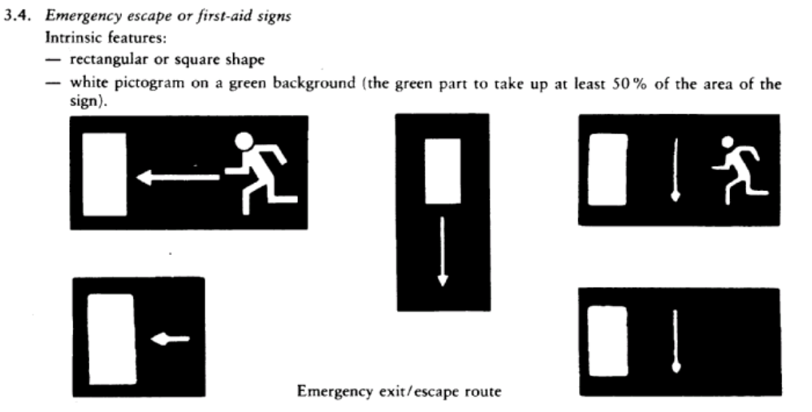

Paragraphs 7.7.1.1. and 7.7.1.2., amend to read:

"7.7.1.1. The free space extending inwards into the vehicle from the side wall in which the door is mounted shall permit the free passage of one test gauge having the dimensions of either test gauge 1 or test gauge 2 specified in Annex 4, Figure 1.

The test gauge shall be maintained parallel with the door aperture as it is moved from the starting position, where the plane of the face nearest to the interior of the vehicle is tangential to the outermost edge of the aperture, to the position where it touches the first step, after which it shall be kept at right angles to the probable direction of motion of a person using the entrance.

7.7.1.2. (Reserved)"

Paragraph 7.7.1.3., amend to read:

"7.7.1.3. When the centre line of this test gauge has traversed a distance of 300 mm from its starting position and the test gauge is touching the surface of the step or floor, it shall be retained in that position."

Paragraph 7.7.1.6., amend to read:

"7.7.1.6. The free passage clearance for this figure shall not include any space extending to 300 mm in front of any uncompressed seat cushion of a forward or rearward facing seat, or 225 mm in the case of sideways-facing seats, and to the height of the top of the seat cushion (see Annex 4, figure 25)."

Paragraph 7.7.1.8., amend to read:

"7.7.1.8. However, one or more folding seat(s) for use by the crew may obstruct the access passage to a service door when in the position of use provided that:"

Paragraph 7.7.1.12., amend to read:

"7.7.1.12. Gangways and access passages shall be covered with a slip-resistant material"

Paragraph 7.7.2.1., amend to read:

"7.7.2.1. Except as provided for in paragraph 7.7.2.4., the free space between the gangway and the emergency door ..."

Paragraph 7.7.5.6., amend to read:

"7.7.5.6. Folding seats allowing passengers to sit in the gangway shall not be permitted. Folding seats shall, however, be permitted in other areas of the vehicle so long as they do not obstruct the passage down the gangway of the gangway test gauge when in the open (seating) position."

Paragraph 7.7.7.2., amend to read:

"7.7.7.2. The height of a step shall be measured at the centre of its width at the outer edge, the tyre equipment and pressure being as specified by the manufacturer for the technically permissible maximum mass (MT)."

Paragraph 7.7.8.3. (title)., amend to read:

"7.7.8.3. Height of seat cushion (dimension H, see Annex 4, Figure 11a)"

Paragraph 7.7.8.3., amend to read:

The height of the ... less than 350 mm at the wheel arches (taking into account the allowances permitted in paragraph 7.7.8.6.2.) and at the engine/transmission compartment."

Paragraph 7.7.8.5.1., amend to read:

"7.7.8.5.1. For a seat behind a partition or other rigid structure other than a seat, a minimum clear space in front of each required passenger seating space (as defined in paragraph 7.7.8.6.) shall be provided as shown in Annex 4, figure 13. A partition whose contour corresponds approximately to that of the inclined seat back may intrude into this space. In the case of seats alongside the driver's seat in vehicles of Class A or B, intrusion of the dashboard, instrument panel, gear change control, windscreen, sun visor, seat belts and seat belt anchorages shall be allowed."

Insert a new paragraph 7.7.8.5.2., to read:

"7.7.8.5.2. For a seat behind a seat and/or a seat facing the gangway, a minimum clear foot space of at least 300 mm depth and a width according to paragraph 7.7.8.1.1., shall be provided as shown in Annex 4, figure 11b. The local presence in this space of seat legs, passenger footrests and of intrusions as provided by paragraph 7.7.8.6. shall be permitted provided that adequate space remains for the passengers' feet. This foot space may partly be situated in and/or above the gangway but shall not create any obstruction when measuring the minimum gangway-width in accordance with paragraph 7.7.5. In the case of seats alongside the driver's seat in vehicles of Class A or B, intrusion of the seat belts and seat belt anchorages shall be allowed. "

Paragraphs 7.7.8.5.2. and 7.7.8.5.2.1. (former), renumber as paragraphs 7.7.8.5.3. and 7.7.8.5.3.1.

Paragraph 7.7.8.5.3. (former 7.7.8.5.2.), amend to read:

"7.7.8.5.3. However, at least two in Class I and Class II and one in Class A forward or rearward facing seats specifically intended and marked for passengers with reduced mobility other than wheelchair users shall be provided in that part of the bus which is most suitable for boarding. These seats shall be designed for passengers with reduced mobility so as to provide enough space, shall have suitably designed and placed handholds to facilitate entry and exit of the seat and provide communication in accordance with paragraph 7.7.9. from the seated position."

Paragraph 7.7.8.6.1., first sub paragraph, amend to read:

"7.7.8.6.1. In the case of single deck vehicles, over each seating position and, except in the case of the seats(s) alongside the driver in a vehicle of Class A or B, its associated foot space, there shall be measured a free space with a height of not less than 900 mm measured from the highest point of the uncompressed seat cushion and at least 1350 mm from the mean level of the floor in the foot space. In the case of vehicles to which paragraph 7.7.1.10. applies, and also for the seats(s) alongside the driver in a vehicle of Class A or B, these dimensions may be reduced to 1200 mm measured from the floor and 800 mm measured from the highest point of the uncompressed seat cushion."
(remainder unchanged).

Note: During the eighty-sixth GRSG session, study reservations were entered by Spain and the United Kingdom.

Paragraph 7.7.8.6.3.2., amend to read:

"7.7.8.6.3.2. in the case of the upper part of the outboard seating position, a zone with triangular cross-section whose apex is situated 700 mm from the top and whose base is 100 mm in width (see Figure 15); The space needed for safety belts and their anchorages and for the sun visor is also excluded."

Paragraph 7.7.8.6.3.3., amend to read:

"7.7.8.6.3.3. in the case of the foot well of an outboard seating position, a zone of a cross-sectional area not exceeding, 0.02 m² (0.03 m² for low floor vehicles) and having a maximum width not exceeding 100mm (150mm for low floor vehicles) (see Annex 4, Figure 16)."

Paragraph 7.7.9.1., replace the value "1200 mm" to read "1500 mm", and add at end:

"The provisions of paragraph 7.6.11.4. apply to any textual markings used."

Insert a new paragraph 7.8.5., to read:

"7.8.5. Control of the mandatory interior lighting shall be by manual switches under the control of the driver or automatically controlled."

Paragraph 7.11.1.4., amend to read:

"7.11.1.4. The clearance between a hand-rail or hand-hold, along the majority of its length, and the adjacent part of the vehicle body or walls shall be at least 40 mm. However, in the case of a handrail on a door or a seat, or in the access passage of a vehicle of Class II, III or B, a minimum clearance of 35 mm shall be permitted."

Paragraph 7.11.2., amend to read:

"7.11.2. Additional requirements for handrails and handholds for vehicles designed to carry standing passengers"

Paragraph 7.12.1., amend to read:

"7.12.1. Where any seated passenger is likely to be thrown forward into a stepwell as a result of heavy braking, either a guard or, in the case of a vehicle of Class A or B, a seat belt shall be fitted. Where fitted, the guard shall have a minimum height ..."

Annex 4

Figure 1, amend to read:

"Figure 1
ACCESS TO SERVICE DOORS

(see Annex 3, paragraph 7.7.1.)

Test Gauge 1 Test Gauge 2

400mm
550mm
700mm
see Annex 3,
para 7.7.1.6
20mm
400mm
400mm
A
30 º
30 º
500mm
A
700mm
400mm
550mm

Vehicle Class | Height of the upper panel (mm)  (Dimension ‘A’ figure 1)
 | Test gauge 1 | Test gauge 2
Class A | 950 (*) | 950
Class B | 700 (*) | 950
Class I | 1100 | 1100
Class II | 950 | 1100
Class III | 850 | 1100

(*) For vehicles of Class A or B, the lower panel may be displaced horizontally relative to the upper panel provided that it is in the same direction."

Figure 11, renumber as figure 11a:

Insert a new figure 11b, to read:

"Figure 11b

SPACE FOR FEET OF SEATED PASSENGERS BEHIND A SEAT AND OR/OR A SEAT FACING THE GANGWAY
(see Annex 3, paragraph 7.7.8.5.2.)

60 cm max
30 cm min
30 ° max
– 8 ° min
70 cm min
15cm min

"
Figure 13, the title, amend to read:

"Figure 13

SPACE FOR SEATED PASSENGERS BEHIND A PARTITION OR OTHER RIGID STRUCTURE OTHER THAN A SEAT
(see Annex 3, paragraph 7.7.8.5.1.)"

Insert new Figures 27 and 28, to read:

"Figure 27

ACCESS TO DRIVER’S DOOR
(See Annex 3, paragraph 7.6.1.7.2.)

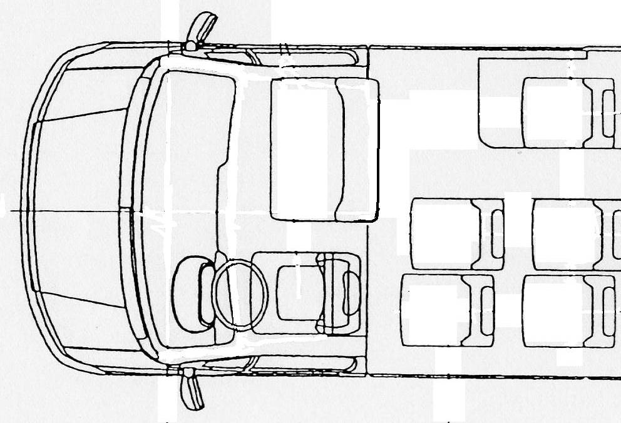
Test gauge of 600mm x 400mm as in Annex 3, paragraph 7.7.3.3.
Gangway test gauge

Figure 28

ACCESS TO DRIVER’S DOOR
(See Annex 3, paragraph 7.6.1.9.3.)
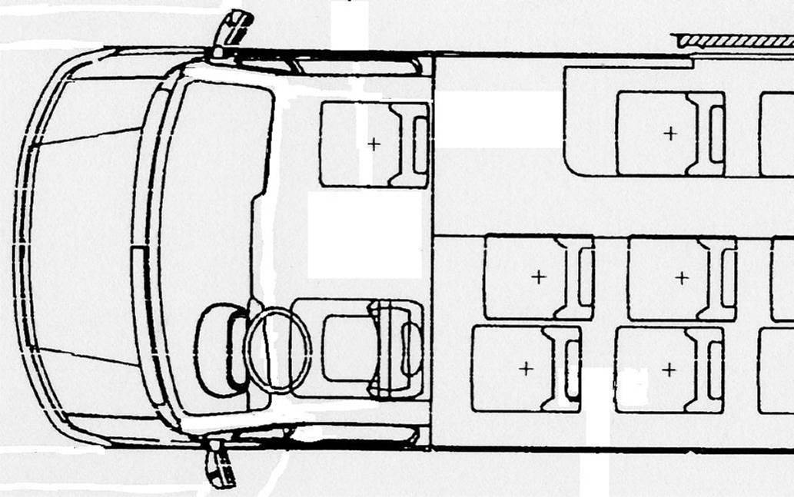
Test gauge of 60 cm x 40 cm as described in paragraph 5.7.3.3.
Gangway test gauge
Test gauge of 600 mm x 400 mm as described in Annex 3, paragraph 7.7.3.3.

"
Annex 7

Title, amend to read:

"ALTERNATIVE REQUIREMENTS FOR VEHICLES OF CLASSES A AND B"

After the title, insert a text to read:

"Vehicles of classes A and B shall comply with the requirements of annex 3 with the exception that:

- in place of paragraph 7.6.3.1. of annex 3, a vehicle may comply with paragraph 1.1. of this Annex;

- in place of paragraph 7.6.2. of annex 3, a vehicle may comply with paragraph 1.2. of this Annex."

Paragraph 1.1.1., amend to read:

"1.1.1. A vehicle to which paragraph 7.7.1.10. of Annex 3 applies shall meet the requirements of paragraph 7.6.3.1. of Annex 3 or paragraph 1.1. of this annex as regards emergency windows and escape hatches, and the following minimum requirements as regards service doors and emergency doors:"

Annex 8

Paragraph 3.1., amend to read:

"3.1. Steps

The height of the first step from the ground of at least one service door shall not exceed 250 mm for vehicles of Class I and A and 320 mm for vehicles of Class II, III and B. In the case where only one service door meets this requirement there must be no barrier or sign which prevents that door from being used as both an entrance and an exit.

As an alternative for vehicles of Class I and A, the first step from the ground shall not exceed 270 mm in two door openings, one entrance and one exit.

A kneeling system and/or retractable step may be engaged.

The height of steps in an access passage at the above-mentioned door(s), and in the gangway, shall be not more than 200 mm for vehicles of Class I and A and 250 mm for vehicles of Class II, III and B."

Paragraph 3.2.3., amend to read:

"3.2.3. Armrests shall be fitted on seats between the seating position and the gangway and shall be capable of being moved easily out of the way to permit clear access to the seat. In the case of seats facing each other one of the gangway seats may alternatively be fitted with a vertical stanchion. This stanchion shall be positioned such that the seat occupant is kept securely on the seat and easy access to the seat is possible.

Handrails or handholds shall be fitted adjacent to priority seats in such a way as to allow the passenger to grasp them easily."

Paragraph 3.2.7., amend to read:

"3.2.7. Each priority seating position shall have a free height of not less than 1 300 mm for vehicles of Class I and A and 900 mm for vehicles of Class II, measured from the highest point of the uncompressed seat cushion. This free height shall extend over the vertical projection of the whole of the seat and the associated foot space. Intrusion of a seat back or other object into this space shall be permitted provided that a minimum clear vertical space extending 230 mm in front of the seat cushion is maintained. Where the priority seat is positioned facing a bulkhead more than 1200 mm in height this space shall be 300 mm. From the edges of the free space defined above, intrusions are permitted in accordance with paragraphs 7.7.8.6.3.1. to 7.7.8.6.3.4. of Annex 3 as if reference to the clear space in paragraphs 7.7.8.6.1. and 7.7.8.6.2. of Annex 3 is a reference to the clear space defined above. The provisions of paragraph 7.7.8.1.4. of Annex 3 may apply. Intrusions of handholds or handrails as mentioned in the second sub-paragraph of paragraph 3.2.3. may protrude by a maximum of 100 mm from the sidewall into the clear space over the vertical projection of the foot space."

Paragraph 3.3.4., amend to read:

"3.3.4. If a vehicle is fitted with a ramp or lift, a means of communication with the driver shall be fitted outside, adjacent to the door, and at a height between 850 mm and 1300 mm from the ground. This requirement shall not apply to a door situated in the direct field of vision of the driver."

Paragraph 3.8.1., amend to read:

"3.8.1. Wheelchair restraint system. In vehicles required to have occupant restraint systems fitted, the wheelchair space shall be designed for the wheelchair user to travel facing forwards and shall be fitted with wheelchair and occupant restraint systems complying with paragraphs 3.8.1.2. or 3.8.2.

In vehicles not required to have occupant restraint systems fitted, the wheelchair space shall be fitted with restraint systems complying with paragraph 3.8.1.1. or 3.8.3."

Paragraph 3.9.1., amend to read:

"3.9.1. If a door referred to in paragraph 3.6. is fitted with opening controls for use under normal circumstances, whether being outside or inside of the vehicle, these controls shall be adjacent to that door at a height between 850 mm and 1300 mm from the ground (exterior controls) or the floor (interior controls)."

Paragraph 3.11.2.3., amend to read:

"3.11.2.3. The lowering process shall be capable of being stopped and immediately reversed ..."

Paragraph 3.11.2.4., amend to read:

"3.11.2.4. Any kneeling system that is fitted to a vehicle shall neither:

3.11.2.4.1 allow the vehicle to be driven at a speed of more than 5 km/h when the vehicle is lower than the normal height of travel, nor

3.11.2.4.2 allow the vehicle to be lowered when the operation of the service door is prevented for any reason."

Paragraph 3.11.4.3.3., amend to read:

"3.11.4.3.3. These safety devices shall immediately stop the movement of the ramp when the ramp is subject to a reactive force not exceeding 150 N."

Paragraph 3.11.4.3.4, amend to read:

"3.11.4.3.4. The horizontal movement of a ramp shall be interrupted when a mass of 15 kg is placed upon it."

Paragraph 3.11.4.4.1., amend to read:

"3.11.4.4.1. Where the driver has adequate view of the ramp sufficient to monitor its deployment and use, to ensure the safety of passengers, the ramp may be operated by the driver when in the driver’s seat. This requirement may be met by using suitable indirect vision devices."

Annex 12

Paragraph 1.2 (ii), amend to read:

"(ii) "low voltage circuits" means circuits supplied with accumulator battery and with a charger outlet of nominal 12 V, 24 V or 42 V voltage."

_____________

